**Supplementary Material:**

***Ocean model-based covariates improve a marine fish stock assessment when observations are limited***

Hubert du Pontavice1,2, Timothy J. Miller3, Brian C. Stock3,4, Zhuomin Chen5, Vincent S. Saba2

*1 Princeton University, Atmospheric and Oceanic Sciences Program, 300 Forrestal Road, Sayre Hall, Princeton, NJ, 08540, USA.*

*2 National Oceanic and Atmospheric Administration, National Marine Fisheries Service, Northeast Fisheries Science Center, Geophysical Fluid Dynamics Laboratory, Princeton University, 201 Forrestal Road, Princeton, NJ, 08540, USA.*

*3 National Oceanic and Atmospheric Administration, National Marine Fisheries Service, Northeast Fisheries Science Center, 166 Water Street, Woods Hole, MA, 02543, USA.*

*4 Institute of Marine Research, P.O. Box 1870 Nordnes, 5817 Bergen, Norway*

*5 Department of Marine Sciences, University of Connecticut, Groton, CT 06340, USA.*

# Supplementary Material I

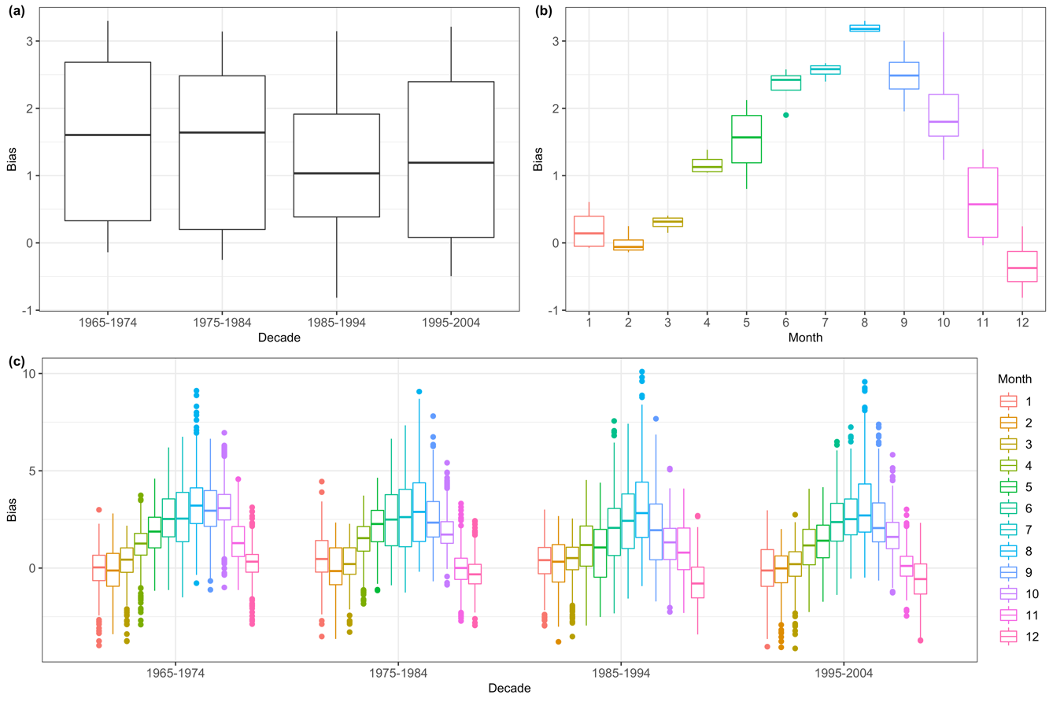

**Figure S1.1: Decadal bias estimates in the Cold Pool domain between ROMS-NWA and the NWA-climatology during the summer period (June-September).** Panels (a) and (b) represent the mean decadal (a) and monthly (b) bias estimates while panel (c) represents the raw bias estimates for each month and each decade in each grid cell.

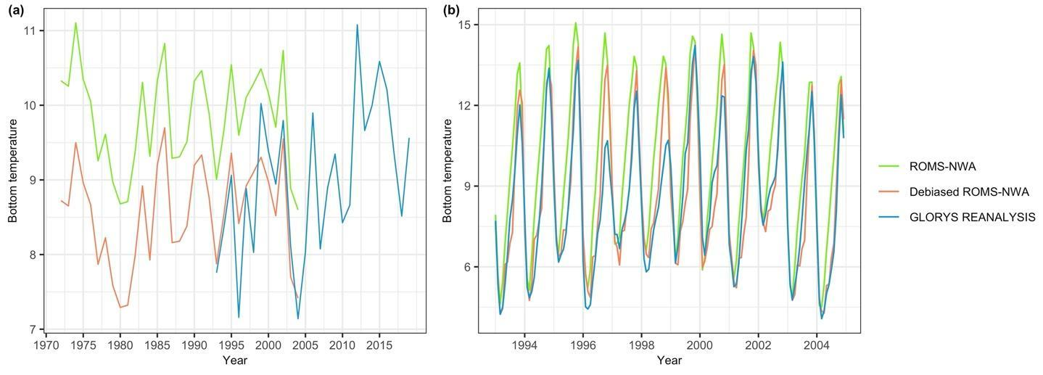

**Figure S1.2: Interannual (a) and monthly (b) comparisons of bottom temperature over the Cold Pool domain among ROMS-NWA before the bias correction (ROMS-NWA), ROMS-NWA after the bias correction (debiased ROMS-NWA), and GLORYS12v1 reanalysis.**

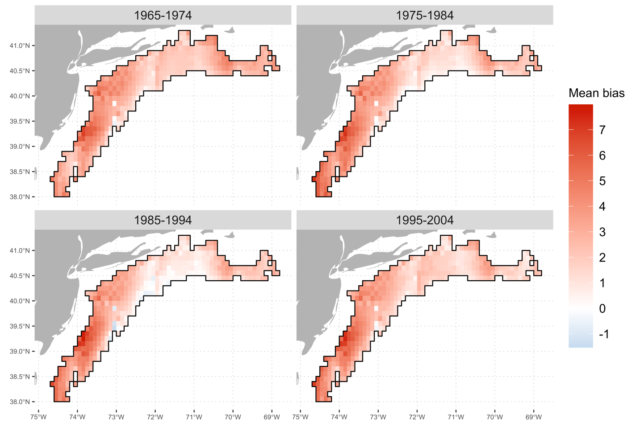

**Figure S1.3: Maps of the mean decadal bias estimates between ROMS-NWA and the NWA-climatology during the summer period (June-September) in the Cold Pool domain.**

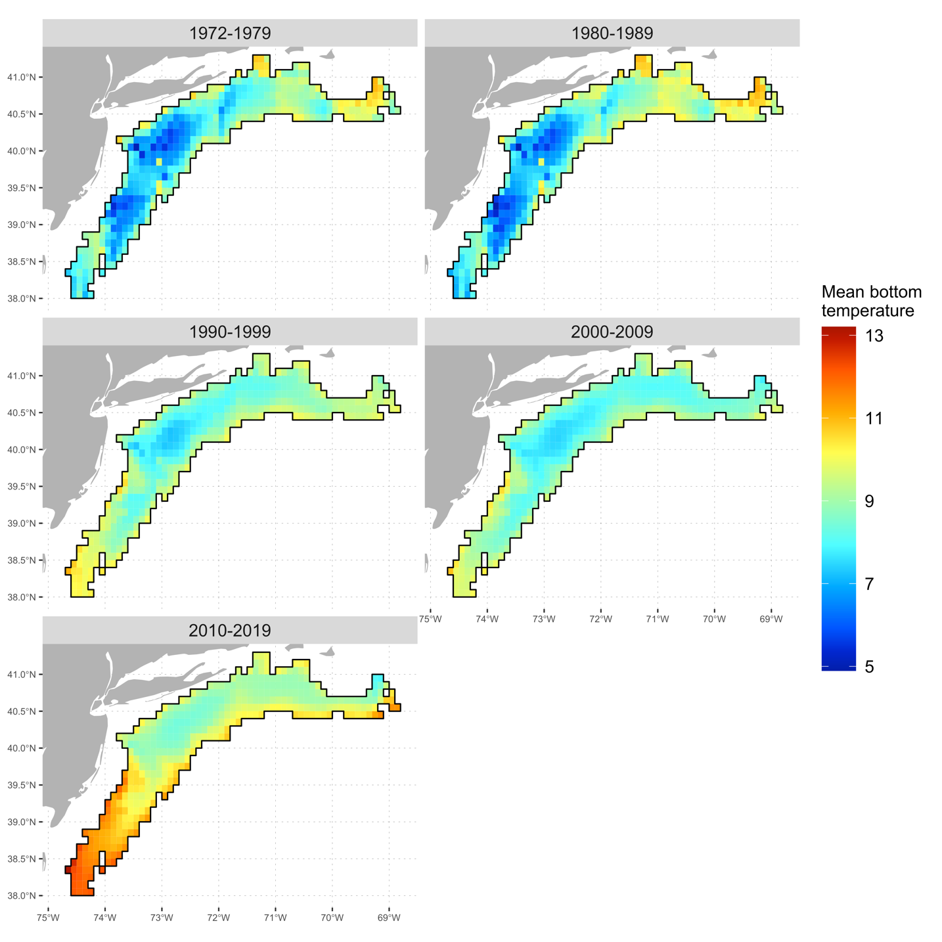

**Figure S1.4: Maps of the mean bottom temperature during the summer period (June-September) in the Cold Pool domain for each decade between 1972 and 2019.**

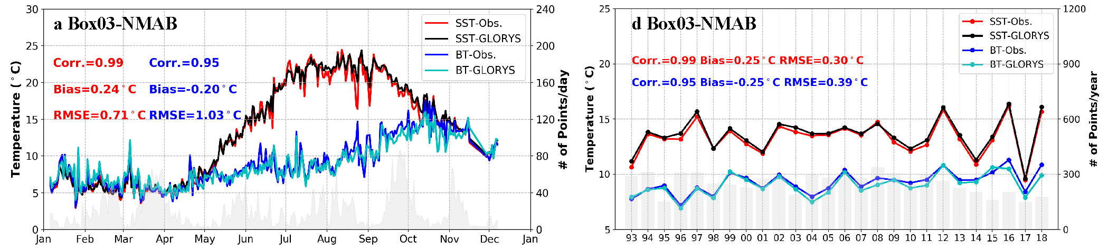

**Figure S1.5: Seasonal (a) and interannual (d) comparisons of sea surface temperature (SST) (red and black lines) and bottom temperature (BT) (blue and cyan lines) between the GLORYS12v1 reanalysis (black and cyan lines) and observations (red and blue lines) for the Southern New England-Mid Atlantic.** The gray bars in the background indicate the number of observations in SST used in each panel, and which is almost identical to the number of observations in BT (difference < 0.03%). Credit: extracted from Chen et al. (2020).

# Supplementary Material II

Two ocean model products were used for regional bottom temperature estimates over time and space in southern New England and the Mid-Atlantic Bight. Bottom temperature from the global product GLORYS12v1 was highly consistent with *in situ* observations between 1993 and 2018 within the region on both monthly and interannual time scales as shown in Chen *et al.* (2021) (Supplementary Material I, Figure S1.5). However, ROMS-NWA bottom temperature was systematically warm-biased, especially during the warmer months when the ocean is more stratified (Chen and Curchitser, 2020). The process to reduce the bias of ROMS-NWA using NWA-climatology improved the consistency with GLORYS12v1 during the period shared by both datasets between 1993 and 2004 (Supplementary Material I, Figure S1.2). However, the correction we calculated accounted only for monthly decadal bias, so it did not consider the potential interannual errors. Further investigation using *in situ* observations would be necessary to evaluate the performance of the bottom temperature time series based on the debiased ROMS-NWA and GLORYS12v1 at an interannual scale in the Northeast US shelf.

We reduced the temporal resolution of two data sources from daily resolution to monthly resolution because the bias correction of ROMS-NWA was applied monthly. This may directly affect the accuracy of Model_PI which was calculated based on the monthly bottom temperature instead of daily. This can also indirectly reduce the quality of Model_CPI and Model_SEI.

**REFERENCES**

Chen, Z., and Curchitser, E. N. 2020. Interannual Variability of the Mid‐Atlantic Bight Cold Pool. Journal of Geophysical Research: Oceans, 125.

Chen, Z., Kwon, Y., Chen, K., Fratantoni, P., Gawarkiewicz, G., Joyce, T. M., Miller, T. J., *et al.* 2021. Seasonal Prediction of Bottom Temperature on the Northeast U.S. Continental Shelf. Journal of Geophysical Research: Oceans, 126.

# Supplementary Material III

## S3.1. Model details

Maturity was fixed at 0.0052, 0.6836, 0.9854, 0.9970, 0.9963, and 1 for ages 1–6, while natural mortality was specified as 0.405, 0.336, 0.296, 0.275, 0.256, and 0.2311 yr-1 for ages 1–6.

Logistic selectivity was estimated for the fleet and indices, except in three time blocks where age-specific, flat-topped selectivity facilitated convergence, i.e., we fixed selectivity at 1 for older ages and estimated selectivity at younger ages as free parameters.

## S3.2. Observation errors of the spatial extent index (Model_SEI)

The Obs_CPI and Model_CPI observation error variances were calculated as the standard error of the mean residual bottom temperature. The Model_PI observation error variance was calculated as the standard error of the mean “residual month”. The observation error variance for Model_SEI was estimated from the Model_CPI and Model_PI observation variances which were based on the same data (GLORYS12v1 and ROMS-NWA) because no direct method was identified. Thus, the observation error variance for Model_SEI ($σ_{{Model_SEI}_{t}}^{2}$) was estimated as the average of the standard errors of Model_CPI ($σ_{{Model_CPI}_{t}}^{2}$) and Model_PI ($σ_{{Model_PI}_{t}}^{2}$) by adjusting the standard errors based on the range of the observations of Model_CPI, Model_PI and Model_SEI such that :

$$σ_{{Model_SEI}_{t}}^{2}= \frac{rg_SEI ( \frac{σ_{{Model_CPI}_{t}}^{2} }{rg_CPI} - \frac{σ_{{Model_PI}_{t}}^{2} }{rg_PI}) }{2}$$

with

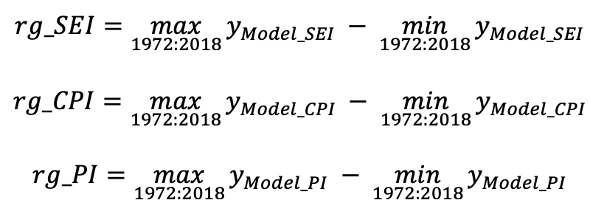

## S3.3. Model diagnostics - Cold Pool Indices

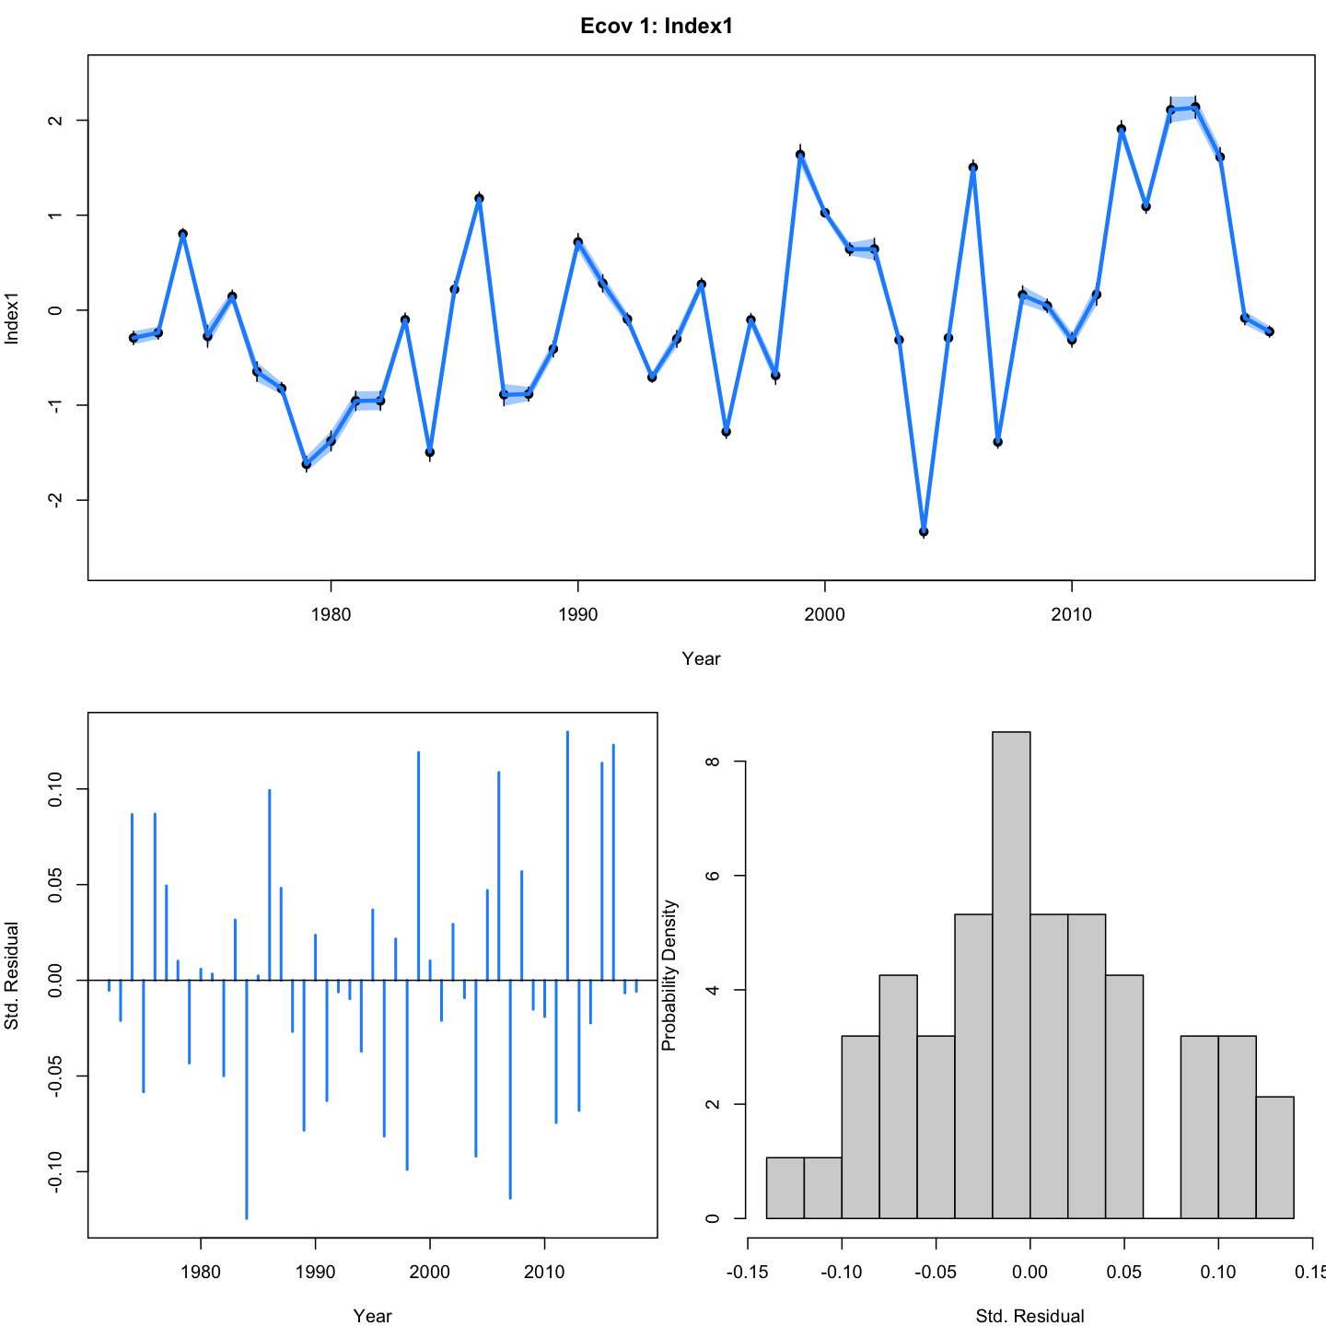

**Figure 2.2.1: Model_CPI (Cold Pool Index) estimated from the model g(Model_CPI) (top), denoted m1 in Table 1 and its standard residuals (bottom).** In the top panel, points are observations with 95% confidence interval and the line with shading is the model estimated CPI with 95% confidence interval.

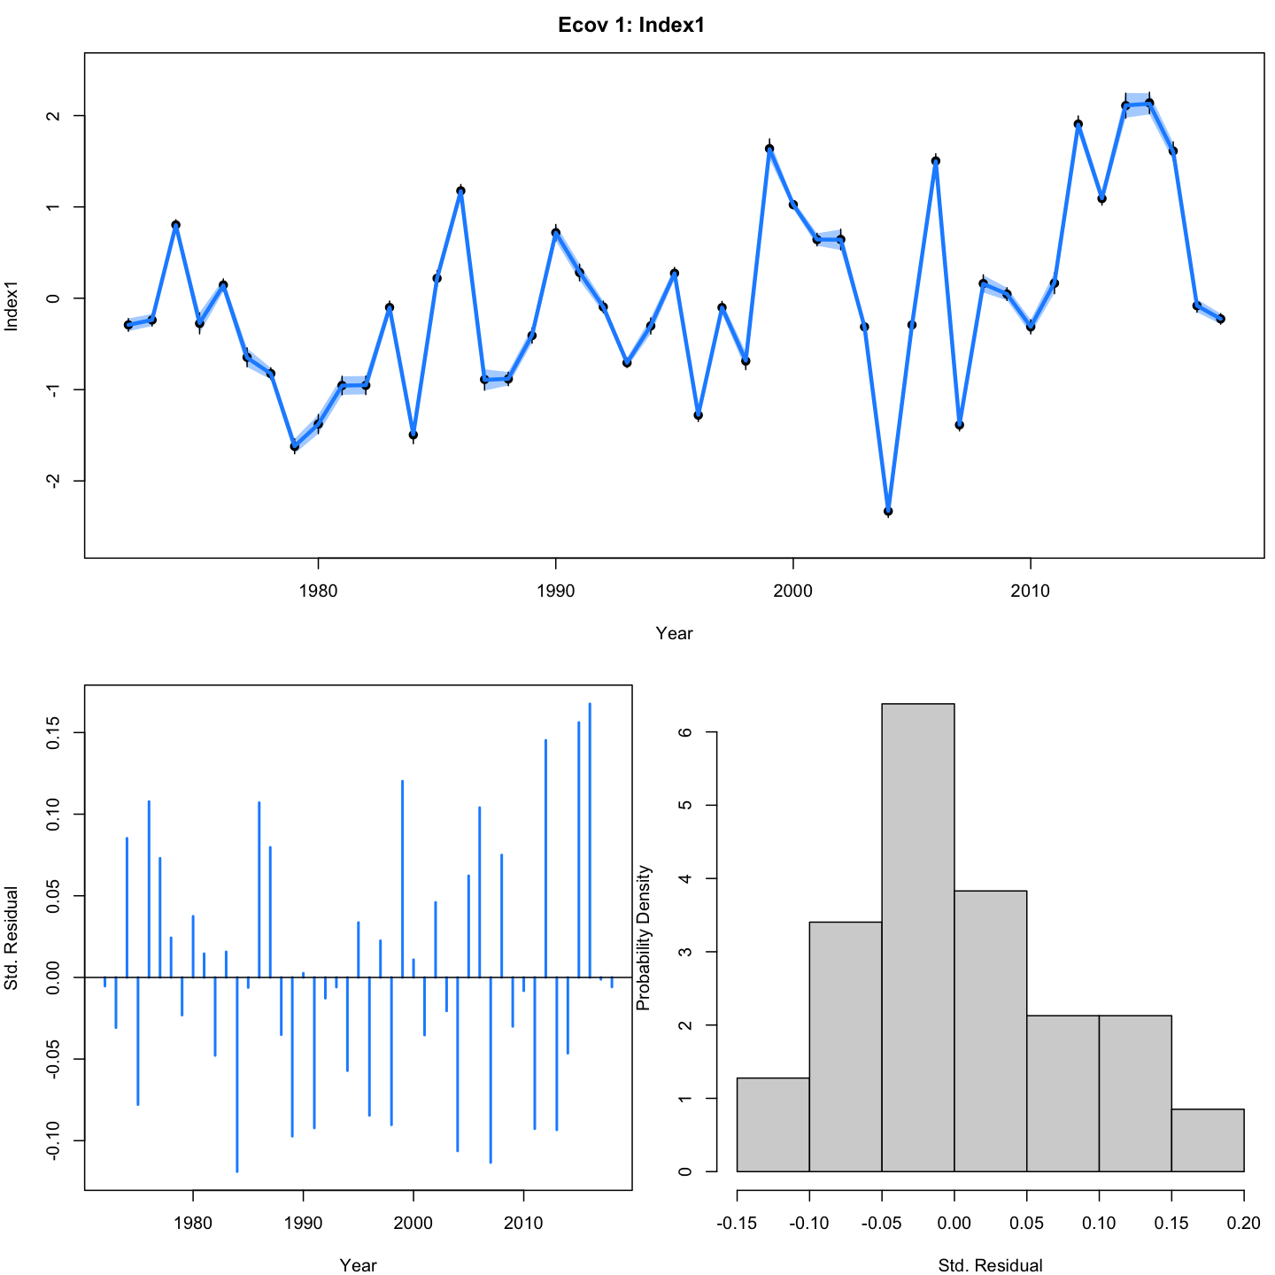

**Figure 2.2.2: Model_CPI (Cold Pool Index) estimated from the model g(Model_CPI+PI) (top), denoted m2 in Table 1 and its standard residuals (bottom).** In the top panel, points are observations with 95% confidence interval and the line with shading is the model estimated CPI with 95% confidence interval.

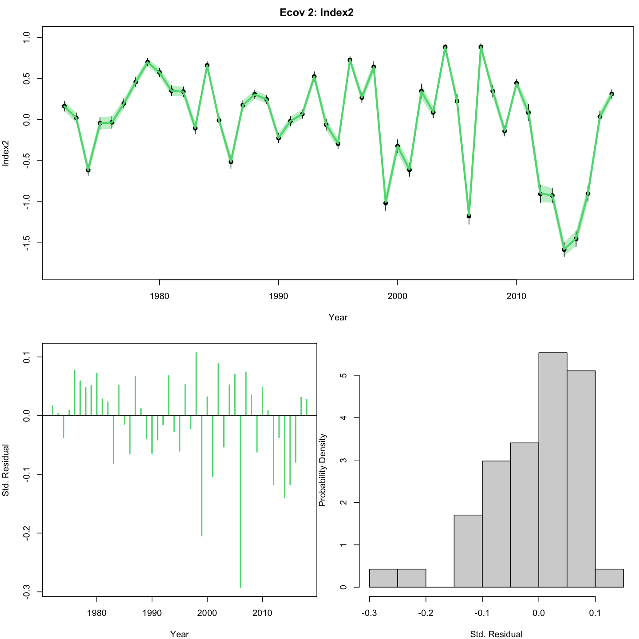

**Figure 2.2.3: Model_PI (Persistence Index) estimated from the model g(Model_CPI+PI) (top), denoted m2 in Table 1 and its standard residuals (bottom).** In the top panel, points are observations with 95% confidence interval and the line with shading is the model estimated PI with 95% confidence interval.

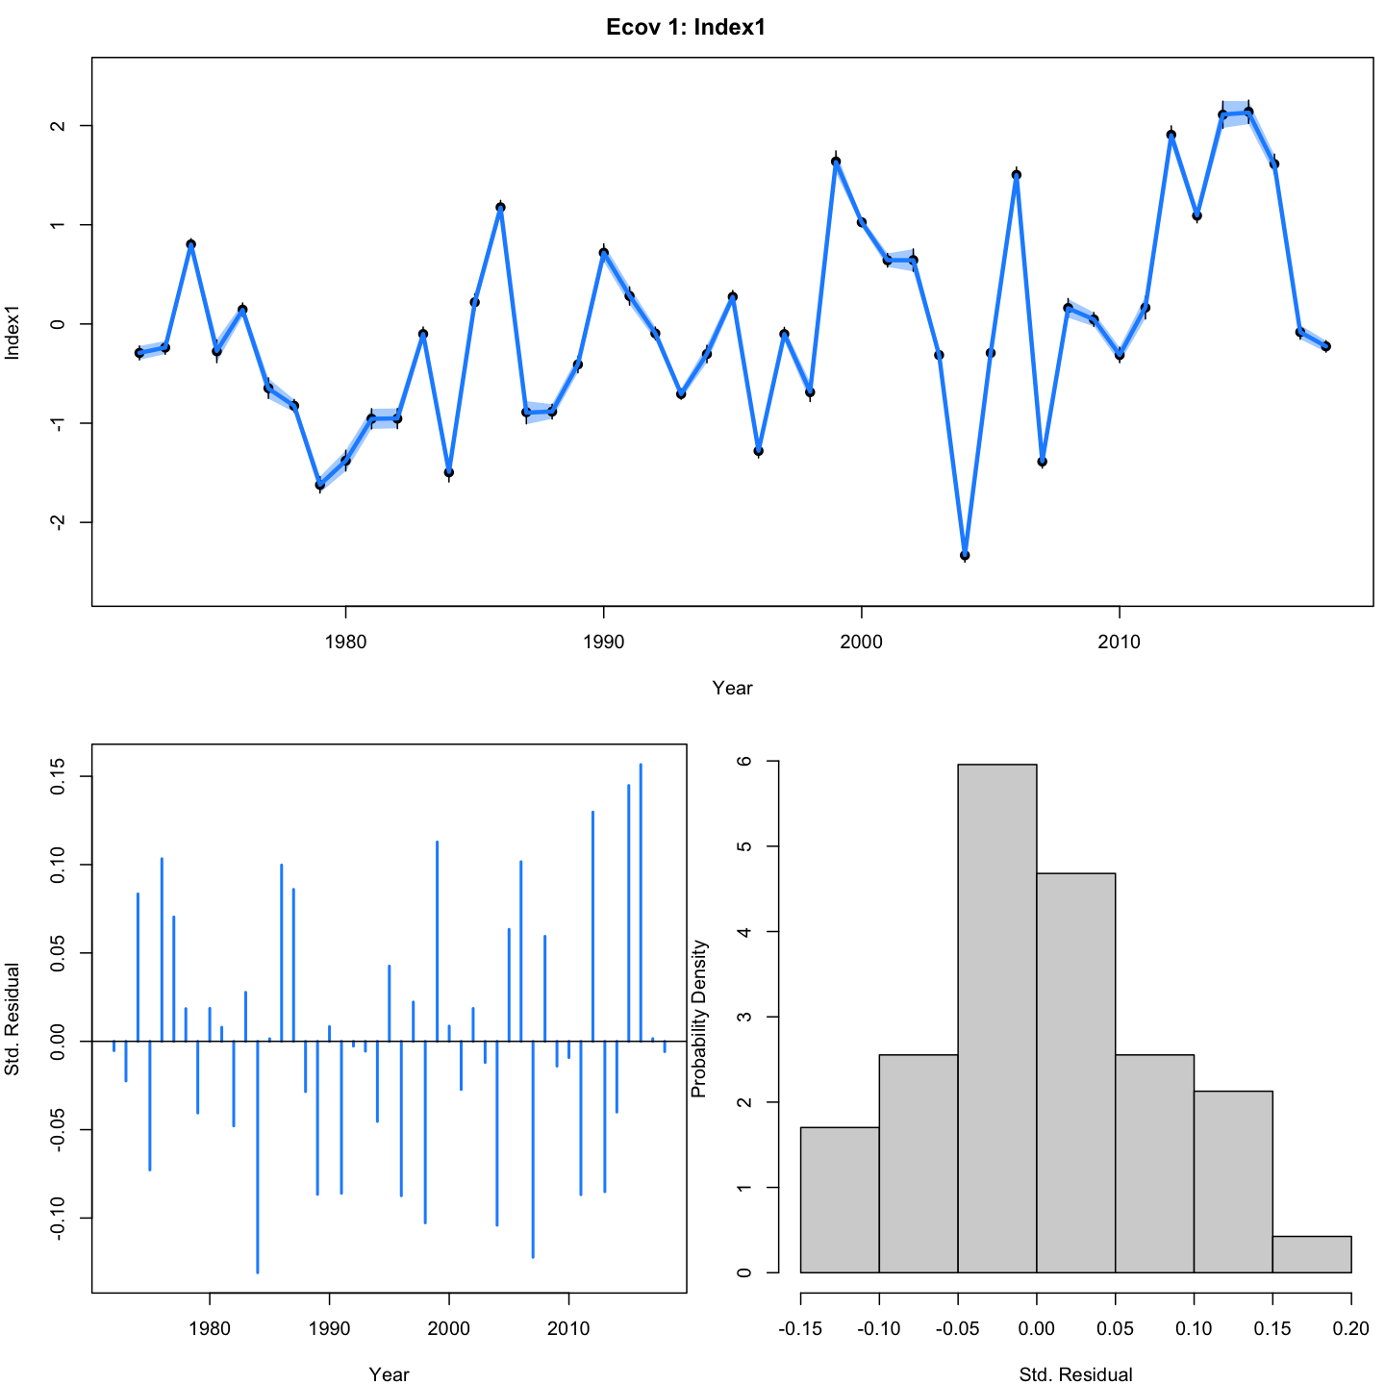

**Figure 2.2.4: Model_CPI (Cold Pool Index) estimated from the model g(Model_CPI+SEI) (top), denoted m3 in Table 1 and its standard residuals (bottom).** In the top panel, points are observations with 95% confidence interval and the line with shading is the model estimated CPI with 95% confidence interval.

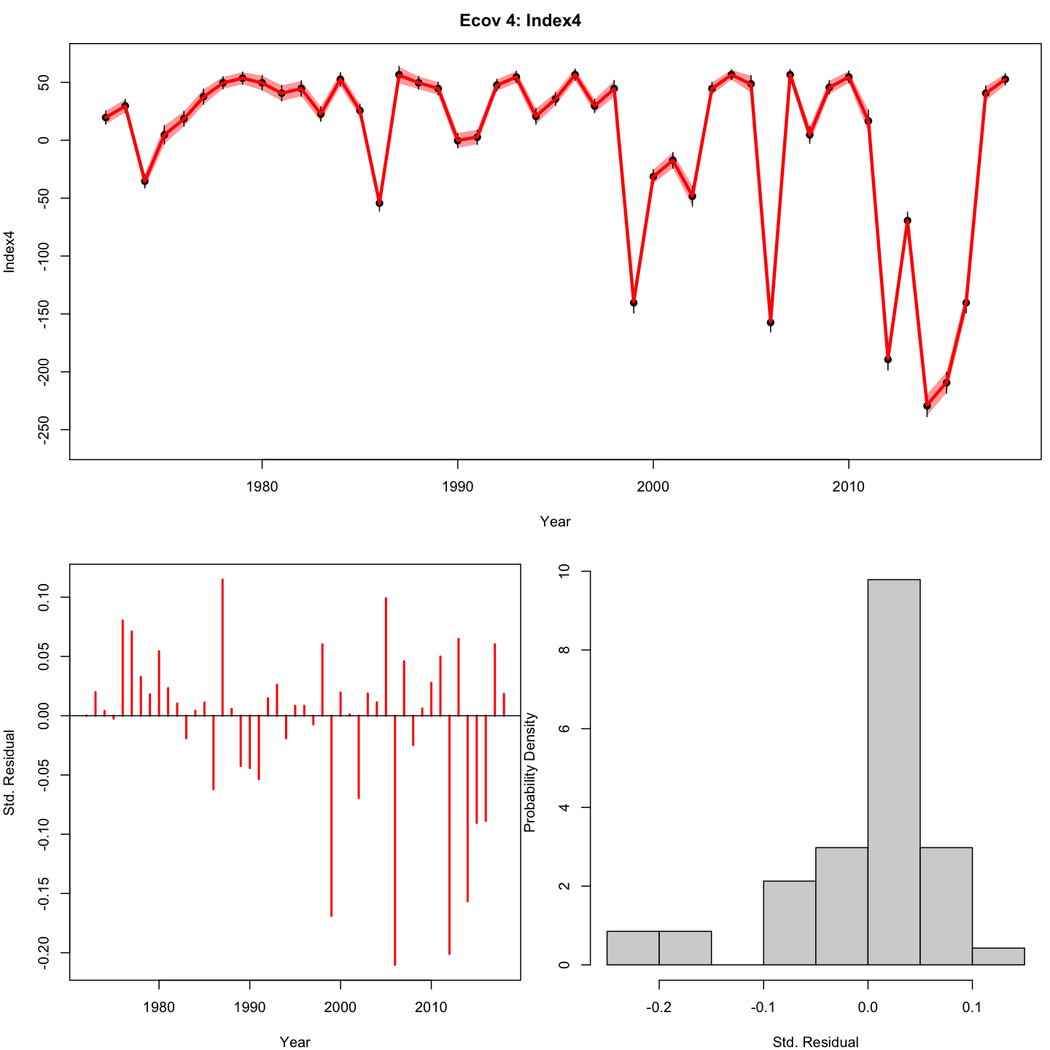

**Figure 2.2.5: Model_SEI (Spatial Extent Index) estimated from the model g(Model_CPI+SEI) (top), denoted m3 in Table 1 and its standard residuals (bottom).** In the top panel, points are observations with 95% confidence interval and the line with shading is the model estimated SEI with 95% confidence interval.

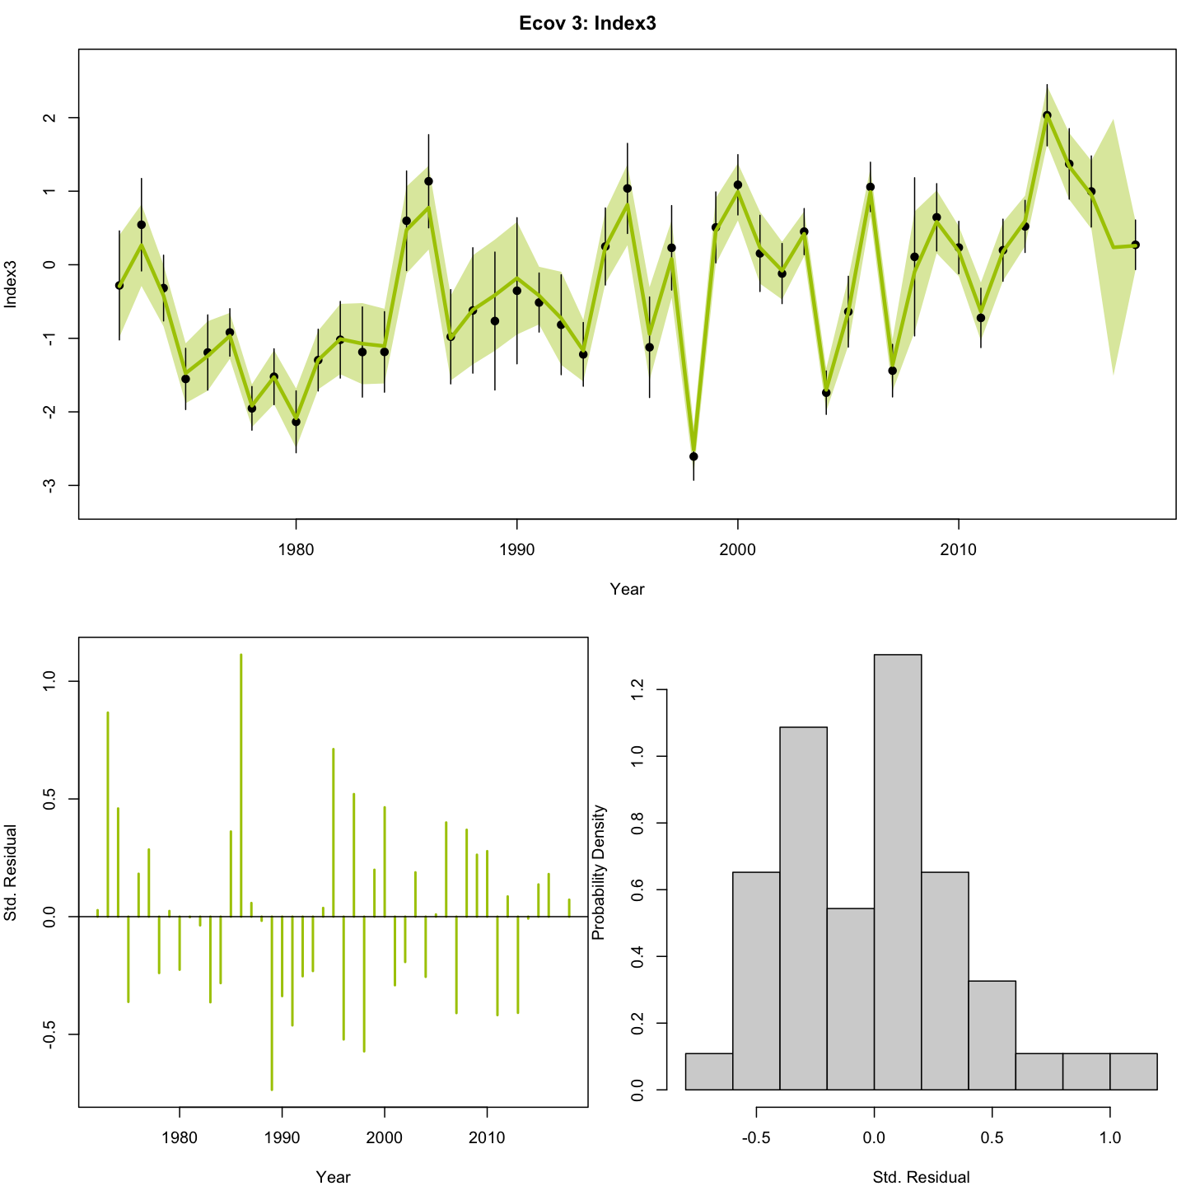

**Figure 2.2.6: Obs_CPI (Cold Pool Index) estimated from the model g(Obs_CPI) (top), denoted m8 in Table 1 and its standard residuals (bottom).** In the top panel, points are observations with 95% confidence interval and the line with shading is the model estimated SEI with 95% confidence interval.

## S3.4. Model diagnostics - convergence

**Table S3.4: Model convergence, the invertible hessian matrix (pdHess : “positive-definite Hessian"), negative log-likelihood (NLL) and the correlations (Cor) between the environmental covariates for each of the 25 tested models.**

|  |  |  |  |  |  |  |  |  |
| --- | --- | --- | --- | --- | --- | --- | --- | --- |
|  | **Obs_CPI** | **Model_CPI** | **Model_PI** | **Model_SEI** | **Convergence** | **pdHess** | **NLL** | **Cor** |
| m1 | --- | Controlling | --- | --- | TRUE | TRUE | -612.84 | NA |
| m2 | --- | Controlling | Limiting | --- | TRUE | TRUE | -613.57 | -0.67 |
| m3 | --- | Controlling | --- | Limiting | TRUE | TRUE | -613.31 | -0.54 |
| m4 | --- | Masking | --- | --- | TRUE | TRUE | -612.04 | NA |
| m5 | --- | Controlling | Masking | --- | TRUE | TRUE | -612.94 | 0.88 |
| m6 | --- | Controlling | --- | Masking | TRUE | TRUE | -612.85 | 0.82 |
| m7 | --- | Limiting | Masking | --- | TRUE | TRUE | -612.51 | -0.50 |
| m8 | Limiting | --- | --- | --- | TRUE | TRUE | -611.40 | NA |
| m9 | --- | Masking | --- | Controlling | TRUE | TRUE | -612.24 | 0.93 |
| m10 | --- | Masking | Limiting | --- | TRUE | TRUE | -612.19 | -0.79 |
| m11 | --- | Masking | Controlling | --- | TRUE | TRUE | -612.09 | 0.89 |
| m12 | --- | Masking | --- | Limiting | TRUE | TRUE | -612.11 | -0.59 |
| m13 | Controlling | --- | --- | --- | TRUE | TRUE | -610.96 | NA |
| m14 | Masking | --- | --- | --- | TRUE | TRUE | -610.74 | NA |
| m15 | --- | Limiting | --- | --- | TRUE | TRUE | -610.56 | NA |
| m16 | --- | Limiting | --- | Masking | TRUE | TRUE | -611.53 | -0.54 |
| m17 | --- | --- | Controlling | --- | TRUE | TRUE | -610.44 | NA |
| m18 | --- | --- | Masking | --- | TRUE | TRUE | -610.39 | NA |
| m19 | --- | Limiting | Controlling | --- | TRUE | TRUE | -611.30 | -0.87 |
| m20 | --- | --- | Limiting | --- | TRUE | TRUE | -609.91 | NA |
| m21 | --- | Limiting | --- | Controlling | TRUE | TRUE | -610.80 | -0.88 |
| m22 | --- | --- | --- | Controlling | TRUE | TRUE | -608.89 | NA |
| m23 | --- | --- | --- | Masking | TRUE | TRUE | -608.30 | NA |
| m24 | --- | --- | --- | Limiting | TRUE | TRUE | -607.96 | NA |
| m25 | --- | --- | --- | --- | TRUE | TRUE | -600.56 | NA |

## S3.5. Model diagnostics - OSA residuals for the catch data and bottom trawl surveys

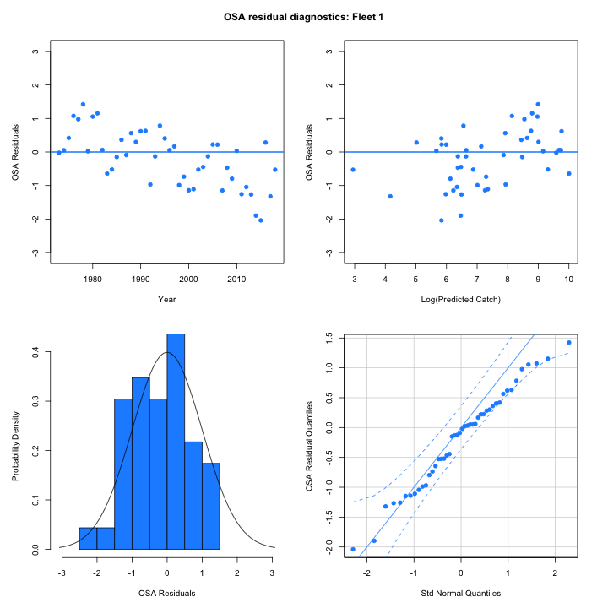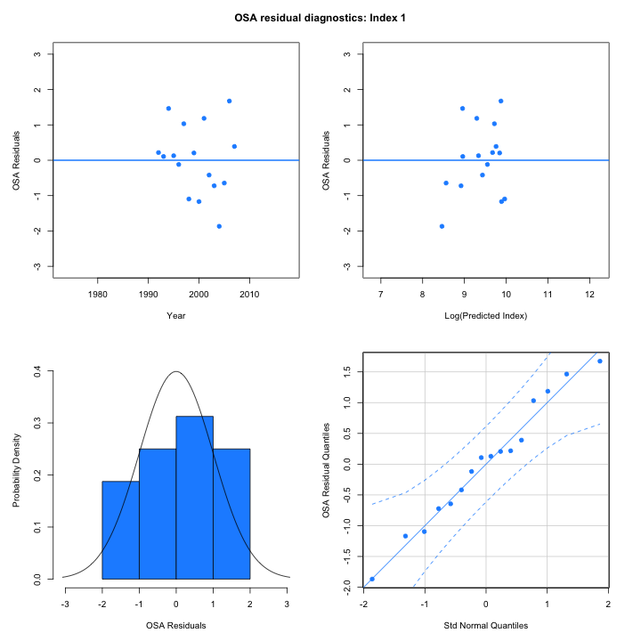

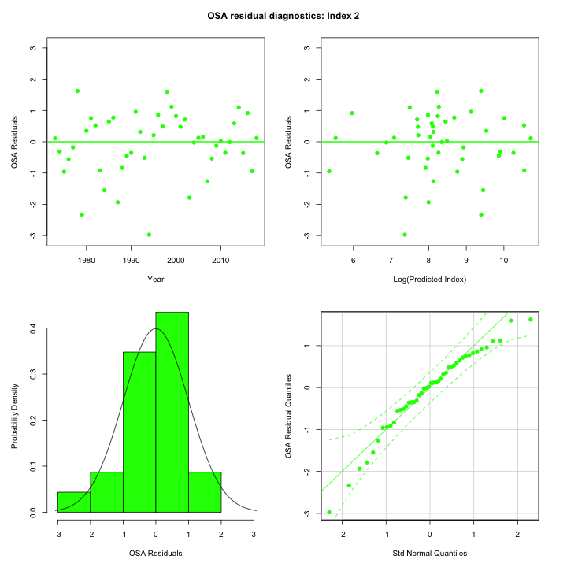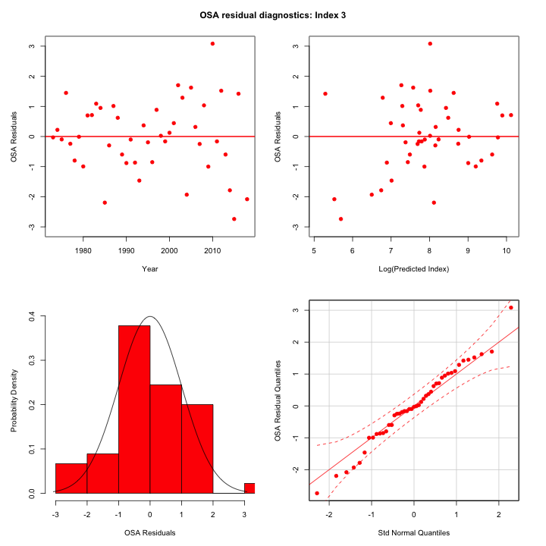

**Figure 3.5.1: One-Step-Ahead (OSA) residuals of the model g(Model_CPI) (denoted m1 in Table 1) for the catch data (top left, Fleet 1) and for the three bottom trawl surveys (top right and bottom, Index 1, Index 2 and Index 3, respectively).**

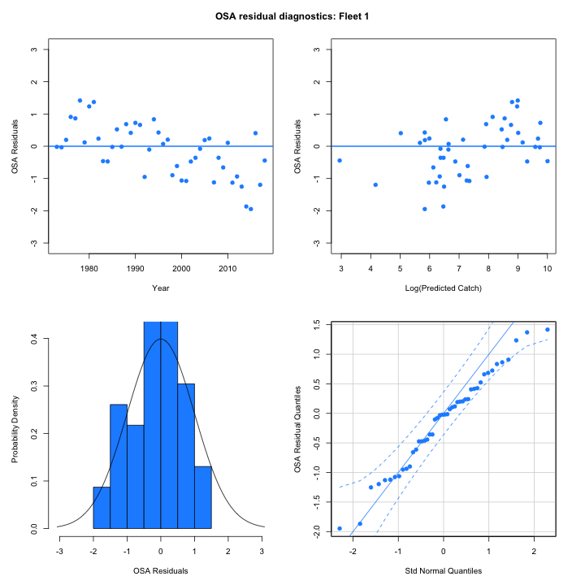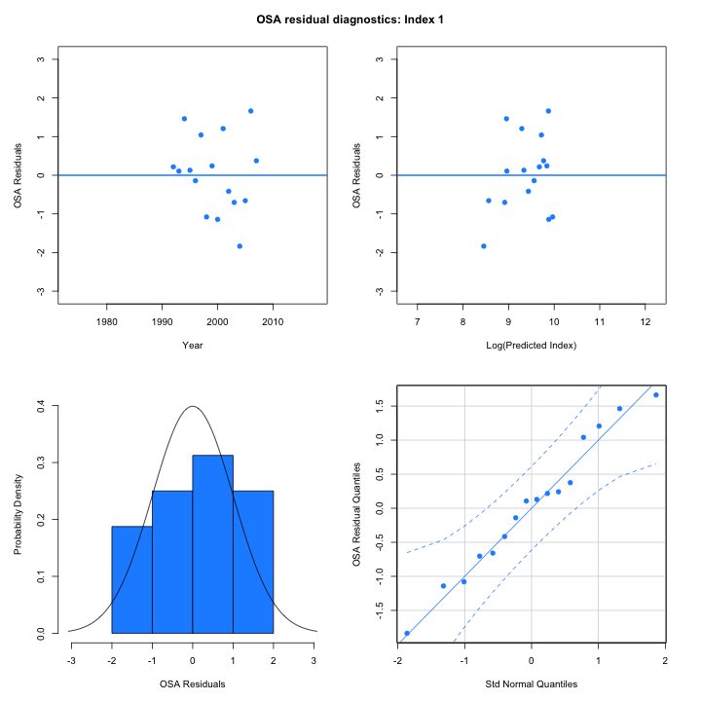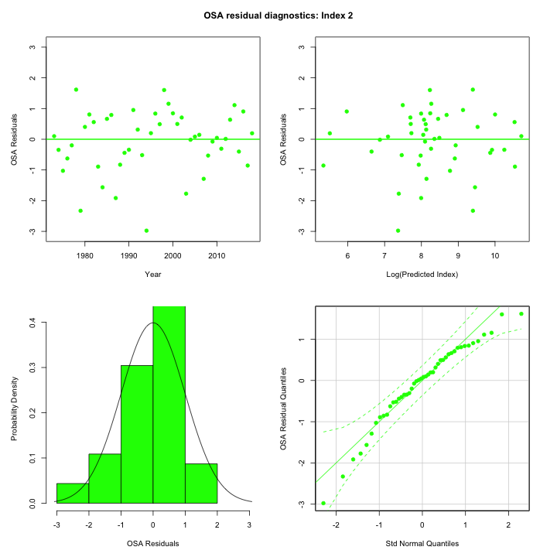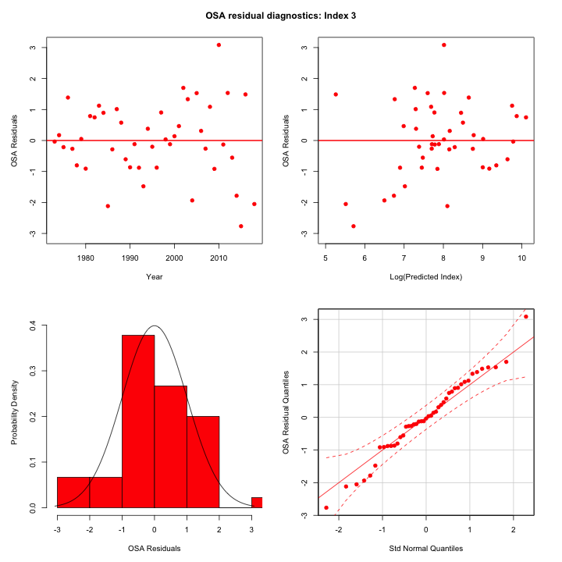

**Figure 3.5.2: One-Step-Ahead (OSA) residuals of the model g(Model_CPI+PI) (denoted m2 in Table 1) for the catch data (top left, Fleet 1) and for the three bottom trawl surveys (top right and bottom, Index 1, Index 2 and Index 3, respectively).**

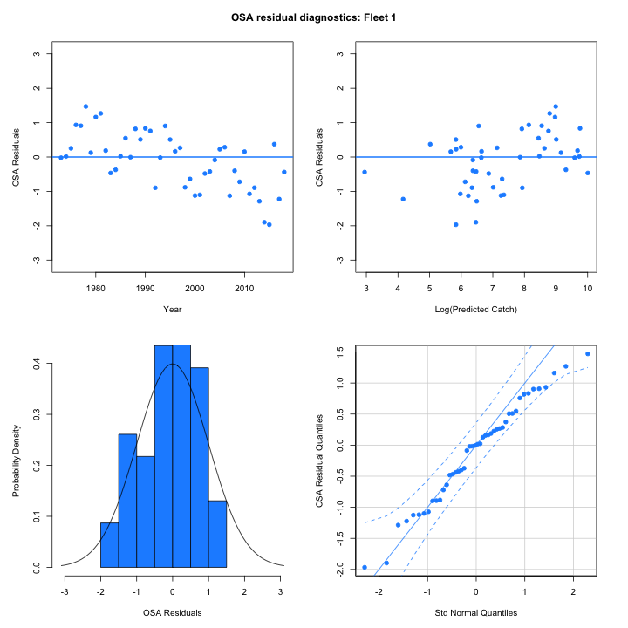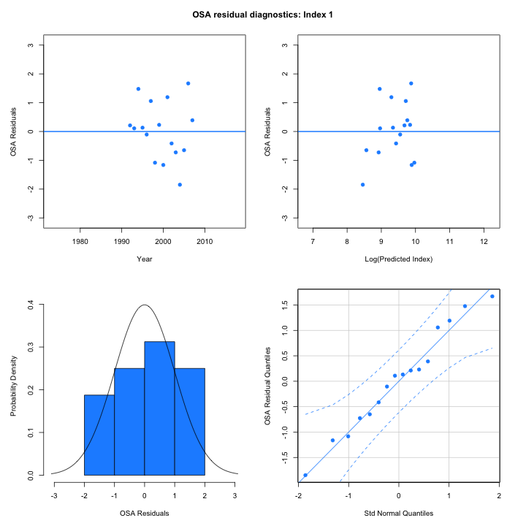

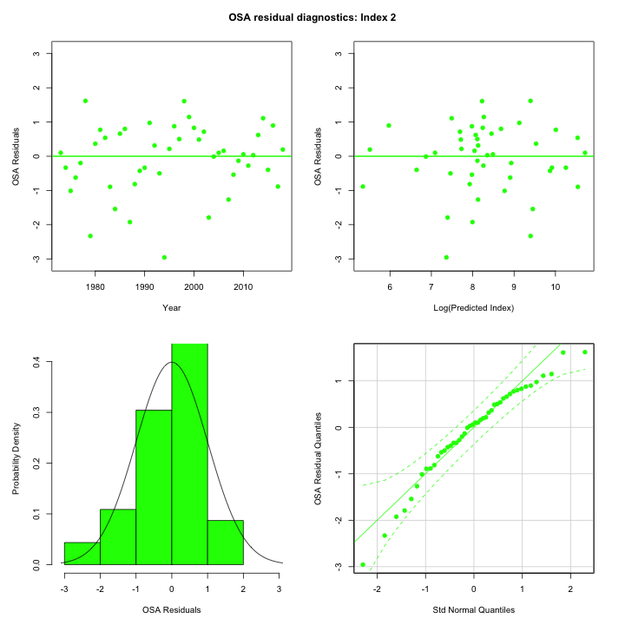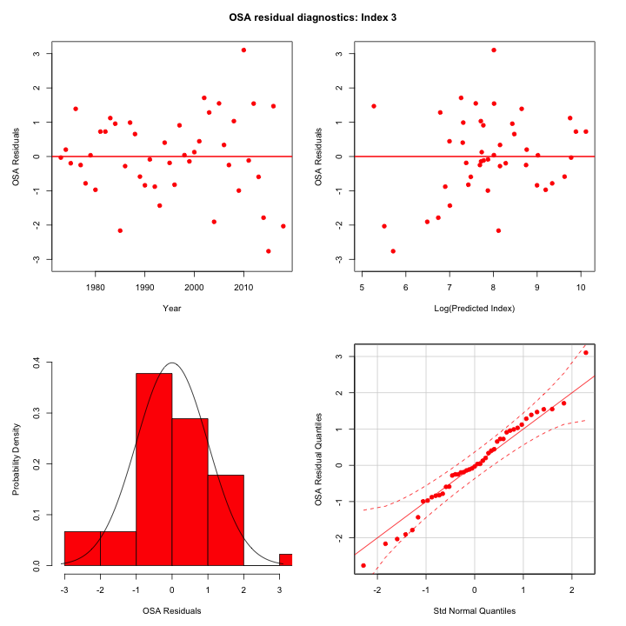

**Figure 3.5.3: One-Step-Ahead (OSA) residuals of the model g(Model_CPI+SEI) (denoted m3 in Table 1) for the catch data (top left, Fleet 1) and for the three bottom trawl surveys (top right and bottom, Index 1, Index 2 and Index 3, respectively).**

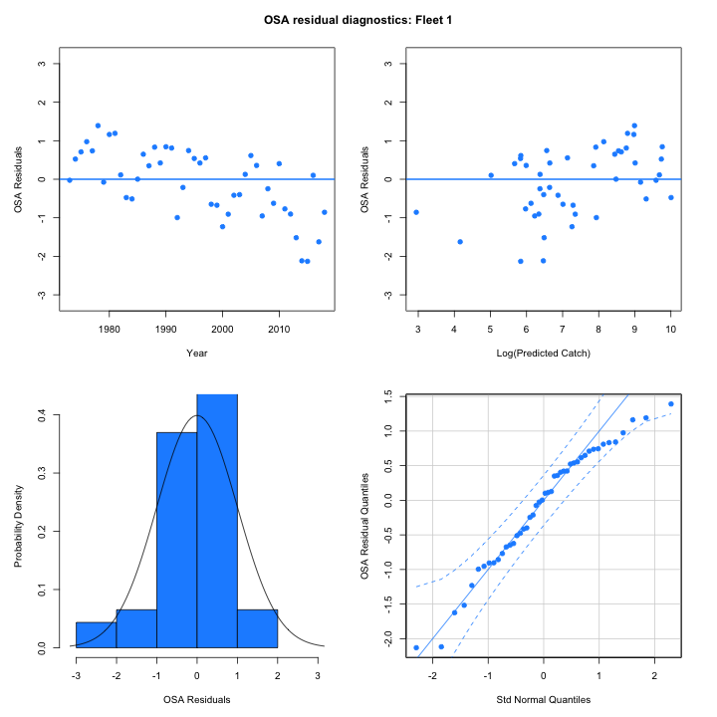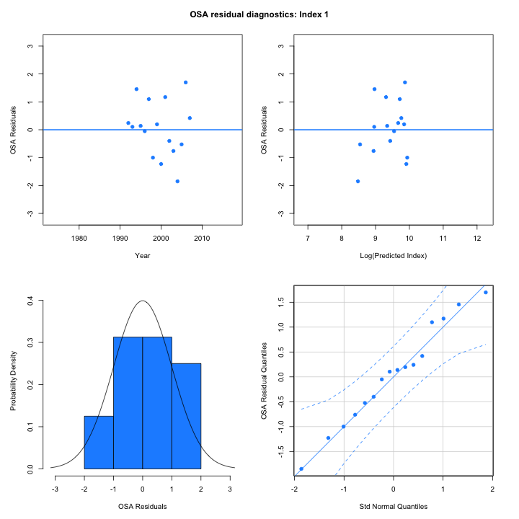

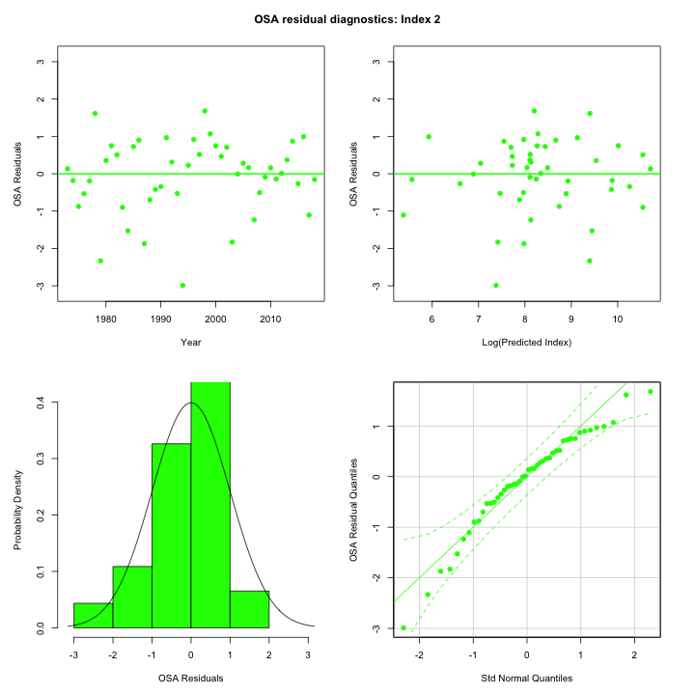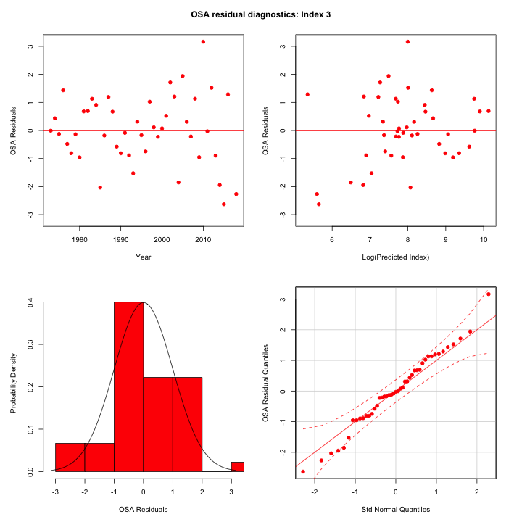

**Figure 3.5.4: One-Step-Ahead (OSA) residuals of the model g(Obs_CPI) (denoted m8 in Table 1) for the catch data (top left, Fleet 1) and for the three bottom trawl surveys (top right and bottom, Index 1, Index 2 and Index 3, respectively).**

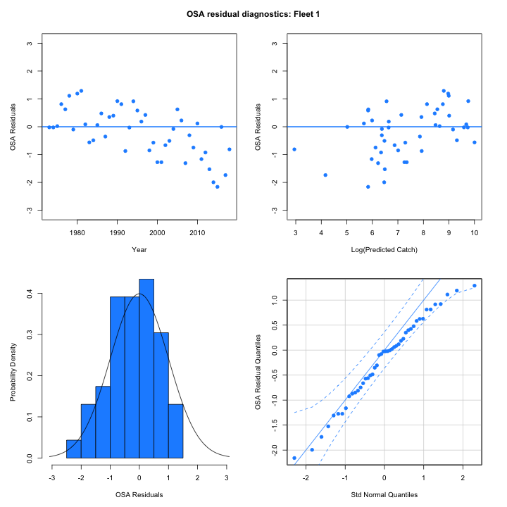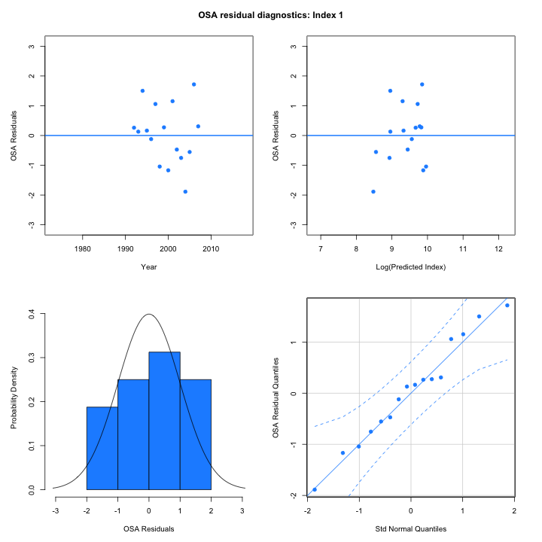

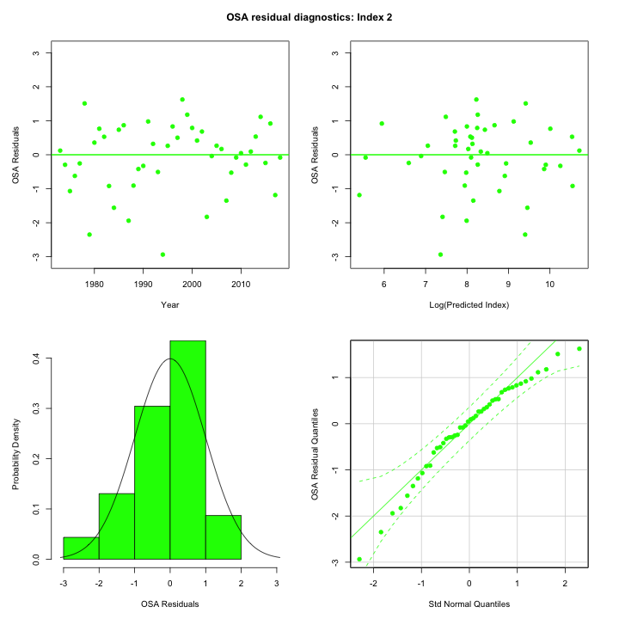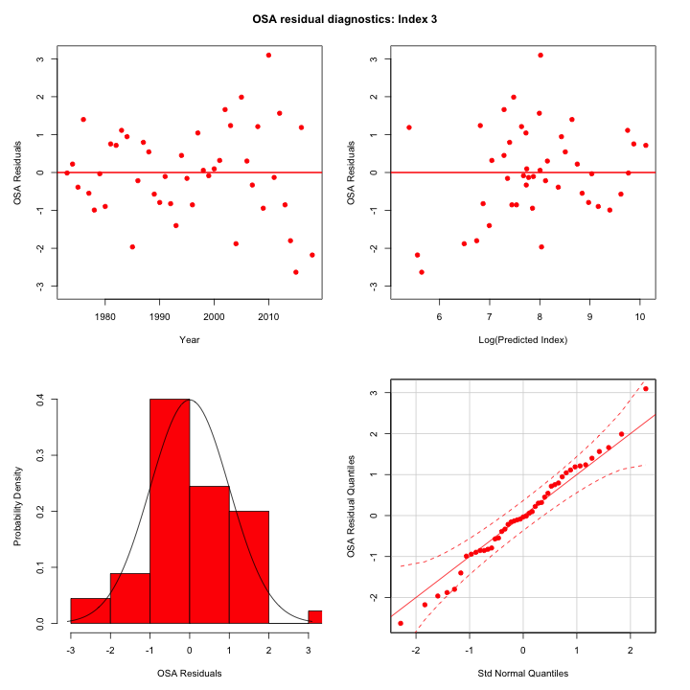

**Figure 3.5.6: One-Step-Ahead (OSA) residuals of the model Base denoted m25 in Table 1) for the catch data (top left, Fleet 1) and for the three bottom trawl surveys (top right and bottom, Index 1, Index 2 and Index 3, respectively).**

# Supplementary Material IV

**Table S4.1: Fixed effects parameters estimates from the model g(Obs_CPI) (denoted m8 in Table 1), with standard errors.** The random effects variance parameters are underlined in orange.

|  |  |  |  |  |
| --- | --- | --- | --- | --- |
| **Name in the model** | **Notation in the paper** | **Description** | **Value** | **Standard Error** |
| mean_rec_pars |  | Beverton-Holt stock-recruit function param 1 | 3.022 | 0.457 |
| mean_rec_pars |  | Beverton-Holt stock-recruit function param 2 | -6.752 | 0.640 |
| logit_q |  | Fully-selected catchability for winter bottom trawl survey | -6.064 | 0.142 |
| logit_q |  | Fully-selected catchability for spring bottom trawl survey | -7.354 | 0.116 |
| logit_q |  | Fully-selected catchability for fall bottom trawl survey | -8.081 | 0.147 |
| log_F1 |  | log fully-selected fishing mortality in 2013 | -0.638 | 0.199 |
| F_devs |  | log-ratios of fishing mortalities in 1974 | 0.943 | 0.242 |
| F_devs |  | log-ratios of fishing mortalities in 1975 | -0.116 | 0.238 |
| F_devs |  | log-ratios of fishing mortalities in 1976 | -1.197 | 0.294 |
| F_devs |  | log-ratios of fishing mortalities in 1977 | 0.819 | 0.303 |
| F_devs |  | log-ratios of fishing mortalities in 1978 | 0.066 | 0.344 |
| F_devs |  | log-ratios of fishing mortalities in 1979 | 0.313 | 0.269 |
| F_devs |  | log-ratios of fishing mortalities in 1980 | -0.345 | 0.248 |
| F_devs |  | log-ratios of fishing mortalities in 1981 | -0.668 | 0.274 |
| F_devs |  | log-ratios of fishing mortalities in 1982 | 0.340 | 0.291 |
| F_devs |  | log-ratios of fishing mortalities in 1983 | 0.504 | 0.275 |
| F_devs |  | log-ratios of fishing mortalities in 1984 | 0.618 | 0.233 |
| F_devs |  | log-ratios of fishing mortalities in 1985 | -0.037 | 0.241 |
| F_devs |  | log-ratios of fishing mortalities in 1986 | -0.859 | 0.302 |
| F_devs |  | log-ratios of fishing mortalities in 1987 | 0.466 | 0.266 |
| F_devs |  | log-ratios of fishing mortalities in 1988 | -0.544 | 0.324 |
| F_devs |  | log-ratios of fishing mortalities in 1989 | -0.017 | 0.476 |
| F_devs |  | log-ratios of fishing mortalities in 1990 | 0.703 | 0.324 |
| F_devs |  | log-ratios of fishing mortalities in 1991 | 0.127 | 0.221 |
| F_devs |  | log-ratios of fishing mortalities in 1992 | -0.117 | 0.217 |
| F_devs |  | log-ratios of fishing mortalities in 1993 | -0.824 | 0.224 |
| F_devs |  | log-ratios of fishing mortalities in 1994 | 0.707 | 0.263 |
| F_devs |  | log-ratios of fishing mortalities in 1995 | -1.016 | 0.246 |
| F_devs |  | log-ratios of fishing mortalities in 1996 | 0.159 | 0.277 |
| F_devs |  | log-ratios of fishing mortalities in 1997 | 0.323 | 0.293 |
| F_devs |  | log-ratios of fishing mortalities in 1998 | 0.131 | 0.282 |
| F_devs |  | log-ratios of fishing mortalities in 1999 | -0.093 | 0.281 |
| F_devs |  | log-ratios of fishing mortalities in 2000 | 0.019 | 0.278 |
| F_devs |  | log-ratios of fishing mortalities in 2001 | 0.512 | 0.289 |
| F_devs |  | log-ratios of fishing mortalities in 2002 | -0.111 | 0.304 |
| F_devs |  | log-ratios of fishing mortalities in 2003 | -0.360 | 0.254 |
| F_devs |  | log-ratios of fishing mortalities in 2004 | 0.415 | 0.247 |
| F_devs |  | log-ratios of fishing mortalities in 2005 | -0.267 | 0.239 |
| F_devs |  | log-ratios of fishing mortalities in 2006 | -0.343 | 0.264 |
| F_devs |  | log-ratios of fishing mortalities in 2007 | -0.250 | 0.272 |
| F_devs |  | log-ratios of fishing mortalities in 2008 | -0.229 | 0.296 |
| F_devs |  | log-ratios of fishing mortalities in 2009 | -0.240 | 0.293 |
| F_devs |  | log-ratios of fishing mortalities in 2010 | -0.821 | 0.260 |
| F_devs |  | log-ratios of fishing mortalities in 2011 | 0.382 | 0.235 |
| F_devs |  | log-ratios of fishing mortalities in 2012 | 0.548 | 0.246 |
| F_devs |  | log-ratios of fishing mortalities in 2013 | 0.324 | 0.249 |
| F_devs |  | log-ratios of fishing mortalities in 2014 | 0.384 | 0.259 |
| F_devs |  | log-ratios of fishing mortalities in 2015 | 0.176 | 0.261 |
| F_devs |  | log-ratios of fishing mortalities in 2016 | -0.204 | 0.257 |
| F_devs |  | log-ratios of fishing mortalities in 2017 | -0.332 | 0.276 |
| F_devs |  | log-ratios of fishing mortalities in 2018 | -1.034 | 0.281 |
| log_N1_pars |  | log numbers at age 1in year *1973* | 10.639 | 0.448 |
| log_N1_pars |  | log numbers at age 2in year 1973 | 10.244 | 0.406 |
| log_N1_pars |  | log numbers at age 3in year 1973 | 10.596 | 0.332 |
| log_N1_pars |  | log numbers at age 4in year 1973 | 9.900 | 0.400 |
| log_N1_pars |  | log numbers at age 5in year 1973 | 9.395 | 0.465 |
| log_N1_pars |  | log numbers at age 6+in year 1973 | 9.517 | 0.253 |
| log_NAA_sigma |  | log survival deviations at age 1 | -0.333 | 0.149 |
| log_NAA_sigma |  | log survival deviations at age 2+ | -0.528 | 0.081 |
| logit_selpars |  | Selectivity at age 1 for spring bottom trawl survey | -3.064 | 0.531 |
| logit_selpars |  | Selectivity of summer bottom trawl survey - logistic param 1 | -2.150 | 0.632 |
| logit_selpars |  | Selectivity of summer bottom trawl survey - logistic param 2 | -1.203 | 0.253 |
| logit_selpars |  | Selectivity at age 1 for winter bottom trawl survey | 0.732 | 0.556 |
| logit_selpars |  | Selectivity of commercial - logistic param 1 - time block 1 | -0.727 | 0.098 |
| logit_selpars |  | Selectivity of commercial - logistic param 2 - time block 1 | -0.736 | 0.159 |
| logit_selpars |  | Selectivity of commercial - logistic param 1 - time block 2 | -0.345 | 0.110 |
| logit_selpars |  | Selectivity of commercial - logistic param 2 - time block 2 | -0.052 | 0.091 |
| logit_selpars |  | Selectivity of commercial - logistic param 1 - time block 3 | -0.669 | 0.071 |
| logit_selpars |  | Selectivity of commercial - logistic param 2 - time block 3 | -0.421 | 0.073 |
| logit_selpars |  | Selectivity of commercial - logistic param 1 - time block 4 | -3.202 | 0.173 |
| logit_selpars |  | Selectivity of commercial - logistic param 2 - time block 4 | -3.051 | 0.280 |
| logit_selpars |  | Selectivity of commercial - logistic param 1 - time block 5 | -3.105 | 0.143 |
| logit_selpars |  | Selectivity of commercial - logistic param 2 - time block 5 | -2.724 | 0.092 |
| logit_selpars |  | Selectivity at age 1 for commercial fleet | -3.281 | 0.103 |
| logit_selpars |  | Selectivity at age 2 for commercial fleet | -2.778 | 0.088 |
| catch_paa_pars |  | Commercial fleet age composition | 1.952 | 0.071 |
| index_paa_pars |  | Winter bottom trawl survey age composition | 1.000 | 0.108 |
| index_paa_pars |  | Spring bottom trawl survey age composition | 0.874 | 0.070 |
| index_paa_pars |  | Fall bottom trawl survey age composition | 1.067 | 0.067 |
| Ecov_beta | $$β_{1}$$ | Environmental effect parameter – limiting factor | 1.221 | 0.240 |
| Ecov_process_pars | $$μ_{X1}$$ | marginal mean of Model_CPI | -0.093 | 0.521 |
| Ecov_process_pars | $$σ_{X1}^{2}$$ | conditional variance of Model_CPI | -0.071 | 0.103 |
| Ecov_process_pars | $$ϕ_{X1}$$ | autocorrelation parameters of Model_CPI | 0.806 | 0.316 |
| Ecov_process_pars | $$μ_{X2}$$ | marginal mean of Model_PI | -0.006 | 0.262 |
| Ecov_process_pars | $$σ_{X2}^{2}$$ | conditional variance of Model_PI | -0.608 | 0.104 |
| Ecov_process_pars | $$ϕ_{X2}$$ | autocorrelation parameters of Model_PI | 0.757 | 0.313 |
| Ecov_process_pars | $$μ_{X3}$$ | marginal mean of Obs_CPI | -0.571 | 0.460 |
| Ecov_process_pars | $$σ_{X3}^{2}$$ | conditional variance of Obs_CPI | -0.060 | 0.111 |
| Ecov_process_pars | $$ϕ_{X3}$$ | autocorrelation parameters of Obs_CPI | 0.690 | 0.299 |
| Ecov_process_pars | $$μ_{X4}$$ | marginal mean of Model_SEI | 8.898 | 54.174 |
| Ecov_process_pars | $$σ_{X4}^{2}$$ | conditional variance of Model_SEI | 4.221 | 0.104 |
| Ecov_process_pars | $$ϕ_{X4}$$ | autocorrelation parameters of Model_SEI | 0.914 | 0.329 |

**Table S4.2: Fixed effects parameters estimates from the model g(Obs_CPI) (denoted m1 in Table 1), with standard errors.** The random effects variance parameters are underlined in orange.

|  |  |  |  |  |
| --- | --- | --- | --- | --- |
| **Name in the model** | **Notation in the paper** | **Description** | **Value** | **Standard Error** |
| mean_rec_pars |  | Beverton-Holt stock-recruit function param 1 | 2.304 | 0.330 |
| mean_rec_pars |  | Beverton-Holt stock-recruit function param 2 | -8.313 | 0.638 |
| logit_q |  | Fully-selected catchability for winter bottom trawl survey | -6.049 | 0.140 |
| logit_q |  | Fully-selected catchability for spring bottom trawl survey | -7.341 | 0.114 |
| logit_q |  | Fully-selected catchability for fall bottom trawl survey | -8.060 | 0.145 |
| log_F1 |  | log fully-selected fishing mortality in 2013 | -0.629 | 0.197 |
| F_devs |  | log-ratios of fishing mortalities in 1974 | 0.927 | 0.239 |
| F_devs |  | log-ratios of fishing mortalities in 1975 | -0.122 | 0.239 |
| F_devs |  | log-ratios of fishing mortalities in 1976 | -1.172 | 0.293 |
| F_devs |  | log-ratios of fishing mortalities in 1977 | 0.832 | 0.298 |
| F_devs |  | log-ratios of fishing mortalities in 1978 | 0.053 | 0.342 |
| F_devs |  | log-ratios of fishing mortalities in 1979 | 0.301 | 0.266 |
| F_devs |  | log-ratios of fishing mortalities in 1980 | -0.325 | 0.246 |
| F_devs |  | log-ratios of fishing mortalities in 1981 | -0.683 | 0.273 |
| F_devs |  | log-ratios of fishing mortalities in 1982 | 0.354 | 0.288 |
| F_devs |  | log-ratios of fishing mortalities in 1983 | 0.496 | 0.272 |
| F_devs |  | log-ratios of fishing mortalities in 1984 | 0.607 | 0.230 |
| F_devs |  | log-ratios of fishing mortalities in 1985 | -0.039 | 0.237 |
| F_devs |  | log-ratios of fishing mortalities in 1986 | -0.861 | 0.299 |
| F_devs |  | log-ratios of fishing mortalities in 1987 | 0.459 | 0.264 |
| F_devs |  | log-ratios of fishing mortalities in 1988 | -0.530 | 0.318 |
| F_devs |  | log-ratios of fishing mortalities in 1989 | -0.021 | 0.471 |
| F_devs |  | log-ratios of fishing mortalities in 1990 | 0.709 | 0.319 |
| F_devs |  | log-ratios of fishing mortalities in 1991 | 0.132 | 0.218 |
| F_devs |  | log-ratios of fishing mortalities in 1992 | -0.118 | 0.212 |
| F_devs |  | log-ratios of fishing mortalities in 1993 | -0.825 | 0.220 |
| F_devs |  | log-ratios of fishing mortalities in 1994 | 0.721 | 0.259 |
| F_devs |  | log-ratios of fishing mortalities in 1995 | -1.013 | 0.244 |
| F_devs |  | log-ratios of fishing mortalities in 1996 | 0.152 | 0.273 |
| F_devs |  | log-ratios of fishing mortalities in 1997 | 0.340 | 0.290 |
| F_devs |  | log-ratios of fishing mortalities in 1998 | 0.105 | 0.278 |
| F_devs |  | log-ratios of fishing mortalities in 1999 | -0.065 | 0.281 |
| F_devs |  | log-ratios of fishing mortalities in 2000 | 0.021 | 0.277 |
| F_devs |  | log-ratios of fishing mortalities in 2001 | 0.512 | 0.285 |
| F_devs |  | log-ratios of fishing mortalities in 2002 | -0.125 | 0.298 |
| F_devs |  | log-ratios of fishing mortalities in 2003 | -0.351 | 0.249 |
| F_devs |  | log-ratios of fishing mortalities in 2004 | 0.400 | 0.241 |
| F_devs |  | log-ratios of fishing mortalities in 2005 | -0.285 | 0.236 |
| F_devs |  | log-ratios of fishing mortalities in 2006 | -0.338 | 0.261 |
| F_devs |  | log-ratios of fishing mortalities in 2007 | -0.253 | 0.269 |
| F_devs |  | log-ratios of fishing mortalities in 2008 | -0.227 | 0.293 |
| F_devs |  | log-ratios of fishing mortalities in 2009 | -0.235 | 0.288 |
| F_devs |  | log-ratios of fishing mortalities in 2010 | -0.829 | 0.256 |
| F_devs |  | log-ratios of fishing mortalities in 2011 | 0.383 | 0.233 |
| F_devs |  | log-ratios of fishing mortalities in 2012 | 0.567 | 0.243 |
| F_devs |  | log-ratios of fishing mortalities in 2013 | 0.343 | 0.247 |
| F_devs |  | log-ratios of fishing mortalities in 2014 | 0.396 | 0.256 |
| F_devs |  | log-ratios of fishing mortalities in 2015 | 0.098 | 0.255 |
| F_devs |  | log-ratios of fishing mortalities in 2016 | -0.216 | 0.252 |
| F_devs |  | log-ratios of fishing mortalities in 2017 | -0.285 | 0.272 |
| F_devs |  | log-ratios of fishing mortalities in 2018 | -1.027 | 0.278 |
| log_N1_pars |  | log numbers at age 1in year *1973* | 10.621 | 0.444 |
| log_N1_pars |  | log numbers at age 2in year 1973 | 10.238 | 0.403 |
| log_N1_pars |  | log numbers at age 3in year 1973 | 10.584 | 0.330 |
| log_N1_pars |  | log numbers at age 4in year 1973 | 9.893 | 0.398 |
| log_N1_pars |  | log numbers at age 5in year 1973 | 9.393 | 0.464 |
| log_N1_pars |  | log numbers at age 6+in year 1973 | 9.511 | 0.252 |
| log_NAA_sigma |  | log survival deviations at age 1 | -0.331 | 0.139 |
| log_NAA_sigma |  | log survival deviations at age 2+ | -0.557 | 0.083 |
| logit_selpars |  | Selectivity at age 1 for spring bottom trawl survey | -3.049 | 0.534 |
| logit_selpars |  | Selectivity of summer bottom trawl survey - logistic param 1 | -2.192 | 0.641 |
| logit_selpars |  | Selectivity of summer bottom trawl survey - logistic param 2 | -1.205 | 0.251 |
| logit_selpars |  | Selectivity at age 1 for winter bottom trawl survey | 0.761 | 0.562 |
| logit_selpars |  | Selectivity of commercial - logistic param 1 - time block 1 | -0.734 | 0.098 |
| logit_selpars |  | Selectivity of commercial - logistic param 2 - time block 1 | -0.747 | 0.160 |
| logit_selpars |  | Selectivity of commercial - logistic param 1 - time block 2 | -0.337 | 0.113 |
| logit_selpars |  | Selectivity of commercial - logistic param 2 - time block 2 | -0.055 | 0.091 |
| logit_selpars |  | Selectivity of commercial - logistic param 1 - time block 3 | -0.670 | 0.071 |
| logit_selpars |  | Selectivity of commercial - logistic param 2 - time block 3 | -0.422 | 0.073 |
| logit_selpars |  | Selectivity of commercial - logistic param 1 - time block 4 | -3.208 | 0.175 |
| logit_selpars |  | Selectivity of commercial - logistic param 2 - time block 4 | -3.055 | 0.285 |
| logit_selpars |  | Selectivity of commercial - logistic param 1 - time block 5 | -3.097 | 0.146 |
| logit_selpars |  | Selectivity of commercial - logistic param 2 - time block 5 | -2.720 | 0.094 |
| logit_selpars |  | Selectivity at age 1 for commercial fleet | -3.281 | 0.103 |
| logit_selpars |  | Selectivity at age 2 for commercial fleet | -2.772 | 0.089 |
| catch_paa_pars |  | Commercial fleet age composition | 1.966 | 0.070 |
| index_paa_pars |  | Winter bottom trawl survey age composition | 1.001 | 0.108 |
| index_paa_pars |  | Spring bottom trawl survey age composition | 0.882 | 0.070 |
| index_paa_pars |  | Fall bottom trawl survey age composition | 1.073 | 0.067 |
| Ecov_beta | $$α_{1}$$ | Environmental effect parameter – controlling factor | -0.707 | 0.124 |
| Ecov_process_pars | $$μ_{X1}$$ | marginal mean of Model_CPI | -0.093 | 0.524 |
| Ecov_process_pars | $$σ_{X1}^{2}$$ | conditional variance of Model_CPI | -0.071 | 0.103 |
| Ecov_process_pars | $$ϕ_{X1}$$ | autocorrelation parameters of Model_CPI | 0.807 | 0.317 |
| Ecov_process_pars | $$μ_{X2}$$ | marginal mean of Model_PI | -0.006 | 0.262 |
| Ecov_process_pars | $$σ_{X2}^{2}$$ | conditional variance of Model_PI | -0.608 | 0.104 |
| Ecov_process_pars |  | autocorrelation parameters of Model_PI | 0.757 | 0.313 |
| Ecov_process_pars |  | marginal mean of Obs_CPI | -0.542 | 0.431 |
| Ecov_process_pars |  | conditional variance of Obs_CPI | -0.043 | 0.111 |
| Ecov_process_pars |  | autocorrelation parameters of Obs_CPI | 0.657 | 0.306 |
| Ecov_process_pars |  | marginal mean of Model_SEI | 8.898 | 54.174 |
| Ecov_process_pars |  | conditional variance of Model_SEI | 4.221 | 0.104 |
| Ecov_process_pars | $$ϕ_{X4}$$ | autocorrelation parameters of Model_SEI | 0.914 | 0.329 |

**Table S4.3: Fixed effects parameters estimates from the model g(Obs_CPI) (denoted m2 in Table 1), with standard errors.** The random effects variance parameters are underlined in orange.

|  |  |  |  |  |
| --- | --- | --- | --- | --- |
| **Name in the model** | **Notation in the paper** | **Description** | **Value** | **Standard Error** |
| mean_rec_pars |  | Beverton-Holt stock-recruit function param 1 | 2.317 | 0.308 |
| mean_rec_pars |  | Beverton-Holt stock-recruit function param 2 | -8.438 | 0.614 |
| logit_q |  | Fully-selected catchability for winter bottom trawl survey | -6.044 | 0.139 |
| logit_q |  | Fully-selected catchability for spring bottom trawl survey | -7.335 | 0.114 |
| logit_q |  | Fully-selected catchability for fall bottom trawl survey | -8.051 | 0.144 |
| log_F1 |  | log fully-selected fishing mortality in 2013 | -0.624 | 0.196 |
| F_devs |  | log-ratios of fishing mortalities in 1974 | 0.920 | 0.238 |
| F_devs |  | log-ratios of fishing mortalities in 1975 | -0.123 | 0.238 |
| F_devs |  | log-ratios of fishing mortalities in 1976 | -1.175 | 0.293 |
| F_devs |  | log-ratios of fishing mortalities in 1977 | 0.842 | 0.298 |
| F_devs |  | log-ratios of fishing mortalities in 1978 | 0.057 | 0.341 |
| F_devs |  | log-ratios of fishing mortalities in 1979 | 0.296 | 0.265 |
| F_devs |  | log-ratios of fishing mortalities in 1980 | -0.313 | 0.245 |
| F_devs |  | log-ratios of fishing mortalities in 1981 | -0.683 | 0.272 |
| F_devs |  | log-ratios of fishing mortalities in 1982 | 0.354 | 0.287 |
| F_devs |  | log-ratios of fishing mortalities in 1983 | 0.491 | 0.271 |
| F_devs |  | log-ratios of fishing mortalities in 1984 | 0.601 | 0.229 |
| F_devs |  | log-ratios of fishing mortalities in 1985 | -0.040 | 0.237 |
| F_devs |  | log-ratios of fishing mortalities in 1986 | -0.854 | 0.298 |
| F_devs |  | log-ratios of fishing mortalities in 1987 | 0.461 | 0.262 |
| F_devs |  | log-ratios of fishing mortalities in 1988 | -0.540 | 0.318 |
| F_devs |  | log-ratios of fishing mortalities in 1989 | -0.026 | 0.469 |
| F_devs |  | log-ratios of fishing mortalities in 1990 | 0.721 | 0.317 |
| F_devs |  | log-ratios of fishing mortalities in 1991 | 0.130 | 0.217 |
| F_devs |  | log-ratios of fishing mortalities in 1992 | -0.117 | 0.211 |
| F_devs |  | log-ratios of fishing mortalities in 1993 | -0.828 | 0.220 |
| F_devs |  | log-ratios of fishing mortalities in 1994 | 0.727 | 0.259 |
| F_devs |  | log-ratios of fishing mortalities in 1995 | -1.014 | 0.243 |
| F_devs |  | log-ratios of fishing mortalities in 1996 | 0.147 | 0.273 |
| F_devs |  | log-ratios of fishing mortalities in 1997 | 0.347 | 0.290 |
| F_devs |  | log-ratios of fishing mortalities in 1998 | 0.105 | 0.278 |
| F_devs |  | log-ratios of fishing mortalities in 1999 | -0.061 | 0.281 |
| F_devs |  | log-ratios of fishing mortalities in 2000 | 0.021 | 0.276 |
| F_devs |  | log-ratios of fishing mortalities in 2001 | 0.518 | 0.283 |
| F_devs |  | log-ratios of fishing mortalities in 2002 | -0.141 | 0.296 |
| F_devs |  | log-ratios of fishing mortalities in 2003 | -0.343 | 0.249 |
| F_devs |  | log-ratios of fishing mortalities in 2004 | 0.397 | 0.241 |
| F_devs |  | log-ratios of fishing mortalities in 2005 | -0.290 | 0.235 |
| F_devs |  | log-ratios of fishing mortalities in 2006 | -0.340 | 0.260 |
| F_devs |  | log-ratios of fishing mortalities in 2007 | -0.260 | 0.267 |
| F_devs |  | log-ratios of fishing mortalities in 2008 | -0.219 | 0.292 |
| F_devs |  | log-ratios of fishing mortalities in 2009 | -0.226 | 0.287 |
| F_devs |  | log-ratios of fishing mortalities in 2010 | -0.835 | 0.256 |
| F_devs |  | log-ratios of fishing mortalities in 2011 | 0.386 | 0.233 |
| F_devs |  | log-ratios of fishing mortalities in 2012 | 0.562 | 0.243 |
| F_devs |  | log-ratios of fishing mortalities in 2013 | 0.359 | 0.247 |
| F_devs |  | log-ratios of fishing mortalities in 2014 | 0.388 | 0.254 |
| F_devs |  | log-ratios of fishing mortalities in 2015 | 0.080 | 0.252 |
| F_devs |  | log-ratios of fishing mortalities in 2016 | -0.215 | 0.251 |
| F_devs |  | log-ratios of fishing mortalities in 2017 | -0.262 | 0.272 |
| F_devs |  | log-ratios of fishing mortalities in 2018 | -1.032 | 0.277 |
| log_N1_pars |  | log numbers at age 1in year *1973* | 10.619 | 0.444 |
| log_N1_pars |  | log numbers at age 2in year 1973 | 10.235 | 0.403 |
| log_N1_pars |  | log numbers at age 3in year 1973 | 10.580 | 0.330 |
| log_N1_pars |  | log numbers at age 4in year 1973 | 9.892 | 0.398 |
| log_N1_pars |  | log numbers at age 5in year 1973 | 9.390 | 0.465 |
| log_N1_pars |  | log numbers at age 6+in year 1973 | 9.508 | 0.252 |
| log_NAA_sigma |  | log survival deviations at age 1 | -0.361 | 0.143 |
| log_NAA_sigma |  | log survival deviations at age 2+ | -0.563 | 0.083 |
| logit_selpars |  | Selectivity at age 1 for spring bottom trawl survey | -3.077 | 0.534 |
| logit_selpars |  | Selectivity of summer bottom trawl survey - logistic param 1 | -2.199 | 0.640 |
| logit_selpars |  | Selectivity of summer bottom trawl survey - logistic param 2 | -1.212 | 0.250 |
| logit_selpars |  | Selectivity at age 1 for winter bottom trawl survey | 0.755 | 0.558 |
| logit_selpars |  | Selectivity of commercial - logistic param 1 - time block 1 | -0.734 | 0.098 |
| logit_selpars |  | Selectivity of commercial - logistic param 2 - time block 1 | -0.751 | 0.158 |
| logit_selpars |  | Selectivity of commercial - logistic param 1 - time block 2 | -0.334 | 0.113 |
| logit_selpars |  | Selectivity of commercial - logistic param 2 - time block 2 | -0.055 | 0.092 |
| logit_selpars |  | Selectivity of commercial - logistic param 1 - time block 3 | -0.670 | 0.071 |
| logit_selpars |  | Selectivity of commercial - logistic param 2 - time block 3 | -0.422 | 0.073 |
| logit_selpars |  | Selectivity of commercial - logistic param 1 - time block 4 | -3.204 | 0.174 |
| logit_selpars |  | Selectivity of commercial - logistic param 2 - time block 4 | -3.068 | 0.282 |
| logit_selpars |  | Selectivity of commercial - logistic param 1 - time block 5 | -3.094 | 0.146 |
| logit_selpars |  | Selectivity of commercial - logistic param 2 - time block 5 | -2.717 | 0.094 |
| logit_selpars |  | Selectivity at age 1 for commercial fleet | -3.282 | 0.103 |
| logit_selpars |  | Selectivity at age 2 for commercial fleet | -2.772 | 0.089 |
| catch_paa_pars |  | Commercial fleet age composition | 1.962 | 0.070 |
| index_paa_pars |  | Winter bottom trawl survey age composition | 1.004 | 0.108 |
| index_paa_pars |  | Spring bottom trawl survey age composition | 0.889 | 0.070 |
| index_paa_pars |  | Fall bottom trawl survey age composition | 1.074 | 0.067 |
| Ecov_beta1 | $$α_{1}$$ | Environmental effect parameter – controlling factor | -0.945 | 0.206 |
| Ecov_beta2 | $$β_{2}$$ | Environmental effect parameter – limiting factor | 1.496 | 0.980 |
| Ecov_process_pars | $$μ_{X1}$$ | marginal mean of Model_CPI | -0.094 | 0.524 |
| Ecov_process_pars | $$σ_{X1}^{2}$$ | conditional variance of Model_CPI | -0.071 | 0.103 |
| Ecov_process_pars | $$ϕ_{X1}$$ | autocorrelation parameters of Model_CPI | 0.808 | 0.317 |
| Ecov_process_pars | $$μ_{X2}$$ | marginal mean of Model_PI | -0.006 | 0.261 |
| Ecov_process_pars | $$σ_{X2}^{2}$$ | conditional variance of Model_PI | -0.608 | 0.104 |
| Ecov_process_pars | $$ϕ_{X2}$$ | autocorrelation parameters of Model_PI | 0.756 | 0.313 |
| Ecov_process_pars | $$μ_{X3}$$ | marginal mean of Obs_CPI | -0.542 | 0.431 |
| Ecov_process_pars | $$σ_{X3}^{2}$$ | conditional variance of Obs_CPI | -0.043 | 0.111 |
| Ecov_process_pars |  | autocorrelation parameters of Obs_CPI | 0.657 | 0.306 |
| Ecov_process_pars |  | marginal mean of Model_SEI | 8.898 | 54.174 |
| Ecov_process_pars |  | conditional variance of Model_SEI | 4.221 | 0.104 |
| Ecov_process_pars | $$ϕ_{X4}$$ | autocorrelation parameters of Model_SEI | 0.914 | 0.329 |

**Table S4.4: Fixed effects parameters estimates from the model g(Obs_CPI) (denoted m3 in Table 1), with standard errors.** The random effects variance parameters are underlined in orange.

|  |  |  |  |  |
| --- | --- | --- | --- | --- |
| **Name in the model** | **Notation in the paper** | **Description** | **Value** | **Standard Error** |
| mean_rec_pars |  | Beverton-Holt stock-recruit function param 1 | 2.226 | 0.286 |
| mean_rec_pars |  | Beverton-Holt stock-recruit function param 2 | -8.788 | 0.773 |
| logit_q |  | Fully-selected catchability for winter bottom trawl survey | -6.047 | 0.140 |
| logit_q |  | Fully-selected catchability for spring bottom trawl survey | -7.340 | 0.114 |
| logit_q |  | Fully-selected catchability for fall bottom trawl survey | -8.058 | 0.145 |
| log_F1 |  | log fully-selected fishing mortality in 2013 | -0.628 | 0.196 |
| F_devs |  | log-ratios of fishing mortalities in 1974 | 0.923 | 0.238 |
| F_devs |  | log-ratios of fishing mortalities in 1975 | -0.121 | 0.238 |
| F_devs |  | log-ratios of fishing mortalities in 1976 | -1.180 | 0.293 |
| F_devs |  | log-ratios of fishing mortalities in 1977 | 0.841 | 0.298 |
| F_devs |  | log-ratios of fishing mortalities in 1978 | 0.060 | 0.341 |
| F_devs |  | log-ratios of fishing mortalities in 1979 | 0.298 | 0.265 |
| F_devs |  | log-ratios of fishing mortalities in 1980 | -0.320 | 0.245 |
| F_devs |  | log-ratios of fishing mortalities in 1981 | -0.683 | 0.273 |
| F_devs |  | log-ratios of fishing mortalities in 1982 | 0.354 | 0.288 |
| F_devs |  | log-ratios of fishing mortalities in 1983 | 0.495 | 0.271 |
| F_devs |  | log-ratios of fishing mortalities in 1984 | 0.604 | 0.229 |
| F_devs |  | log-ratios of fishing mortalities in 1985 | -0.040 | 0.236 |
| F_devs |  | log-ratios of fishing mortalities in 1986 | -0.860 | 0.298 |
| F_devs |  | log-ratios of fishing mortalities in 1987 | 0.460 | 0.263 |
| F_devs |  | log-ratios of fishing mortalities in 1988 | -0.531 | 0.315 |
| F_devs |  | log-ratios of fishing mortalities in 1989 | -0.015 | 0.469 |
| F_devs |  | log-ratios of fishing mortalities in 1990 | 0.709 | 0.318 |
| F_devs |  | log-ratios of fishing mortalities in 1991 | 0.131 | 0.217 |
| F_devs |  | log-ratios of fishing mortalities in 1992 | -0.124 | 0.212 |
| F_devs |  | log-ratios of fishing mortalities in 1993 | -0.822 | 0.220 |
| F_devs |  | log-ratios of fishing mortalities in 1994 | 0.721 | 0.259 |
| F_devs |  | log-ratios of fishing mortalities in 1995 | -1.015 | 0.243 |
| F_devs |  | log-ratios of fishing mortalities in 1996 | 0.156 | 0.273 |
| F_devs |  | log-ratios of fishing mortalities in 1997 | 0.339 | 0.290 |
| F_devs |  | log-ratios of fishing mortalities in 1998 | 0.106 | 0.278 |
| F_devs |  | log-ratios of fishing mortalities in 1999 | -0.063 | 0.280 |
| F_devs |  | log-ratios of fishing mortalities in 2000 | 0.020 | 0.275 |
| F_devs |  | log-ratios of fishing mortalities in 2001 | 0.516 | 0.284 |
| F_devs |  | log-ratios of fishing mortalities in 2002 | -0.133 | 0.296 |
| F_devs |  | log-ratios of fishing mortalities in 2003 | -0.355 | 0.249 |
| F_devs |  | log-ratios of fishing mortalities in 2004 | 0.407 | 0.241 |
| F_devs |  | log-ratios of fishing mortalities in 2005 | -0.291 | 0.235 |
| F_devs |  | log-ratios of fishing mortalities in 2006 | -0.336 | 0.260 |
| F_devs |  | log-ratios of fishing mortalities in 2007 | -0.260 | 0.267 |
| F_devs |  | log-ratios of fishing mortalities in 2008 | -0.225 | 0.292 |
| F_devs |  | log-ratios of fishing mortalities in 2009 | -0.236 | 0.287 |
| F_devs |  | log-ratios of fishing mortalities in 2010 | -0.824 | 0.256 |
| F_devs |  | log-ratios of fishing mortalities in 2011 | 0.386 | 0.233 |
| F_devs |  | log-ratios of fishing mortalities in 2012 | 0.562 | 0.243 |
| F_devs |  | log-ratios of fishing mortalities in 2013 | 0.355 | 0.247 |
| F_devs |  | log-ratios of fishing mortalities in 2014 | 0.394 | 0.254 |
| F_devs |  | log-ratios of fishing mortalities in 2015 | 0.079 | 0.252 |
| F_devs |  | log-ratios of fishing mortalities in 2016 | -0.217 | 0.251 |
| F_devs |  | log-ratios of fishing mortalities in 2017 | -0.267 | 0.272 |
| F_devs |  | log-ratios of fishing mortalities in 2018 | -1.025 | 0.277 |
| log_N1_pars |  | log numbers at age 1in year *1973* | 10.618 | 0.444 |
| log_N1_pars |  | log numbers at age 2in year 1973 | 10.235 | 0.403 |
| log_N1_pars |  | log numbers at age 3in year 1973 | 10.585 | 0.330 |
| log_N1_pars |  | log numbers at age 4in year 1973 | 9.895 | 0.398 |
| log_N1_pars |  | log numbers at age 5in year 1973 | 9.392 | 0.465 |
| log_N1_pars |  | log numbers at age 6+in year 1973 | 9.510 | 0.252 |
| log_NAA_sigma |  | log survival deviations at age 1 | -0.349 | 0.141 |
| log_NAA_sigma |  | log survival deviations at age 2+ | -0.562 | 0.083 |
| logit_selpars |  | Selectivity at age 1 for spring bottom trawl survey | -3.062 | 0.534 |
| logit_selpars |  | Selectivity of summer bottom trawl survey - logistic param 1 | -2.193 | 0.641 |
| logit_selpars |  | Selectivity of summer bottom trawl survey - logistic param 2 | -1.203 | 0.250 |
| logit_selpars |  | Selectivity at age 1 for winter bottom trawl survey | 0.768 | 0.562 |
| logit_selpars |  | Selectivity of commercial - logistic param 1 - time block 1 | -0.733 | 0.098 |
| logit_selpars |  | Selectivity of commercial - logistic param 2 - time block 1 | -0.745 | 0.160 |
| logit_selpars |  | Selectivity of commercial - logistic param 1 - time block 2 | -0.337 | 0.113 |
| logit_selpars |  | Selectivity of commercial - logistic param 2 - time block 2 | -0.057 | 0.092 |
| logit_selpars |  | Selectivity of commercial - logistic param 1 - time block 3 | -0.672 | 0.071 |
| logit_selpars |  | Selectivity of commercial - logistic param 2 - time block 3 | -0.424 | 0.073 |
| logit_selpars |  | Selectivity of commercial - logistic param 1 - time block 4 | -3.205 | 0.175 |
| logit_selpars |  | Selectivity of commercial - logistic param 2 - time block 4 | -3.052 | 0.285 |
| logit_selpars |  | Selectivity of commercial - logistic param 1 - time block 5 | -3.097 | 0.146 |
| logit_selpars |  | Selectivity of commercial - logistic param 2 - time block 5 | -2.719 | 0.094 |
| logit_selpars |  | Selectivity at age 1 for commercial fleet | -3.284 | 0.104 |
| logit_selpars |  | Selectivity at age 2 for commercial fleet | -2.772 | 0.089 |
| catch_paa_pars |  | Commercial fleet age composition | 1.963 | 0.070 |
| index_paa_pars |  | Winter bottom trawl survey age composition | 1.005 | 0.108 |
| index_paa_pars |  | Spring bottom trawl survey age composition | 0.889 | 0.070 |
| index_paa_pars |  | Fall bottom trawl survey age composition | 1.071 | 0.067 |
| Ecov_beta1 | $$α_{1}$$ | Environmental effect parameter – controlling factor | -0.876 | 0.177 |
| Ecov_beta2 | $$β_{2}$$ | Environmental effect parameter – limiting factor | 0.015 | 0.015 |
| Ecov_process_pars | $$μ_{X1}$$ | marginal mean of Model_CPI | -0.093 | 0.524 |
| Ecov_process_pars | $$σ_{X1}^{2}$$ | conditional variance of Model_CPI | -0.071 | 0.103 |
| Ecov_process_pars | $$ϕ_{X1}$$ | autocorrelation parameters of Model_CPI | 0.808 | 0.317 |
| Ecov_process_pars | $$μ_{X2}$$ | marginal mean of Model_PI | -0.006 | 0.262 |
| Ecov_process_pars | $$σ_{X2}^{2}$$ | conditional variance of Model_PI | -0.608 | 0.104 |
| Ecov_process_pars |  | autocorrelation parameters of Model_PI | 0.757 | 0.313 |
| Ecov_process_pars |  | marginal mean of Obs_CPI | -0.542 | 0.431 |
| Ecov_process_pars |  | conditional variance of Obs_CPI | -0.043 | 0.111 |
| Ecov_process_pars | $$ϕ_{X3}$$ | autocorrelation parameters of Obs_CPI | 0.657 | 0.306 |
| Ecov_process_pars | $$μ_{X4}$$ | marginal mean of Model_SEI | 8.862 | 54.065 |
| Ecov_process_pars | $$σ_{X4}^{2}$$ | conditional variance of Model_SEI | 4.221 | 0.104 |
| Ecov_process_pars | $$ϕ_{X4}$$ | autocorrelation parameters of Model_SEI | 0.913 | 0.329 |

# Supplementary Material V

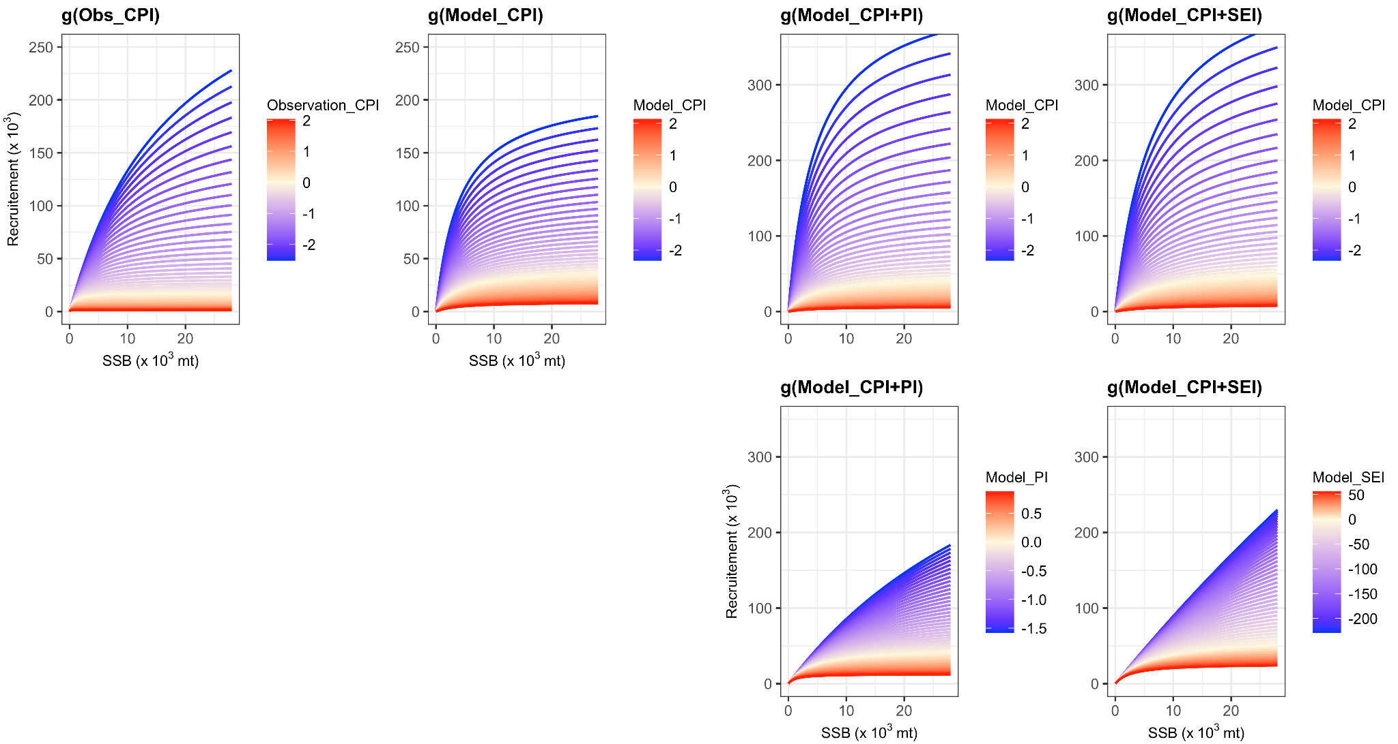

**Figure S5: Beverton-Holt stock-recruit relationships (SSB vs recruitment) for the 4 selected models which include one or two cold pool indices (g(Obs_CPI), g(Model_CPI), g(Model_CPI+PI) and g(Model_CPI+SEI)) for each year between 1973 and 2018.** Lines depict the expected stock-recruit relationship in each year given the value of the cold pool index in the year y-1.

# Supplementary Material VI

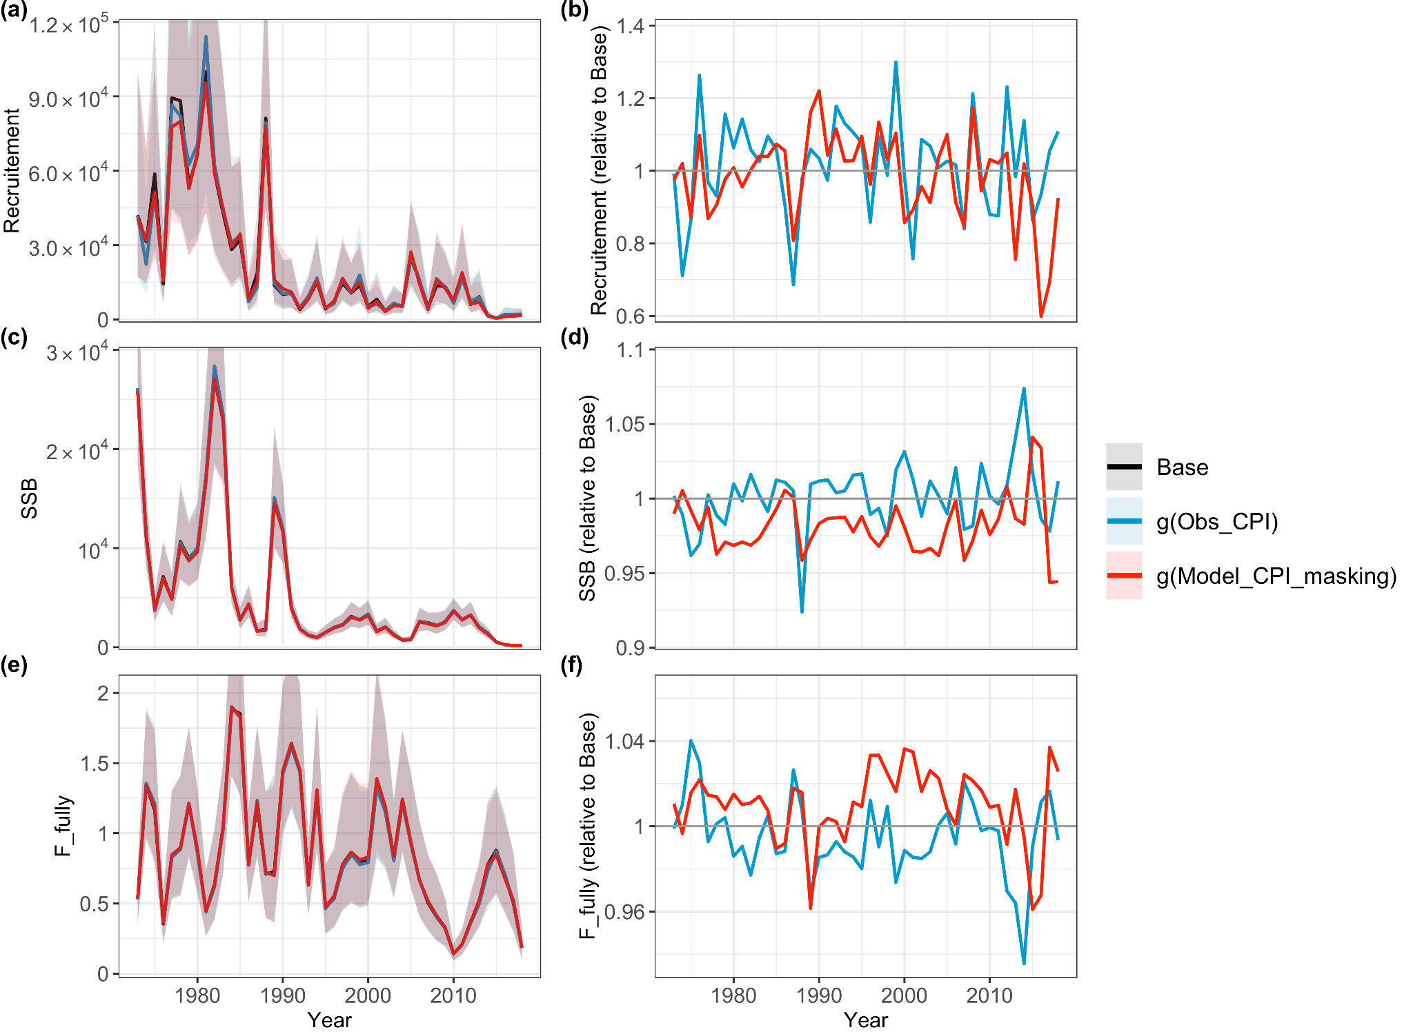

**Figure S6.1: Annual raw (left column) and relative (to the Base model without environmental covariates, right column) estimates of recruitment (a and b), spawning stock biomass (SSB, c and d) and fully selected fishing mortality (*F*, e, and f) for the model Base, g(Obs_CPI) and g(Model_CPI_masking) (denoted m25, m8 and m4 in Table 1, respectively).** The colored polygons represent the 95% confidence intervals.

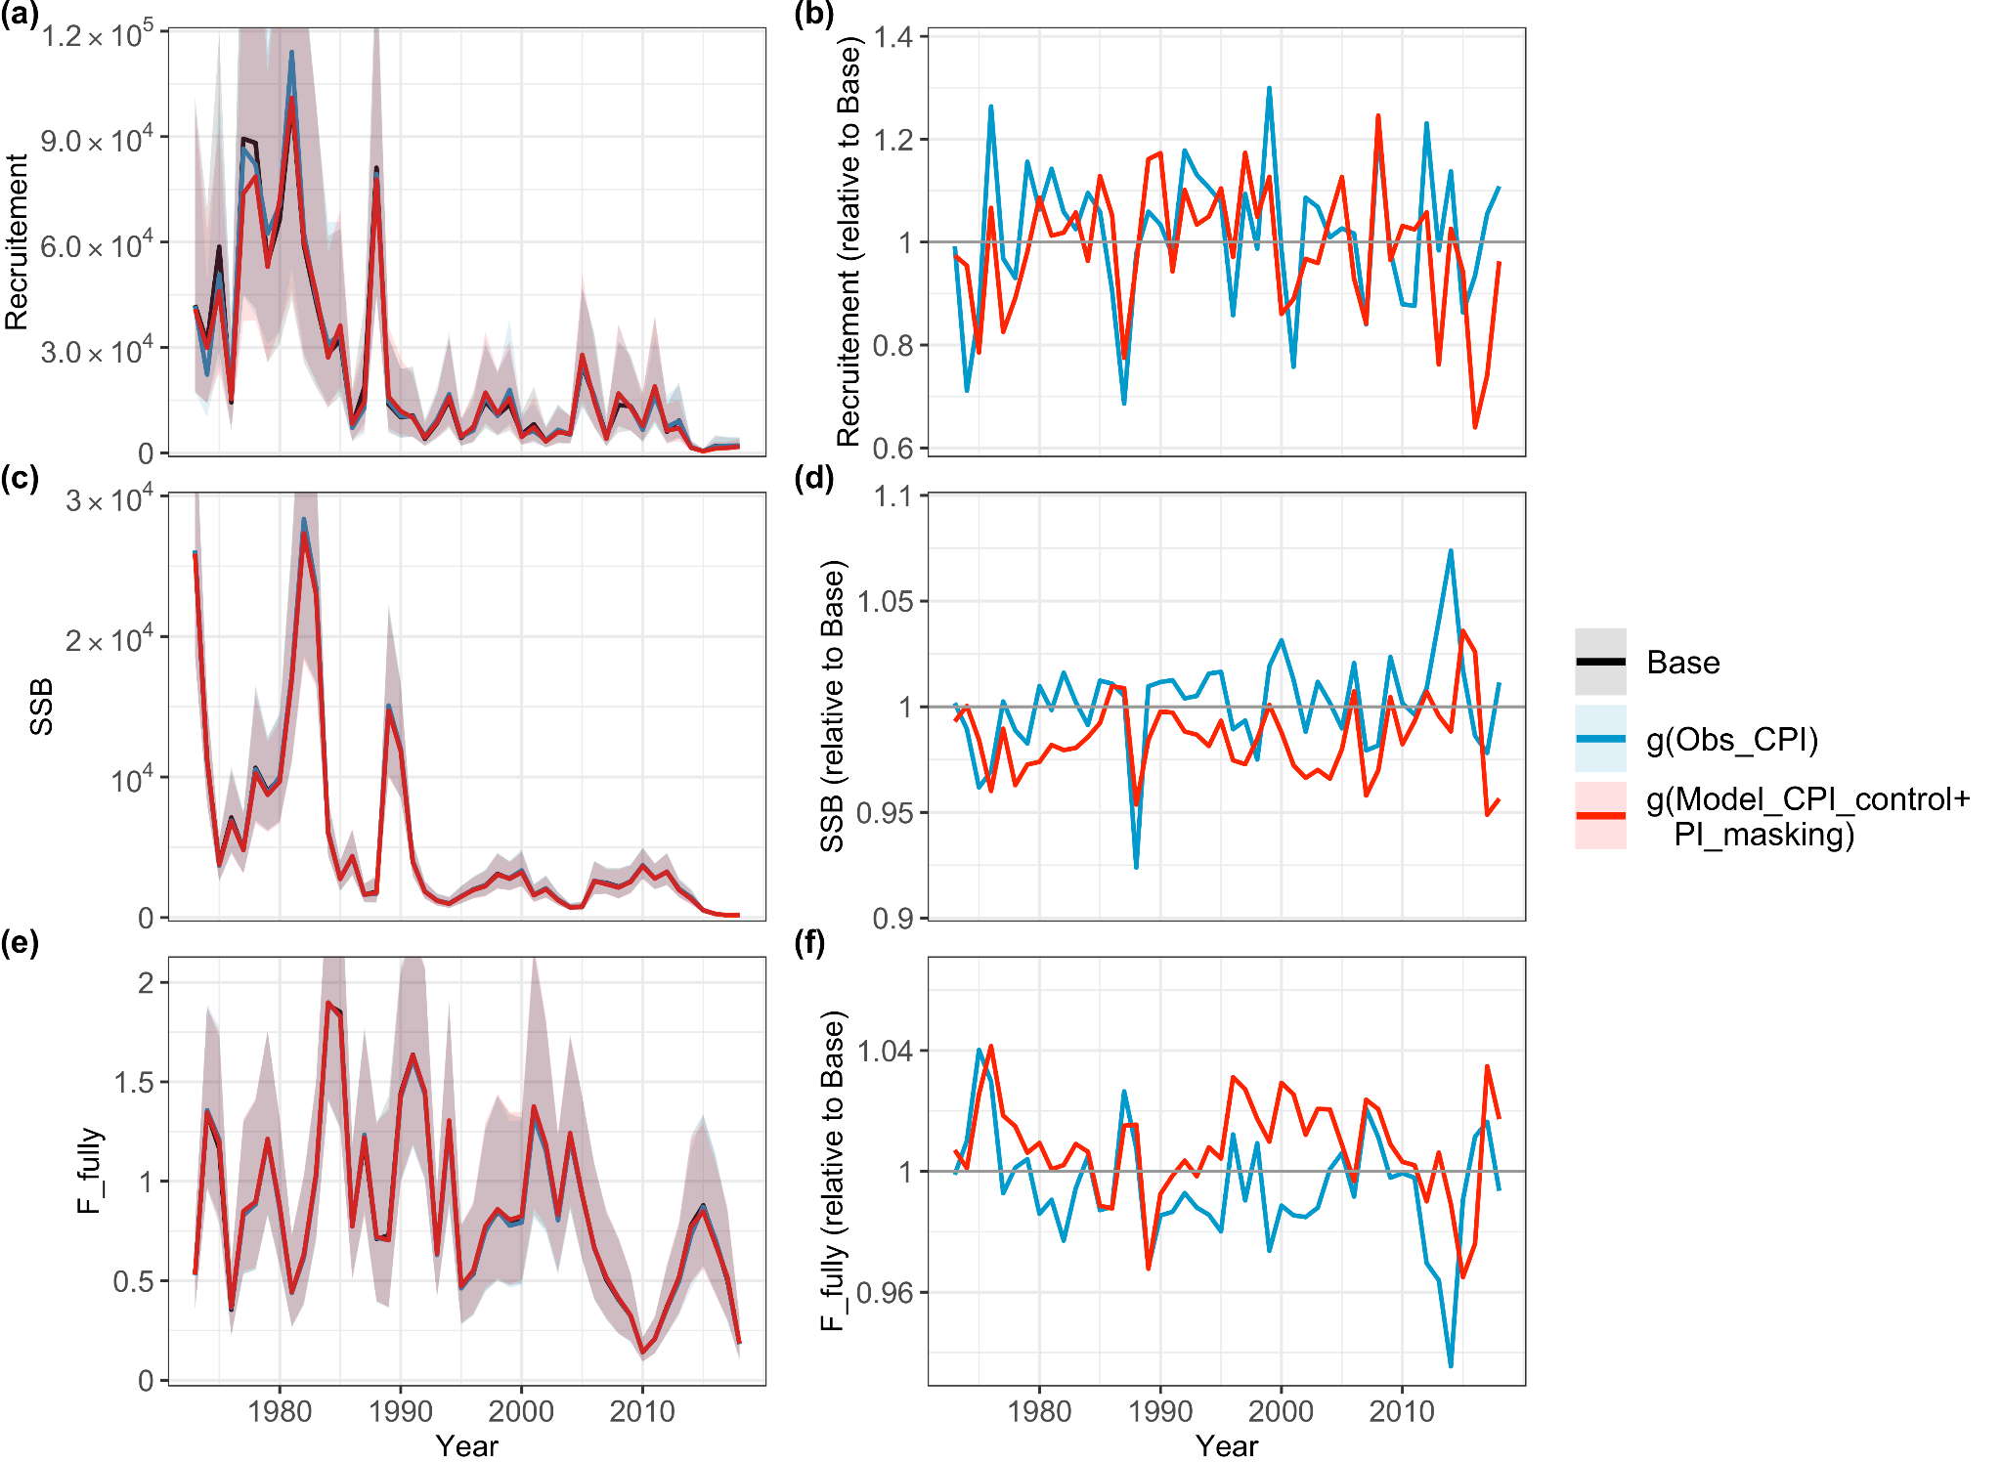

**Figure S6.2: Annual raw (left column) and relative ((to the Base model without environmental covariates, right column) estimates of recruitment (a and b), spawning stock biomass (SSB, c and d) and fully selected fishing mortality (*F*, e, and f) for the model Base, g(Obs_CPI) and g(Model_CPI_control+PI_masking) (denoted m25, m8 and m5 in Table 1, respectively).** The colored polygons represent the 95% confidence intervals.

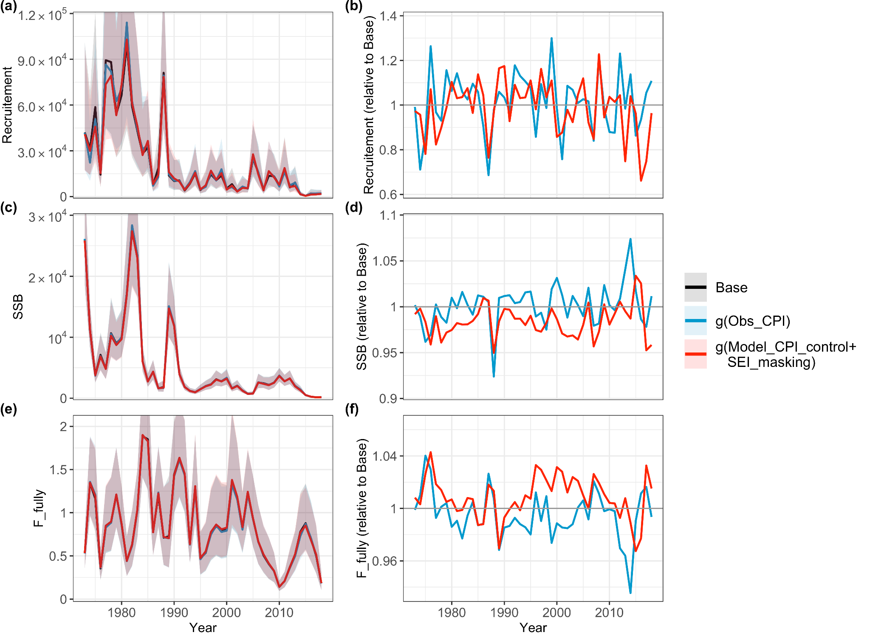

**Figure S6.3: Annual raw (left column) and relative (to the Base model without environmental covariates, right column) estimates of recruitment (a and b), spawning stock biomass (SSB, c and d) and fully selected fishing mortality (*F*, e, and f) for the model Base, g(Obs_CPI) and g(Model_CPI_control+SEI_masking) (denoted m25, m8 and m6 in Table 1, respectively).** The colored polygons represent the 95% confidence intervals

# Supplementary Material VII

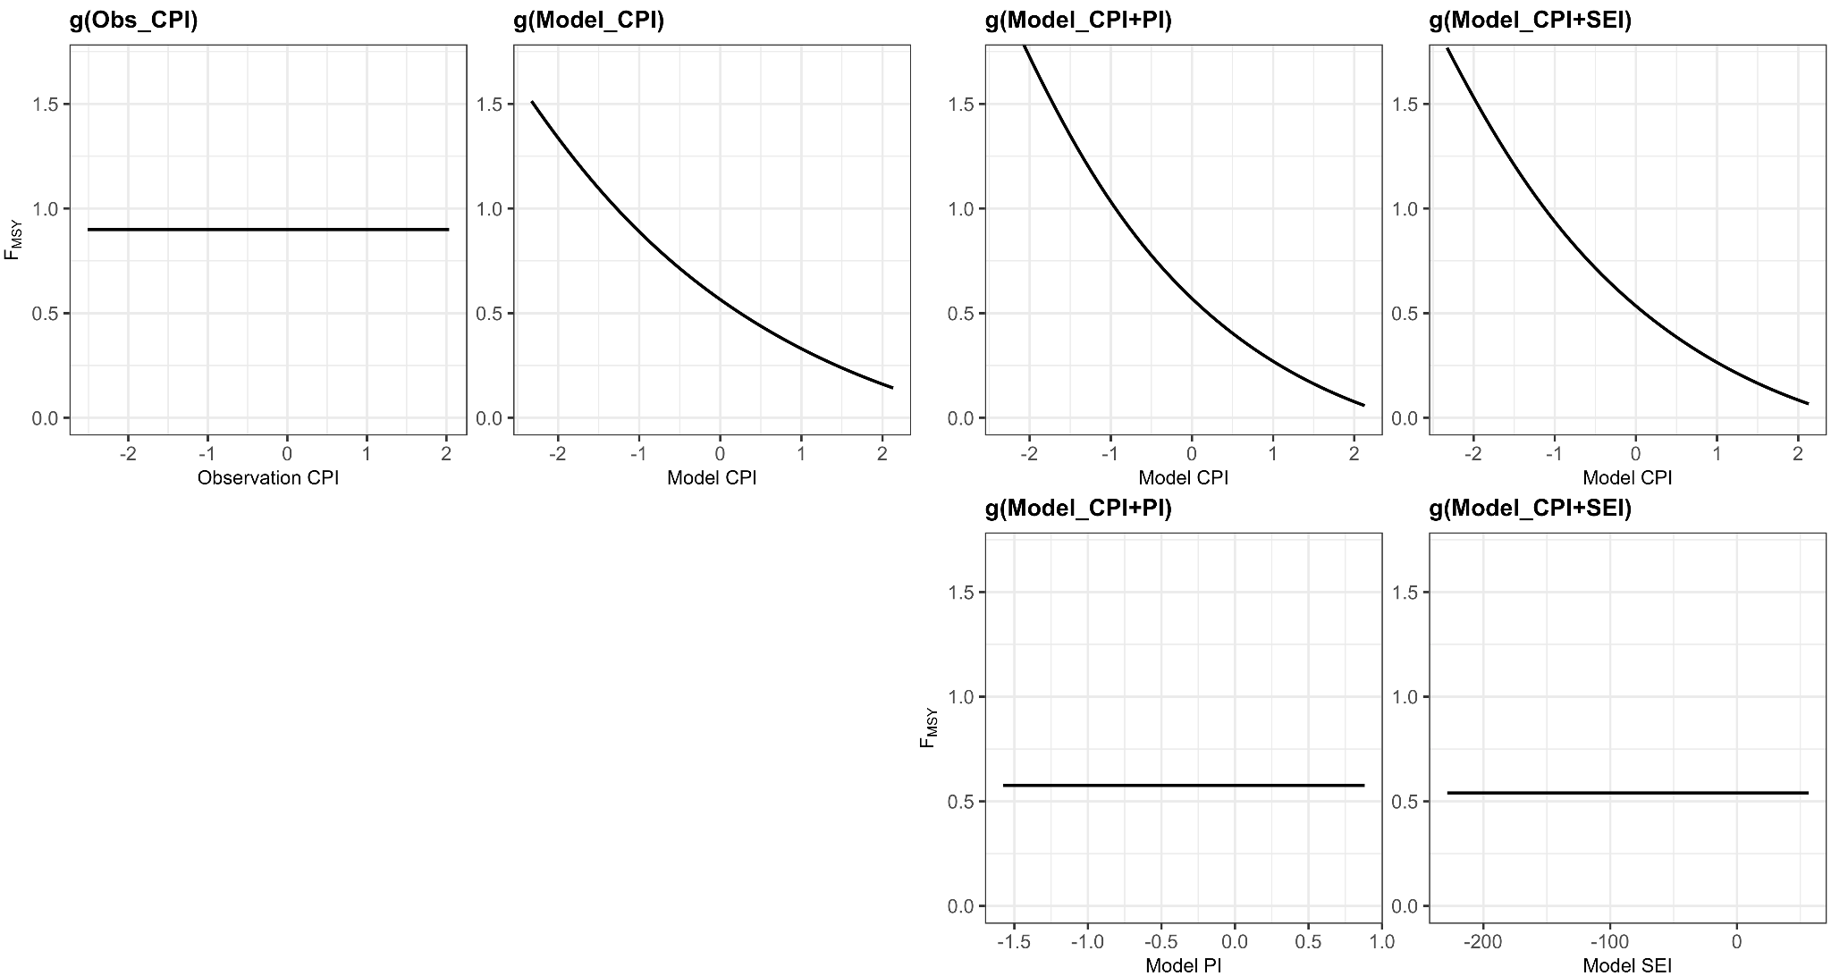

**Figure S7: Fishing mortality at MSY (FMSY) in the projection period over the range of estimated covariates for the 4 selected models including cold pool indices (g(Obs_CPI), g(Model_CPI), g(Model_CPI+PI) and g(Model_CPI+SEI)).**

# Supplementary Material VIII

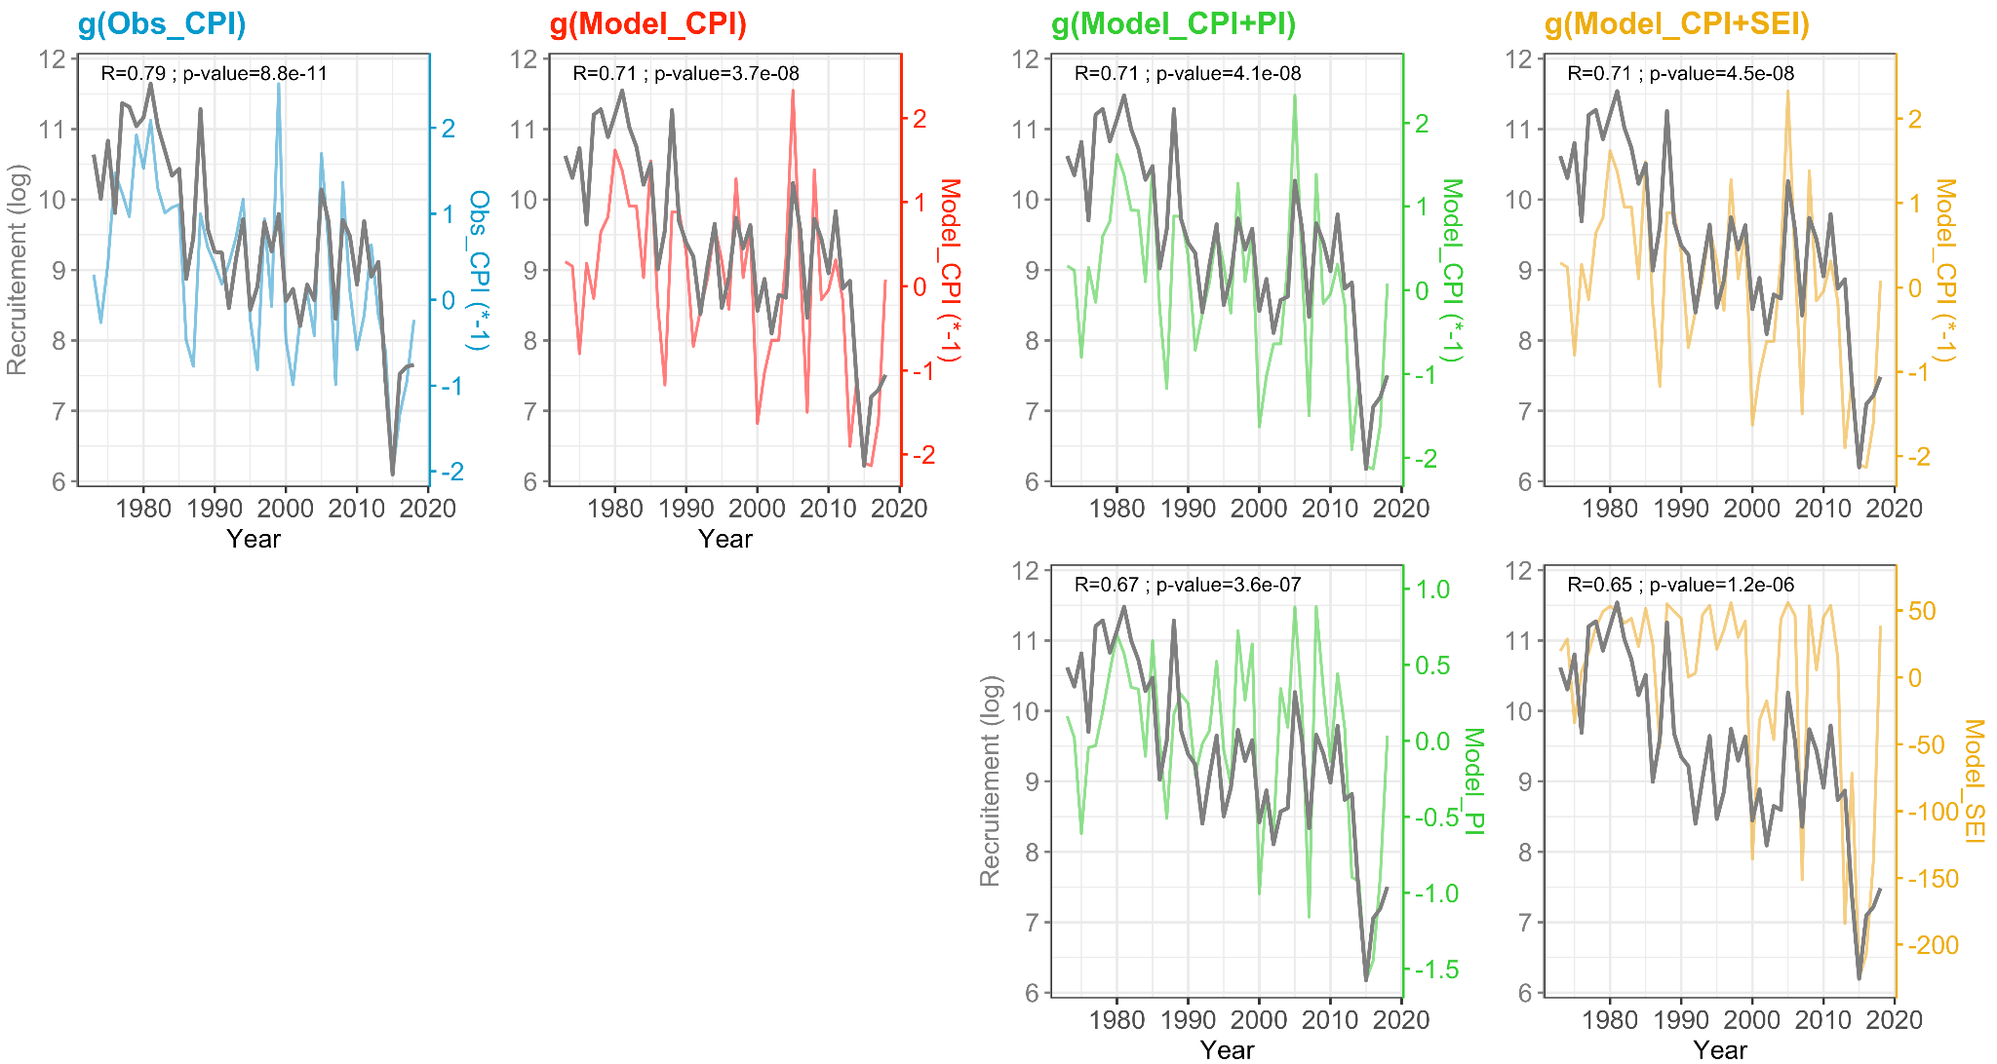

**Figure S8: Recruitment and Cold Pool indices time series for the 4 selected models including one or two cold pool indices (g(Obs_CPI), g(Model_CPI), g(Model_CPI+PI) and g(Model_CPI+SEI)) between 1973 and 2018.** The colored lines are the Cold Pool indices and the grey lines are the recruitment. The Cold Pool indices time series are represented with a lag of 1 year because Cold Pool affects recruitment with a lag of 1 year. R is the Pearson’s correlation coefficient between the recruitment and Cold Pool index time series and p-value is the associated p-value.

# Supplementary Material IX

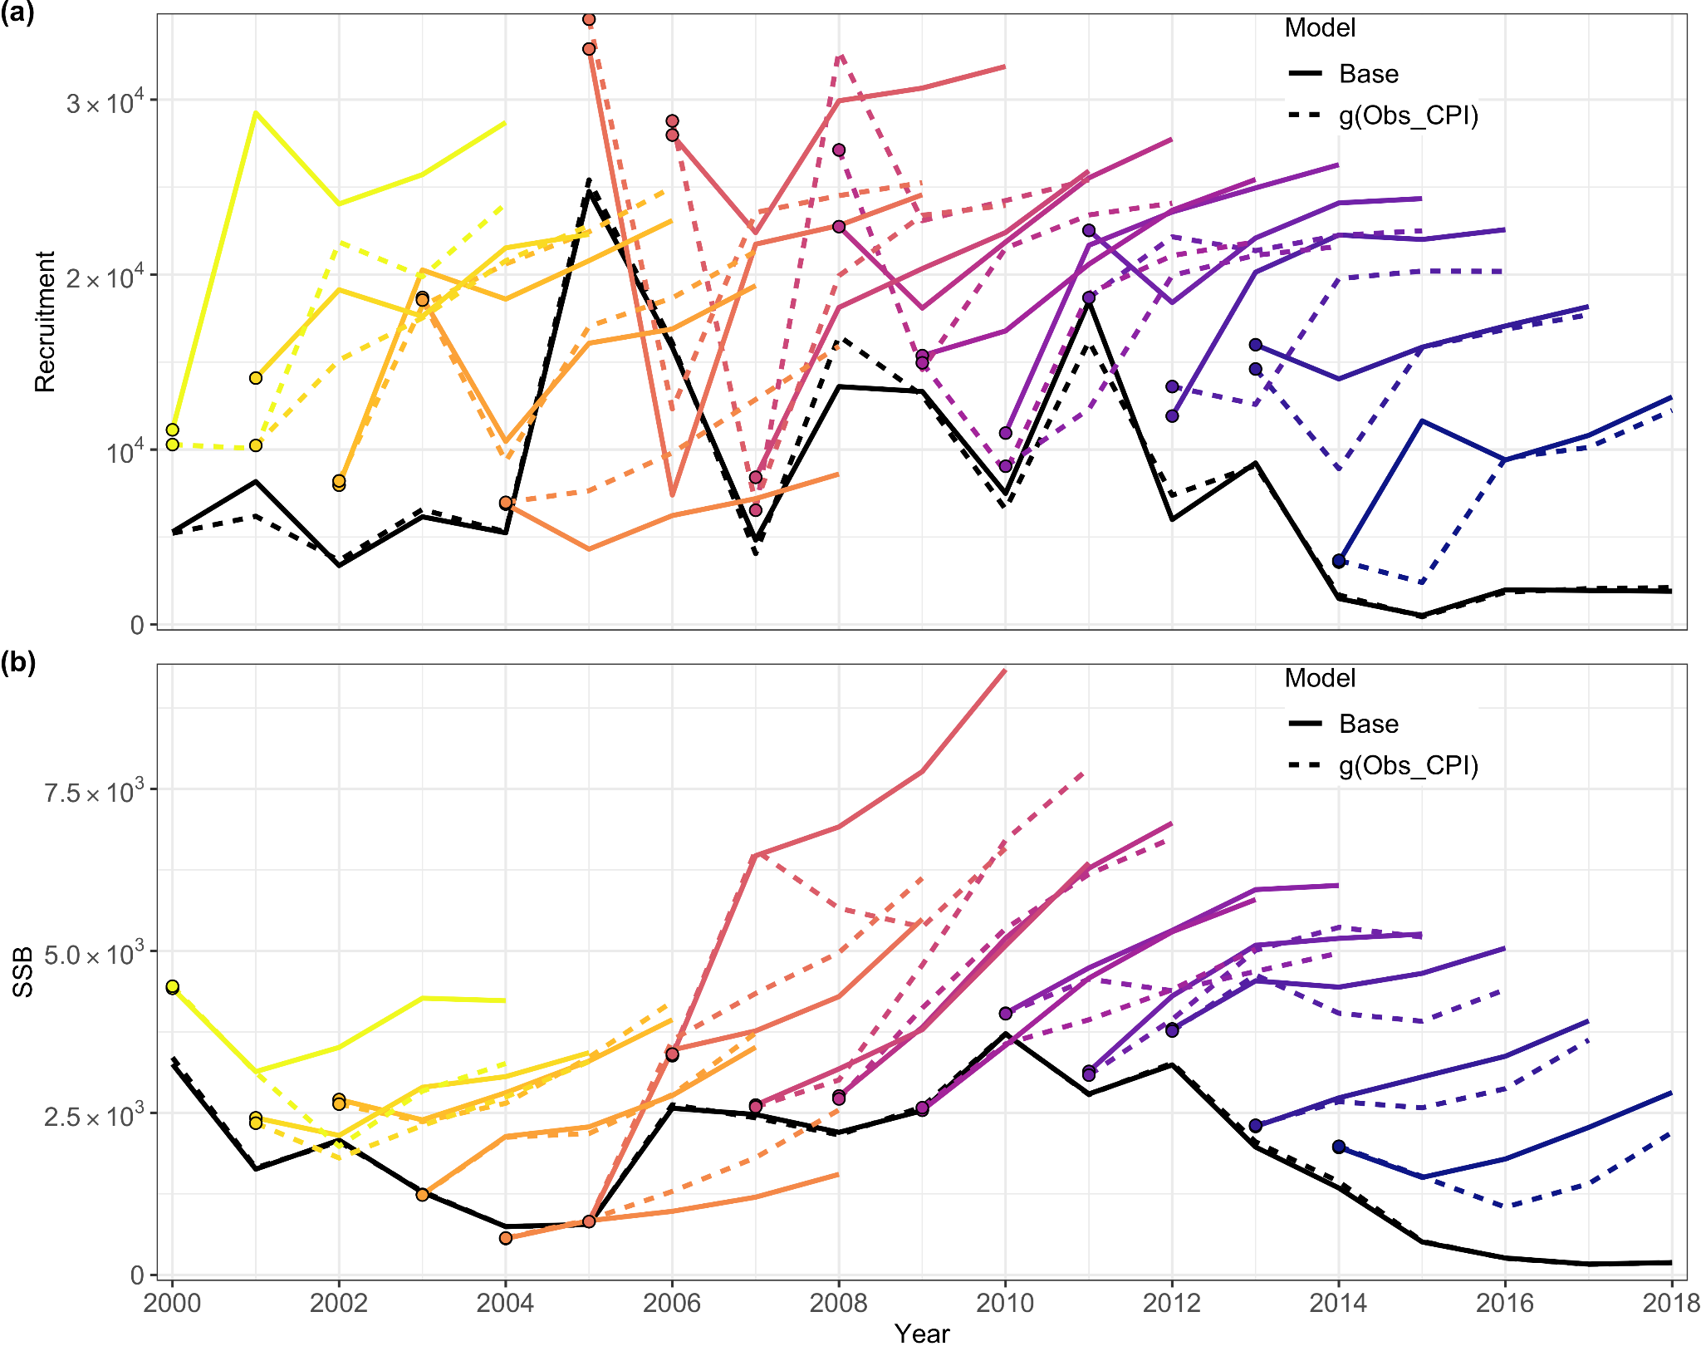**Figure S9.1: The retrospective prediction patterns from the model without environmental covariates (Base) and the model in which Obs_CPI affects SSB and recruitment estimates (g(Obs_CPI)).** The two black lines represent the SSB and recruitment estimates when performing WHAM on full data. The dots are the terminal year recruitment estimates for each

​​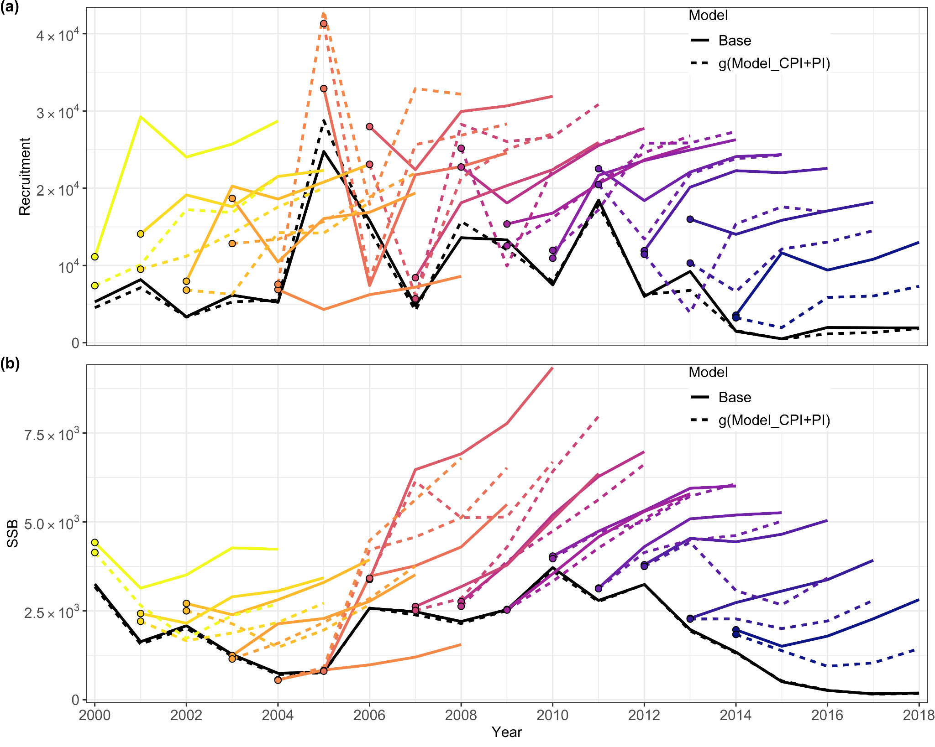

**Figure S9.2: The retrospective prediction patterns from the model without environmental covariates (Base) and the model in which Model_PI affects SSB and recruitment estimates (g(Model_CPI+PI)).** The two black lines represent the SSB and recruitment estimates when performing WHAM on full data. The dots are the terminal year recruitment estimates for each

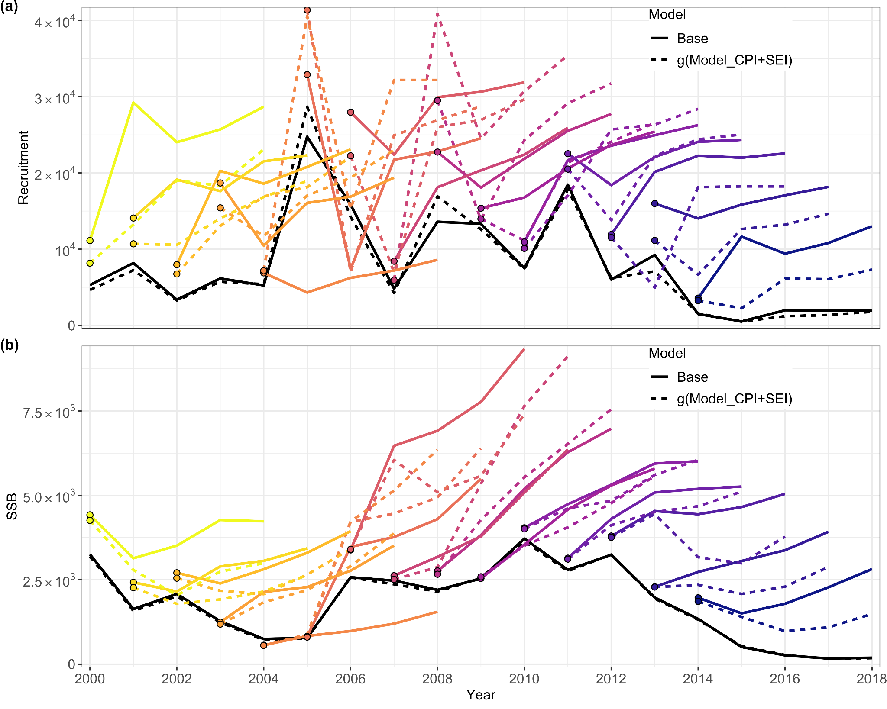

**Figure S9.3: The retrospective prediction patterns from the model without environmental covariates (Base) and the model in which Model_SEI affects SSB and recruitment estimates (g(Model_CPI+SEI)).** The two black lines represent the SSB and recruitment estimates when performing WHAM on full data. The dots are the terminal year recruitment estimates for each

# Supplementary Material X

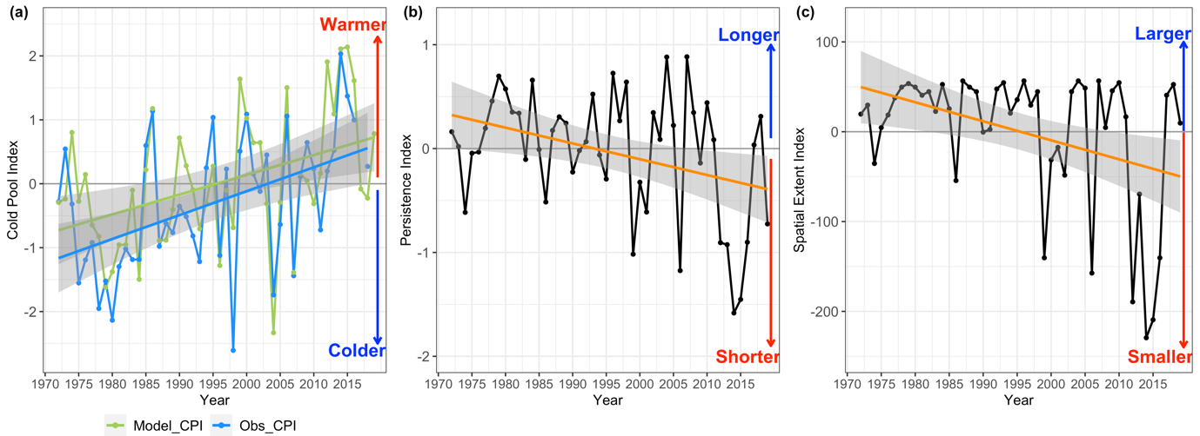

**Figure S10: Time series of the Cold Pool Indices calculated from ocean models (green) and observations (blue) (a), the Persistence Index (b) and the Spatial Extent Index (c) from 1972 to 2019 and their linear trends with 95% confidence interval.**

Both Model_CPI and Obs_CPI show a significant linear increase between 1972 and 2019 (slopes of the linear trend are 0.031 (p-value =0.00259) and 0.037 (p-value=0.000654), respectively; Figure S10). Moreover, Model_PI and Model_SEI show a significant linear decrease between 1972 and 2019 (slopes of the linear trend are -0.015 (p-value =0.01277) and -2.117 (p-value=0.005893); Figure S10).