SUPPORTING TEXT

*Slesinger et al.*

**Oxygen: determining potential variability and error**

Our MI analyses used average oxygen values for each season, which collapsed the spatiotemporal scale of oxygen to use in MI calculations alongside changing temperature. While there were raw bottom oxygen data available, the temporal coverage was sparse and uneven across regions (Fig A). In addition, there are no fully-resolved and validated oxygen models that provide values at depth for the shelf. Compared to other ecosystems, we do not expect oxygen to be a major limiting parameter over long time-scales, yet minor fluctuations in oxygen could potentially affect our interpretation of the amount of metabolically suitable habitat in our analyses. Therefore, we investigated the potential influence of variability in oxygen by 1) assessing the potential utility of using an oxygen model, and 2) using the spatial variability in the model to provide ranges of oxygen levels to investigate these dynamics.

The Glorys12v1 reanalysis product used to provide bottom temperature in our MI calculations also provides a modeled oxygen output at ¼° and on 75 vertical levels for the time period 1993-2020. There is no data assimilation in this product. We compared the modeled product to the raw oxygen values from the CTD casts. Due to low spatial resolution in the raw oxygen data, we compared data across the designated regions (not strata). Overall, we found poor agreement between the raw oxygen data and the modeled oxygen (Fig B). There was better agreement when more raw oxygen data was available, which highlights the challenge in compiling oxygen data for the USNES, namely, poor model fits that are a challenge to validate due to limited raw observations. The modeled oxygen did show some interesting spatial patterns including higher oxygen inshore than offshore in the fall and low bottom oxygen in the GOM. When compared to the raw oxygen data, the spatial pattern in fall was also reflected, but the low oxygen in the GOM would need to be validated with additional *in situ* sampling.

While the comparison between modeled and raw oxygen highlighted the pitfalls of using a modeled product, the model did provide potential spatial anomaly patterns in oxygen (Fig C). To assess the potential error in using the seasonally averaged oxygen, we used these anomalies to provide an empirical basis as to how much oxygen might vary spatially with respect to the seasonal average. These anomalies provided a constrained range of potential oxygen variability, which was then used in a simulation exercise to assess how much of that variation would affect MI. For each species, season, and region, we used a Monte Carlo simulation to calculate MI from a random oxygen value bounded between the constrained range, and repeated this process across 10,000 iterations. From the simulated MI, an average MI value and its confidence intervals were calculated and compared to the actual MI value used in this study. Finally, the range of MI values and the reported MI were compared with the calculated MIcrit, and also compared across the historical (1972-2019; Fig D) and contemporary (2010-2019; Fig E) climatologies.

Overall, for the times where MI decreased below MIcrit, the simulated MI also reflected this trend, and there were very few cases where the simulated MI fell below MIcrit while the MI in the study did not (which occurred 1x for Atlantic cod and 2x cunner in 2010-2019). In the inshore strata where ocean conditions were typically warmer, the O2 anomaly was positive, which may have contributed to the minimal instances of simulated MI values lower than MIcrit­­. The low oxygen in the GOM led to a quite a few cases where the estimated MI from the oxygen anomalies confidence interval was below the MIcrit, but we are cautious of interpreting the large spatial anomaly from the GOM without validation. Altogether, these results suggest that using seasonally averaged oxygen does not alter our interpretation of the availability of metabolically suitable habitat, but when improved oxygen products are available, incorporating them in MI calculations would be valuable (especially for identifying interannual trends).

**FIGURES**

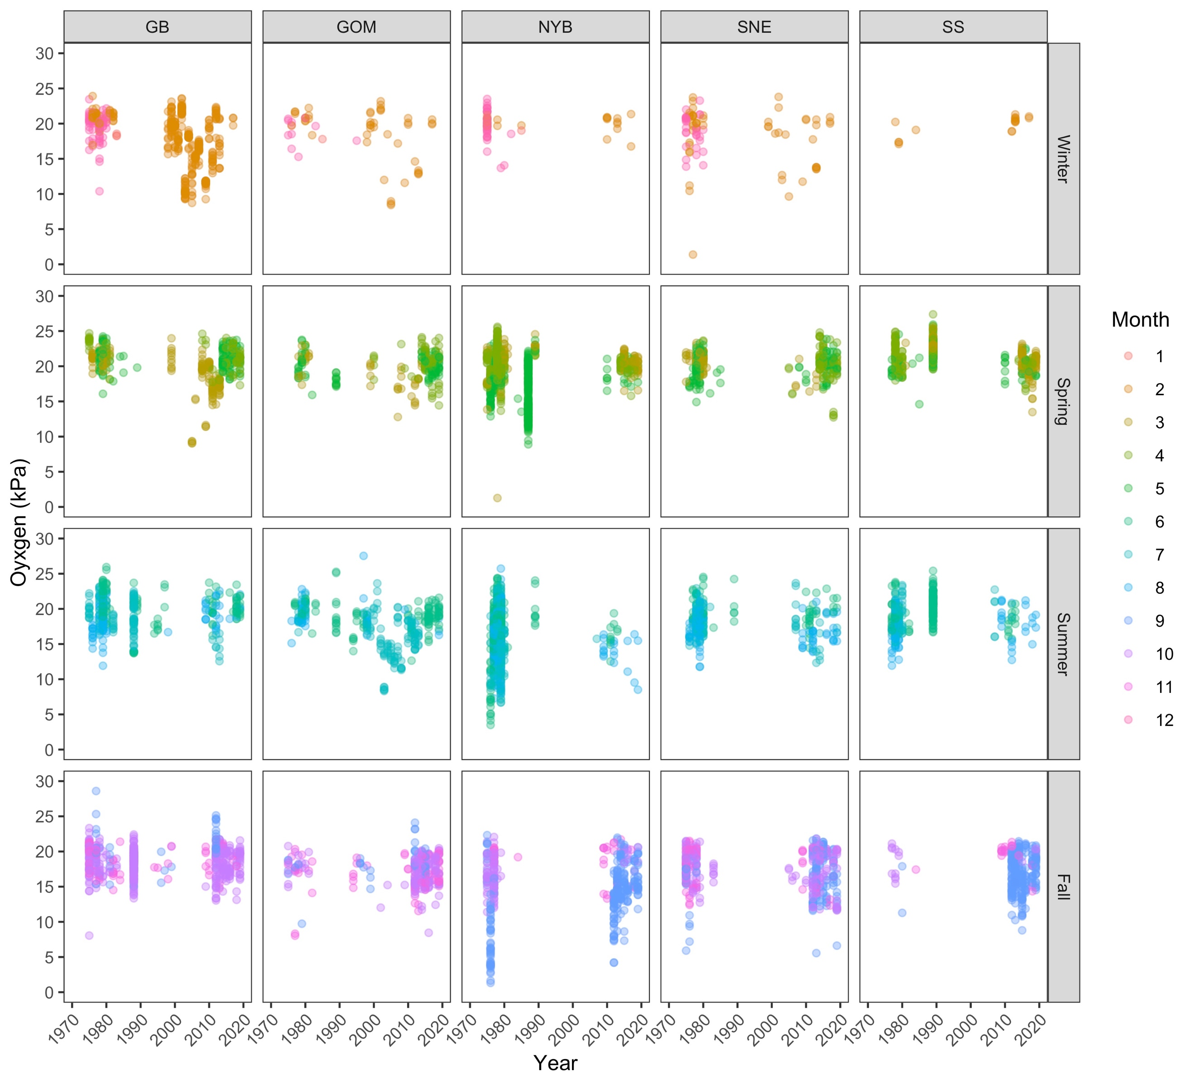

**Fig A. Raw oxygen values for each region and season.** Months within seasons are designated as a different color. These data are plotted across the entire time series (1972-2019) and show the uneven sampling of oxygen across years, and months within a season and region. In addition, while there is variability in oxygen measured, there is no trend of decreasing oxygen over time in any region or season.

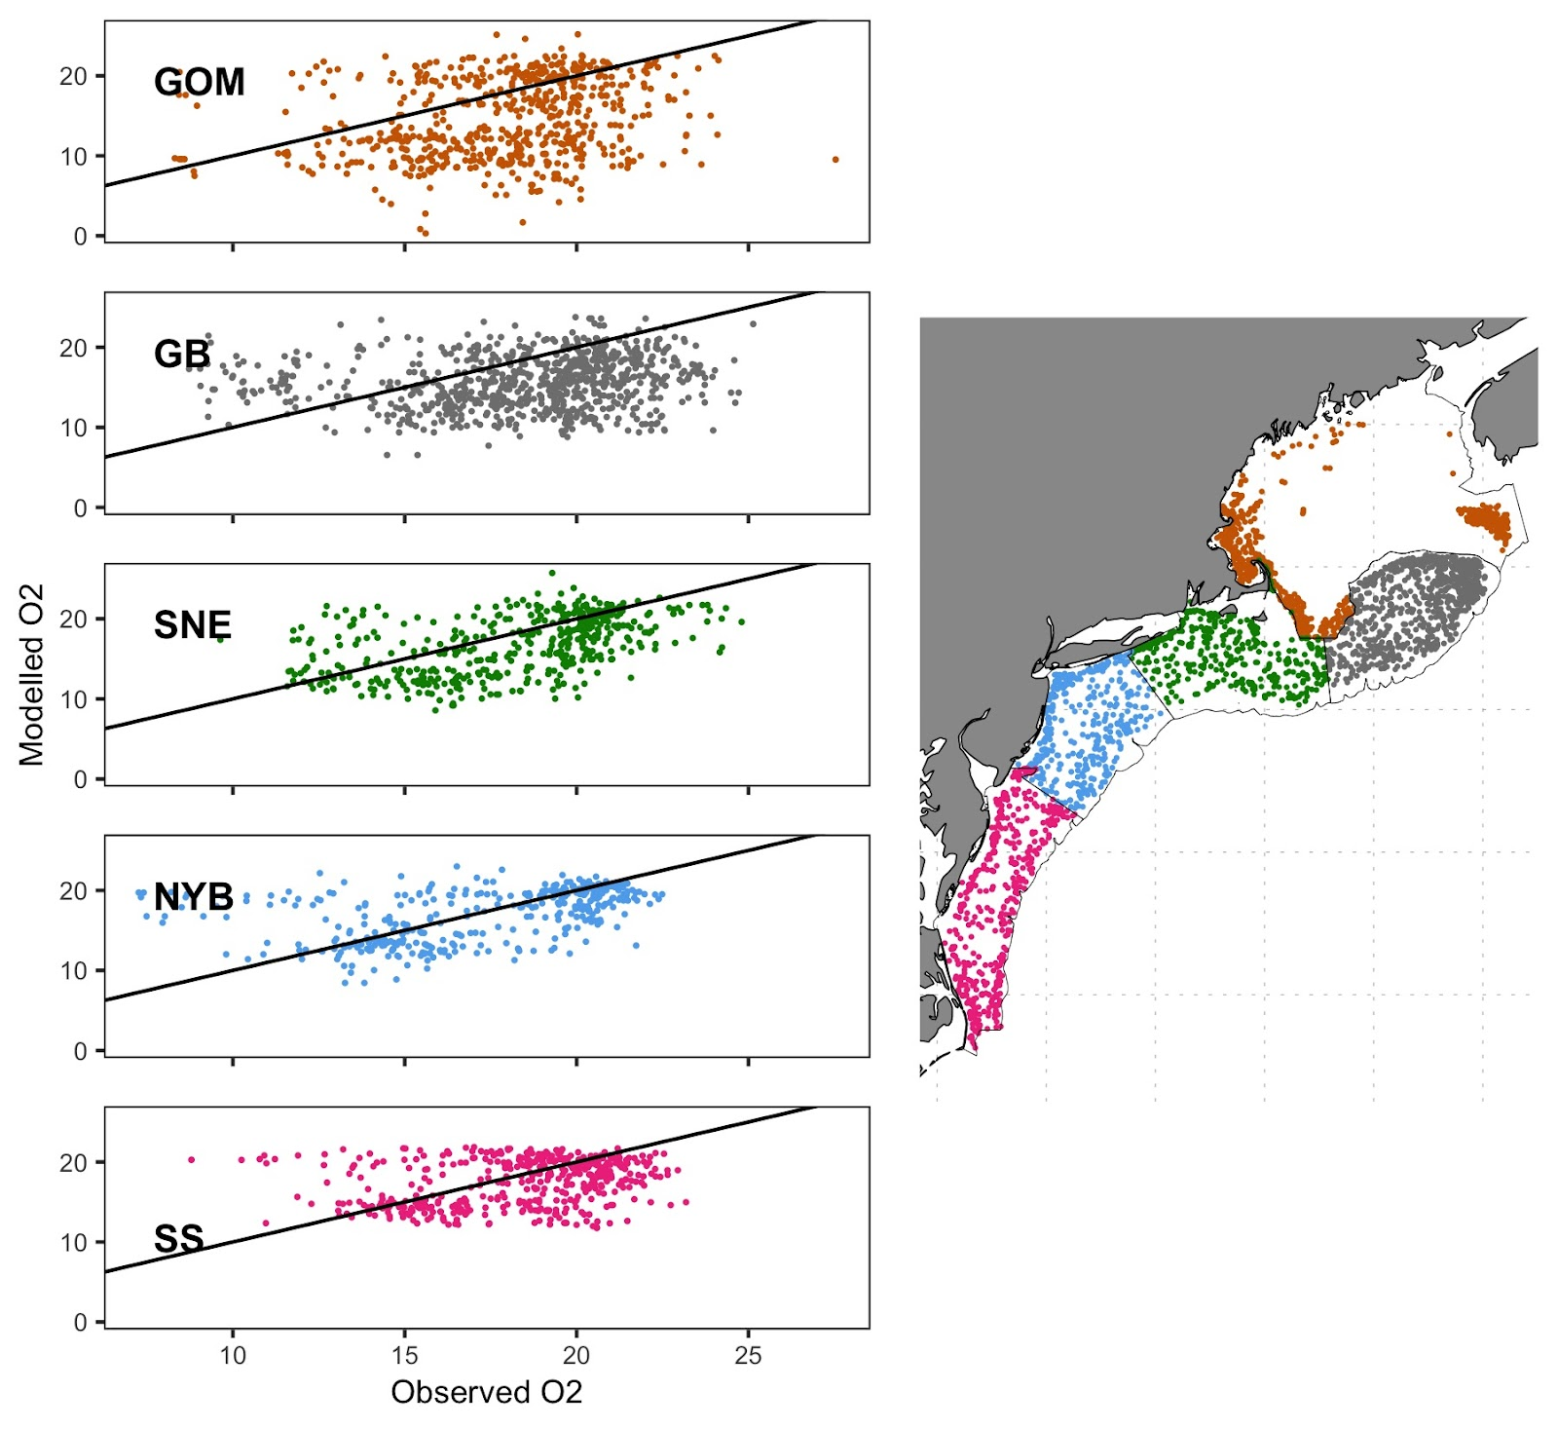

**Fig B. Analysis of observed vs. modeled oxygen data.** Raw oxygen data used from CTD casts in this study were compared to modelled oxygen from the Glorys12v1 reanalysis product. The black line indicates a 1:1 fit, and shows a poor fit between observed and modelled values. The map on the right shows the spatial distribution of oxygen data used in the comparison. Notably these values comprise of all observations from 1972-2019. United States outline data was obtained from the R package ‘maps’ (cran.r-project.org/package=maps).

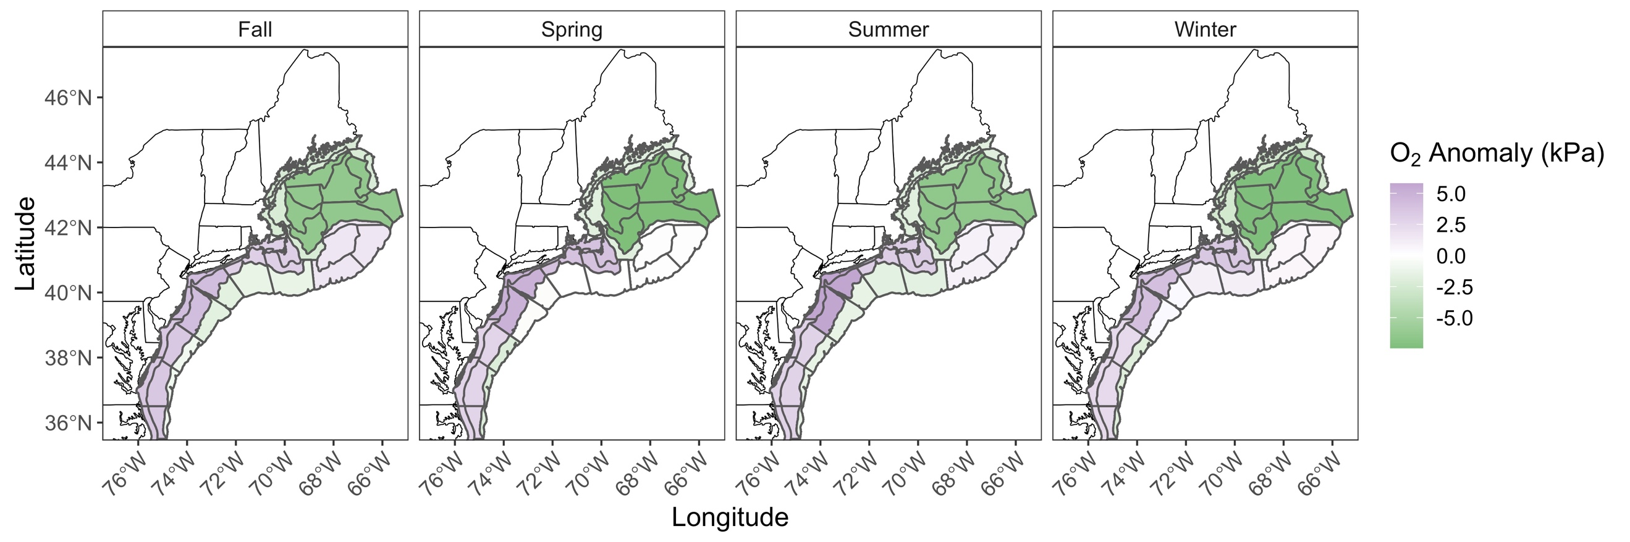

**Fig C.** **Spatial oxygen anomalies**. Using the oxygen levels from the modelled product in Glorys12v1, a regional and seasonal maximum oxygen anomaly was created (strata are still shown for reference). A positive anomaly is shown in purple and a negative anomaly is shown in green. United States state outline data was obtained from the R package ‘maps’ (cran.r-project.org/package=maps).

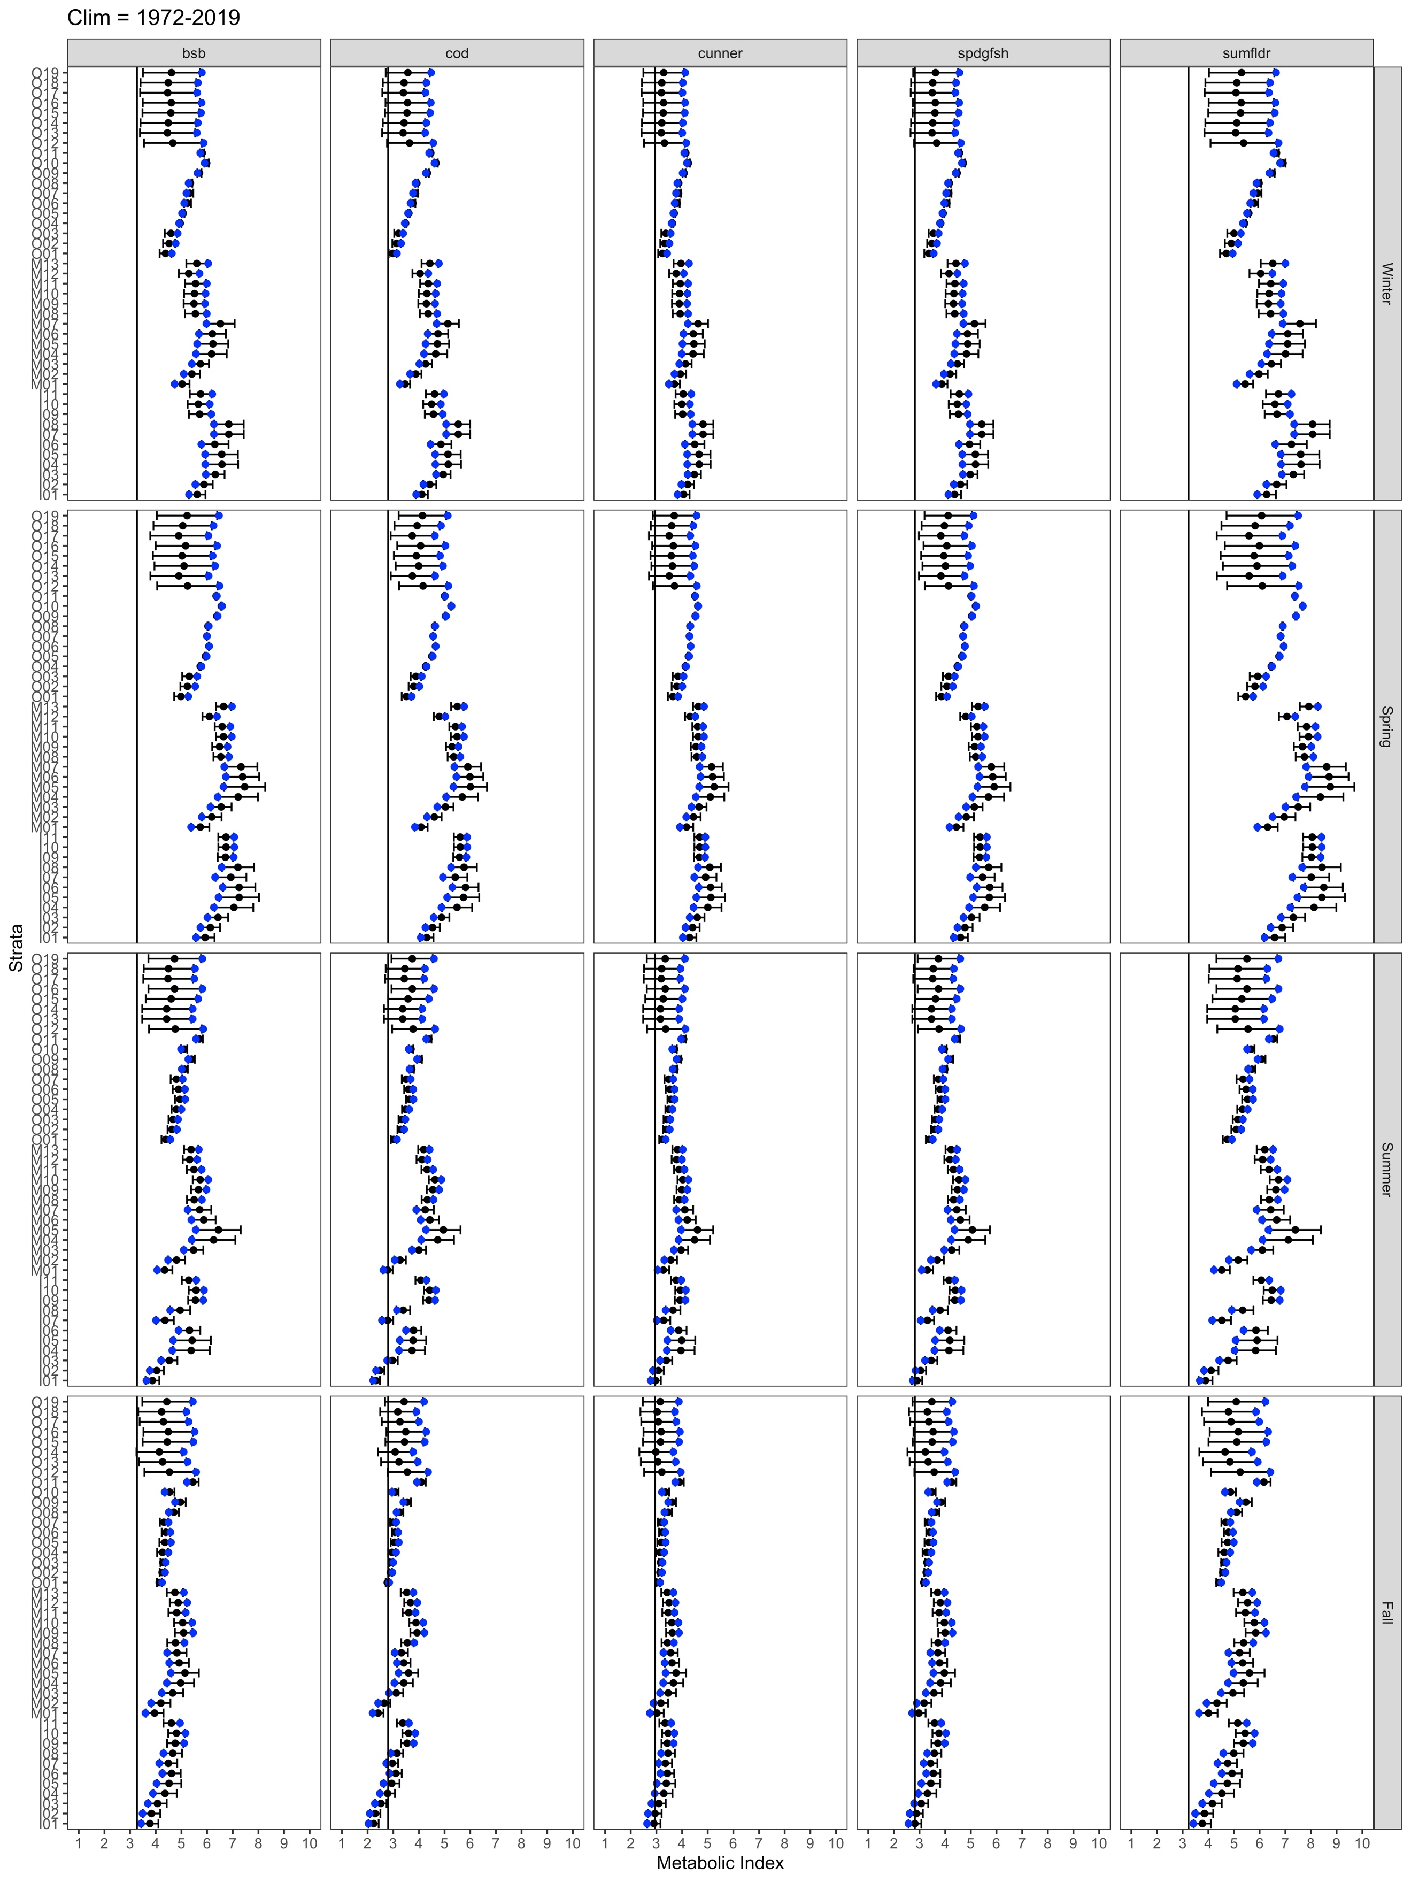

**Fig D.** **Sensitivity analysis of varying oxygen from 1972-2019 climatology.** The modeled MI is plotted as mean and standard error (in black) with the actual MI value calculated for the climatology and stratum is shown in blue. The graph is paneled by species, and the vertical black line depicts the MI value where MIcrit occurs.

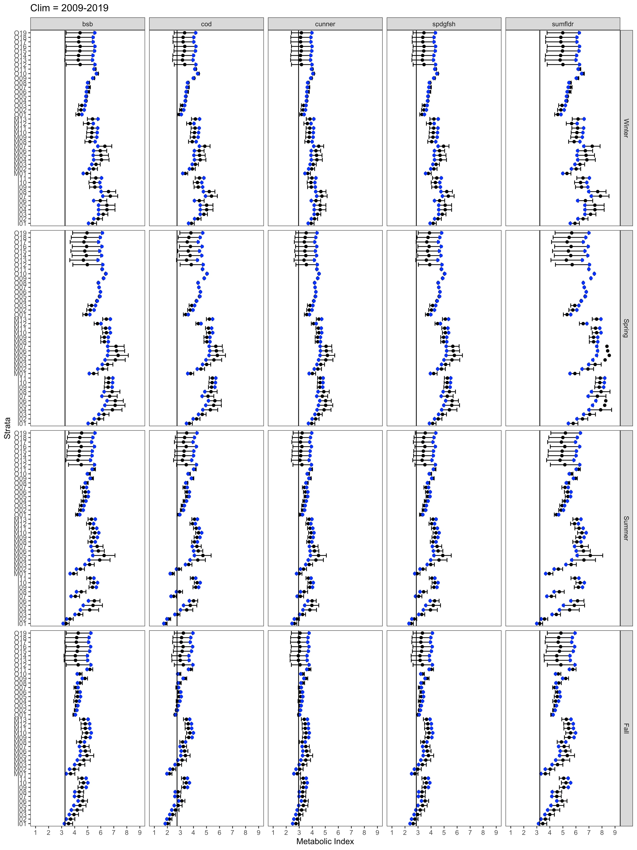

**Fig E. Sensitivity analysis of varying oxygen from 1972-2019 climatology.** The modeled MI is plotted as mean and standard error (in black) with the actual MI value calculated for the climatology and stratum is shown in blue. The graph is paneled by species, and the vertical black line depicts the MI value where MIcrit occurs.