# Supplementary material

# Revealing the adaptation strategies of pelagic fleets in the Bay of Biscay by combining fishery data and fishers' knowledge.

# Authors

Gabriel Lahellec1,*, Fabienne Daurès2, Sigrid Lehuta3

1 DECOD (Ecosystem Dynamics and Sustainability), Institut Agro - Agrocampus Ouest, IFREMER, INRAE, Rennes, France

2 Ifremer, Univ. Brest, CNRS, UMR 6308, AMURE, Unité d’Economie Maritime, IUEM, F-29280, Plouzané, France

3 DECOD (Ecosystem Dynamics and Sustainability), IFREMER, Institut Agro - Agrocampus Ouest, INRAE, Nantes, France

*Corresponding author, tel : +33 (0)2 23 48 55 33, mail : [Gabriel.lahellec@institut-agro.fr](mailto:Gabriel.lahellec@institut-agro.fr)

## Seasonality of anchovy (ANE) and sardine (PIL) landings

Figure and Figure shows monthly landings of anchovy and sardine by vessels of our study fleet. The seasonality of the fishery is clearly visible, with most important landings between May and November :

* Mean landings above zero for anchovy,
* Mean landings above 1000T for sardine.

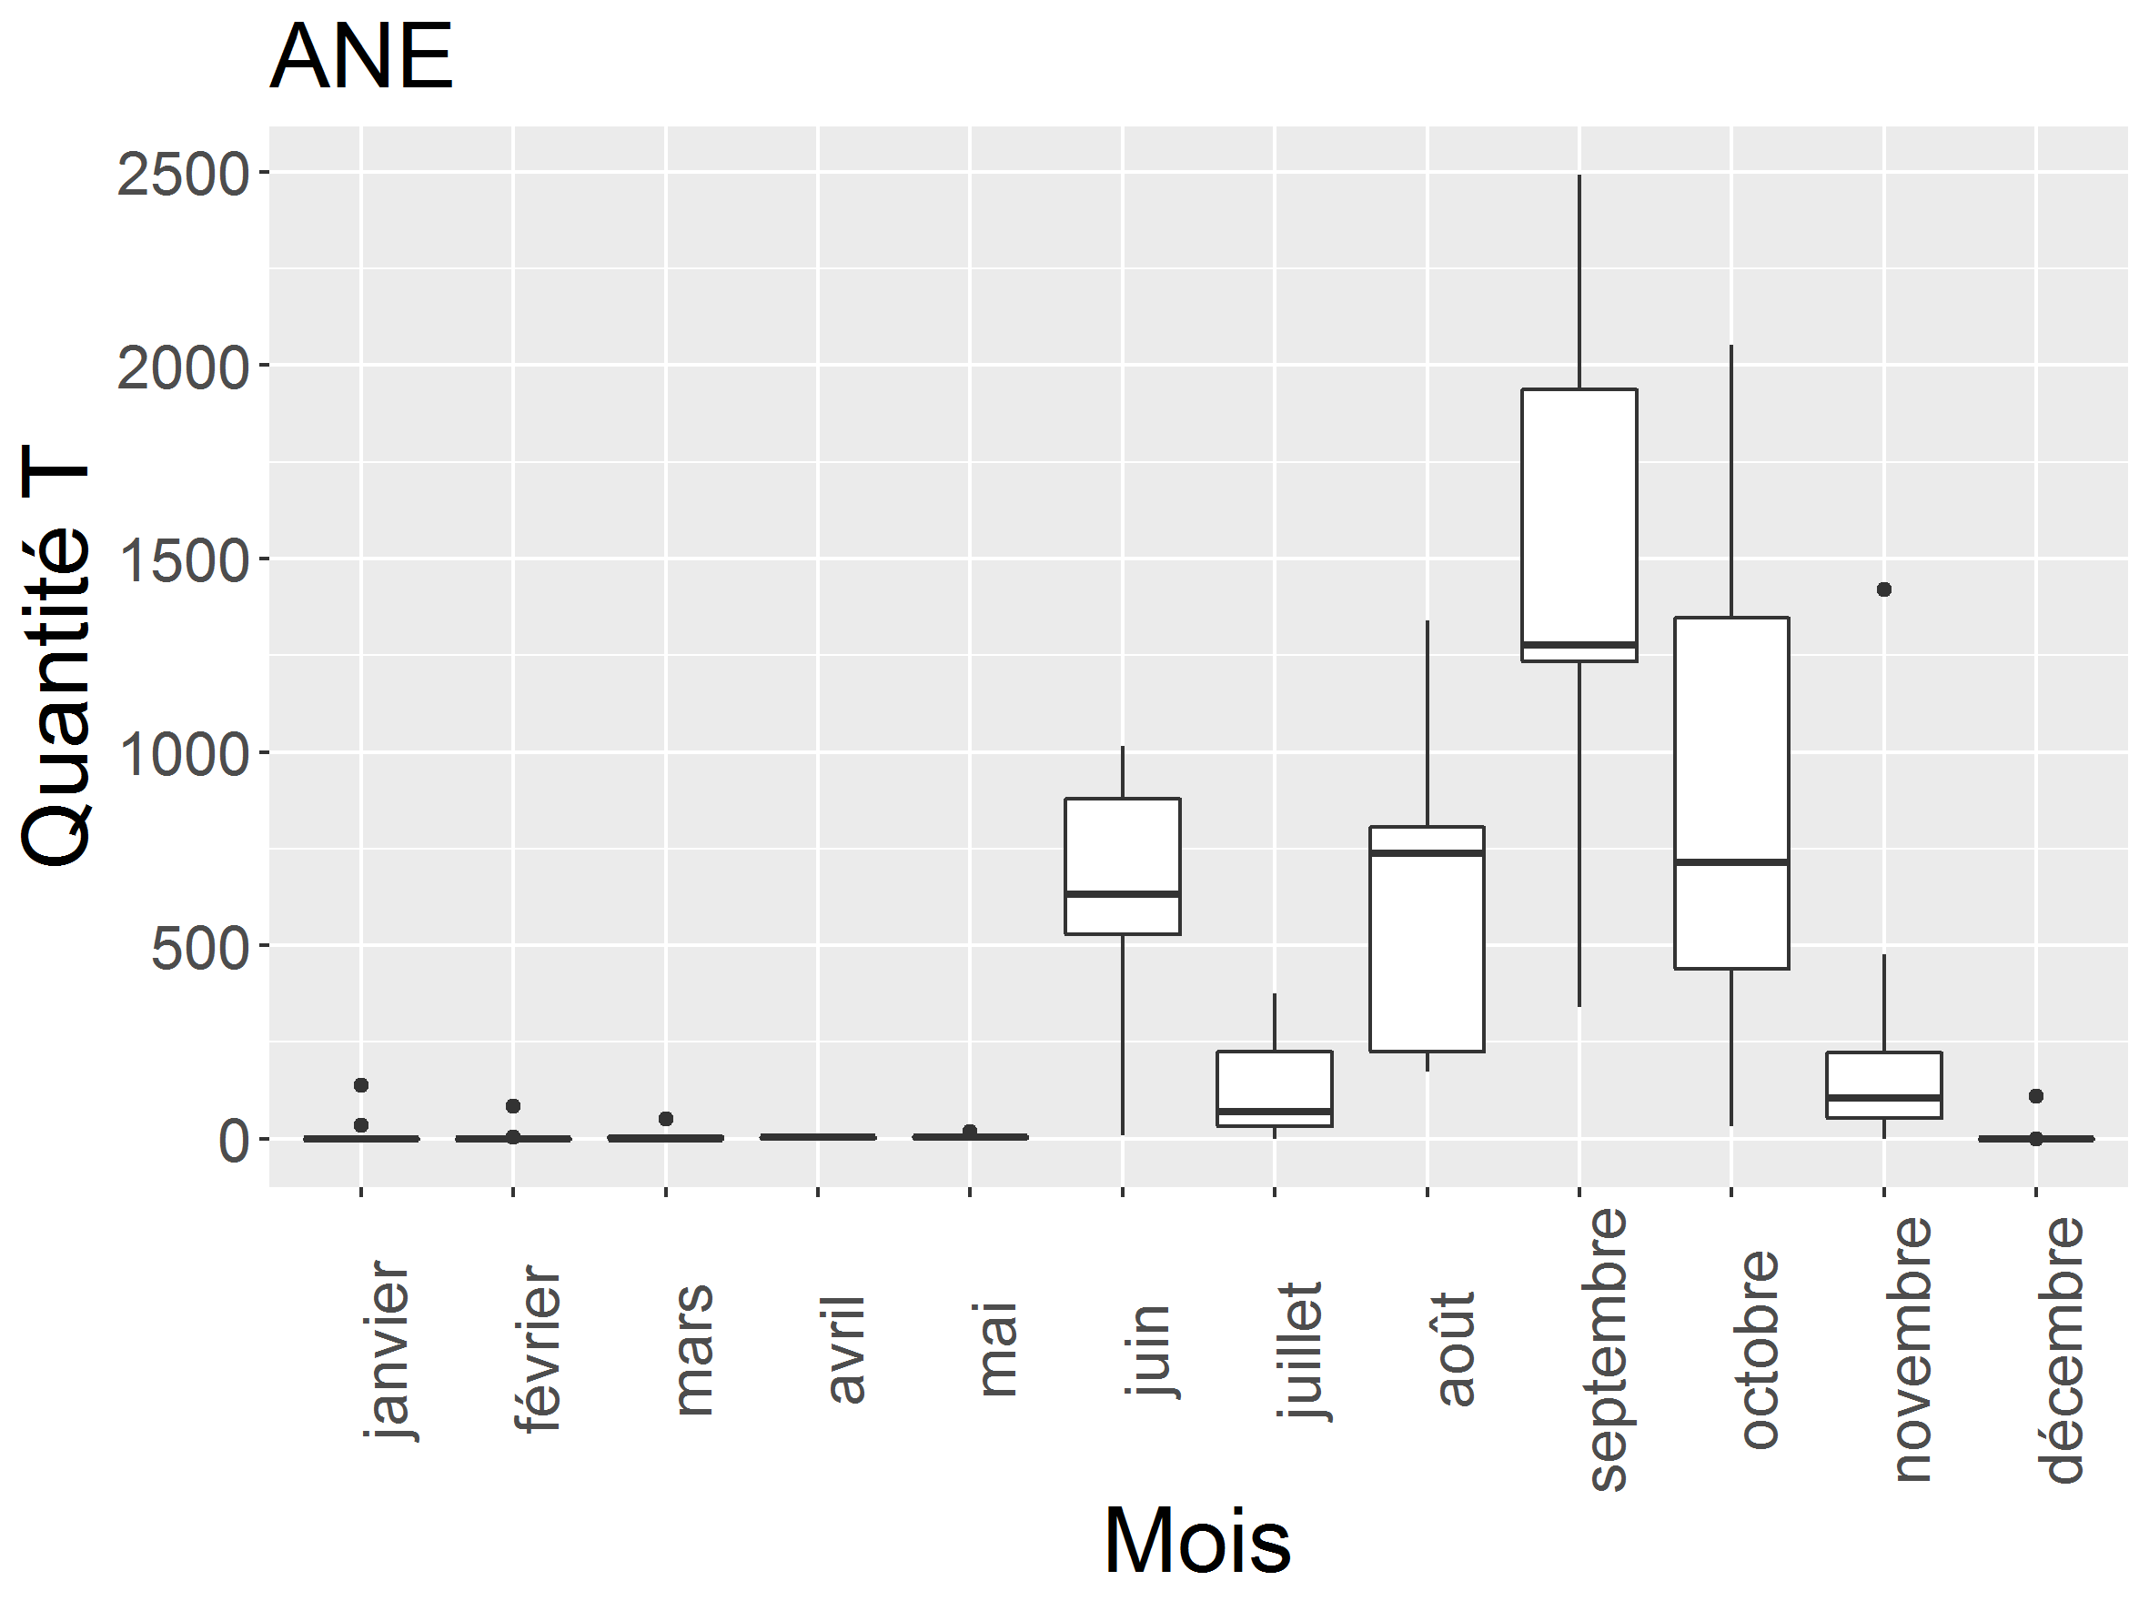

Figure 9 : monthly landings of anchovy by vessels of our study fleet.

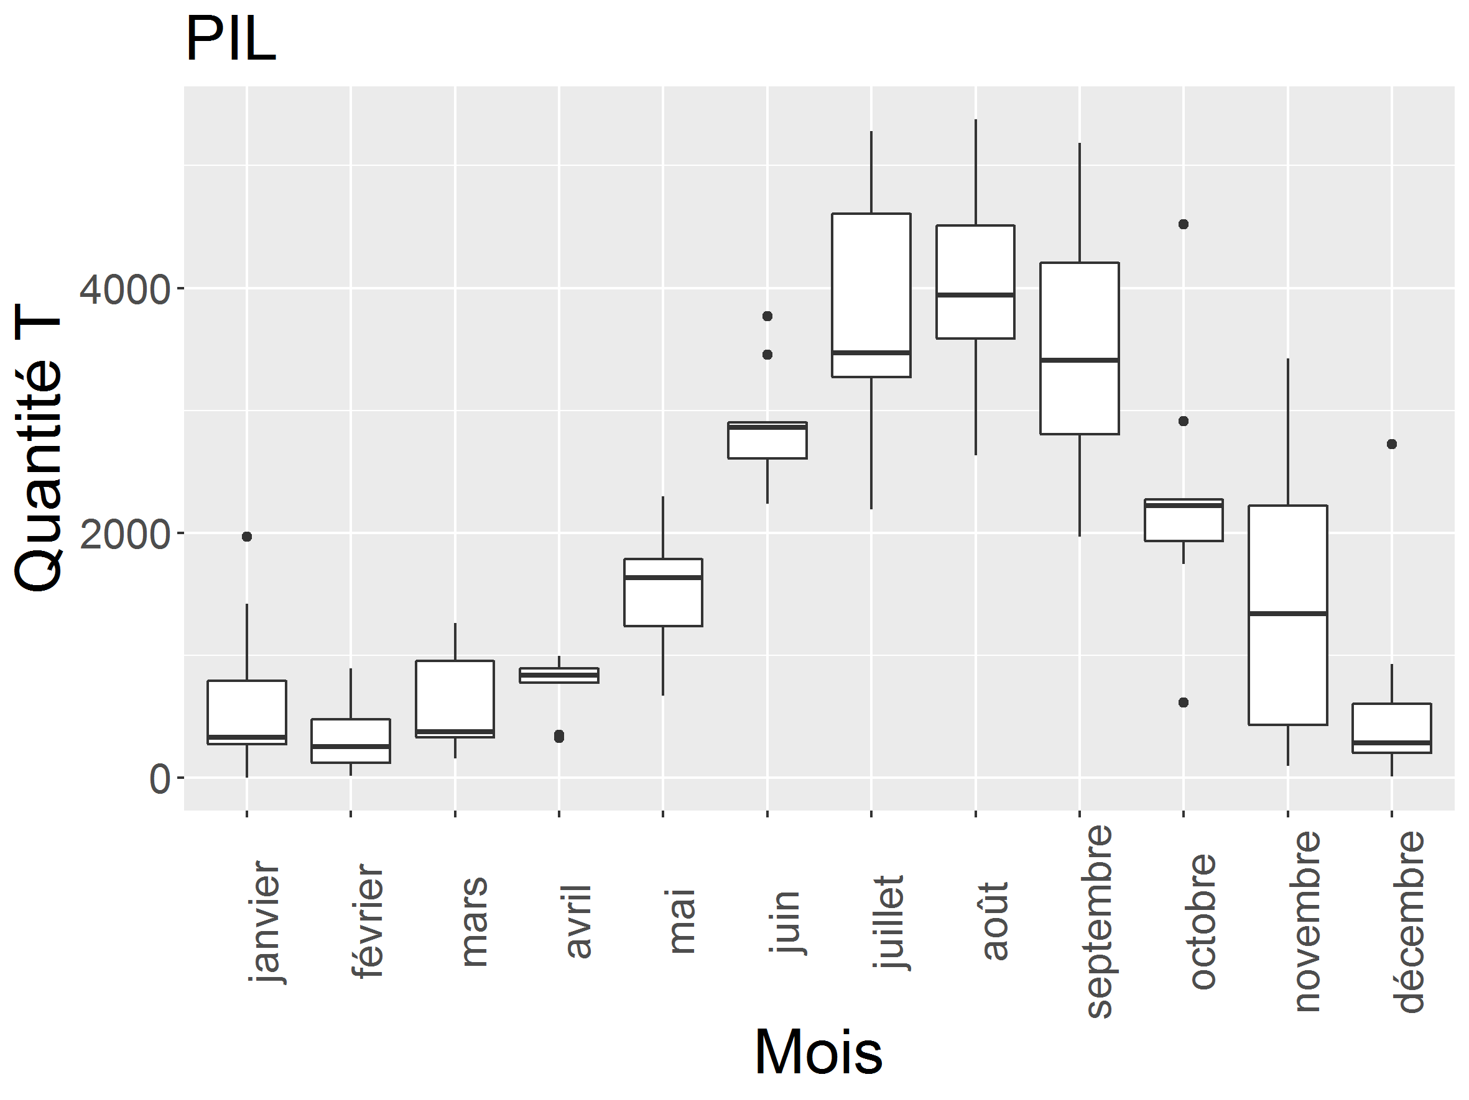

Figure 10 : Monthly landings of sardine by vessels of our study fleet.

## Interview guide

Table 1 shows the guide used for fishers’ interviews. It is structured with 3 phases. First phase focus on basic information about the fisherman and his activity. Second phase focus on the factors underlying fishers’ strategy at different time scale. Finally, third phase focus on the importance of PO in the fishery and the fishers’ thought about the future of the fishery.

|  |  |  |
| --- | --- | --- |
| Fishers’  Information | Fisherman | Age  Harbour  Main harbours of landing  Number of years in fishery  Role |
| Vessel | Number of crew members  Main gear used and gear to fish SPF |
| Armament | Number of vessels in the armament  Activity of other vessels in the armament |
| Factors and Strategy | Long term | Since when and how did you choose to target small pelagic fishes? |
| Annual | How do you plan your annual activity? What elements can modify your strategy from one year to the next? |
| Seasonal | If targeting SPF seasonally, how do you choose to start the season? |
| Fishing trip | How do you choose where and what to fish before a trip? |
| Context of the fishery | Producer Organization | Are you member of a PO? Why did you choose (or not) to become a member? |
| Fishery dynamic | How do you see the future of the fisheries? What are the main issues? |

Table 1 : Guide used for fishers’ interviews

## Extension of the classification for the 2000-2020 period.

The methodology to expand the analysis to new vessel-year is described here (<https://groups.google.com/g/factominer-users/c/eNeRDNsrntw?pli=1>). In order to identify the strategy practiced by vessels in years that were not included in the initial analysis, the PCA was reconducted using the initial data. The new vessel-year are added in the analysis as supplementary individuals, so they do not influence the results of the PCA but they are projected on the PCA axes. In addition, a supplementary variable is added, which gives the strategy identified for the initial vessel year (a dummy value is indicated for the new vessel-year to avoid NAs but does not influence the analysis). The coordinates of the new vessel-year and of the strategies are used to compute the distance of the new individuals to the initial strategies, and vessel-year are attributed to the closest strategy. The same process is repeated for the sub-fleet identification.

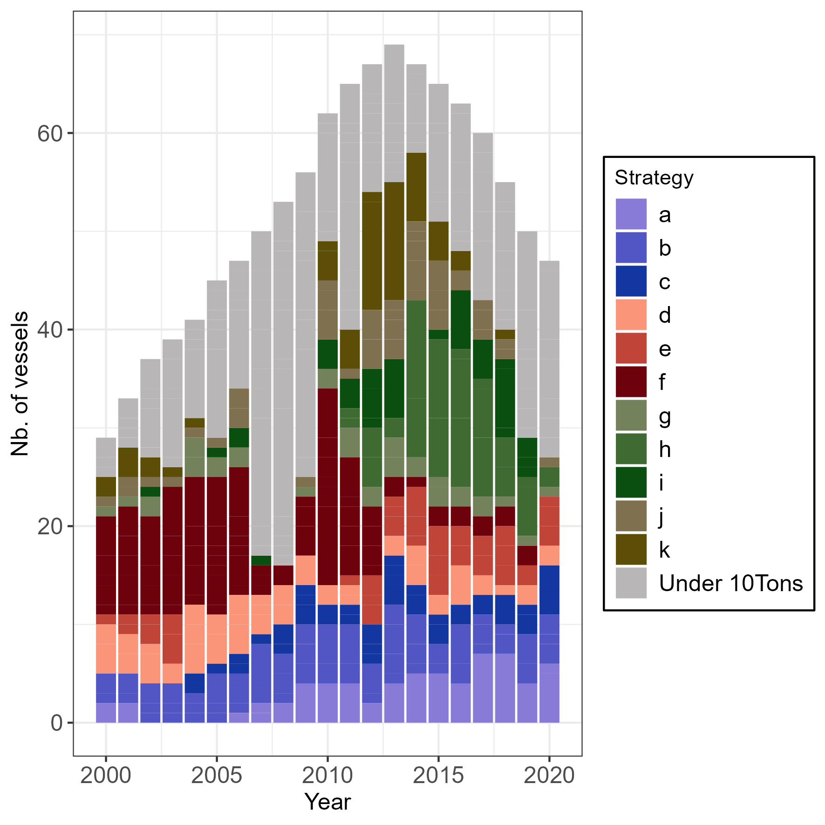

Figure 11: *E*volution of strategy usage in the trawler sub group for the extended period 2000-2020.

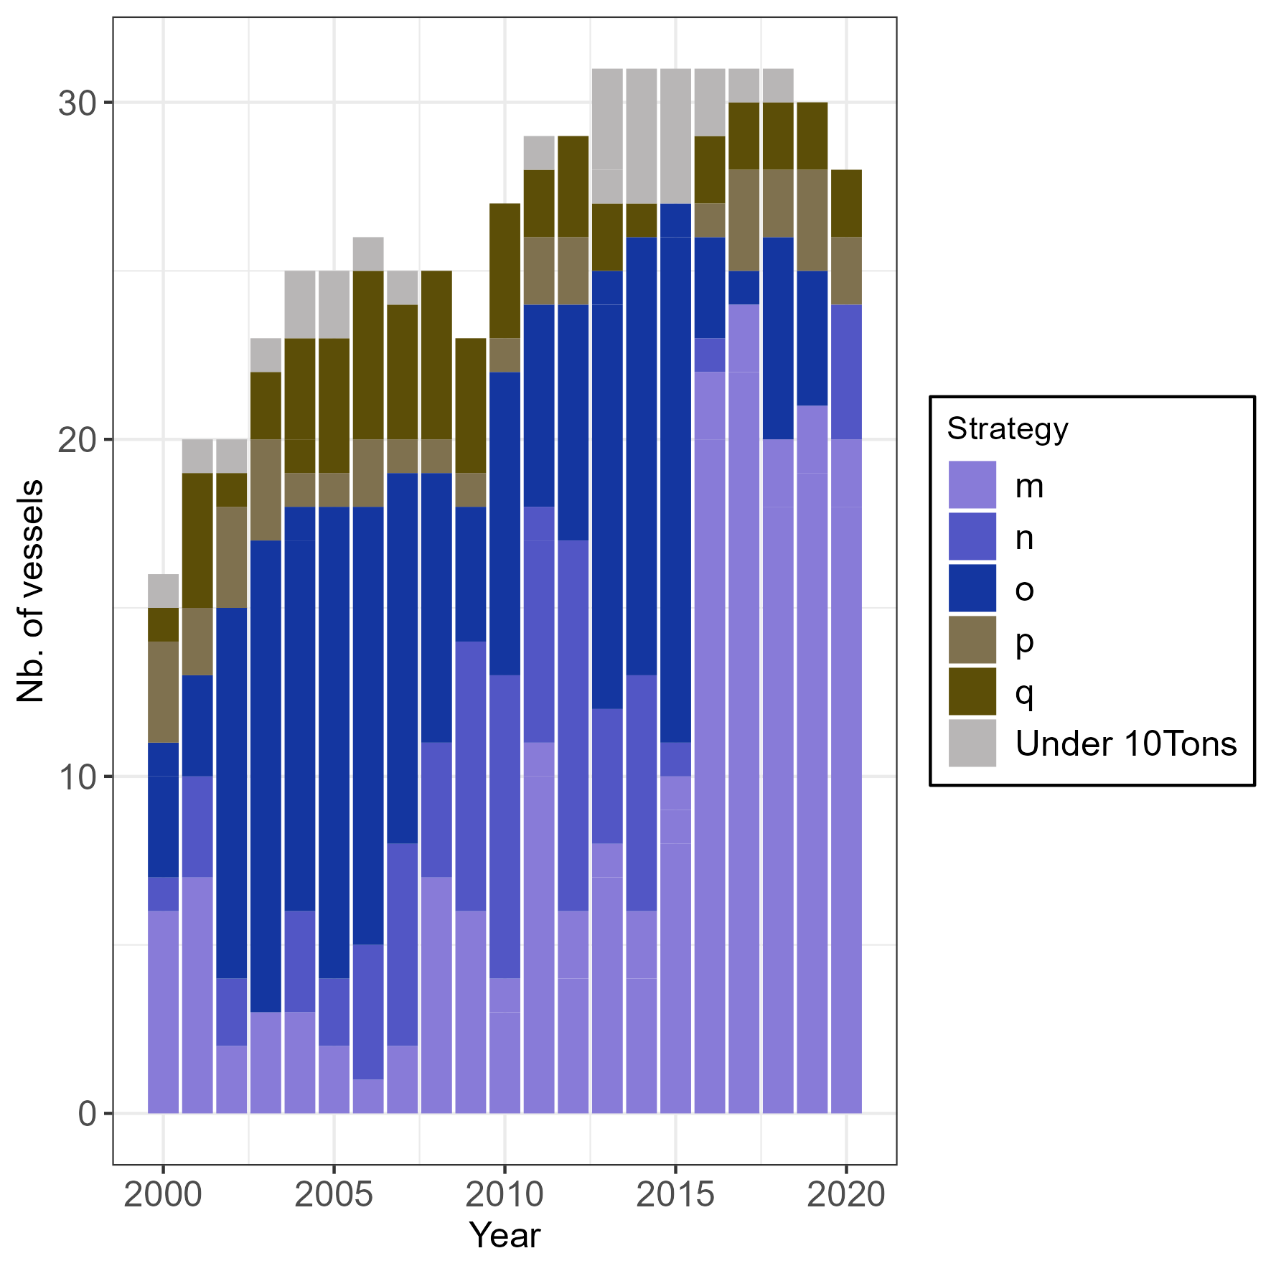

Figure 12: *E*volution of strategy usage in the purse seiners sub group for the extended period 2000-2020.