*Journal of Geophysical Research: Solid Earth*

Supporting Information for

**Phases of magmatism and tectonics along the Madagascar-Comoros volcanic chain, and synchronous changes in the kinematics of the Lwandle and Somalia plates**

Anaïs Rusquet 1,2, Vincent Famin 1,2, Laurent Michon 1,2, Xavier Quidelleur 3, François Nauret 4, Martin Danišík 5, Gilles Ruffet 6, Carole Berthod 1,7, Sidonie Revillon 8, Patrick Bachèlery 4, Isabelle Thinon 9, Anne Lemoine 9, Sylvie Leroy 10, Sébastien Zaragosi 11, Simon Thivet 12, Julien Bernard 10, Loraine Gourbet 13, Etienne Médard 4, Alix Toulier 14

1*Université Paris Cité, Institut de Physique du Globe de Paris, CNRS, UMR 7154, 75005 Paris, France,* 2*Université de La Réunion, Laboratoire GéoSciences Réunion, 97744 Saint Denis, France,* 3*Université Paris-Saclay, Laboratoire GEOPS, 91405 Orsay, France,* 4*Université Clermont-Auvergne, CNRS, IRD, OPGC, Laboratoire Magmas et Volcans, 63178 Aubière, France,* 5*John de Laeter Centre, Curtin University, Perth, WA 6102, Australia,* 6*Université de Rennes 1, CNRS-INSU, UMR 6118, Géosciences Rennes, 35042 Rennes, France,* 7*Observatoire volcanologique et sismologique de la Guadeloupe, 97113, Gourbeyre, France,* 8*SEDISOR/GEO-OCEAN, 65 place N. Copernic; UMR 6538 Univ. Brest-CNRS-IFREMER, Plouzané, France,* 9*BRGM, 3 avenue Claude Guillemin, BP36009, F-45060 Orléans Cédex 2, France,* 10*Sorbonne Université, CNRS-INSU, Institut des Sciences de la Terre de Paris, ISTeP, Paris, France,* 11*Université Bordeaux, CNRS, EPOC, EPHE, UMR 5805, 33600 Pessac, France,* 12*Department of Earth Sciences, University of Geneva, Geneva, Switzerland,* 13*Earth Surface Process Modelling, GFZ German research Center for Geosciences, 14473 Potsdam, Germany,* 14*Water Resources Research Center, University of Hawai‘i at Mānoa, Honolulu, HI, 96848, USA*

**Contents of this file**

Geochronology methods

Filtering procedure of radiometric age data

Figure S1

Captions for Tables S1 to S4

**Additional Supporting Information (Files uploaded separately)**

Tables S1 to S3

**Introduction**

This supporting information provides 1/ the methods used for radiometric dating; 2/ the detailed filtering procedures and cross-comparison of radiometric age data from Mayotte Island; 3/ thin section pictures (Figure S1), and 4/ Tables about the samples and the published radiometric ages. Table S1 contains the location of samples used for radiometric dating and geochemical analyses. Table S2 contains the major and trace element analyses of samples and geostandards. Table S3 presents the detailed 40Ar/39Ar dating results. Table S4 provides the dataset of published radiometric ages of the Comoros Archipelago and the Cenozoic volcanism of northern Madagascar.

1. **Radiometric dating methods**

**1.1. 40Ar/39Ar dating**

Among PAMELA-MOZ01 dredges, ten samples were deemed suitable for the 40Ar/39Ar method based on the absence of secondary mineralization phases (see thin sections in Figure S1). Millimeter-sized whole rock single grains were analyzed by step-heating using a CO2 laser probe coupled with a MAP 215 mass spectrometer following the procedures of Ruffet et al. (1991, 1995, 1997). Samples were irradiated in two batches, IR32 and IR34, in the 8C facility of the McMaster Nuclear Reactor (Hamilton, Ontario, Canada). IR32 (whole rock grains MOZ01-DR06-01, DR07-11, DR08-04, DR08-09, and DR09-02) lasted 49.58 h with a global efficiency (J/h) of 8.201 ✕10-5 h-1 when IR34 (whole rock grains MOZ01-DR06, DR06-03, DR07-03, DR08-03, and DR09-06) lasted 50 h with a global efficiency (J/h) of 8.618 ✕ 10-5 h-1. Sanidine TCRs (28.608 ± 0.033 Ma) was used as the irradiation standard (Renne et al. 2010, 2011). Blanks were analyzed each first or third/fourth run and were subtracted from the analyses of sample gas fractions. Apparent age errors, reported at the 1σ level, do not include the errors on the 40Ar*/39ArK ratio and age of the monitor, and the decay constant. Plateau ages are calculated if 70% or more of the 39ArK was released in at least three or more contiguous steps whose apparent ages agreed, within 2σ, with the integrated age of the plateau segment. A pseudo-plateau age is defined with the same criteria whenever a plateau-segment contains less than 70% of the 39ArK released (Cheilletz et al., 1999). The errors on the 40Ar*/39ArK ratio and age of the monitor and the decay constant are included in the final calculation of the error margins on the plateau ages. Uncertainties on 40Ar/39Ar ages are provided at the1σ level. Data, parameters (isotopic ratios measured on pure K and Cl salts; mass discrimination; atmospheric argon ratios; J parameter; decay constants), and references used for calculations are available in Table S3 of the Supporting Information.

**1.2. K-Ar dating**

The main advantage of the K-Ar technique applied to groundmass is to avoid sample irradiation and its recoil effect and interfering production of 36Ar, which limits the precision of dating on young (<1 Ma) basalts (K-poor and Ca-rich rocks). The drawback of this method is that it is the most sensitive to alteration among the three applied techniques. In consequence, we have used this technique to the groundmass carefully separated from the fresh inner parts of samples, to avoid contamination by atmospheric argon, K incorporation from seawater, or excess radiogenic 40Ar from the outermost few cm of rapidly cooled rocks (Cassignol and Gillot, 1982; Duncan and Hogan, 1994; Gillot et al., 2006). Ten samples were chosen for K-Ar dating based on visual inspection and thin section examination: 18MA30, 19MA05, 19MA07, and 19MA08 from Mayotte, SMR2, and SMR5 from the SISMAORE cruise, and SCR-DR04, SCR-DR07, SCR-DR11, and SCR-DR12 from the SCRATCH cruise. At the GEOPS laboratory (Université Paris-Saclay, France), thin sections were further examined to choose the most suitable fraction size for K-Ar dating based on the size and abundance of phenocrysts (Figure S1).

Samples were crushed, sieved, and cleaned in an ultrasonic bath with a 10% HNO3 solution. Selected fractions were separated using heavy liquids by adjusting the density of diiodomethane with acetone. Potassium and argon data were obtained based on the unspiked Cassignol-Gillot method (Cassignol and Gillot, 1982; Gillot et al., 2006). Each K and Ar measurement was duplicated. Flame-absorption spectrometry, calibrated with the reference standards BCR-2 (Raczek et al., 2001; K = 1.481 %) and MDO-G (Gillot et al., 1992; K = 3.51 %) was used to determine the K content of each sample. A 180° sector multi-collector mass spectrometer was used for argon isotopic measurements by comparing the amount of 36Ar and 40Ar isotopes from the samples and atmospheric aliquots, as detailed in Germa et al. (2010). The 40Ar mass spectrometer signal was calibrated using the biotite standard HD-B1 (Fuhrmann et al., 1987; Hess and Lippolt, 1994), considering an age of 24.18 Ma (Schwarz and Trieloff, 2007). Calculations were made using the 40K decay constants and K isotopic ratio of Steiger and Jäger (1977).

For five submarine samples (SMR2C, SMR5B, SCR-DR07-2, SCR-DR04-1A, and SCR-DR12), we tested the methodological development of Henri et al. (2022) to get rid of possible Ar contamination by seawater gas and compared it to the regular K-Ar dating procedure. Prior to Ar measurements, submarine samples were thus pre-degassed for 15-30 min at low temperature (<200°C) to remove any possible superficial contamination. This protocol was set after multiple trials to prevent radiogenic 40Ar loss in the process (Henri et al., 2022). Following this initial protocol and after complete melting of the sample, a three-step procedure was applied to remove all gasses released from the sample that may alter the mass-spectrometer measurement. Gas clean-up was first performed with about 15 g of Ti foam heated at high temperature (800°C) for one hour, then cooled to 20°C during 20 min. Each batch of Ti foam is replaced after 10 uses maximum. Then, using Al-Zr AP10GP SAES getters heated at 350°C, two successive clean-up steps, 2 min each, were performed to further purify gasses prior to analysis. Four submarine samples (SMR5B, SCR-DR07-2, SCR-DR04-1A, and SCR-DR12) were also analyzed for Ar without pre-degassing to determine the effect of this procedure on dating.

**1.3. (U-Th)/He dating**

Three samples (SCR-DR09, SCR-DR10, and SCR-DR01-1A) were selected for zircon or apatite (U-Th)/He dating based on their elevated alteration precluding the use of the 40Ar/39Ar or K-Ar techniques, and their enrichment in Zr and/or P. Zircon and apatite crystals were separated from crushed samples using standard magnetic and heavy liquids separation procedures. (U-Th)/He dating of zircon and apatite (ZHe and AHe, respectively) was carried out at the WATCH Facility (JdLC, Curtin University, Australia) following the single grain dating protocols of Danišík et al., 2012a, 2012b). In brief, single crystals > 50 μm in both length and width were photographed and measured for physical dimensions, packed into Nb (zircon) or Pt (apatite) microtubes, and then loaded into an Alphachron II instrument for He extraction. 4He and other gasses were extracted at ~1250°C (zircon) or ~960°C (apatite) under ultra-high vacuum with a diode laser, cleaned on Ti-Zr getters, and spiked with 99.9% pure 3He gas. The volume of extracted 4He was measured by isotope dilution with a QMG 220 M1 Pfeiffer Prisma Plus mass-spectrometer. Each analysis was followed by a "re-extract" to verify complete crystal outgassing. Helium gas signals were corrected for blank, determined by applying the same analytical procedure on empty Nb or Pt microtubes interspersed between the unknowns. After He analysis, crystal-filled Nd or Pt microtubes were spiked with 235U and 230Th, and dissolved with HF + HNO3 + HCl acids in Parr digestion vessels (zircon) or in HNO3 (apatite) following the protocols of Evans et al. (2005). Sample, blank, and spiked standard solutions were then diluted by Milli-Q water and analyzed by isotope dilution for 238U and 232Th, and by external calibration for 147Sm with an Agilent 7700 ICP-MS. The total analytical uncertainty (TAU) was calculated as a square root of the sum of squared uncertainty on He and weighted squared uncertainties on U, Th, and Sm measurements. ZHe and AHe ages were corrected for alpha ejection (Farley et al., 1996). The accuracy of the zircon and apatite (U-Th)/He dating procedures was monitored by replicate analyses of zircon (Fish Canyon Tuff) and apatite (Durango) internal standards, which over the course of this study yielded mean (U-Th)/He ages of 29.1 ± 1.5 Ma (1σ; MSWD = 0.39; n = 5) and 31.7 ± 1.3 Ma (1σ; MSWD = 0.34; n = 10) to 30.8 ± 2.3 Ma (1σ; MSWD = 0.37; n = 3), respectively. These are in excellent agreement with the reference (U-Th)/He ages of 28.3 ± 1.8 Ma (Reiners, 2005) and 31.8 ± 1.8 Ma (McDowell et al., 2005).

1. **Filtering and cross-comparison of radiometric data from Mayotte Island**

As a general observation, only three data from Pelleter et al. (2014) fulfill the quality criterion inherent in the 40Ar/39Ar technique, which is to obtain plateaus over at least 50% of the total 39Ar released, including at least three steps, and plateau and isochron ages consistent with each other (e.g. Schaen et al., 2020). Following Michon et al. (2022), we chose to discard the 40Ar/39Ar ages that do not meet this quality criterion for interpretation purposes. We also adopted the procedure of Michon et al. (2022) to (1) recalculate the ages of Hajash and Armstrong (1972) with the decay constants of Steiger and Jäger (1977), and (2) to reject data presenting high uncertainties with respect to their age with the following relative 1σ uncertainty cut-offs : >7.5%, >10%, >15%, >25%, and >50% for ages >5 Ma, between >2.5-5 Ma, between >1-2.5 Ma, between >0.25-1 Ma and <0.25 Ma, respectively. This quality filtering excludes 30 of the 58 published data.

Published and new ages for Mayotte (displayed in Figure 7b) are here compared to check their consistency. For the Mayotte south edifice, our age for the Mount Choungi at 3.466 ± 0.050 Ma (19MA07) is consistent with K-Ar whole-rock ages available in a ~2 km radius (MA-82 at 3.41 ± 0.32 Ma and MA-81 at 3.75 ± 0.12 Ma in Emerick and Duncan, 1982, 1983). Our age for the Mount Choungi is also consistent with the K-Ar age of the Boueni Peninsula further northwest on the same ridge at 3.3 ± 0.1 Ma (sample 112 in Nougier et al., 1986), and with the reliable 40Ar/39Ar age of the Chirongui area at 3.9 ± 0.4 Ma (M39a in Pelleter et al., 2014). Another reliable 40Ar/39Ar age is available on the southern massif at 5.9 ± 0.1 Ma (M140). On the other hand, published K-Ar ages in the Chirongui–M’tsamoudou area display a large dispersion, have large uncertainties (7.7 ± 1 Ma, 4.9 ± 0.5, and 2.7 ± 0.1 Ma, samples 92, 116, and 126, respectively, Nougier et al., 1986), and none is consistent with the reliable 40Ar/39Ar age of 3.9 ± 0.4 Ma (Pelleter et al., 2014).

In the Sada area and on the Bénara ridge (Mayotte south), our age at 3.513 ± 0.050 Ma (18MA30) is consistent with all the K-Ar whole-rock ages previously published on the same ridge (3.65 ± 0.1 Ma, 3.23 ± 0.09 Ma, and 3.3 ± 0.1 Ma, samples MY13-1, 03, 147, and 149, respectively; Hajash & Armstrong, 1972; Nougier et al., 1986). The age of MY13-1 from Hajash and Armstrong (1972) in this area is further corroborated by a reverse paleomagnetic polarity.

On the Mayotte north-west edifice, the three published K-Ar ages of the M’Tsangamouji area (7.7 ± 1 Ma, 2.5 ± 0.09 Ma, and 1.49 ± 0.1 Ma, samples 92, 93, and MA-38, respectively, Nougier et al., 1986; Emerick and Duncan, 1982, 1983), are dispersed and all in disagreement with the reliable 40Ar/39Ar age of 0.8 ± 0.2 Ma (M59 in Pelleter et al., 2014). Finally, on the Mayotte north-east edifice, one age of Hajash and Armstrong (1972) at 1.42 ± 0.15 Ma (sample MY3-1) is corroborated by a reverse paleomagnetic polarity.

**References**

Cassignol, C., & Gillot, P.-Y. (1982). Range and effectiveness of unspiked potassium-argon dating: Experimental groundwork and applications. *In* G.S. Odin (Eds), *Numerical Dating in Stratigraphy*, Wiley, pp. 159–179.

Cheilletz, A., Ruffet, G., Marignac, C., Kolli, O., Gasquet, D., Féraud, G., & Bouillin, J. P. (1999). 40Ar/39Ar dating of shear zones in the Variscan basement of Greater Kabylia (Algeria). Evidence of an Eo-Alpine event at 128 Ma (Hauterivian–Barremian boundary): Geodynamic consequences. *Tectonophysics*, 306(1), 97–116. <https://doi.org/10.1016/S0040-1951(99)00047-5>

Danišík, M., Kuhlemann, J., Dunkl, I., Evans, N. J., Székely, B., & Frisch, W. (2012a). Survival of Ancient Landforms in a Collisional Setting as Revealed by Combined Fission Track and (U-Th)/He Thermochronometry: A Case Study from Corsica (France). *The Journal of Geology*, 120(2), 155–173. <https://doi.org/10.1086/663873>

Danišík, M., Štěpančíková, P., & Evans, N. J. (2012b). Constraining long-term denudation and faulting history in intraplate regions by multisystem thermochronology: An example of the Sudetic Marginal Fault (Bohemian Massif, central Europe). *Tectonics*, 31(2), TC2003. <https://doi.org/10.1029/2011TC003012>

Duncan, R. A., & Hogan, L. G. (1994). Radiometric dating of young MORB using the 40 Ar- 39 Ar incremental heating method. *Geophysical Research Letters*, 21(18), 1927–1930. <https://doi.org/10.1029/94GL01375>

Emerick, C. M., & Duncan, R. A. (1982). Age progressive volcanism in the Comores Archipelago, western Indian Ocean and implications for Somali plate tectonics. *Earth and Planetary Science Letters*, 60(3), 415–428. <https://doi.org/10.1016/0012-821X(82)90077-2>

Emerick, C. M., & Duncan, R. A. (1983). Errata. *Earth and Planetary Science Letters*, 62(3), 439. <https://doi.org/10.1016/0012-821X(83)90014-6>

Evans, N. J., Byrne, J. P., Keegan, J. T., & Dotter, L. E. (2005). Determination of Uranium and Thorium in Zircon, Apatite, and Fluorite: Application to Laser (U-Th)/He Thermochronology. *Journal of Analytical Chemistry*, 60(12), 1159–1165. <https://doi.org/10.1007/s10809-005-0260-1>

Farley, K. A., Wolf, R. A., & Silver, L. T. (1996). The effects of long alpha-stopping distances on (U‐Th)/He ages. *Geochimica et Cosmochimica Acta*, 60(21), 4223–4229. <https://doi.org/10.1016/S0016-7037(96)00193-7>

Fuhrmann, U., Lippolt, H. J., & Hess, J. C. (1987). Examination of some proposed K-Ar standards: Analyses and conventional K-Ar data. *Chemical Geology: Isotope Geoscience Section*, 66(1–2), 41–51. <https://doi.org/10.1016/0168-9622(87)90027-3>

Germa, A., Quidelleur, X., Labanieh, S., Lahitte, P., & Chauvel, C. (2010). The eruptive history of Morne Jacob volcano (Martinique Island, French West Indies): Geochronology, geomorphology and geochemistry of the earliest volcanism in the recent Lesser Antilles arc. *Journal of Volcanology and Geothermal Research*, 198(3–4), 297–310. <https://doi.org/10.1016/j.jvolgeores.2010.09.013>

Gillot, P.-Y., Cornette, Y., Max, N., & Floris, B. (1992). Two reference materials, trachytes MDO-G and ISH-G, for argon dating (K-Ar and 40Ar/39Ar) of Pleistocene and Holocene rocks. *Geostandards and Geoanalytical Research*, 16(1), 55–60. <https://doi.org/10.1111/j.1751-908X.1992.tb00487.x>

Gillot, P.-Y., Hildenbrand, A., Lefèvre, J.-C., & Albore-Livadie, C. (2006). The K/Ar Dating Method: Principle, Analytical Techniques, and Application to Holocene Volcanic Eruptions in Southern Italy. *Acta Vulcanologica : Journal of the National Volcanic Group of Italy*, 1/2. <https://doi.org/10.1400/93820>

Hajash, A., & Armstrong, R. L. (1972). Paleomagnetic and radiometric evidence for the age of the Comores Islands, west central Indian Ocean. *Earth and Planetary Science Letters*, 16(2), 231–236. <https://doi.org/10.1016/0012-821X(72)90195-1>

Henri, M., Quidelleur, X., Le Friant, A., Komorowski, J.-C., Escartín, J., Deplus, C., & Mevel, C. (2022). K-Ar Geochronology and geochemistry of underwater lava samples from the Subsaintes cruise offshore Les Saintes (Guadeloupe): Insights for the Lesser Antilles arc magmatism. *Marine Geology*, 450, 106862. <https://doi.org/10.1016/j.margeo.2022.106862>

Hess, J. C., & Lippolt, H. J. (1994). Compilation of K/Ar measurements on HD-B1 standard biotite; 1994 status report. In *Phanerozoic time scale*. Bulletin de Liaison et d’information, IUGS Subcommission, Geochronology. 12, 19–23.

McDowell, F. W., McIntosh, W. C., & Farley, K. A. (2005). A precise 40Ar–39Ar reference age for the Durango apatite (U–Th)/He and fission-track dating standard. *Chemical Geology*, 214(3–4), 249–263. <https://doi.org/10.1016/j.chemgeo.2004.10.002>

Michon, L., Famin, V., & Quidelleur, X. (2022). Evolution of the East African Rift System from trap-scale to plate-scale rifting. *Earth-Science Reviews*, 231, 104089. <https://doi.org/10.1016/j.earscirev.2022.104089>

Nougier, J., Cantagrel, J. M., & Karche, J. P. (1986). The Comores archipelago in the western Indian Ocean: Volcanology, geochronology and geodynamic setting. *Journal of African Earth Sciences (1983)*, 5(2), 135–145. <https://doi.org/10.1016/0899-5362(86)90003-5>

Pelleter, A.-A., Caroff, M., Cordier, C., Bachèlery, P., Nehlig, P., Debeuf, D., & Arnaud, N. (2014). Melilite-bearing lavas in Mayotte (France): An insight into the mantle source below the Comores. *Lithos*, 208–209, 281–297. <https://doi.org/10.1016/j.lithos.2014.09.012>

Raczek, I., Stoll, B., Hofmann, A. W., & Peter Jochum, K. (2001). High-Precision Trace Element Data for the USGS Reference Materials BCR-1, BCR-2, BHVO-1, BHVO-2, AGV-1, AGV-2, DTS-1, DTS-2, GSP-1 and GSP-2 by ID-TIMS and MIC-SSMS. *Geostandards and Geoanalytical Research*, 25(1), 77–86. <https://doi.org/10.1111/j.1751-908X.2001.tb00789.x>

Reiners, P. W. (2005). Zircon (U-Th)/He Thermochronometry. *Reviews in Mineralogy and Geochemistry*, 58(1), 151–179. <https://doi.org/10.2138/rmg.2005.58.6>

Renne, P. R., Mundil, R., Balco, G., Min, K., & Ludwig, K. R. (2010). Joint determination of 40K decay constants and 40Ar∗/40K for the Fish Canyon sanidine standard, and improved accuracy for 40Ar/39Ar geochronology. *Geochimica et Cosmochimica Acta*, 74(18), 5349–5367. <https://doi.org/10.1016/j.gca.2010.06.017>

Renne, P. R., Balco, G., Ludwig, K. R., Mundil, R., & Min, K. (2011). Response to the comment by W.H. Schwarz et al. On “Joint determination of 40K decay constants and 40Ar∗/40K for the Fish Canyon sanidine standard, and improved accuracy for 40Ar/39Ar geochronology” by P.R. Renne et al. (2010). *Geochimica et Cosmochimica Acta*, 75(17), 5097–5100. <https://doi.org/10.1016/j.gca.2011.06.021>

Ruffet, G., Féraud, G., & Amouric, M. (1991). Comparison of 40Ar-39Ar conventional and laser dating of biotites from the North Trégor Batholith. *Geochimica et Cosmochimica Acta*, 55(6), 1675–1688. <https://doi.org/10.1016/0016-7037(91)90138-U>

Ruffet, G., Féraud, G., Balèvre, M., & Kiénast, J.-R. (1995). Plateau ages and excess argon in phengites: An 40Ar/39Ar laser probe study of Alpine micas (Sesia Zone, Western Alps, northern Italy). *Chemical Geology*, 121(1–4), 327–343. <https://doi.org/10.1016/0009-2541(94)00132-R>

Ruffet, G., Gruau, G., Ballèvre, M., Féraud, G., & Philippot, P. (1997). Rb/Sr and 40Ar/39Ar laser probe dating of high-pressure phengites from the Sesia zone (Western Alps): Underscoring of excess argon and new age constraints on the high-pressure metamorphism. *Chemical Geology*, 141(1–2), 1–18. <https://doi.org/10.1016/S0009-2541(97)00052-1>

Schaen, A.J., Jicha, B.R., Hodges, K.V., Vermeesch, P., Stelten, M.E., Mercer, C.M., Phillips, D., Rivera, T.A., Jourdan, F., Matchan, E.L., Hemming, S.R., Morgan, L.E., Kelley, S.P., Cassata, W.S., Heizler, M.T., Vasconcelos, P.M., Benowitz, J.A., Koppers, A.A.P., Mark, D.F., Niespolo, E.M., Sprain, C.J., Hames, W.E., Kuiper, K.F., Turrin, B.D., Renne, P.R., Ross, J., Nomade, S., Guillou, H., Webb, L.E., Cohen, B.A., Calvert, A.T., Joyce, N., Ganerød, M., Wijbrans, J., Ishizuka, O., He, H., Ramirez, A., Pfänder, J.A., Lopez-Martínez, M., Qiu, H., Singer, B.S. (2020). Interpreting and reporting 40Ar/39Ar geochronologic data. Geological Society of America Bulletin, 133, 461–487. <https://doi.org/10.1130/B35560.1>

Schwarz, W. H., & Trieloff, M. (2007). Intercalibration of 40Ar–39Ar age standards NL-25, HB3gr hornblende, GA1550, SB-3, HD-B1 biotite and BMus/2 muscovite. *Chemical Geology*, 242(1–2), 218–231. <https://doi.org/10.1016/j.chemgeo.2007.03.016>

Steiger, R. H., & Jäger, E. (1977). Subcommission on geochronology: Convention on the use of decay constants in geo- and cosmochronology. *Earth and Planetary Science Letters*, 36(3), 359–362. <https://doi.org/10.1016/0012-821X(77)90060-7>

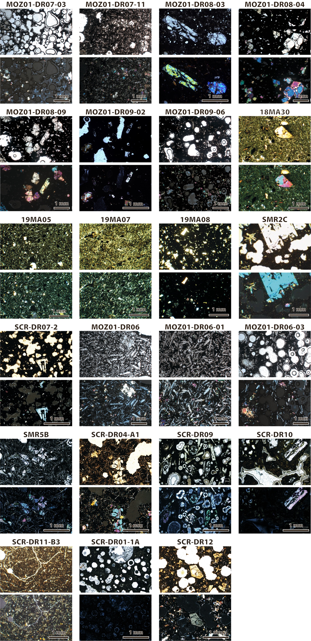

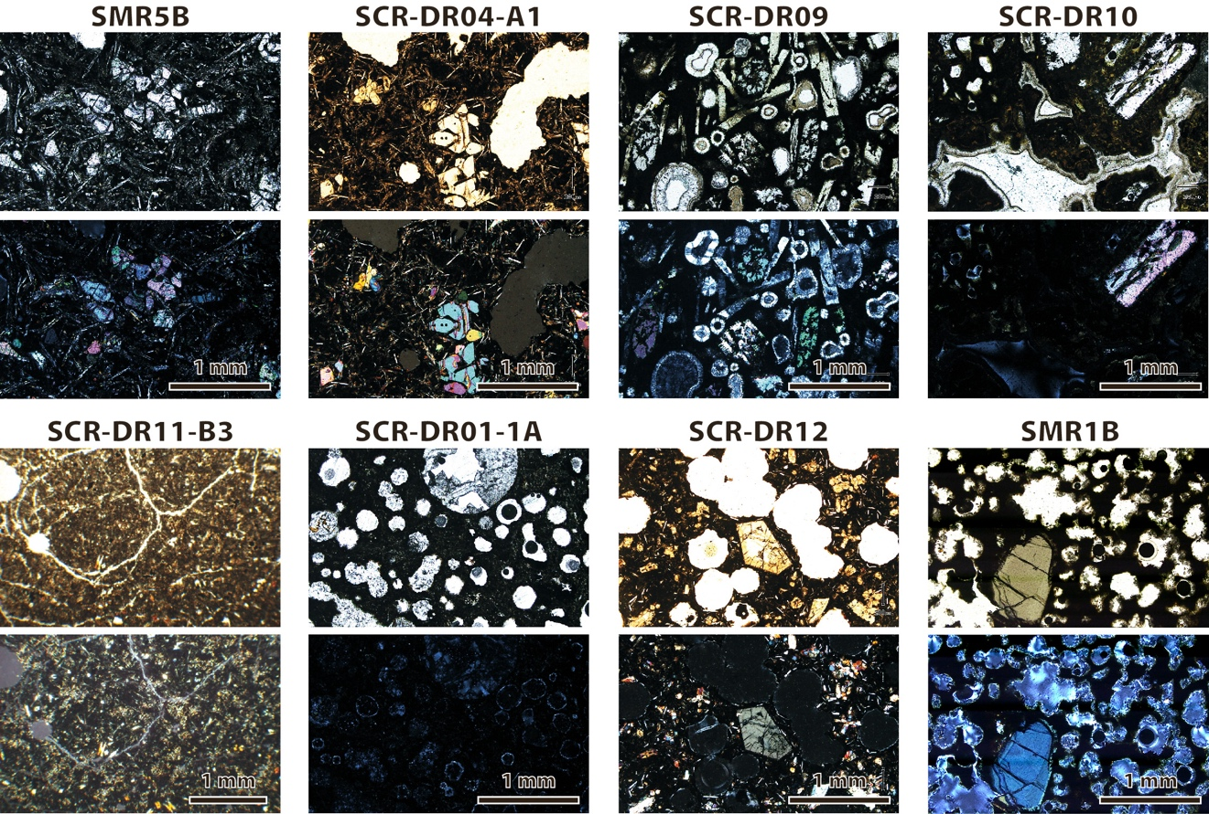

Figure S1. Optical microphotographs of submarine and subaerial samples used for radiometric dating and major-trace element chemistry. Upper picture: plane-polarized light; lower picture: cross-polarized light.

Table S1. Location of dredges and subaerial samples used for major-trace element analyses and radiometric dating.

Table S2. Major and trace element analyses of volcanic samples from the northern Mozambique Channel and geostandards.

Table S3. Parameters and details of 40Ar/39Ar dating results.

Table S4. Complete dataset of published and filtered radiometric ages of the Comoros Archipelago and the Cenozoic volcanism of northern Madagascar.