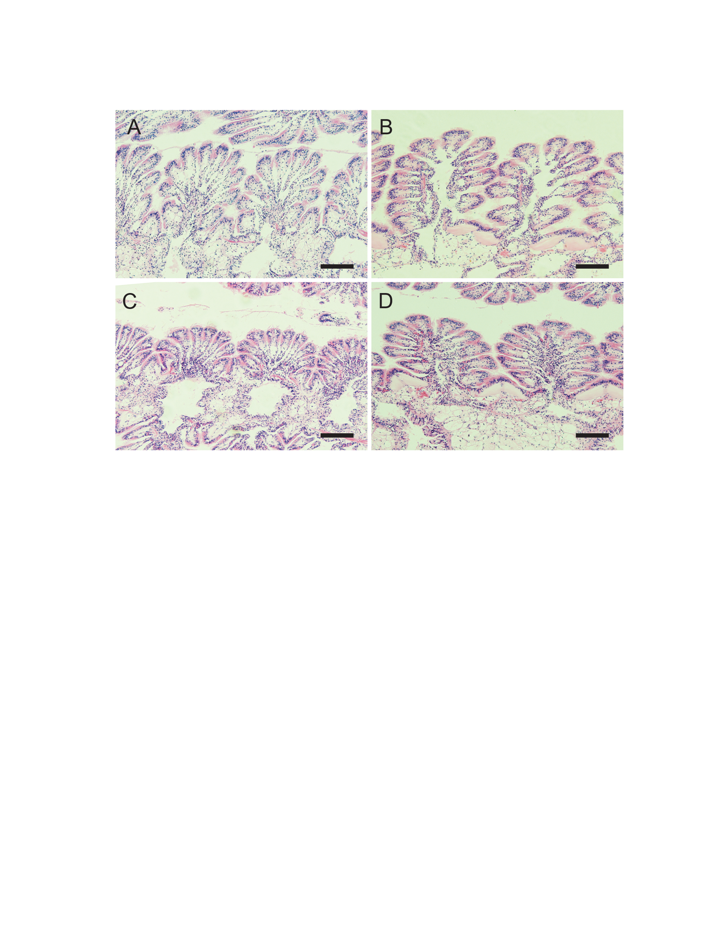Figure S1: Gill tissues of *C. virginica* exposed to 615 ± 47 cells/mL of *A. monilatum* (Tank 1) and subsequently depurated and fed with a mixture of non-toxic phytoplankton (*T. lutea*, *P. pingus*, *T. chui* and *C. muelleri*). All the individuals exhibited healthy gill histology. **A**) Control oyster at t = 0 hour, before exposure to *A. monilatum*. **B**) Oyster exposed 6 hours to *A. monilatum*. **C**) Oyster exposed 96 hours to *A. monilatum*. **D**) Oyster depurated for 96 hours, previously exposed to *A. monilatum*. Scale bar: 100 µm.

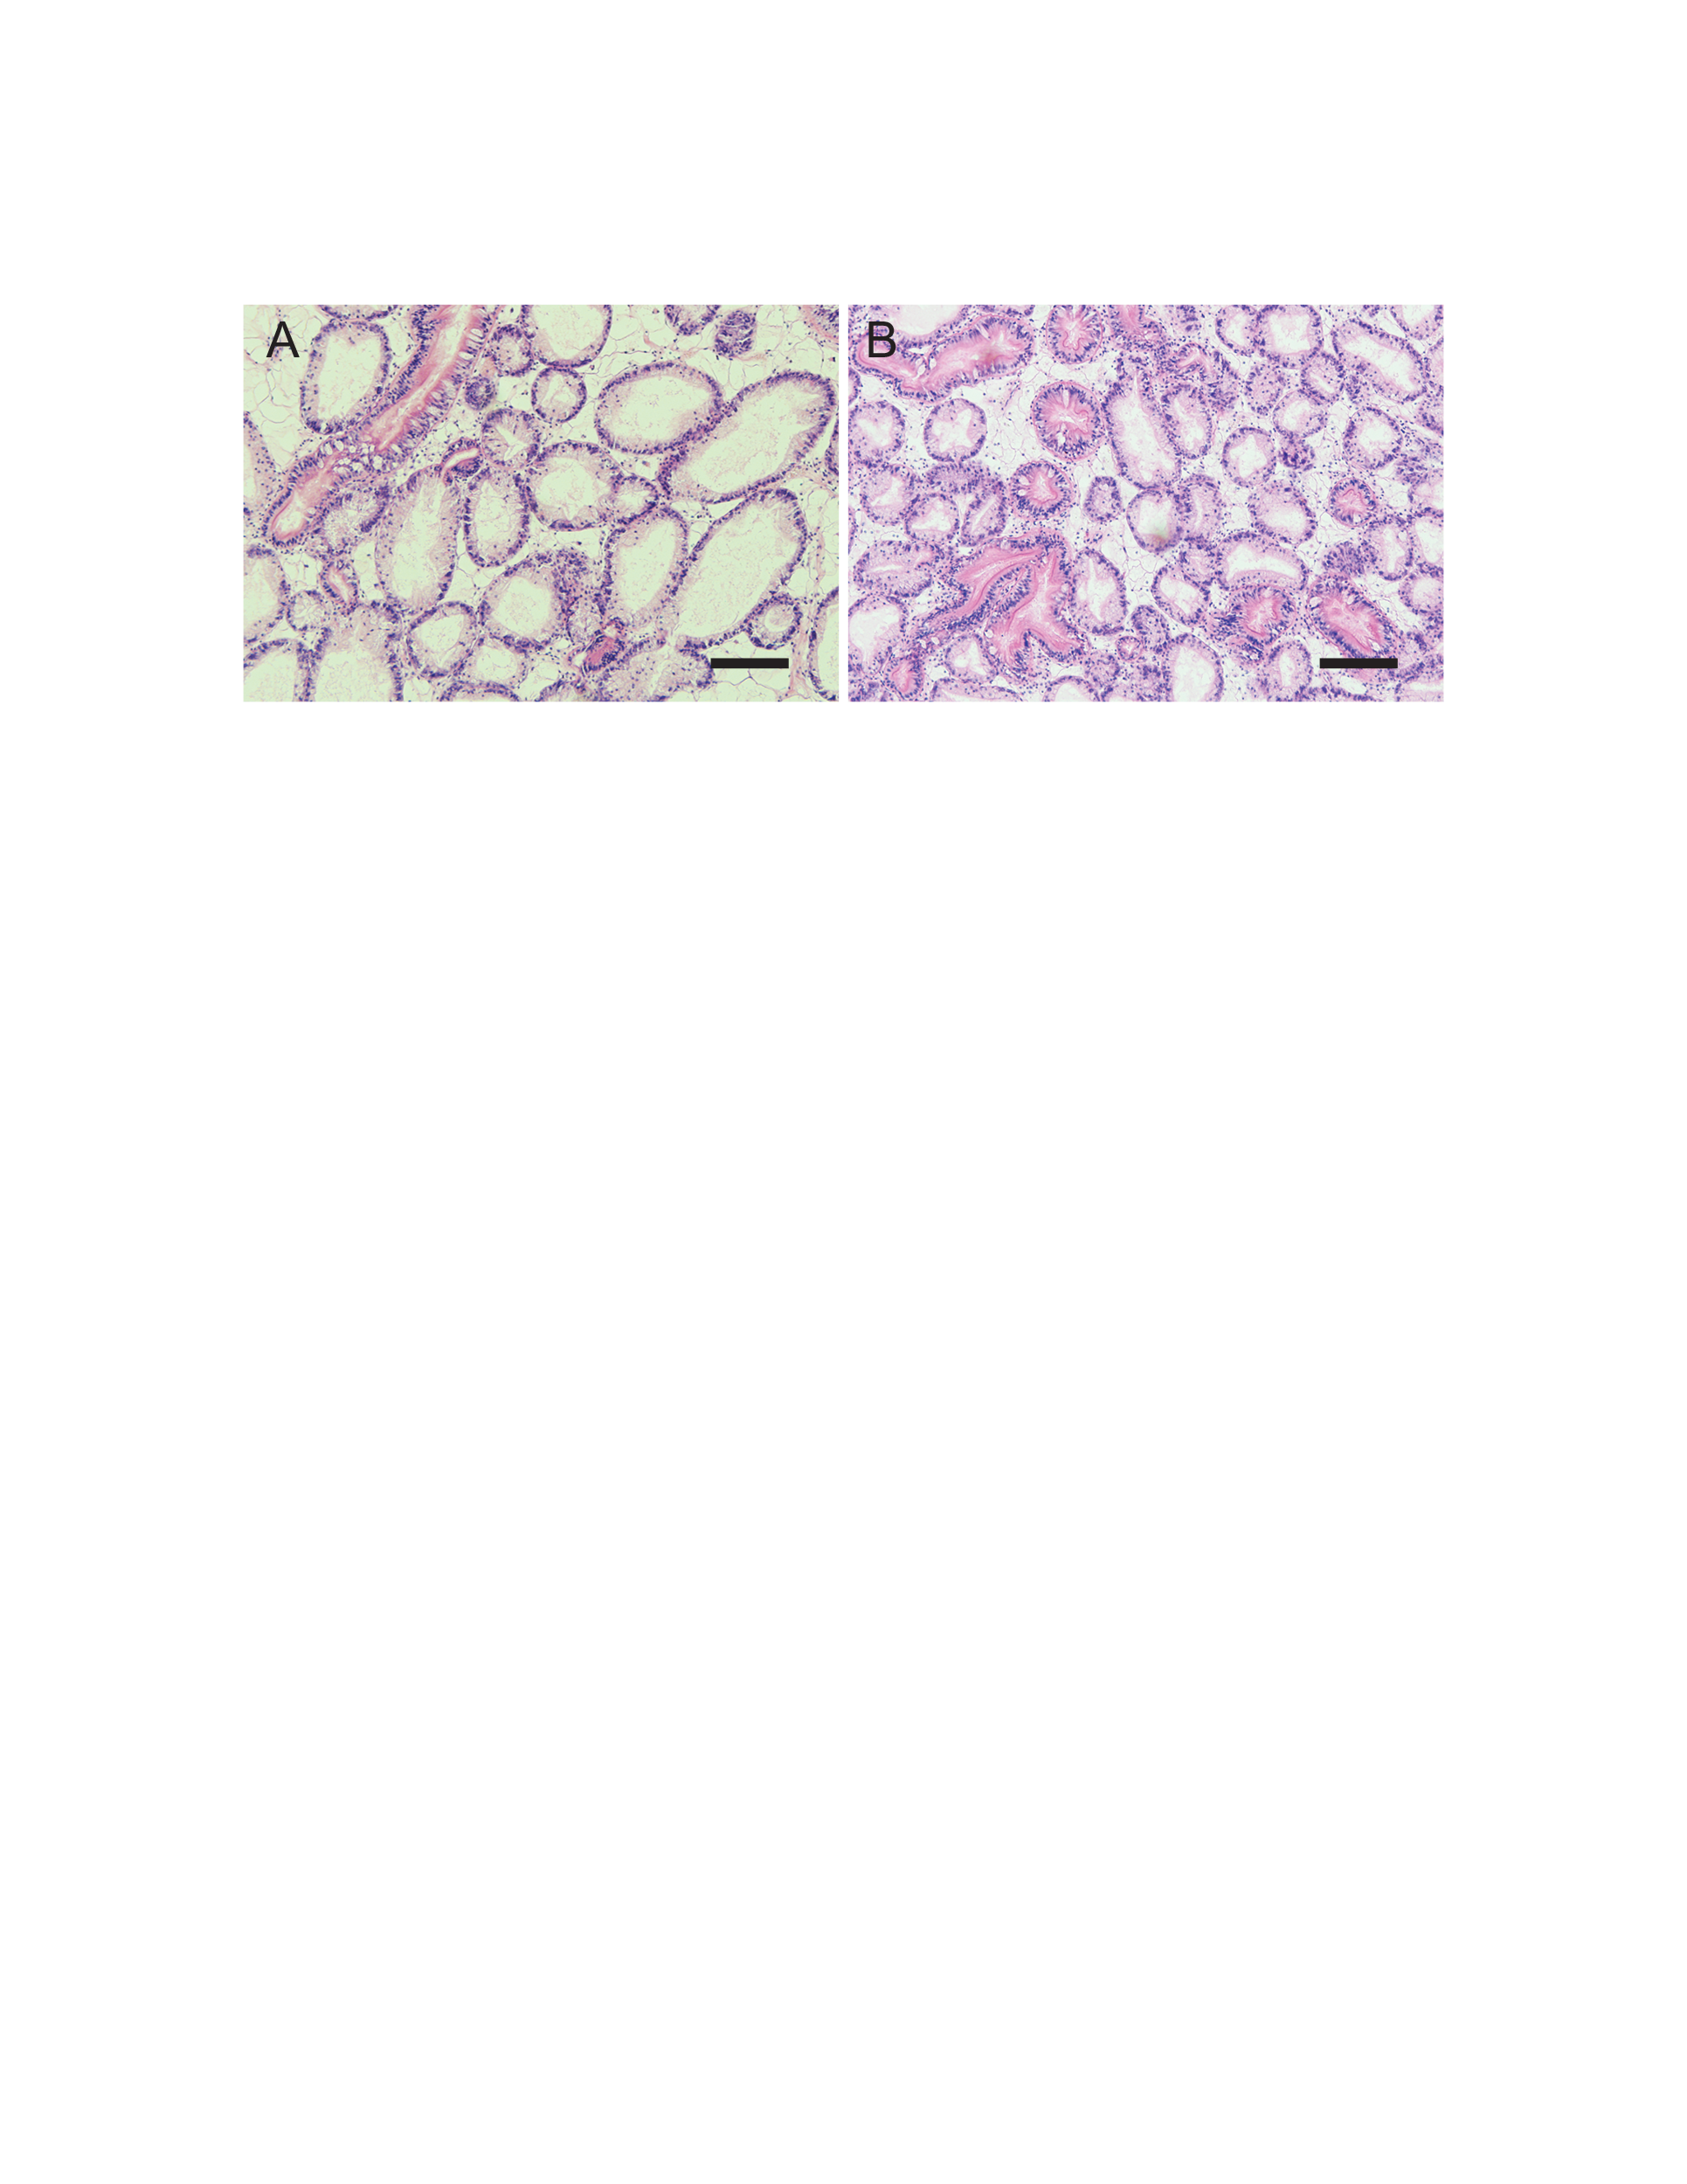Figure S2: Digestive gland tissues of *C. virginica* exposed for 96 hours to **A**) 615 ± 47 cells/mL of *A. monilatum* (Tank 1) or **B**) a mixture of non-toxic phytoplankton (13,925 ± 4,635 cells/mL of *T. lutea*, *P. pingus*, *T. chui* and *C. muelleri*). All the individuals exhibited healthy digestive gland histology. Scale bar: 100 µm.



Figure S3: Chromatograms of A. GDA standard (400 ng/mL), B. mixture of GDA, GDB and GDC (obtained from GDA standard after 24 hours in 50:50 mix MeOH/H20 + 20mM formic acid), C. *A. monilatum* intracellular toxin profile (Amon07 strain), D. *A. monilatum* extracellular toxin profile (Amon07 strain), E. digestive gland of *C. virginica* after 96 h of exposure to *A. monilatum* and F. digestive gland of *C. virginica* after 24 hours of depuration. Note that the different GDA-sa tautomers (Harris et al., 2023) were co-eluted in *A. monilatum* extracts (C-D) while at least two peaks were noted in the digestive gland extracts (E-F).