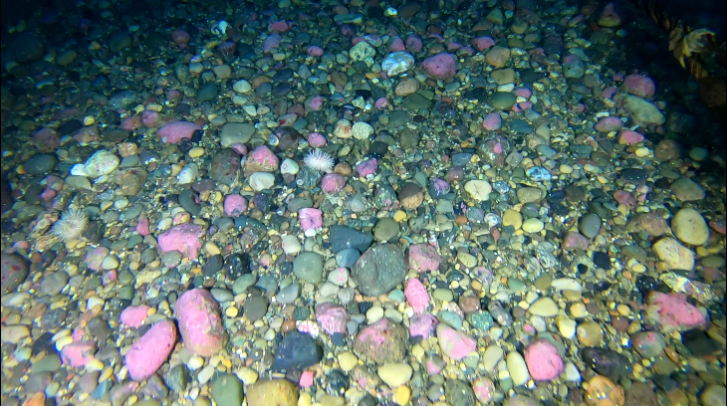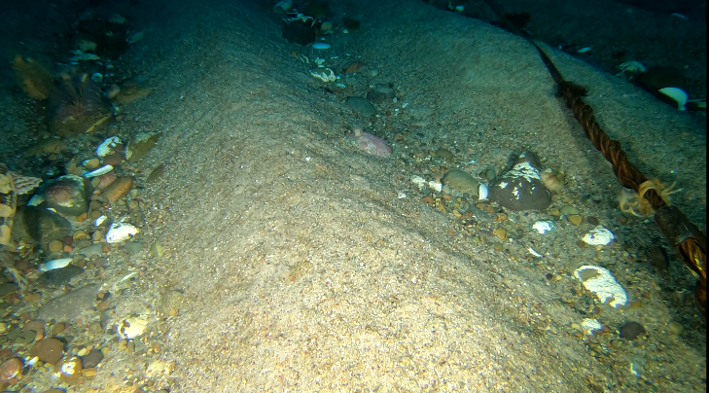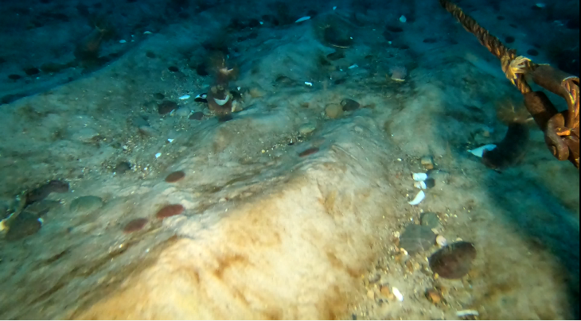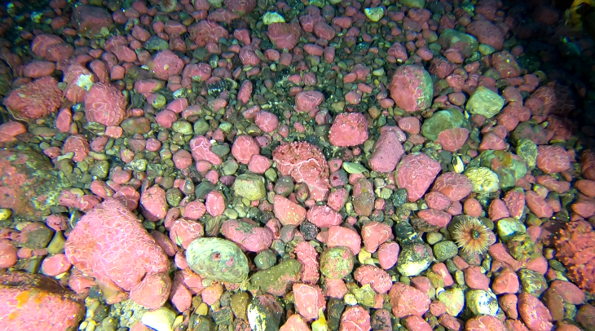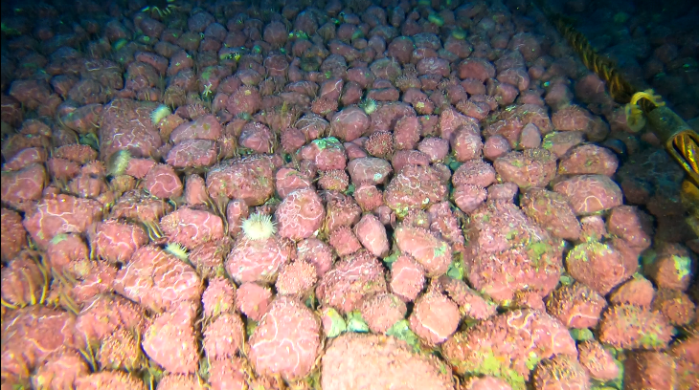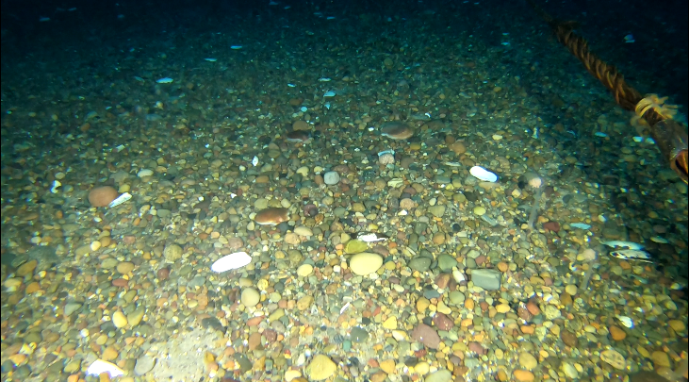**Fig S1:** Description of the sedimentary structures observed on the videos transects; (a) Sand / Gravel / Cobble Banks. (b) Coarse cobble. (c) Coarse Cobble / Gravel. (d) Boulder Fields. (e) Boulder Fields / Coarse Cobble. (f) Sandy mud.

**Supplementary material**

**a**

**b**

**c**

**d**

**e**

**f**

**Figure S2:** Detail of the correlations of all the variables added to the initial RDA model.

**Figure S3:** Number of videos transects where the taxa was observed. The total number of video transect analysed is 50.  
  
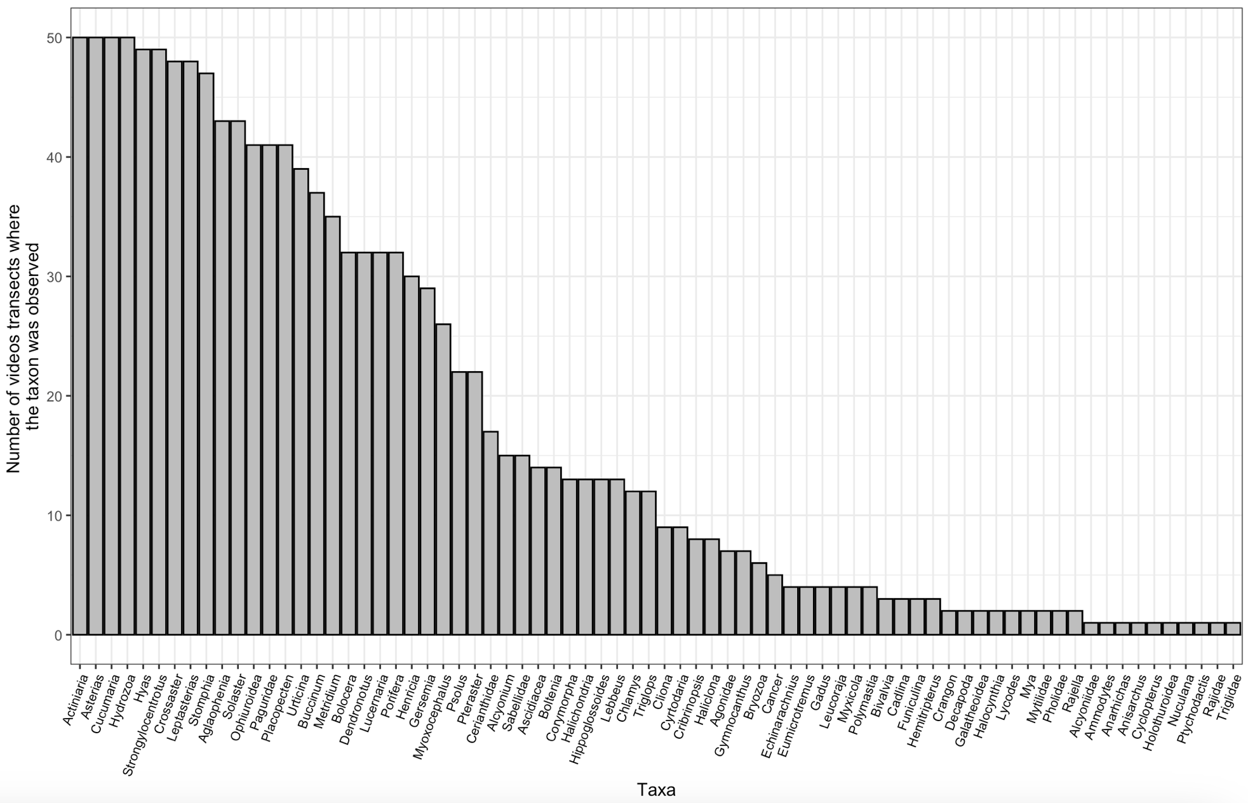

**Table S1:** Taxonomic classification of organisms and density (ind.m-2) across all video transects.

|  |  |  |  |  |  |
| --- | --- | --- | --- | --- | --- |
| **Phylum** | **Class** | **Order** | **Family** | **Genus** | **Density** |
| Cnidaria | Hydrozoa | Leptothecata | Aglaopheniidae | *Aglaophenia* | 0.946 |
| Cnidaria | Octocorallia | Malacalcyonacea | Alcyoniidae | *Alcyonium* | 0.556 |
| Chordata | Teleostei | Perciformes | Ammodytidae | *Ammodytes* | 0.004 |
| Chordata | Teleostei | Perciformes | Anarhichadidae | *Anarhichas* | 0.002 |
| Chordata | Teleostei | Perciformes | Stichaeidae | *Anisarchus* | 0.002 |
| Echinodermata | Asteroidea | Forcipulatida | Asteriidae | *Asterias* | 9.44 |
| Cnidaria | Hexacorallia | Actiniaria | Actiniidae | *Bolocera* | 1.382 |
| Chordata | Ascidiacea | Stolidobranchia | Pyuridae | *Boltenia* | 0.14 |
| Mollusca | Gastropoda | Neogastropoda | Buccinidae | *Buccinum* | 0.204 |
| Mollusca | Gastropoda | Nudibranchia | Cadlinidae | *Cadlina* | 0.006 |
| Arthropoda | Malacostraca | Decapoda | Cancridae | *Cancer* | 0.014 |
| Mollusca | Bivalvia | Pectinida | Pectinidae | *Chlamys* | 0.07 |
| Porifera | Demospongiae | Clionaida | Clionaidae | *Cliona* | 0.212 |
| Cnidaria | Hydrozoa | Anthoathecata | Corymorphidae | *Corymorpha* | 0.19 |
| Arthropoda | Malacostraca | Decapoda | Crangonidae | *Crangon* | 0.026 |
| Cnidaria | Hexacorallia | Actiniaria | Actiniidae | *Cribrinopsis* | 0.062 |
| Echinodermata | Asteroidea | Valvatida | Solasteridae | *Crossaster* | 1.51 |
| Echinodermata | Holothuroidea | Dendrochirotida | Cucumariidae | *Cucumaria* | 125.006 |
| Chordata | Teleostei | Perciformes | Cyclopteridae | *Cyclopterus* | 0.002 |
| Mollusca | Bivalvia | Adapedonta | Hiatellidae | *Cyrtodaria* | 0.054 |
| Mollusca | Gastropoda | Nudibranchia | Dendronotidae | *Dendronotus* | 0.15 |
| Echinodermata | Echinoidea | Echinolampadacea | Echinarachniidae | *Echinarachnius* | 29.482 |
| Chordata | Teleostei | Perciformes | Cyclopteridae | *Eumicrotremus* | 0.008 |
| Cnidaria | Octocorallia | Scleralcyonacea | Funiculinidae | *Funiculina* | 0.064 |
| Chordata | Teleostei | Gadiformes | Gadidae | *Gadus* | 0.008 |
| Cnidaria | Octocorallia | Malacalcyonacea | Alcyoniidae | *Gersemia* | 1.604 |
| Chordata | Teleostei | Perciformes | Cottidae | *Gymnocanthus* | 0.022 |
| Porifera | Demospongiae | Suberitida | Halichondriidae | *Halichondria* | 0.446 |
| Porifera | Demospongiae | Haplosclerida | Chalinidae | *Haliclona* | 0.066 |
| Chordata | Ascidiacea | Stolidobranchia | Pyuridae | *Halocynthia* | 0.004 |
| Chordata | Teleostei | Perciformes | Hemitripteridae | *Hemitripterus* | 0.008 |
| Echinodermata | Asteroidea | Spinulosida | Echinasteridae | *Henricia* | 0.342 |
| Chordata | Teleostei | Pleuronectiformes | Pleuronectidae | *Hippoglossoides* | 0.032 |
| Arthropoda | Malacostraca | Decapoda | Oregoniidae | *Hyas* | 8.328 |
| Arthropoda | Malacostraca | Decapoda | Thoridae | *Lebbeus* | 0.036 |
| Echinodermata | Asteroidea | Forcipulatida | Asteriidae | *Leptasterias* | 3.336 |
| Chordata | Elasmobranchii | Rajiformes | Rajidae | *Leucoraja* | 0.008 |
| Cnidaria | Staurozoa | Stauromedusae | Lucernariidae | *Lucernaria* | 0.364 |
| Chordata | Teleostei | Perciformes | Zoarcidae | *Lycodes* | 0.004 |
| Cnidaria | Hexacorallia | Actiniaria | Metridiidae | *Metridium* | 0.744 |
| Mollusca | Bivalvia | Myida | Myidae | *Mya* | 0.004 |
| Chordata | Teleostei | Perciformes | Cottidae | *Myoxocephalus* | 0.102 |
| Annelida | Polychaeta | Sabellida | Sabellidae | *Myxicola* | 0.012 |
| Annelida | Polychaeta | Sabellida | Sabellidae | - | 0.342 |
| Arthropoda | Malacostraca | Decapoda | Galatheoidea | - | 0.004 |
| Arthropoda | Malacostraca | Decapoda | - | - | 0.012 |
| Bryozoa | - | - | - | - | 0.124 |
| Chordata | Ascidiacea | - | - | - | 3.396 |
| Chordata | Elasmobranchii | Rajiformes | Rajidae | - | 0.002 |
| Chordata | Teleostei | Perciformes | Agonidae | - | 0.014 |
| Chordata | Teleostei | Perciformes | Pholidae | - | 0.004 |
| Cnidaria | Hexacorallia | Actiniaria | - | - | 15.34 |
| Cnidaria | Hexacorallia | Ceriantharia | Cerianthidae | - | 0.282 |
| Cnidaria | Hydrozoa | - | - | - | 23.138 |
| Cnidaria | Octocorallia | Malacalcyonacea | Alcyoniidae | - | 0.002 |
| Echinodermata | Holothuroidea | - | - | - | 0.112 |
| Echinodermata | Ophiuroidea | - | - | - | 213.62 |
| Mollusca | Bivalvia | Mytilida | Mytilidae | - | 0.022 |
| Mollusca | Bivalvia | - | - | - | 0.008 |
| Porifera | - | - | - | - | 1.816 |
| Mollusca | Bivalvia | Nuculanida | Nuculanidae | *Nuculana* | 0.002 |
| Arthropoda | Malacostraca | Decapoda | Paguridae | *-* | 0.56 |
| Mollusca | Bivalvia | Pectinida | Pectinidae | *Placopecten* | 8.188 |
| Porifera | Demospongiae | Polymastiida | Polymastiidae | *Polymastia* | 0.022 |
| Echinodermata | Holothuroidea | Dendrochirotida | Psolidae | *Psolus* | 0.446 |
| Echinodermata | Asteroidea | Velatida | Pterasteridae | *Pteraster* | 0.136 |
| Cnidaria | Hexacorallia | Actiniaria | Ptychodactinidae | *Ptychodactis* | 0.002 |
| Chordata | Elasmobranchii | Rajiformes | Rajidae | *Rajella* | 0.004 |
| Echinodermata | Asteroidea | Valvatida | Solasteridae | *Solaster* | 6.622 |
| Cnidaria | Hexacorallia | Actiniaria | Actinostolidae | *Stomphia* | 10.552 |
| Echinodermata | Echinoidea | Camarodonta | Strongylocentrotidae | *Strongylocentrotus* | 129.342 |
| Chordata | Teleostei | Perciformes | Triglidae | *-* | 0.002 |
| Chordata | Teleostei | Perciformes | Cottidae | *Triglops* | 0.032 |
| Cnidaria | Hexacorallia | Actiniaria | Actiniidae | *Urticina* | 0.47 |

**Table S2**: Relative density (%) of each taxa per cluster.

|  |  |  |  |
| --- | --- | --- | --- |
| Genus | Cluster 1 | Cluster 2 | Cluster 3 |
| Actiniaria | 2.892 | 1.960 | 2.532 |
| *Aglaophenia* | 0.078 | 0.275 | 0.169 |
| Agonidae | 0.001 | 0.005 | 0.002 |
| Alcyoniidae | 0.001 | 0.000 | 0.000 |
| *Alcyonium* | 0.006 | 0.427 | 0.064 |
| *Ammodytes* | 0.000 | 0.005 | 0.000 |
| *Anarhichas* | 0.000 | 0.000 | 0.001 |
| *Anisarchus* | 0.000 | 0.000 | 0.001 |
| Ascidiacea | 0.000 | 0.757 | 0.777 |
| *Asterias* | 2.955 | 2.178 | 0.845 |
| Bivalvia | 0.002 | 0.003 | 0.001 |
| *Bolocera* | 0.026 | 0.095 | 0.348 |
| *Boltenia* | 0.000 | 0.106 | 0.017 |
| Bryozoa | 0.000 | 0.071 | 0.020 |
| *Buccinum* | 0.042 | 0.090 | 0.019 |
| *Cadlina* | 0.000 | 0.000 | 0.002 |
| *Cancer* | 0.001 | 0.005 | 0.002 |
| Cerianthidae | 0.057 | 0.221 | 0.008 |
| *Chlamys* | 0.030 | 0.005 | 0.005 |
| *Cliona* | 0.000 | 0.079 | 0.042 |
| *Corymorpha* | 0.106 | 0.027 | 0.000 |
| *Crangon* | 0.000 | 0.000 | 0.007 |
| *Cribrinopsis* | 0.026 | 0.000 | 0.005 |
| *Crossaster* | 0.243 | 0.297 | 0.247 |
| *Cucumaria* | 69.700 | 3.439 | 2.845 |
| *Cyclopterus* | 0.000 | 0.000 | 0.001 |
| *Cyrtodaria* | 0.012 | 0.003 | 0.009 |
| Decapoda | 0.000 | 0.014 | 0.001 |
| *Dendronotus* | 0.006 | 0.041 | 0.030 |
| *Echinarachnius* | 0.000 | 39.984 | 0.030 |
| *Eumicrotremus* | 0.001 | 0.005 | 0.001 |
| *Funiculina* | 0.000 | 0.082 | 0.001 |
| *Gadus* | 0.002 | 0.003 | 0.001 |
| Galatheoidea | 0.000 | 0.000 | 0.001 |
| *Gersemia* | 0.019 | 0.667 | 0.297 |
| *Gymnocanthus* | 0.011 | 0.000 | 0.001 |
| *Halichondria* | 0.001 | 0.016 | 0.118 |
| *Haliclona* | 0.000 | 0.063 | 0.005 |
| *Halocynthia* | 0.000 | 0.003 | 0.001 |
| *Hemitripterus* | 0.000 | 0.005 | 0.001 |
| *Henricia* | 0.007 | 0.128 | 0.065 |
| *Hippoglossoides* | 0.007 | 0.014 | 0.003 |
| Holothuroidea | 0.000 | 0.152 | 0.000 |
| *Hyas* | 1.060 | 1.410 | 1.529 |
| Hydrozoa | 0.460 | 19.891 | 2.131 |
| *Lebbeus* | 0.007 | 0.011 | 0.004 |
| *Leptasterias* | 1.000 | 0.147 | 0.443 |
| *Leucoraja* | 0.001 | 0.005 | 0.001 |
| *Lucernaria* | 0.071 | 0.008 | 0.067 |
| *Lycodes* | 0.001 | 0.000 | 0.001 |
| *Metridium* | 0.009 | 0.112 | 0.177 |
| *Mya* | 0.000 | 0.000 | 0.001 |
| *Myoxocephalus* | 0.025 | 0.054 | 0.006 |
| Mytilidae | 0.000 | 0.000 | 0.006 |
| *Myxicola* | 0.001 | 0.000 | 0.003 |
| *Nuculana* | 0.000 | 0.000 | 0.001 |
| Ophiuroidea | 8.271 | 1.824 | 54.463 |
| Paguridae | 0.062 | 0.504 | 0.025 |
| Pholidae | 0.001 | 0.000 | 0.001 |
| *Placopecten* | 0.774 | 7.683 | 0.356 |
| *Polymastia* | 0.001 | 0.019 | 0.002 |
| Porifera | 0.024 | 0.158 | 0.455 |
| *Psolus* | 0.030 | 0.000 | 0.109 |
| *Pteraster* | 0.020 | 0.016 | 0.025 |
| *Ptychodactis* | 0.000 | 0.000 | 0.001 |
| *Rajella* | 0.001 | 0.003 | 0.000 |
| Rajidae | 0.000 | 0.000 | 0.001 |
| Sabellidae | 0.076 | 0.283 | 0.003 |
| *Solaster* | 3.414 | 1.209 | 0.067 |
| *Stomphia* | 2.638 | 0.975 | 1.531 |
| *Strongylocentrotus* | 5.710 | 14.299 | 30.014 |
| Triglidae | 0.000 | 0.000 | 0.001 |
| *Triglops* | 0.010 | 0.014 | 0.002 |
| *Urticina* | 0.098 | 0.150 | 0.055 |