**Appendix A. Supplementary Data**

**Multifactored accelerated marine corrosion of immersed steels influenced by washed ashore *Sargassum* rafts**

Diana Bénufféa, Fatima Radouania,1, Maxence Quemenerb, Olivia Oziera, Marilyne Fauchonb, Yannick Toueixb, Fabienne Faӱc, Anthony Magueressed, Benoit Lescope, Stéphane Riouale, Pascal Zongoa, Christophe Roosa, Claire Helliob, Paule Salvina,*

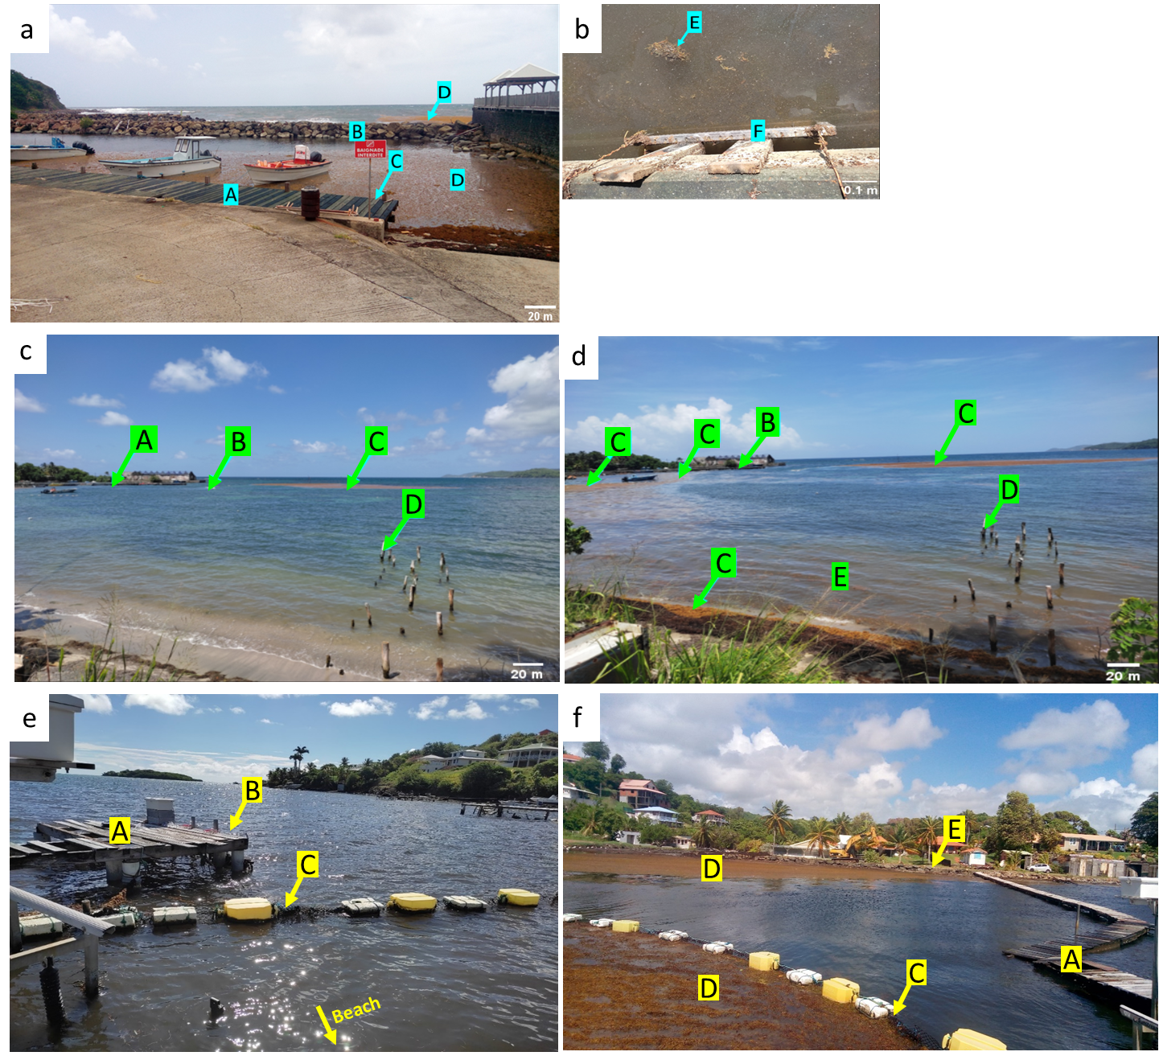

Figure S1: Photographies of exposure sites: a and b - Port of Marigot: pontoon (A), dike (B), exposure zones for samples (C), *Sargassum* strandings (D), decomposed *Sargassum* patch and leachates (E) and stainless steel frame with samples (F). c and d - Cosmy: fishing port (A), floating dam (B), *Sargassum* strandings (C), exposure zones for samples (D) and brown seawater due to *Sargassum* leachates (E). e and f - Frégate Est 2: pontoon (A), exposure zones for samples (B), floating dam (C), *Sargassum* strandings (D), position of H2S sensor (E) and beach (F).

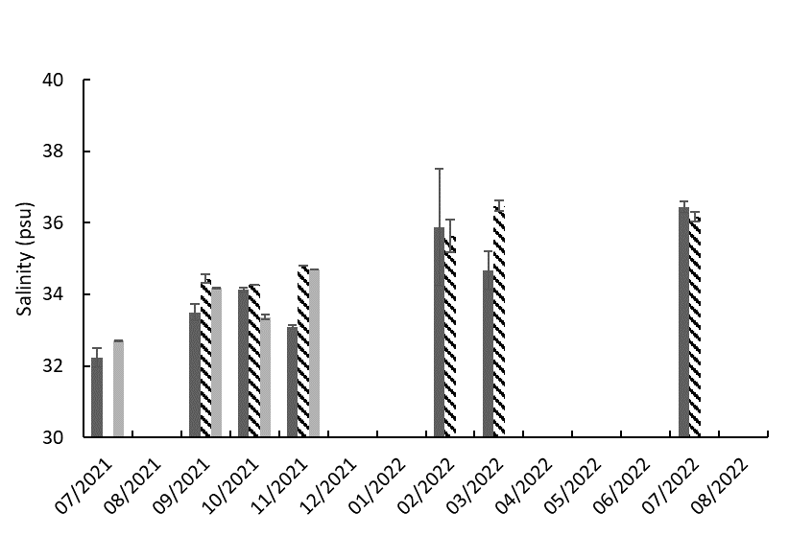

Rainy

season

Mid

season

Dry

season

Mid

season

Rainy

season

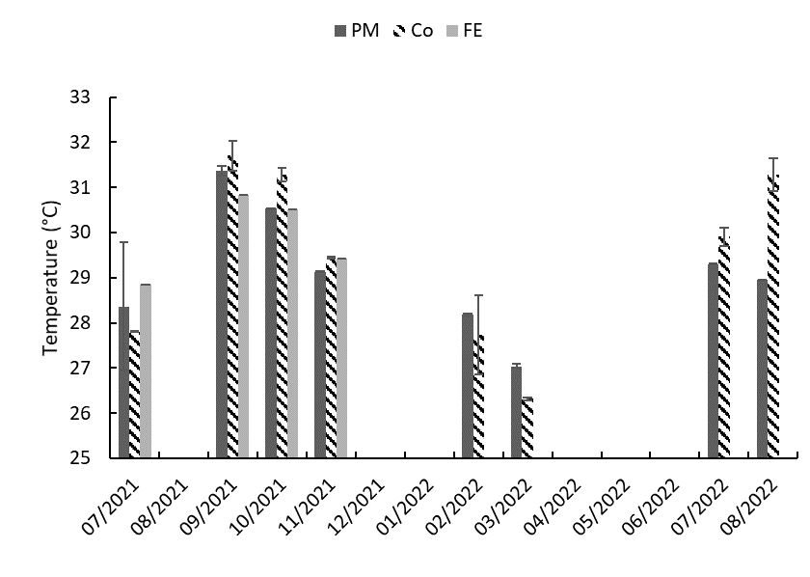

Mid

season

Mid

season

Rainy

season

Dry

season

Rainy

season

Figure S2: Mean values of physico-chemical parameters (temperature and salinity) monitored over study period with standard deviation. markers indicate absenceof *Sargassum* strandings.

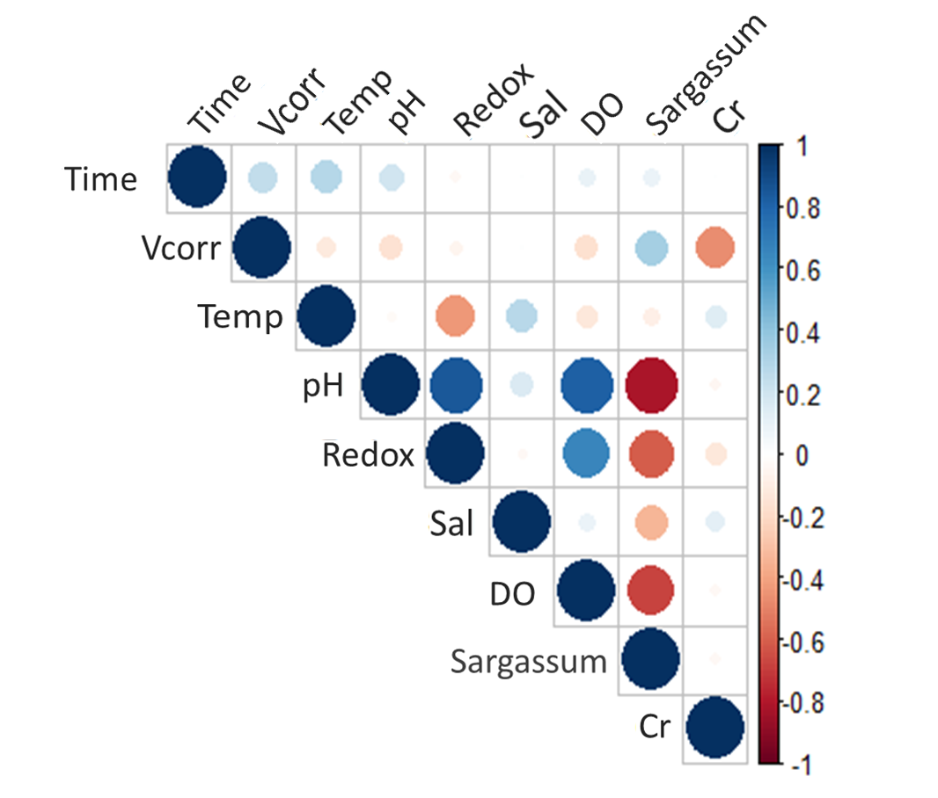

Figure S3: Correlation plot applied to immersion time (Time), corrosion rate (Vcorr), temperature (Temp), pH, redox potential (Redox), salinity (Sal), dissolved oxygen (DO), Sargassum and chrome content (Cr).

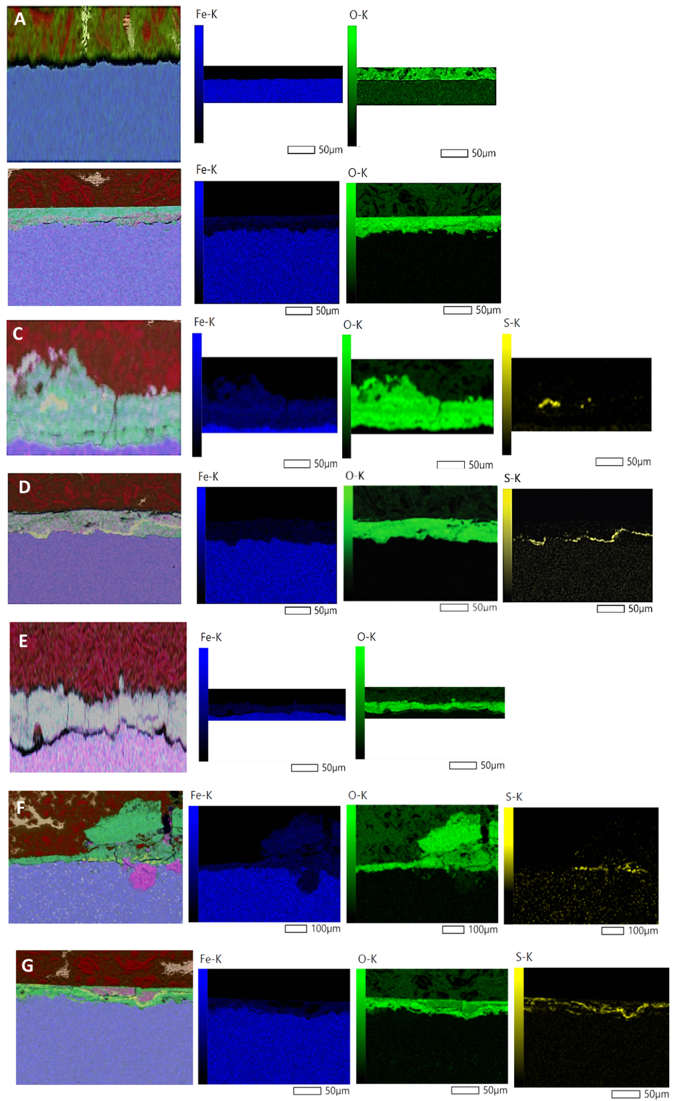

Figure S4: EDS mapping of iron (Fe), oxygen (O), sulphur (S) on the surface of carbon steel DC01 coupons at 0 day (A) and after 7 days’ immersion at Port of Marigot (B), Frégate Est 2 (C) and Cosmy (D) and after 60 days’ immersion at Port of Marigot (E), Frégate Est 2 (F) and Cosmy (G). Red: electro-conductive resin.

Figure S5: Relative abundance of bacterial communities (at species level) of seawater from Port of Marigot (PM SW) and Sargassum from Port of Marigot (PM Sarg) and 304L coupons at Cosmy (Co 304L) and Port of Marigot (PM 304L) after 90 days of immersion.