### **Fig. S1: Beta diversity distribution in the water and hemolymph samples according to the site.** PCoA representation of the Beta diversity based on: **A.** the Jaccard distance, **B.** the UniFrac distance, **C.** the Weighted UniFrac distance. Ellipses regrouped 80 % of the samples around the centroid per type and site. Turquoise points stand for the water samples collected in New Caledonia (NC); green lozenges for the hemolymph samples collected in NC; purple triangle for the water sample collected in French Polynesia (FP); pink crosses for the hemolymph (Hem) samples collected in French Polynesia.

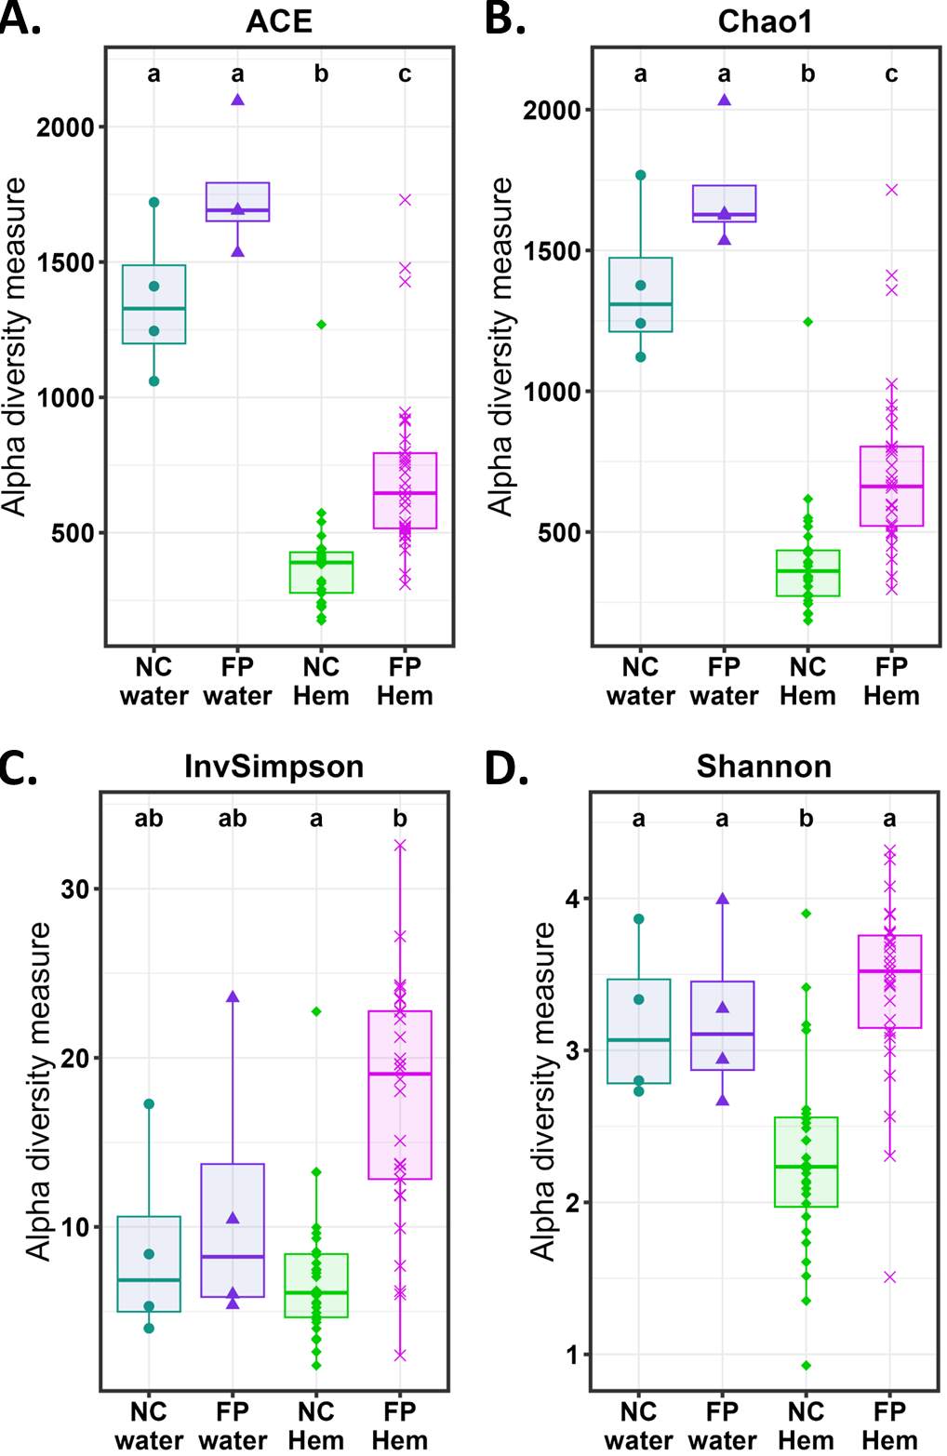

### **Fig. S2: Alpha diversity distribution in the water and hemolymph samples according to the site.** The alpha diversity based on: **A.** ACE index, **B.** Chao1 index, **C.** Inverse Simpson index, **D.** Shannon index. The conditions without common letter are significantly different, p-values < 0.05, according to pairwise Wilcoxon tests. Turquoise points stand for the water samples collected in New Caledonia (NC); green lozenges for the hemolymph samples collected in NC; purple triangle for the water sample collected in French Polynesia (FP); pink crosses for the hemolymph (Hem) samples collected in French Polynesia.

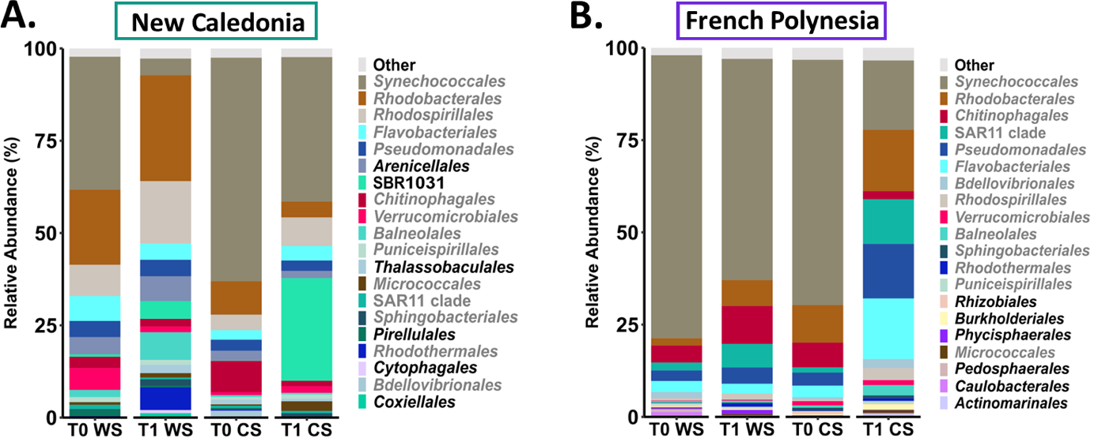

**Fig. S3: Relative abundance of the 20 most abundant bacterial orders in seawater samples. A.** Seawater samples collected in New Caledonia. **B.** Seawater samples collectedin French Polynesia.Each sample match to a given conditions corresponding to the sampling time: beginning of the experimentation (T0), 1 month later (T1); season: warm season (WS), cold season (CS). Orders written in grey are common in both sites.

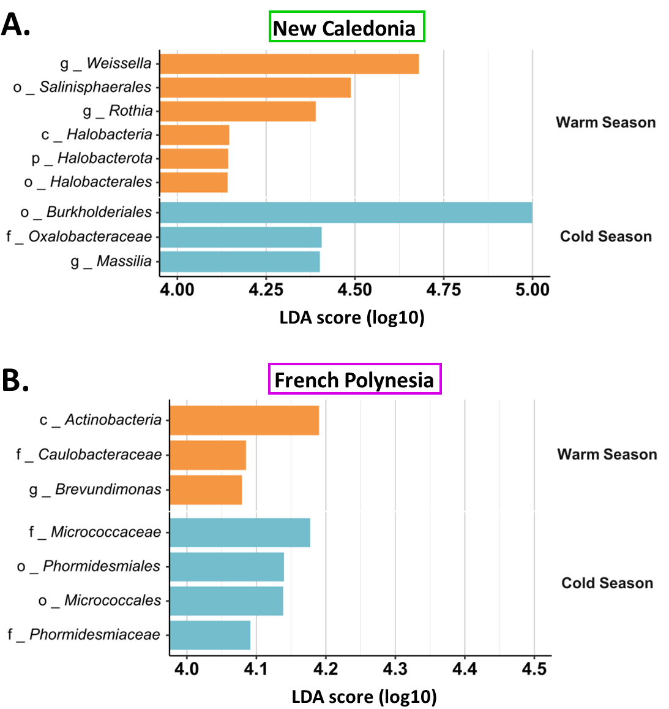

### **Fig. S4: Biomarkers of enriched taxa at all taxonomic ranks in warm and cold seasons per site.** Measure by LEfSe with an LDA cutoff score of 4 **A.** in New Caledonia, **B.** in French Polynesia; Indicated in front of each taxa names: k stands for Kingdom, p for Phylum, c for Class, o for Order, f for Family and g for Genus.

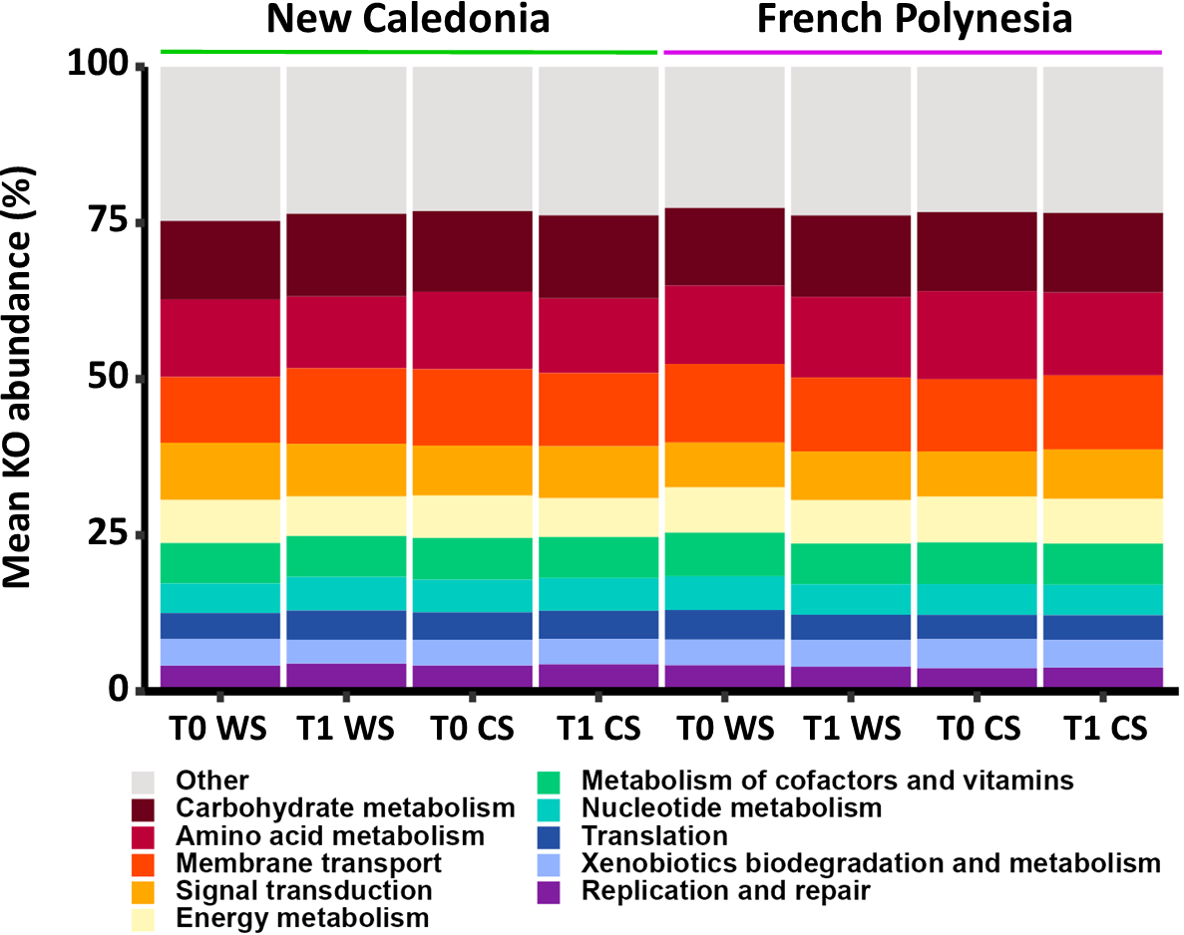

### **Fig. S5: Relative abundance of the putative functions of the microbial diversity inhabiting the hemolymph samples per condition at the KEGG orthology (K.O) level 2.** The putative functions of the host associated-microbiota were identified and assigned with the R package Tax4Fun, the public prokaryote database FAPROTAX and the Silva KO references (Louca et al., 2016)[46], according to the variable, T0 : beginning of the experimentations, T1: 1 month later; WS: Warm Season, CS: Cold Season.



**Fig. S6: Correlogram based on the putative microbial function identified as biomarkers and the relative expressions of the immune effectors.**

Heatmap of the spearman correlation coefficient comparing the relative expressions of each immune effector and the putative microbial functions identified as biomarkers identified in the figure 7. Asterix indicated significant correlations.