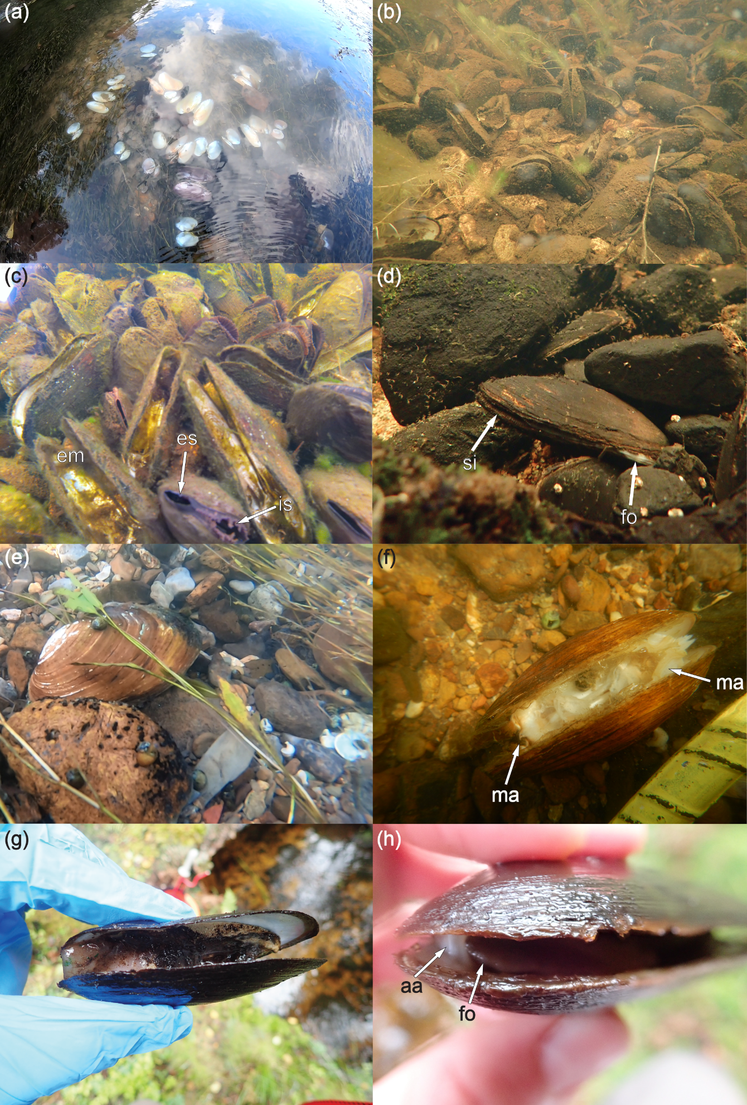
SUPPLEMENTARY FIGURE 1
Examples of freshwater mussels from mass mortality events. (a) Empty shells resting on the substrate in the Clinch River, Tennessee, USA, including fluted kidneyshell (Ptychobranchus subtentus), oyster mussel (Epioblasma capsaeformis), Cumberlandian combshell (E. brevidens), spike (Eurynia dilatata), and others. Photograph courtesy of Meagan Racey, USFWS. (b) Empty shells partially embedded in or resting on the surface of the substrate intermingled with intact and moribund freshwater pearl mussels (Margaritifera margaritifera) in Lakselva River, Norway. Photograph by Dr. Jon Magerøy, NINA, used with permission. (c) Empty shells resting on the surface of the substrate intermingled with intact freshwater pearl mussels (Margaritifera margaritifera) in Lakselva River, Norway. Empty shells (em) have a nacre covered by a yellow-brown residue with little or no tissue attached whereas intact mussels are partially closed with the incurrent siphon (is) and excurrent siphon (es) fully extended. Photograph by Dr. Jon Magerøy, NINA, used with permission. (d) A moribund freshwater pearl mussel (Margaritifera margaritifera) resting on the surface of the substrate with the siphon (si) and foot (fo) partially extended in Örasjöbäcken Stream, Sweden. Photograph by Daniel Cossey, University of Cambridge. (e) A moribund pheasantshell (Ortmanniana pectorosa) resting on the surface of the substrate in the Clinch River, Tennessee, USA. Photograph by Dr. Jordan Richard, USFWS. (f) A recently dead pheasantshell (O. pectorosa) resting on the surface of the substrate with mantle tissue (ma) attached to the valves in the Clinch River, Tennessee, USA. Photograph by Dr. Jordan Richard, USFWS. (g) A dead and decomposing freshwater pearl mussel (Margaritifera margaritifera) with a small amount of soft tissue attached to the valves. Soft tissues are covered by a black residue. Mussel was removed from Örasjöbäcken Stream, Sweden. Photograph by Daniel Cossey, University of Cambridge. (h) A moribund freshwater pearl mussel (Margaritifera margaritifera) demonstrating an inability to close its valves revealing the anterior adductor (aa) and foot (fo). Mussel was removed from the Örasjöbäcken Stream, Sweden. Photograph by Daniel Cossey, University of Cambridge.

