**Supplementary Materials**

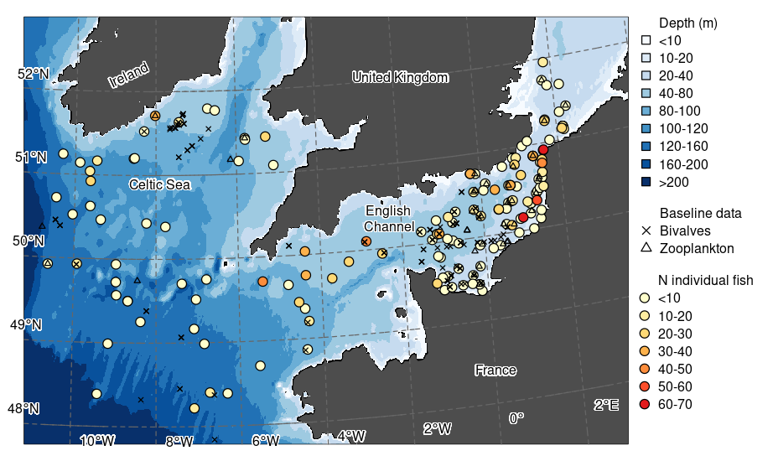

**Fig. S1.** Map of the English Channel-Celtic Sea continuum. Background displays bathymetry at 10, 20, 40, 80, 100, 120, 160 and 200 m isobath intervals. Circles identify stations where fish were sampled and are coloured according to the number (N) of fishes included from the respective stations. Black symbols represent sampling locations of baseline data: crosses = bivalves (the queen scallop, *Aequipecten opercularis* in the English Channel and the great scallop, *Pecten maximus* in the Celtic Sea), and triangles = zooplankton (calanoid copepods in the English Channel and Celtic Sea).

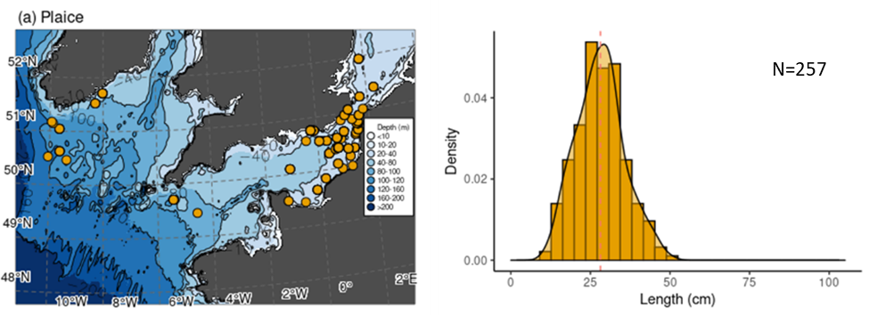

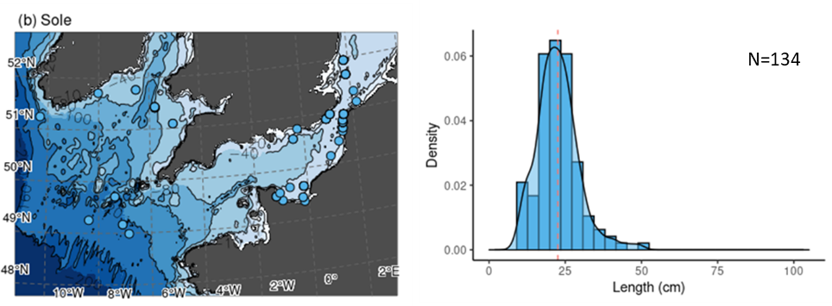

**Figure S2.** Spatial distribution of observations (left panel) and density plot of fish length (right panel) for: (a) plaice *Pleuronectes platessa*, (b) sole *Solea solea*, (c) thickback sole *Microchirus variegatus*, (d) poor cod *Trisopterus minutus*, (e) grey gurnard *Eutrigla gurnardus*, (f) cod *Gadus morhua*, (g) lesser spotted dogfish *Scyliorhinus canicula*, (h) John Dory *Zeus faber*, (i) whiting *Merlangius merlangus*, (j) horse mackerel *Trachurus trachurus* and (k) mackerel *Scomber scombrus*. Vertical broken lines on density plots indicate mean values.

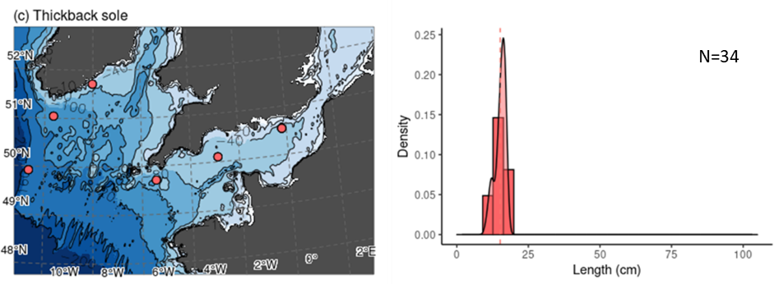

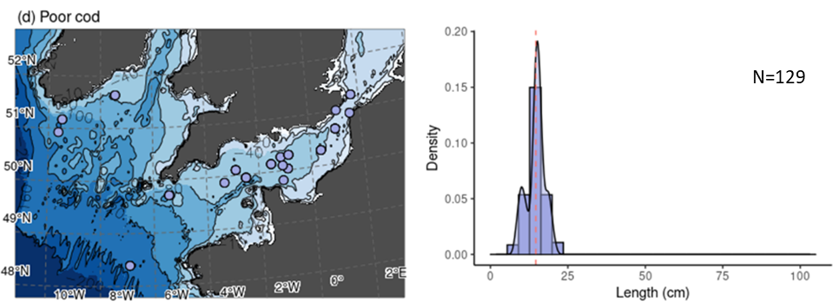

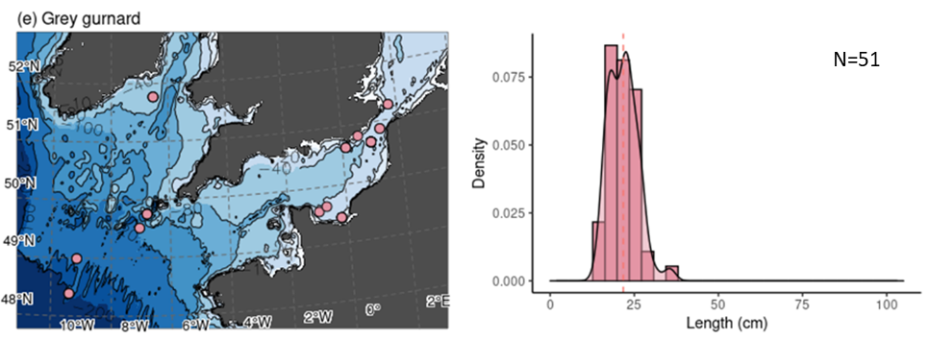

**Figure S2 (cont.)**

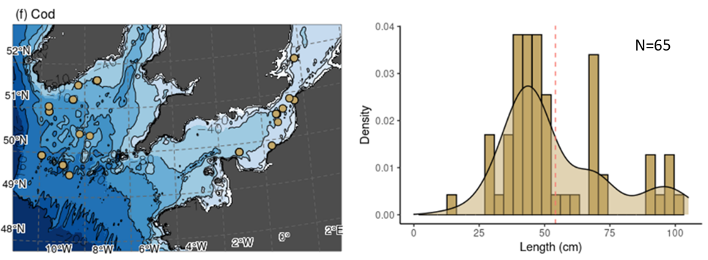

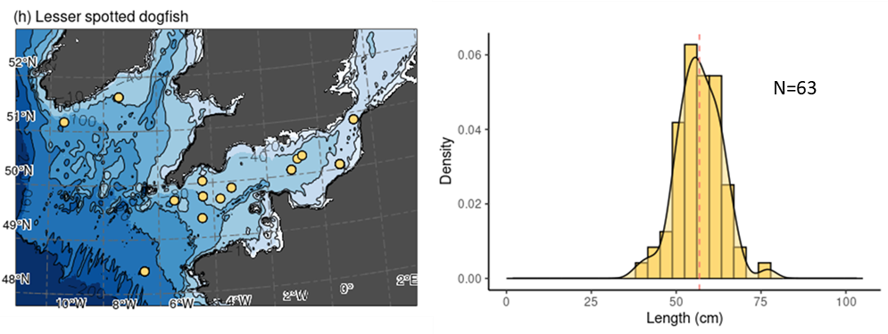

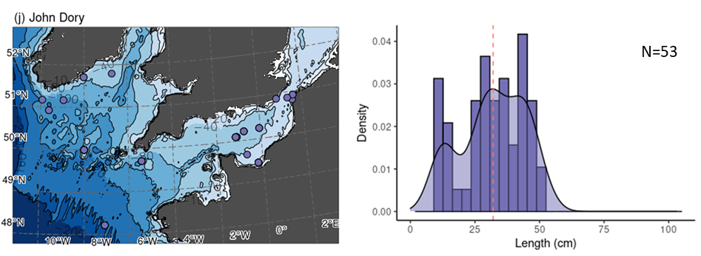

**Figure S2 (cont.)**

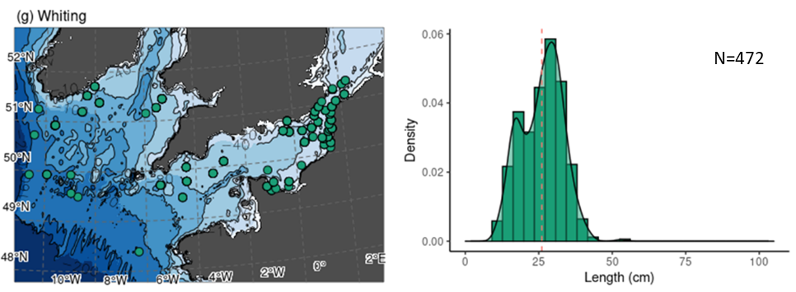

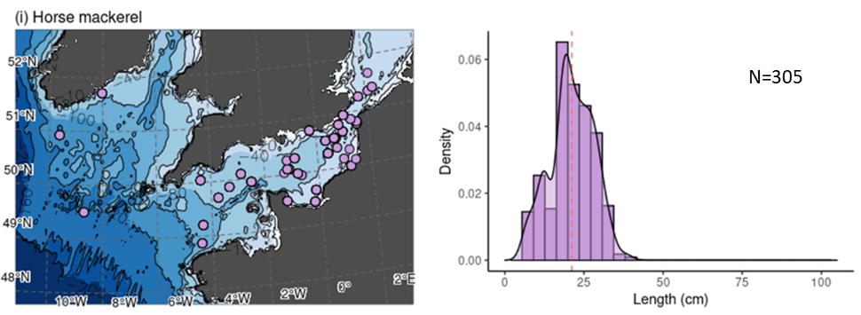

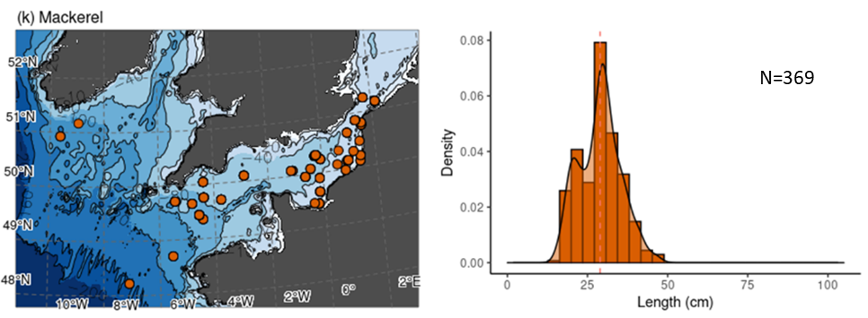

**Figure S2 (cont.)**

Figure S3. Distribution of the proportion of fish consumers with increasing body size (A) and depth (B).

**Table S1.** Summary of the generalised linear model (GLM) comparisons examining the proportion (α) of benthic sources to fish and the relationship with body size and depth for: (a) Community models, and (b) feeding guild models in the English Channel-Celtic Sea Shelf continuum. LL, log-likelihood; AIC, Akaike’s Information Criterion; ΔAIC, difference in AIC from that of the best fitting model; *w*AIC, weight. Estimates and significance (p-values) for each term included are also given. *p < 0.05; **p < 0.01; ***p < 0.001. The accepted model is presented in bold.

| **Candidate models** | **LL** | **AIC** | **ΔAIC** | **ωAIC** | **Estimates** | | | |
| --- | --- | --- | --- | --- | --- | --- | --- | --- |
| **Intercept** | **size** | **depth** | **size:depth** |
| *(a) Community models* |  |  |  |  |  |  |  |  |
| **α~size+depth** | **674.1** | **-1340.3** | **0.0** | **0.595** | **0.4785** | **0.0899 p < 0.001** | **0.0346**  **p <0.05** |  |
| α~size+depth+size:depth | 674.3 | -1338.5 | 1.7 | 0.249 | 0.4782 | 0.0869 p <0.001 | 0.0337  p <0.05 | 0.0065 |
| α~size | 671.8 | -1337.6 | 2.7 | 0.156 | 0.4785 | 0.0953 p < 0.001 |  |  |
|  |  |  |  |  |  |  |  |  |
| α~depth | 654.2 | -1311.0 | 29.3 | 0.000 | 0.4785 |  | 0.0485  p < 0.01 |  |
| *(b) Feeding guild models* |  |  |  |  |  |  |  |  |
| Benthivore |  |  |  |  |  |  |  |  |
| α~size+depth+size:depth | 165.3 | -320.6 | 0.0 | 0.500 | 0.4888 | 0.1678  p < 0.01 | -0.0188 | 0.1406 p < 0.05 |
| **α~size** | **162.7** | **-319.5** | **1.2** | **0.278** | **0.5157** | **0.1046 p < 0.05** |  |  |
| α~size+depth | 163.0 | -318.0 | 2.6 | 0.134 | 0.5263 | 0.0928 | 0.0309 |  |
| α~depth | 161.6 | -317.2 | 3.5 | 0.088 | 0.5281 |  | 0.0512 |  |
| Zoobenthivore |  |  |  |  |  |  |  |  |
| **α~size+depth+size:depth** | **131.6** | **-253.1** | **0.0** | **0.786** | **0.7322** | **1.0162 p <0.001** | **-0.2284** | **-0.3631**  **p < 0.05** |
| α~size+depth | 129.1 | -250.2 | 2.9 | 0.182 | 0.6988 | 0.8528 p < 0.001 | 0.0974  p < 0.05 |  |
| α~size | 126.3 | -246.7 | 6.4 | 0.032 | 0.7419 | 0.9964 p < 0.001 |  |  |
| α~depth | 116.1 | -226.3 | 26.8 | 0.000 | 0.4735 |  | 0.1775 p < 0.001 |  |
| Piscivore |  |  |  |  |  |  |  |  |
| **α~size+depth** | **459.5** | **-911.0** | **0.0** | **0.630** | **0.4475** | **0.1058 p <0.001** | **0.0840 p < 0.001** |  |
| α~size+depth+size:depth | 460.0 | -910.0 | 1.1 | 0.370 | 0.4479 | 0.1145 p < 0.001 | 0.0893 p < 0.001 | -0.0129 |
| α~size | 450.1 | -894.3 | 16.8 | 0.000 | 0.4483 | 0.1275 p < 0.001 |  |  |
| α~depth | 442.3 | -878.6 | 32.5 | 0.000 | 0.4558 |  | 0.1161 p < 0.001 |  |
| Generalist planktivore |  |  |  |  |  |  |  |  |
| **α~size** | **226.9** | **-447.7** | **0.0** | **0.503** | **0.3936** | **0.1230 p < 0.01** |  |  |
| α~size+depth+size:depth | 228.3 | -446.6 | 1.1 | 0.284 | 0.3974 | 0.1648  p < 0.001 | 0.0566 | 0.1006 |
| α~size+depth | 227.0 | -446.0 | 1.8 | 0.209 | 0.3942 | 0.1245 p < 0.01 | 0.0174 |  |
| α~depth | 222.1 | -438.2 | 9.5 | 0.004 | 0.3893 |  | 0.0095 |  |

**Table S2.** Summary of the generalised linear model (GLM) comparisons examining trophic level (TL) variability and the relationship with fish body size and depth for: (a) Community models, and (b) feeding guild models in the English Channel-Celtic Sea Shelf continuum. LL, log-likelihood; AIC, Akaike’s Information Criterion; ΔAIC, difference in AIC from that of the best fitting model; *w*AIC, weight. Estimates and significance (p-values) for each term included are also given. *p < 0.05; **p < 0.01; ***p < 0.001. The accepted model is presented in bold.

| **Candidate models** | **LL** | **AIC** | **ΔAIC** | **ωAIC** | **Estimates** | | | |
| --- | --- | --- | --- | --- | --- | --- | --- | --- |
| **Intercept** | **size** | **depth** | **size:depth** |
| *(a) Community models* |  |  |  |  |  |  |  |  |
| **TL~size+depth+size:depth** | **-1126.5** | **2263.0** | **0.0** | **1.000** | **3.7578** | **0.1105**  **p < 0.001** | **-0.1806 p < 0.001** | **0.0339 p < 0.001** |
| TL~size+depth | -1135.9 | 2279.7 | 16.7 | 0.000 | 3.7632 | 0.1273 p < 0.001 | -0.1762 p < 0.001 |  |
| TL~depth | -1213.0 | 2432.0 | 169.0 | 0.000 | 3.7632 |  | -0.1561 p < 0.001 |  |
| TL~size | -1278.4 | 2562.8 | 299.8 | 0.000 | 3.7632 | 0.0996 p < 0.001 |  |  |
| *(b) Feeding guild models* |  |  |  |  |  |  |  |  |
| Benthivore |  |  |  |  |  |  |  |  |
| TL~size+depth+size:depth | -100.5 | 211.1 | 0.0 | 0.658 | 3.6513 | -0.1730 p < 0.001 | -0.1412 p < 0.001 | 0.0519 |
| **TL~size+depth** | **-102.2** | **212.4** | **1.3** | **0.342** | **3.6665** | **-0.1997 p < 0.001** | **-0.1205 p < 0.001** |  |
|  |  |  |  |  |  |  |  |  |
| TL~size | -120.5 | 247.1 | 36.0 | 0.000 | 3.7084 | -0.2413 p < 0.001 |  |  |
| TL~depth | -132.4 | 270.7 | 59.7 | 0.000 | 3.6621 |  | -0.1631 p < 0.001 |  |
| Zoobenthivore |  |  |  |  |  |  |  |  |
| **TL~size+depth** | **21.1** | **-34.3** | **0.0** | **0.658** | **3.9479** | **0.3468 p < 0.001** | **-0.1531 p < 0.001** |  |
| TL~size+depth+size:depth | 21.5 | -33.0 | 1.3 | 0.342 | 3.9195 | 0.3185  p < 0.001 | -0.0962 | 0.0639 |
| TL~depth | 11.5 | -17.1 | 17.2 | 0.000 | 3.5621 |  | -0.1195 p < 0.001 |  |
| TL~size | -5.3 | 16.7 | 50.9 | 0.000 | 3.6009 | 0.1124 |  |  |
| Piscivore |  |  |  |  |  |  |  |  |
| TL~size+depth+size:depth | -405.8 | 821.6 | 0.0 | 0.522 | 3.9429 | 0.1026  p < 0.001 | -0.1801 p < 0.001 | 0.0127 |
| **TL~size+depth** | **-406.9** | **821.7** | **0.2** | **0.478** | **3.9445** | **0.1116 p < 0.001** | **-0.1748 p < 0.001** |  |
| TL~depth | -449.9 | 905.8 | 84.2 | 0.000 | 3.9760 |  | -0.1397 p < 0.001 |  |
| TL~size | -491.3 | 988.6 | 167.0 | 0.000 | 3.9390 | 0.0654 p < 0.001 |  |  |
| Generalist planktivore |  |  |  |  |  |  |  |  |
| **TL~size+depth+size:depth** | **-336.1** | **682.1** | **0.0** | **0.910** | **3.5127** | **0.0575** | **-0.3372**  **p < 0.001** | **-0.1140**  **p < 0.05** |
| TL~size+depth | -339.4 | 686.73 | 4.6 | 0.090 | 3.5284 | 0.1032 p < 0.001 | -0.2903 p < 0.001 |  |
| TL~depth | -346.0 | 697.91 | 15.8 | 0.000 | 3.5107 |  | -0.2960 p < 0.001 |  |
| TL~size | -400.6 | 807.29 | 125.2 | 0.000 | 3.5691 | 0.1243 p < 0.001 |  |  |

**Table S3.** Details of isotopic values of benthic and pelagic sources used in mixing models and for trophic level calculation. Sampling locations are given in Fig. S1.

|  |  |  |  |  |  |  |
| --- | --- | --- | --- | --- | --- | --- |
| Ecosystem | Depth range  of trawls (m) | N | Isotopic  baseline | δ13C (‰) | δ15N (‰) | Reference |
| English Channel | NA | 90 | Benthic | -18.02 ± 0.80 | 7.70 ± 0.94 | Average values for *Aequipecten opercularis* collected during La CAmpagne MANche OCcidentale pluridisciplinaire (CAMANOC) survey in 2014 (Travers-Trolet and Verin 2014) |
|  | 19-63 | 31 | Pelagic | -20.46 ± 0.97 | 7.80 ± 1.98 | Average values for calanoid copepods collected during the CAMANOC survey in 2014 (Travers-Trolet and Verin 2014), Channel Ground Fish Survey in 2015 (CGFS; Travers-Trolet 2015) and International Bottom Trawl Survey in 2016 (ITBS; Verin 2016) |
| Celtic Sea | 73-177 | 50 | Benthic | -17.46 ± 1.20 | 6.92 ± 1.75 | Average values for *Pecten maximus* collected during the ÉValuation Halieutique Ouest de l’Europe (EVHOE) survey in 2015 and 2016 (Leaute et al. 2015, 2016) and from commercial fishers in 2014. |
|  | 71-191 | 6 | Pelagic | -21.06 ± 0.79 | 7.14 ± 0.88 | Average values for calanoid copepods collected during the EVHOE survey in 2014 (Duhamel et al. 2014) |

**Table S4.** Summary of the generalised linear model (GLM) comparisons examining the proportion (α) of benthic sources and trophic level variability (TL) in relation to fish feeding guild for community models. Estimates and significance (p-values) for each term included: *p < 0.05; **p < 0.01; ***p < 0.001.

| **Community models** | **Estimates** | | | |
| --- | --- | --- | --- | --- |
| **Intercept** | **Generalist**  **planktivores** | **Zoobenthivores** | **Piscivores** |
| *(a) Proportion of benthic sources* |  |  |  |  |
| **α~feeding guild** | **0.4943** | **-0.6952**  **p < 0.001** | **0.1092 p < 0.01** | **-0.1014 p < 0.01** |
| *(b) Trophic level* |  |  |  |  |
| **TL~feeding guild** | **3.6784** | **-0.0096**  **p = 0.6552** | **-0.0861**  **p < 0.001** | **-0.3586**  **p < 0.001** |
|  |  |  |  |  |