**Novel** **settlement substrates for European flat oyster (*Ostrea edulis*) restoration** **Supplementary material**

For substrates of the field experiment in Bay of Brest extra measurements on rugosity and colour were carried out.

**Methods**

Determination of rugosity

Roughness measurements were carried out by using a 3D microscope KEYENCE VHX 6000. This 3D microscope allows the reconstruction of relief images. The parameter we used to evaluate surface roughness was the Arithmetical Mean Height (Sa). It expresses, as an absolute value, the difference in height of each point compared to the arithmetical mean of the surface. More explanation can be found on the Keyence web site (<https://www.keyence.com/ss/products/microscope/roughness/surface/parameters.jsp>).

On each sample, 4 areas of 5x5 mm have been chosen randomly and Sa was measured on each at X50 magnification with the same light exposure. Note that the surface to be measured must be flat, *i.e.* the sample must not be inclined.

Determination of colour

The colour of all substrates was determined from pictures (Fig. S1) using the CIE lab colourspace, this colourspace indexing allows for perceptually uniform colour indexing. The colour spectrum was determined based on *L\** (lightness), *a*\* (redness), and *b*\* (yellowness). Images of the grids, made before the grids were deployed in the field, were used for colour indexing. sRGB images were converted to CIE lab colour indexing using the “RGB to L*a*b plugin from ImageJ. The luminance values *L*\*, *a*\*, and *b*\* were determined for each substrate block by calculating the average of four measurements taken for each substrate.

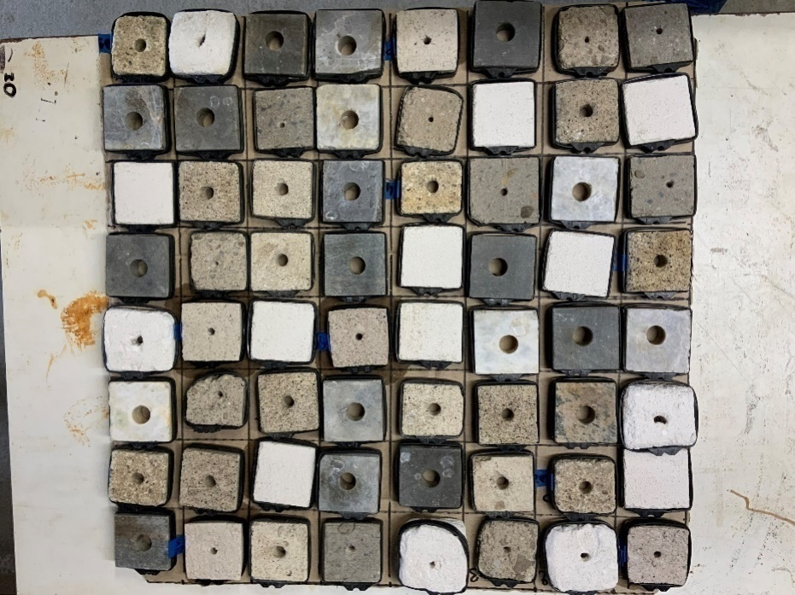

*Figure S1. Substrates before going into the field. Note the different colours.*

Statistical analysis

All stastistical analyses were performed on both grids independently. Data was tested for normality with Shapiro-Wilk tests and homogeneity of variance was tested with Levene’s test using the car package (Fox & Weisberg, 2019). Non-parametric tests were used in down-stream analysis as data violated normality and homogeneity requirements. Spearman rank tests were used to test for a correlation between settled spat density and substrate colour or rugosity. In addition, Spearman rank tests were used to test for a potential correlation between susbtrate colour and rugosity indices.

**Results and discussion**

The different substrates showed differences in rugosity (Figure S2). No strong correlation observed between settled spat density and substrate colourspacing indices (Figure S3). Highest value for Spearman Rho was 0.6. Spearman correlation coefficients were statistically significant for L* and a* colourspacing indices and spat settlement density per surface area for both grid1 and grid2.

For rugosity indices a significant but weak correlation was found for both Sa and Sz, with highest Rho spearman correlation coefficient of 0.33 (Figure S4).

Also tested for an interaction effect between substrate colourspacing and rugosity, spearman rank correlation tests resulted in significant correlations between a* and b* substrate colourspacing indices and rugosity indices Sa and Sz. Although these correlations are statistically significant, the correlation coefficients are not strong as Spearmans Rho's highest value was 0.65 (Figure S5).

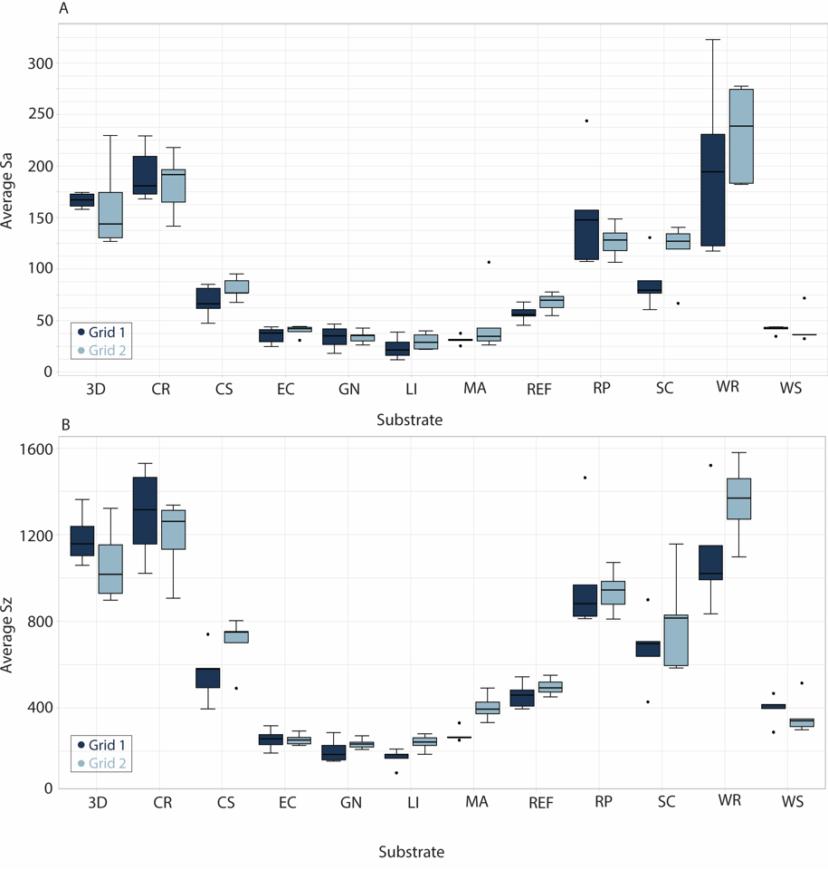

*Figure S2. Boxplots of rugosity values for the different substrates. (A) average Sa values as a measure of rugosity, (B) average Sz values as a measure of rugosity.*

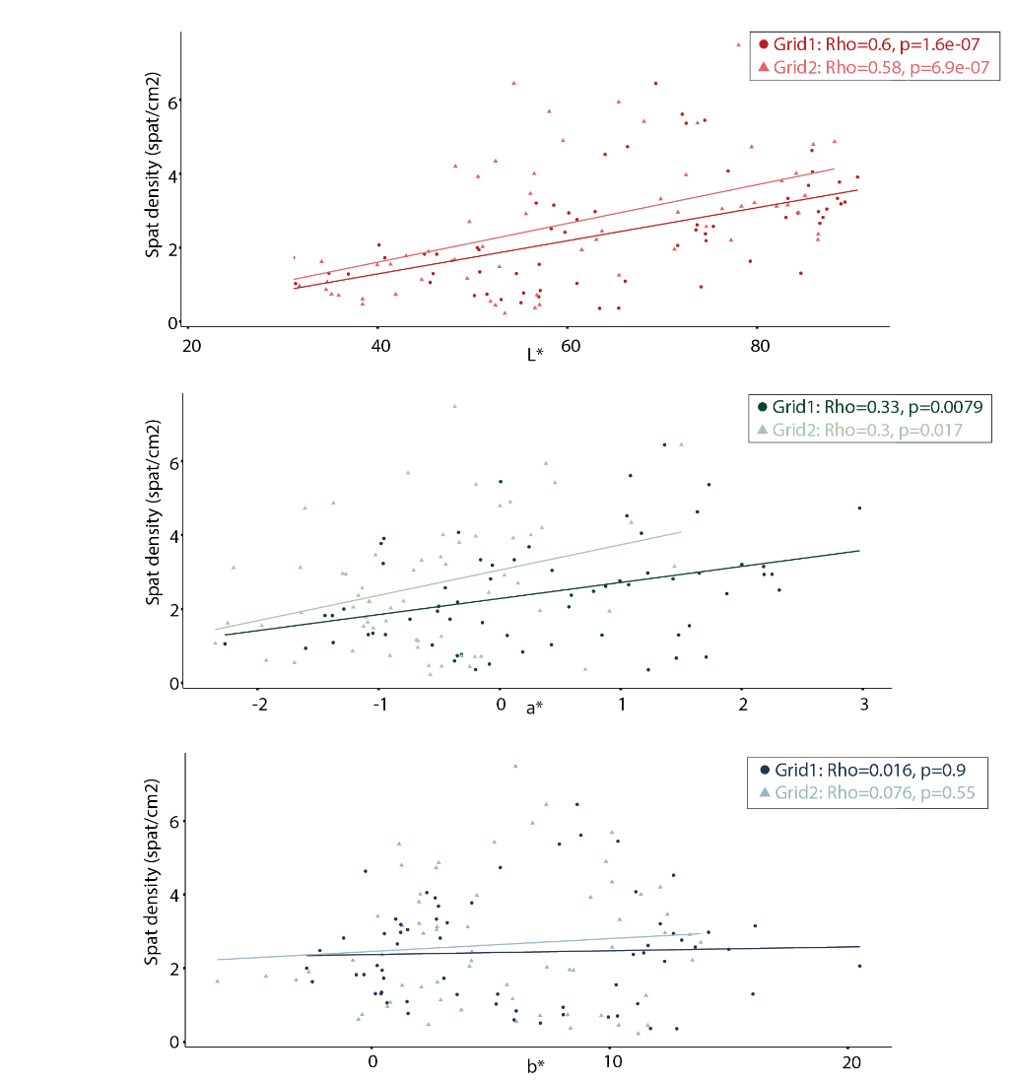

A

B

C

*Figure S3. Spearman correlation between L*, a*, b* colourspacing and oyster settlement density (#spat/cm2) for grid 1 and grid 2 respectively. (A) L* (lightness), (B) a* (redness), and (C) b* (yellowness) measurements for each individual substrate block, circled dots for grid 1 and triangular dots for grid 2. Solid lines represent the Rho Spearman correlation coefficient for each grid; grid 1 darkly coloured and grid 2 lightly coloured. between colour and oyster settlement (#spat/cm2) using the CIELab color space standard (REF: ISBN: 978-3-902842-13-8 or DOI: 10.25039/TR.015.2018). L*, a*, and b* refer to location within the color space of each substrate corresponding to approximately, the luminosity, green-magenta character, and blue-yellow character, respectively.*

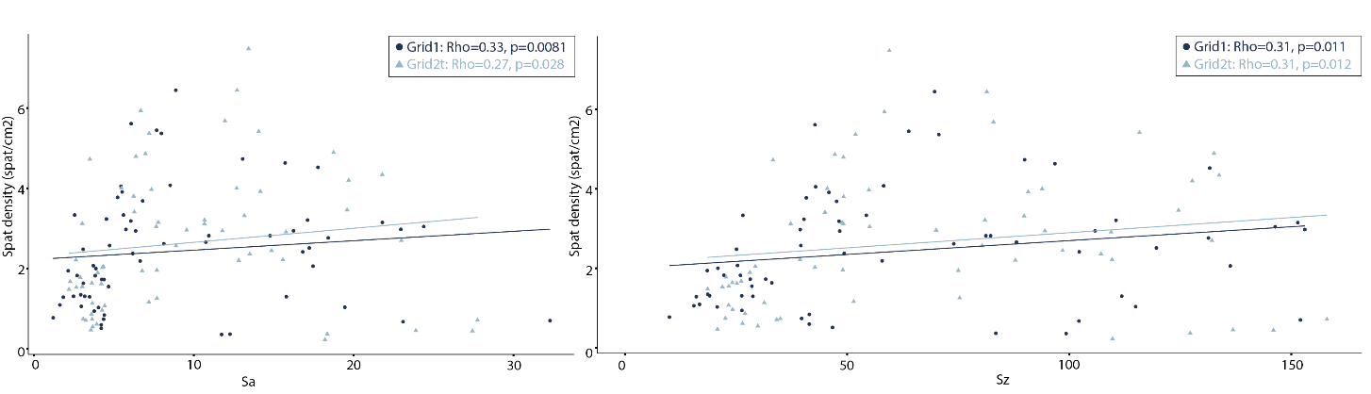

A



B

*Figure S4. Spearman correlation between rugosity indices Sa (=Arithmetical Mean Height) and Sz (=Maximum height) and oyster settlement density (#spat/cm2) for grid 1 (A) and grid 2 (B) respectively. Dots represent Sa and Sz measurements for each individual substrate block, circled dots represent measurements for grid 1 and triangular dots represent measurements for grid 2. Solid lines represent the Rho Spearman correlation coefficient for each grid; grid 1 darkly coloured and grid 2 lightly coloured.*

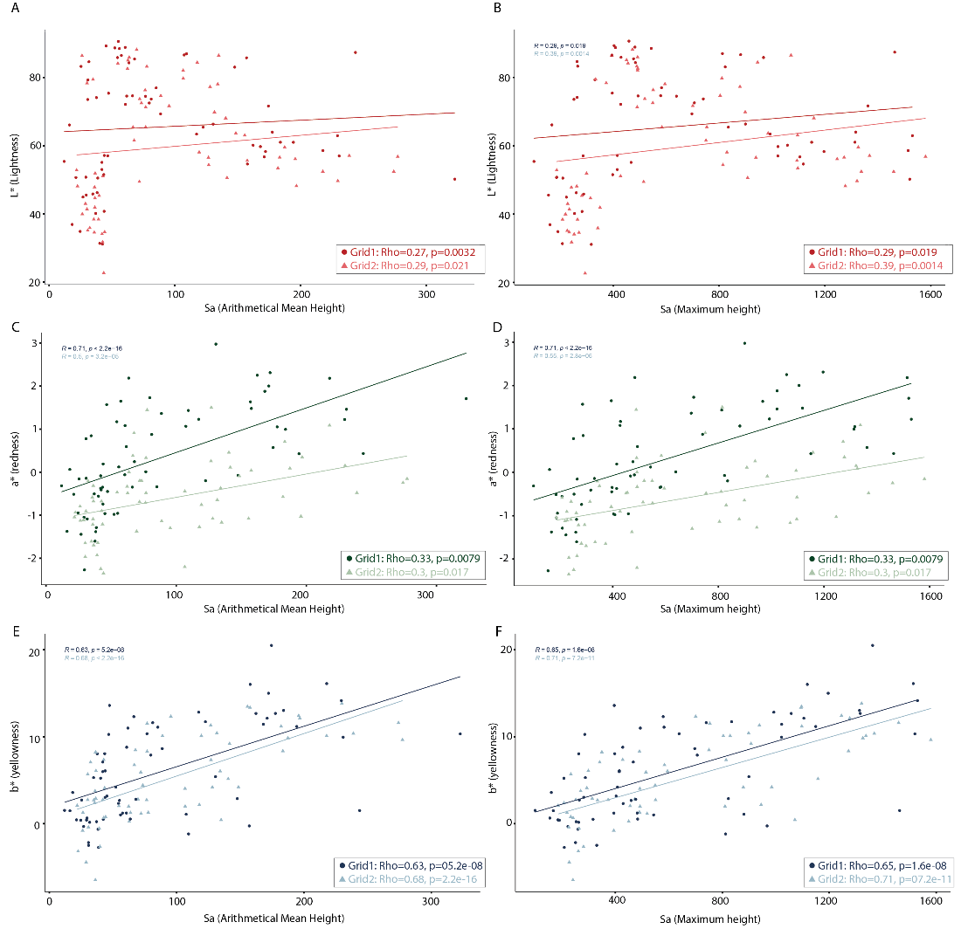

*Figure S5. Spearman correlation between L*, a*, and b* colourspacing and Sa (Arithmetical mean height) and Sz (Maximum height) rugosity indices for all substrate blocks on grid 1 and grid 2 respectively. (A) and (B) represent Spearman correlation between L* (Lightness) colourspacing and rugosity indices Sa and Sz, (C) and (D) represent Spearman correlation between a* (Redness) colourspacing and rugosity indices Sa and Sz, and (E) and (F) represent Spearman correlation between b* (Yellowness) colourspacing and rugosity indices Sa and Sz.*

**References**

Fox J, Weisberg S (2019). *An R Companion to Applied Regression*, Third edition. Sage, Thousand Oaks CA.