Supplementary Information

The correlation between the Fanshan magnetic susceptibility and marine oxygen isotope record is shown in Fig. S1. The age control points are located within the transition between adjacent loess and paleosols to ensure similar climatic conditions and relatively constant sedimentation rates during each time period. The ages of the resulting control points are shown in Table S1.

Table S1 Age control points for the Fanshan loess-paleosol sequence

 | Depth | Marine MIS | Age/ka
Points | 3.562 |  | 654
S6/L7 | 4.625 | 17/18 | 710
L7/S7 | 5.825 | 18/19 | 761
S7/L8 | 6.755 | 19/20 | 790
L8/S8 | 8.38 | 20/21 | 814
S8/L9 | 10.43 | 21/22 | 866
L9/S9 | 13.13 | 22/23 | 898
Fig. S1. Correlation of the Fanshan magnetic susceptibility record (red curve) with the marine oxygen isotope record (blue curve), in accordance with the findings of Lisiecki and Raymo (2005).

Chemical preparation
Approximately 1 g of dry sediment was leached for 24 h at room temperature in 12 M HCl together with 3 ml (30%) of H₂O₂ and 0.5 mg of ⁹Be carrier, after washing with 3 ml of pure water. After two centrifugations the supernatant was dried and then dissolved with 1 M HCl. For ¹⁰Be measurements, this spiked solution needed to be purified using a pretreated cation resin column (Zhou et al., 2007). A new procedure employing acid dissolution-alkali precipitation-alkali dissolution steps was applied to extract ¹⁰Be. After two stages of precipitation using NH₄OH and NaOH, the remaining solution was passed through an ion exchange columns, in which the Be was retained. After washing and dehydration three times, the Be(OH)₂ was converted to BeO by heating at 900°C. Finally, the samples were mixed with Nb and pressed into sample holders.

Fig. S2: Calculation of the geomagnetic component of ¹⁰Be
In the Fanshan section there is a strong similarity between PC1 and ¹⁰Be_{con}. We calculated the climate-related component of ¹⁰Be as follows:.
10Beclimate=25.103×PC1 + 347.26 (R² = 0.723, P<0.01)
Then, we subtracted the climate-related component (¹⁰Be_{climate}) from the ¹⁰Be concentration (¹⁰Be_{con}), and the resulting ¹⁰Be residual is the ¹⁰Be signal primarily influenced by the geomagnetic field (¹⁰BeGM):
¹⁰Be_{GM}=¹⁰Be_{con}-¹⁰Be_{climate}

Fig. S3: As shown in the Al₂O₃ - CaO + Na₂O - K₂O ternary diagram, which mainly reflects the intensity of chemical weathering, the chemical weathering index (CIA) values of the Alum Mountain profile lie within the range of 61–66, which are slightly lower than those of the Xifeng and Lingtai profiles in the hinterland of the Loess Plateau. This indicates that the degree of chemical weathering and soil formation in the Fanshan section are weaker than in typical loess profiles in the interior of the Loess Plateau.

Fig. S3:Al₂O₃-K₂O-CaO+Na₂O ternary diagram of samples from the Fanshan profile

Fig. S4: Monthly average temperatures of three areas on the Chinese Loess Plateau
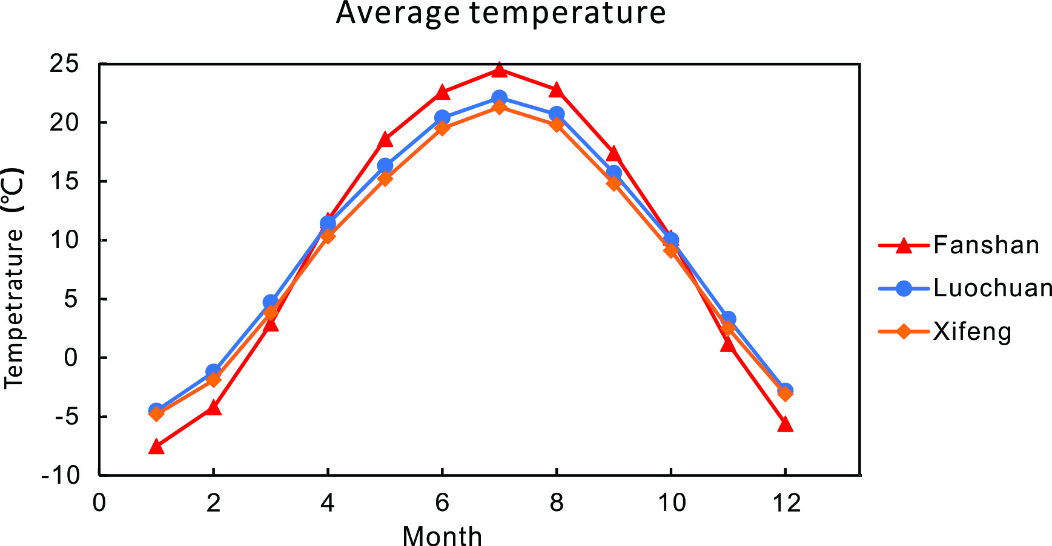
Fig. S4: Monthly average temperatures for Fanshan, Luochuan, and Xifeng based on meteorological station data from the date of inception to the present.

