Assessing sargassum pressure on coastal habitats using a spatial and temporal approach at the territorial scale

Mathilde Teyssier^{a,b*}, Catherine Desrosiersª, Claire Hellio^{b}, Fanny Kerninon^{b}

ª Impact Mer, 20 rue Karukera, F-97200 Fort-de-France, Martinique, France
^{b} Univ Brest, CNRS, IRD, Ifremer, LEMAR, F-29280 Plouzané, France
* Corresponding author: ª mteyssier@impact-mer.fr

Appendix A. Supplementary data

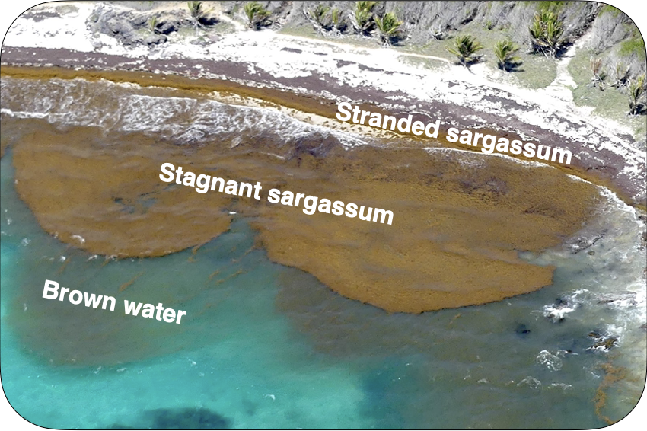
Figure A.1 – Three states of sargassum features.

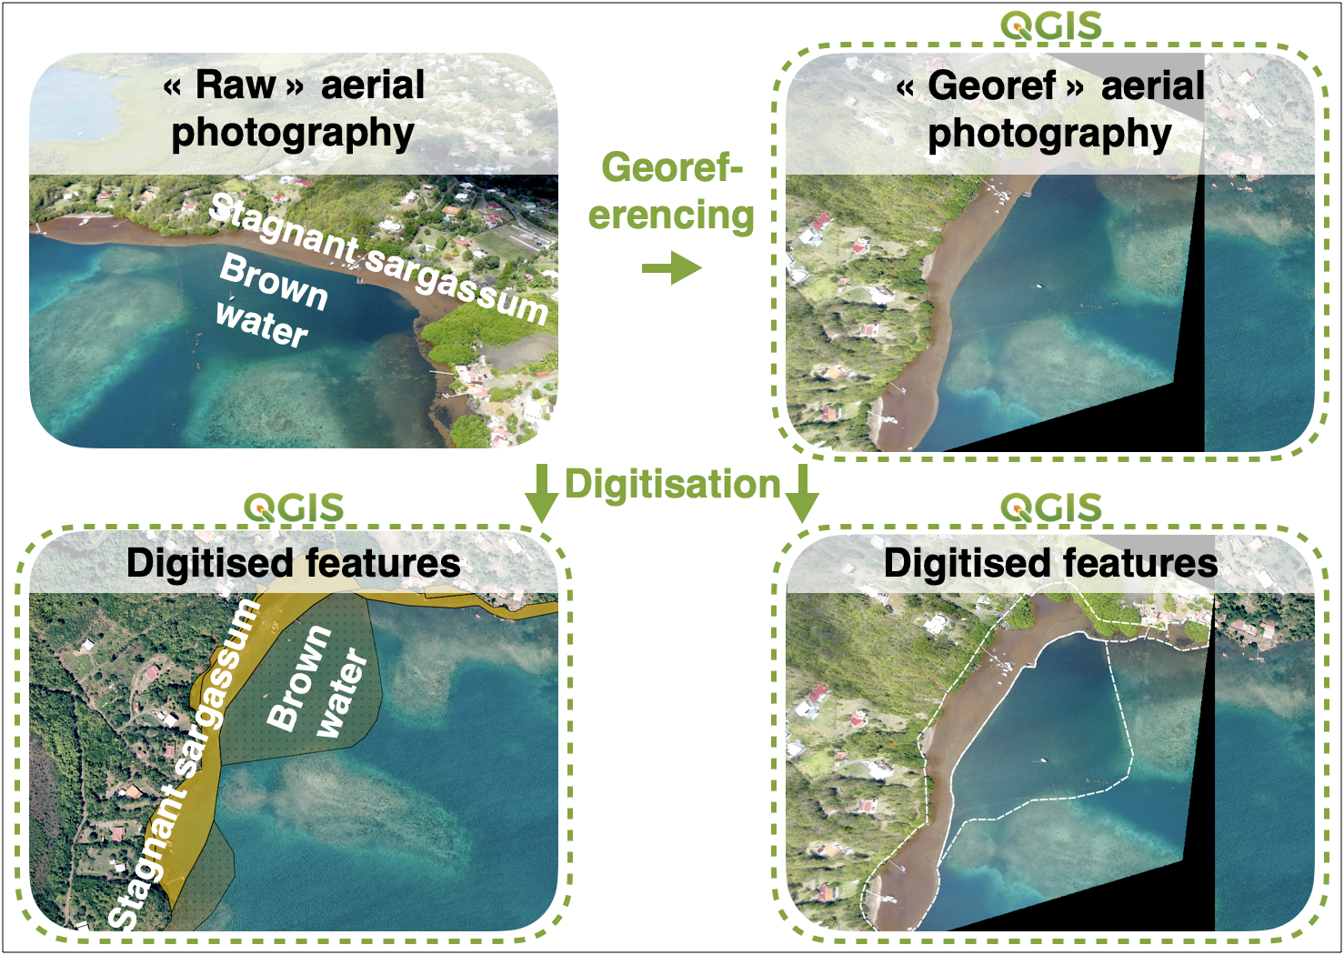
Figure A.2 – Digitisation of sargassum features from raw photographs vs. georeferenced photographs.

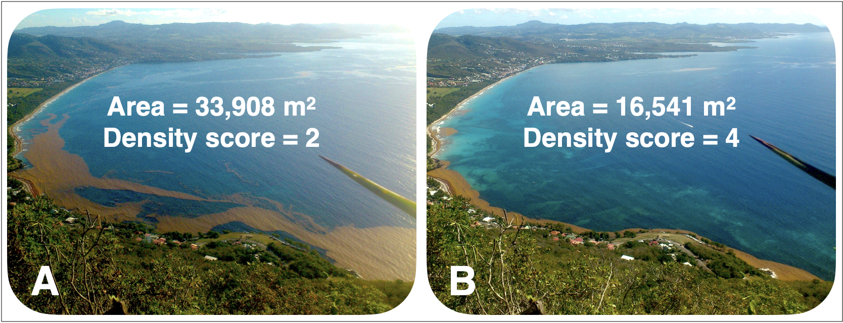
Figure A.3 – Difference of sargassum area in Anse Caffard (site 10) on February 27, 2023 when sargassum raft was reaching the coast at 8am (A) and when sargassum accumulated on the coast at 10am (B).

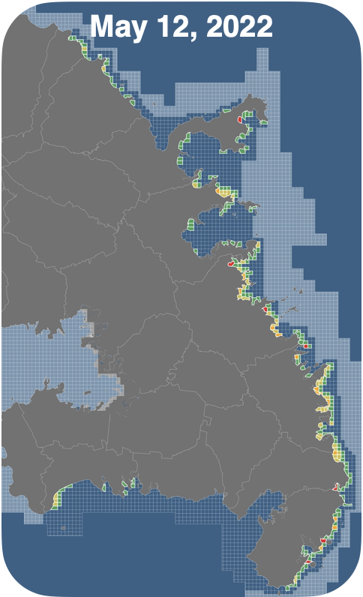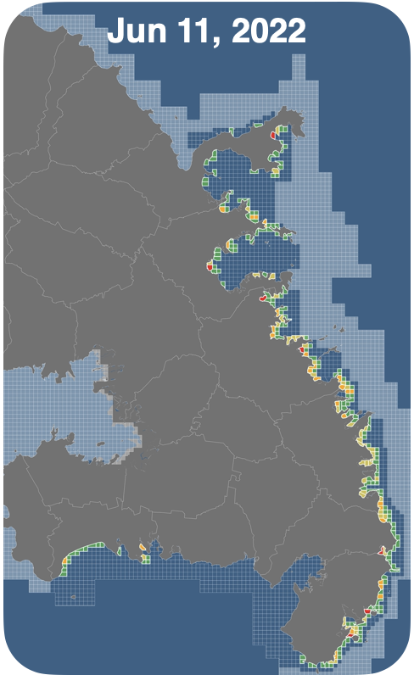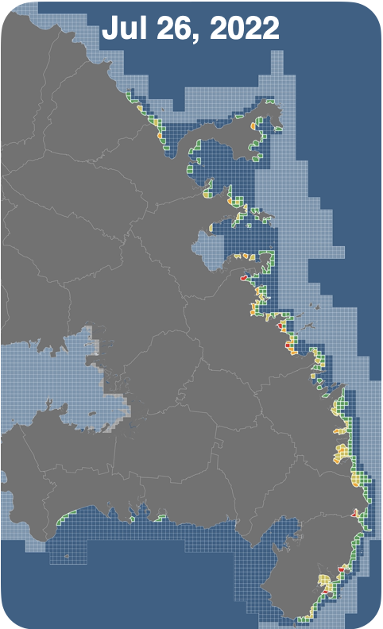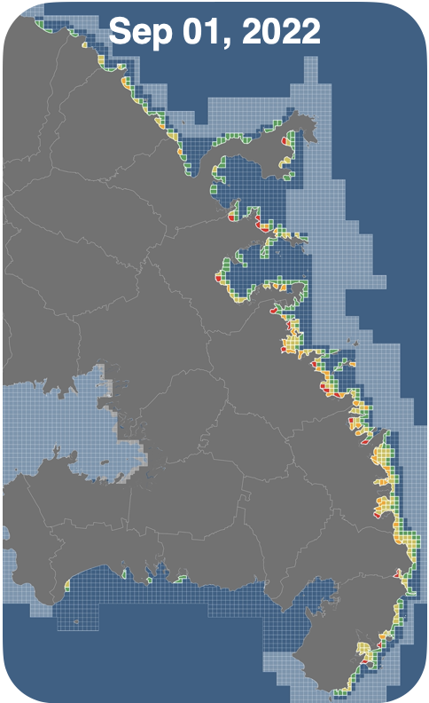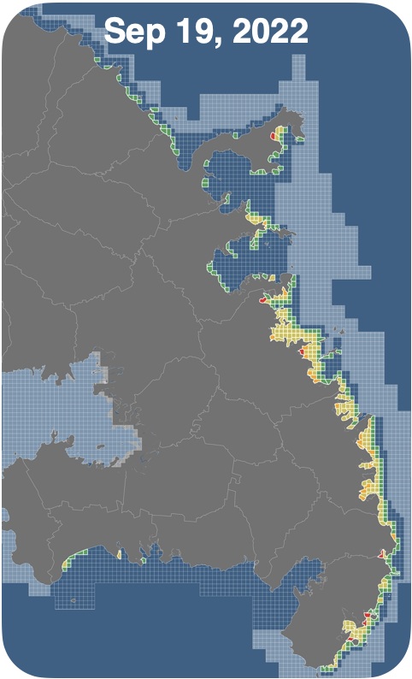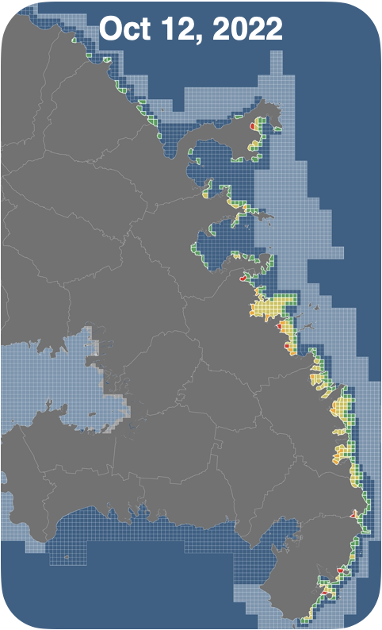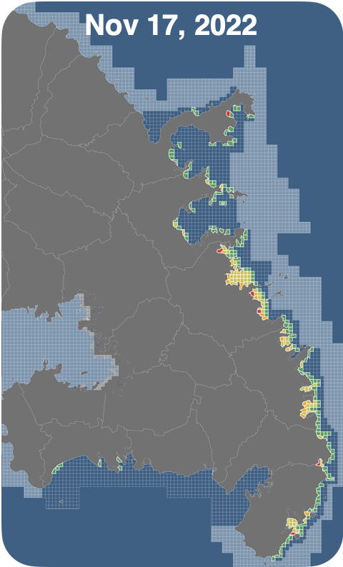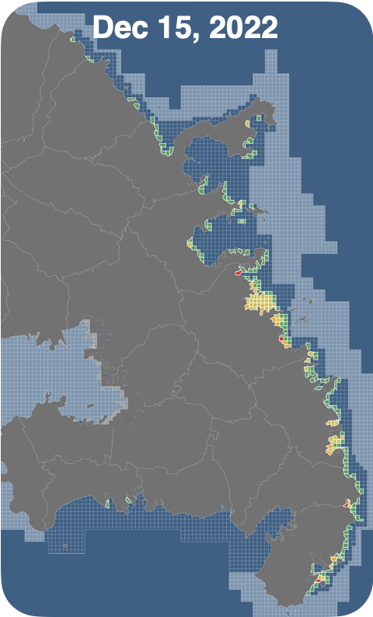
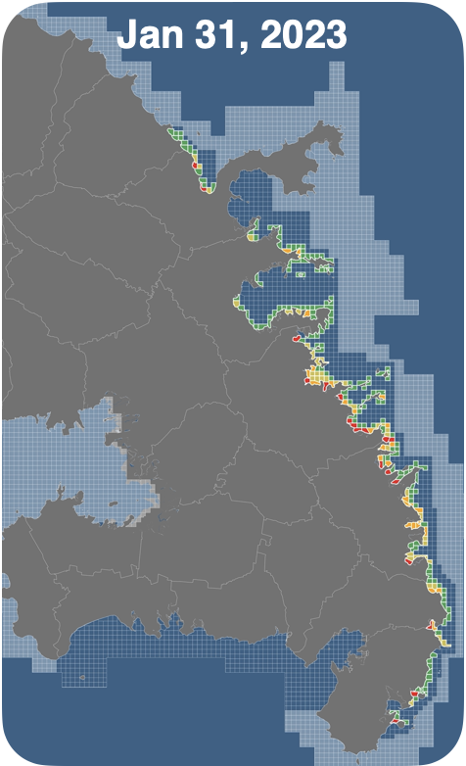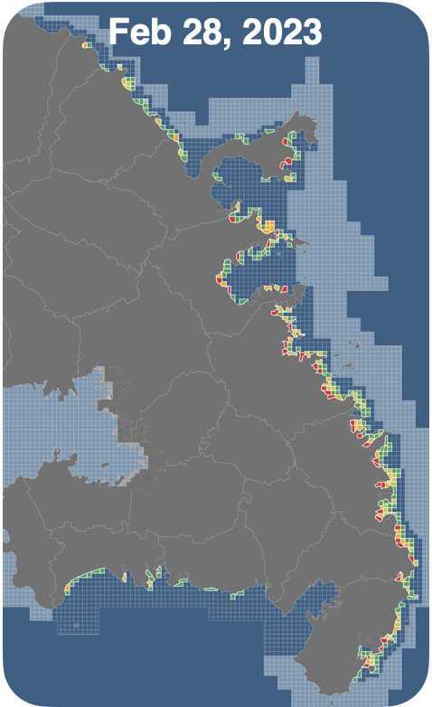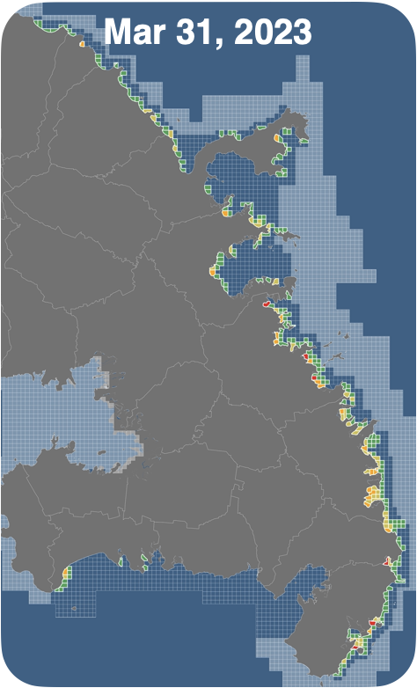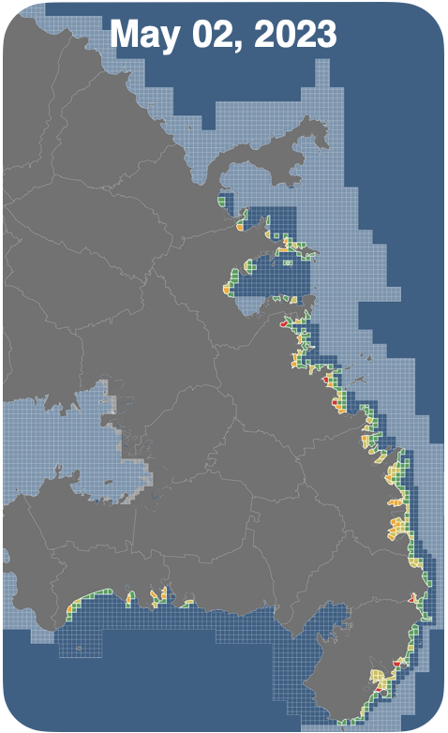
Figure A.4 (1/2) – Evolution of the sargassum pressure index (P_{sarg}) from May 2022 to December 2023 along the coast of Martinique.
Base map: BD TOPO® 2019 - IGN

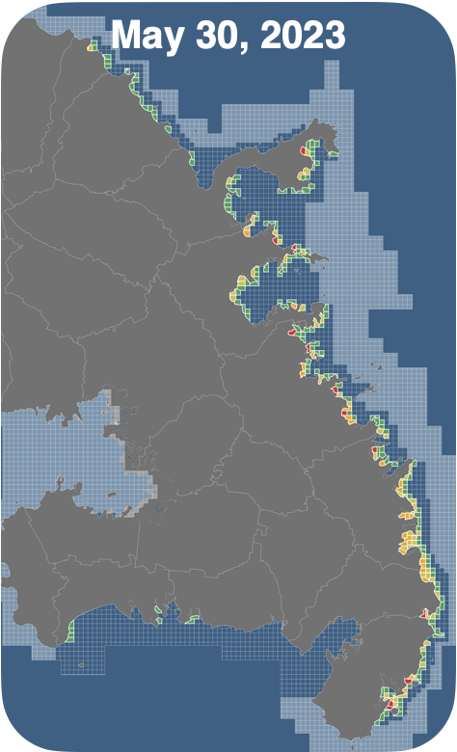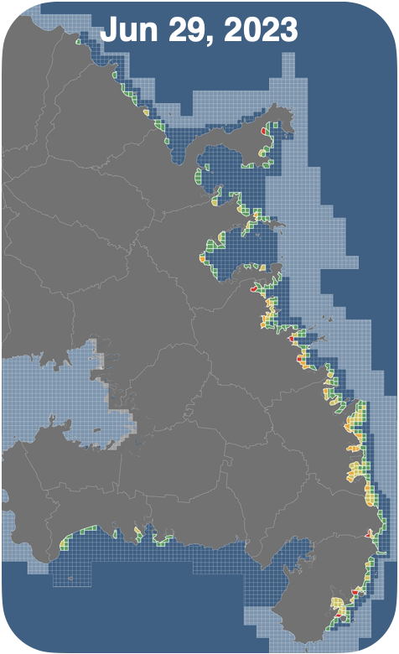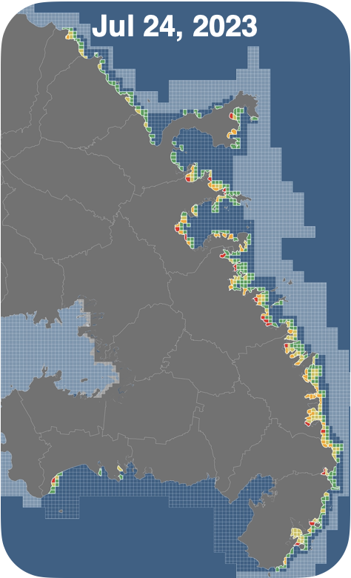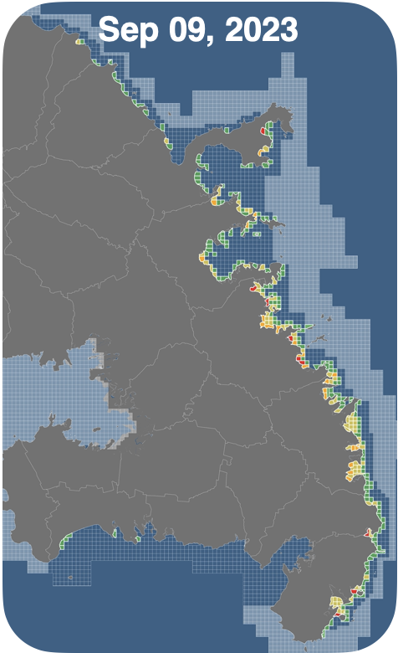
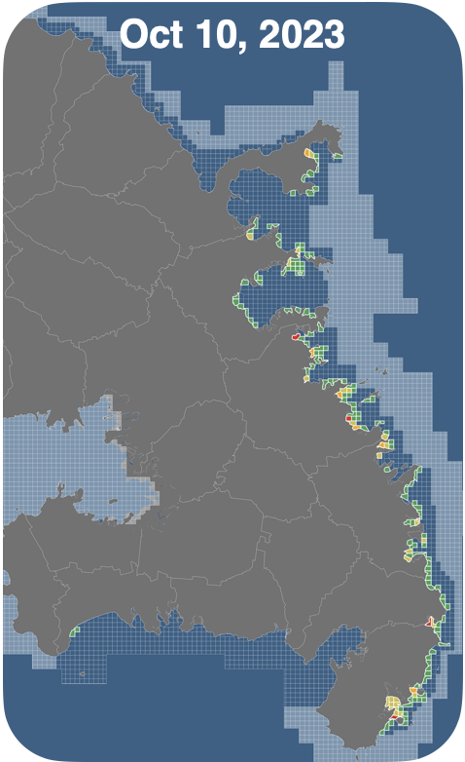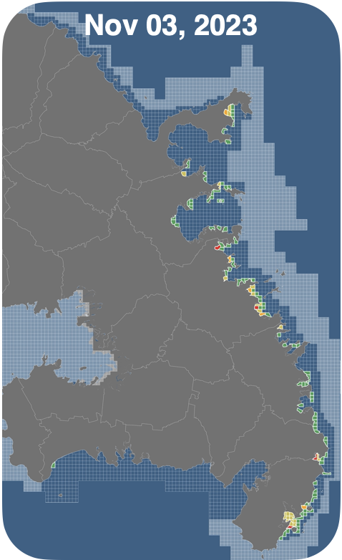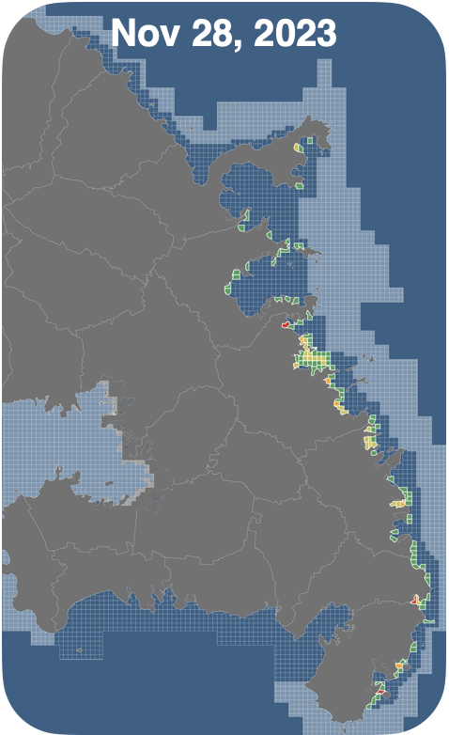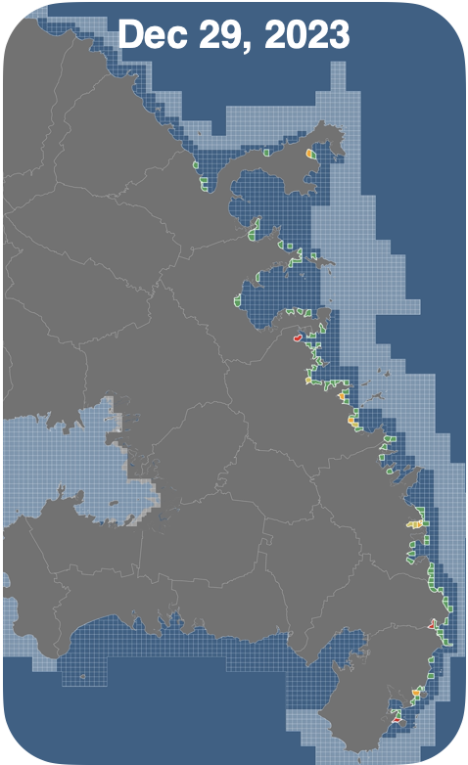
Figure A.4 (2/2) – Evolution of the sargassum pressure index (P_{sarg}) from May 2022 to December 2023 along the coast of Martinique.
Base map: BD TOPO® 2019 - IGN

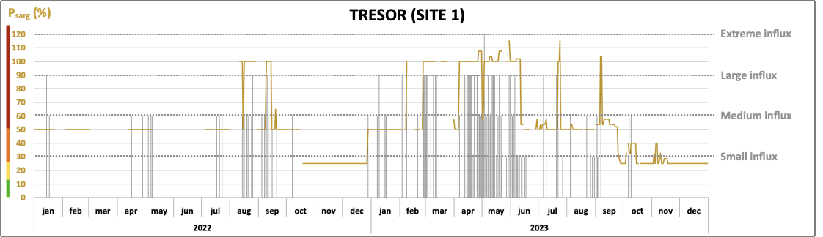
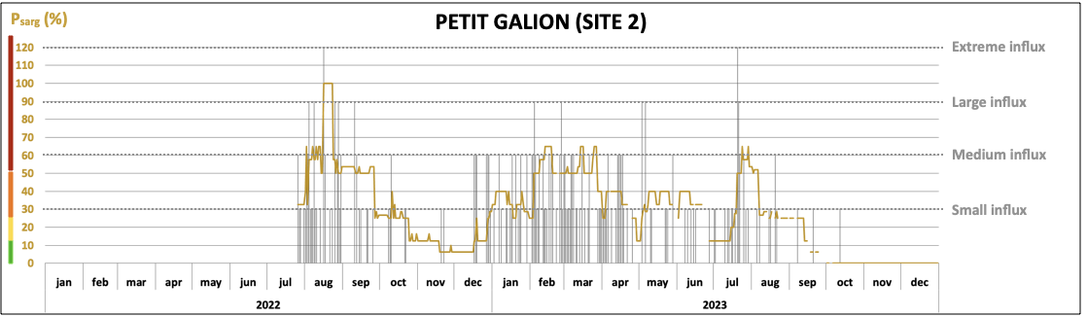
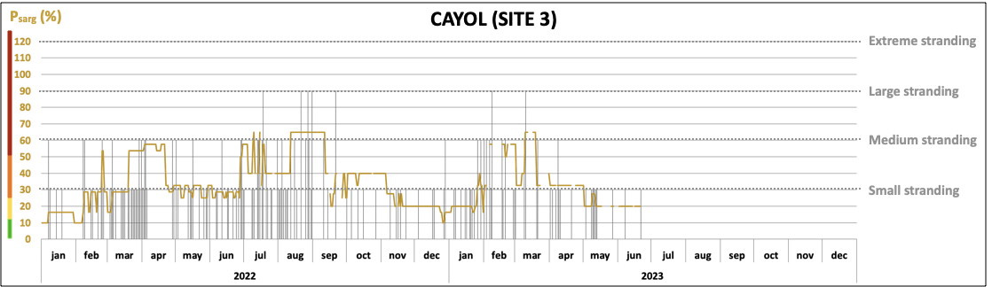
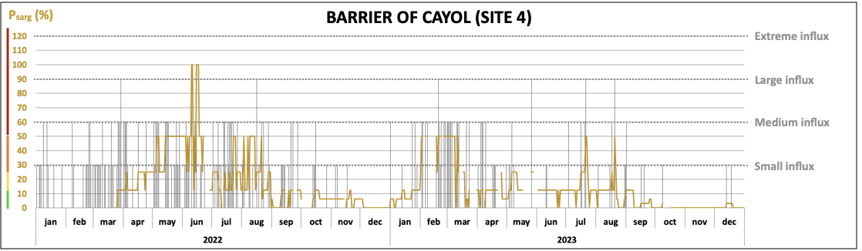
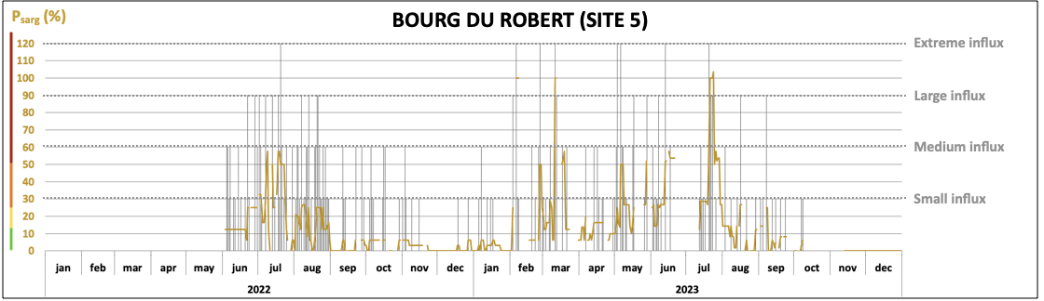
Figure A.5 (1/2) – Daily sargassum pressure index (P_{sarg}) and daily sargassum influx intensity from January 2022 to December 2023 in all in situ camera-monitored sites.
Missing values are due to cameras that had not yet been installed or malfunctions.
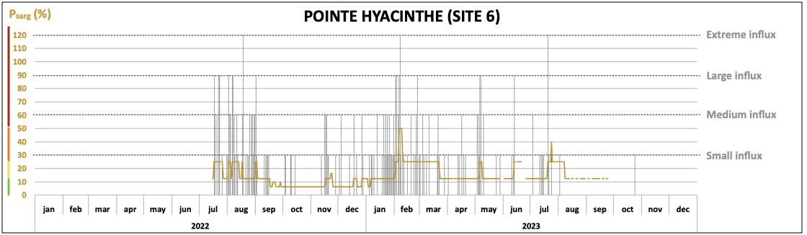
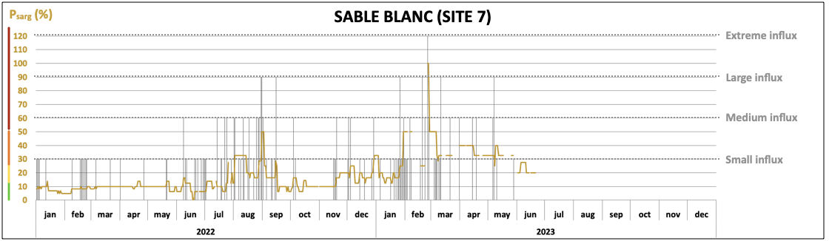
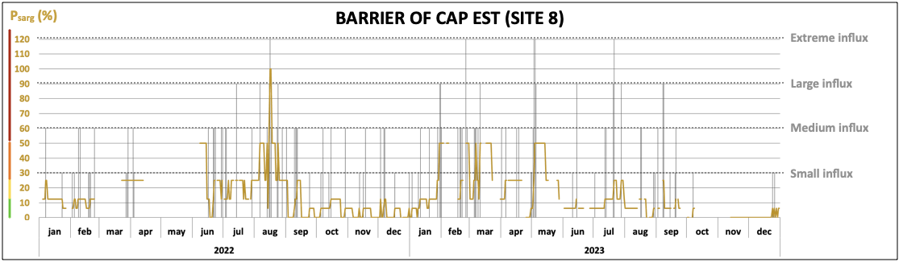
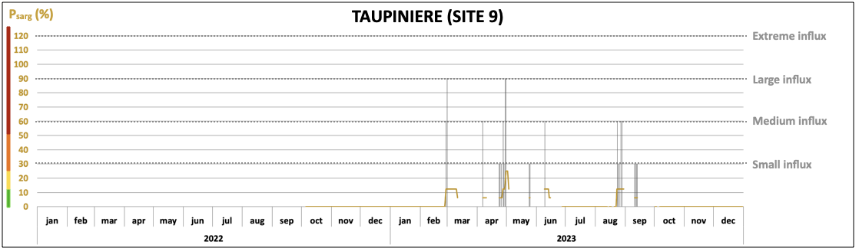
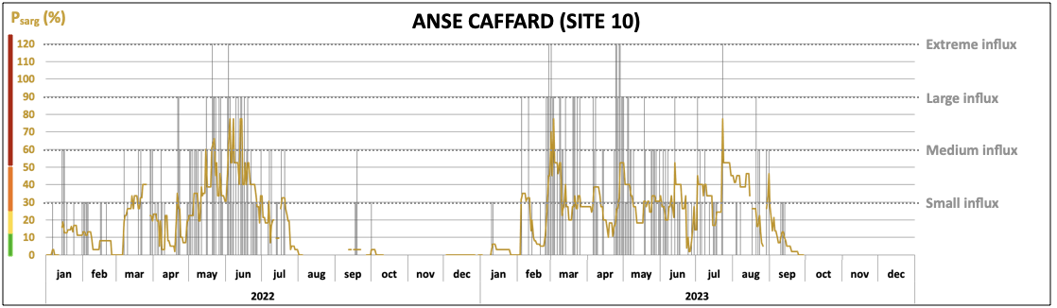
Figure A.2 (2/2) – Daily sargassum pressure index (P_{sarg}) and daily sargassum influx intensity from January 2022 to December 2023 in all in situ camera-monitored sites.
Missing values are due to cameras that had not yet been installed or malfunctions.

