Appendix B
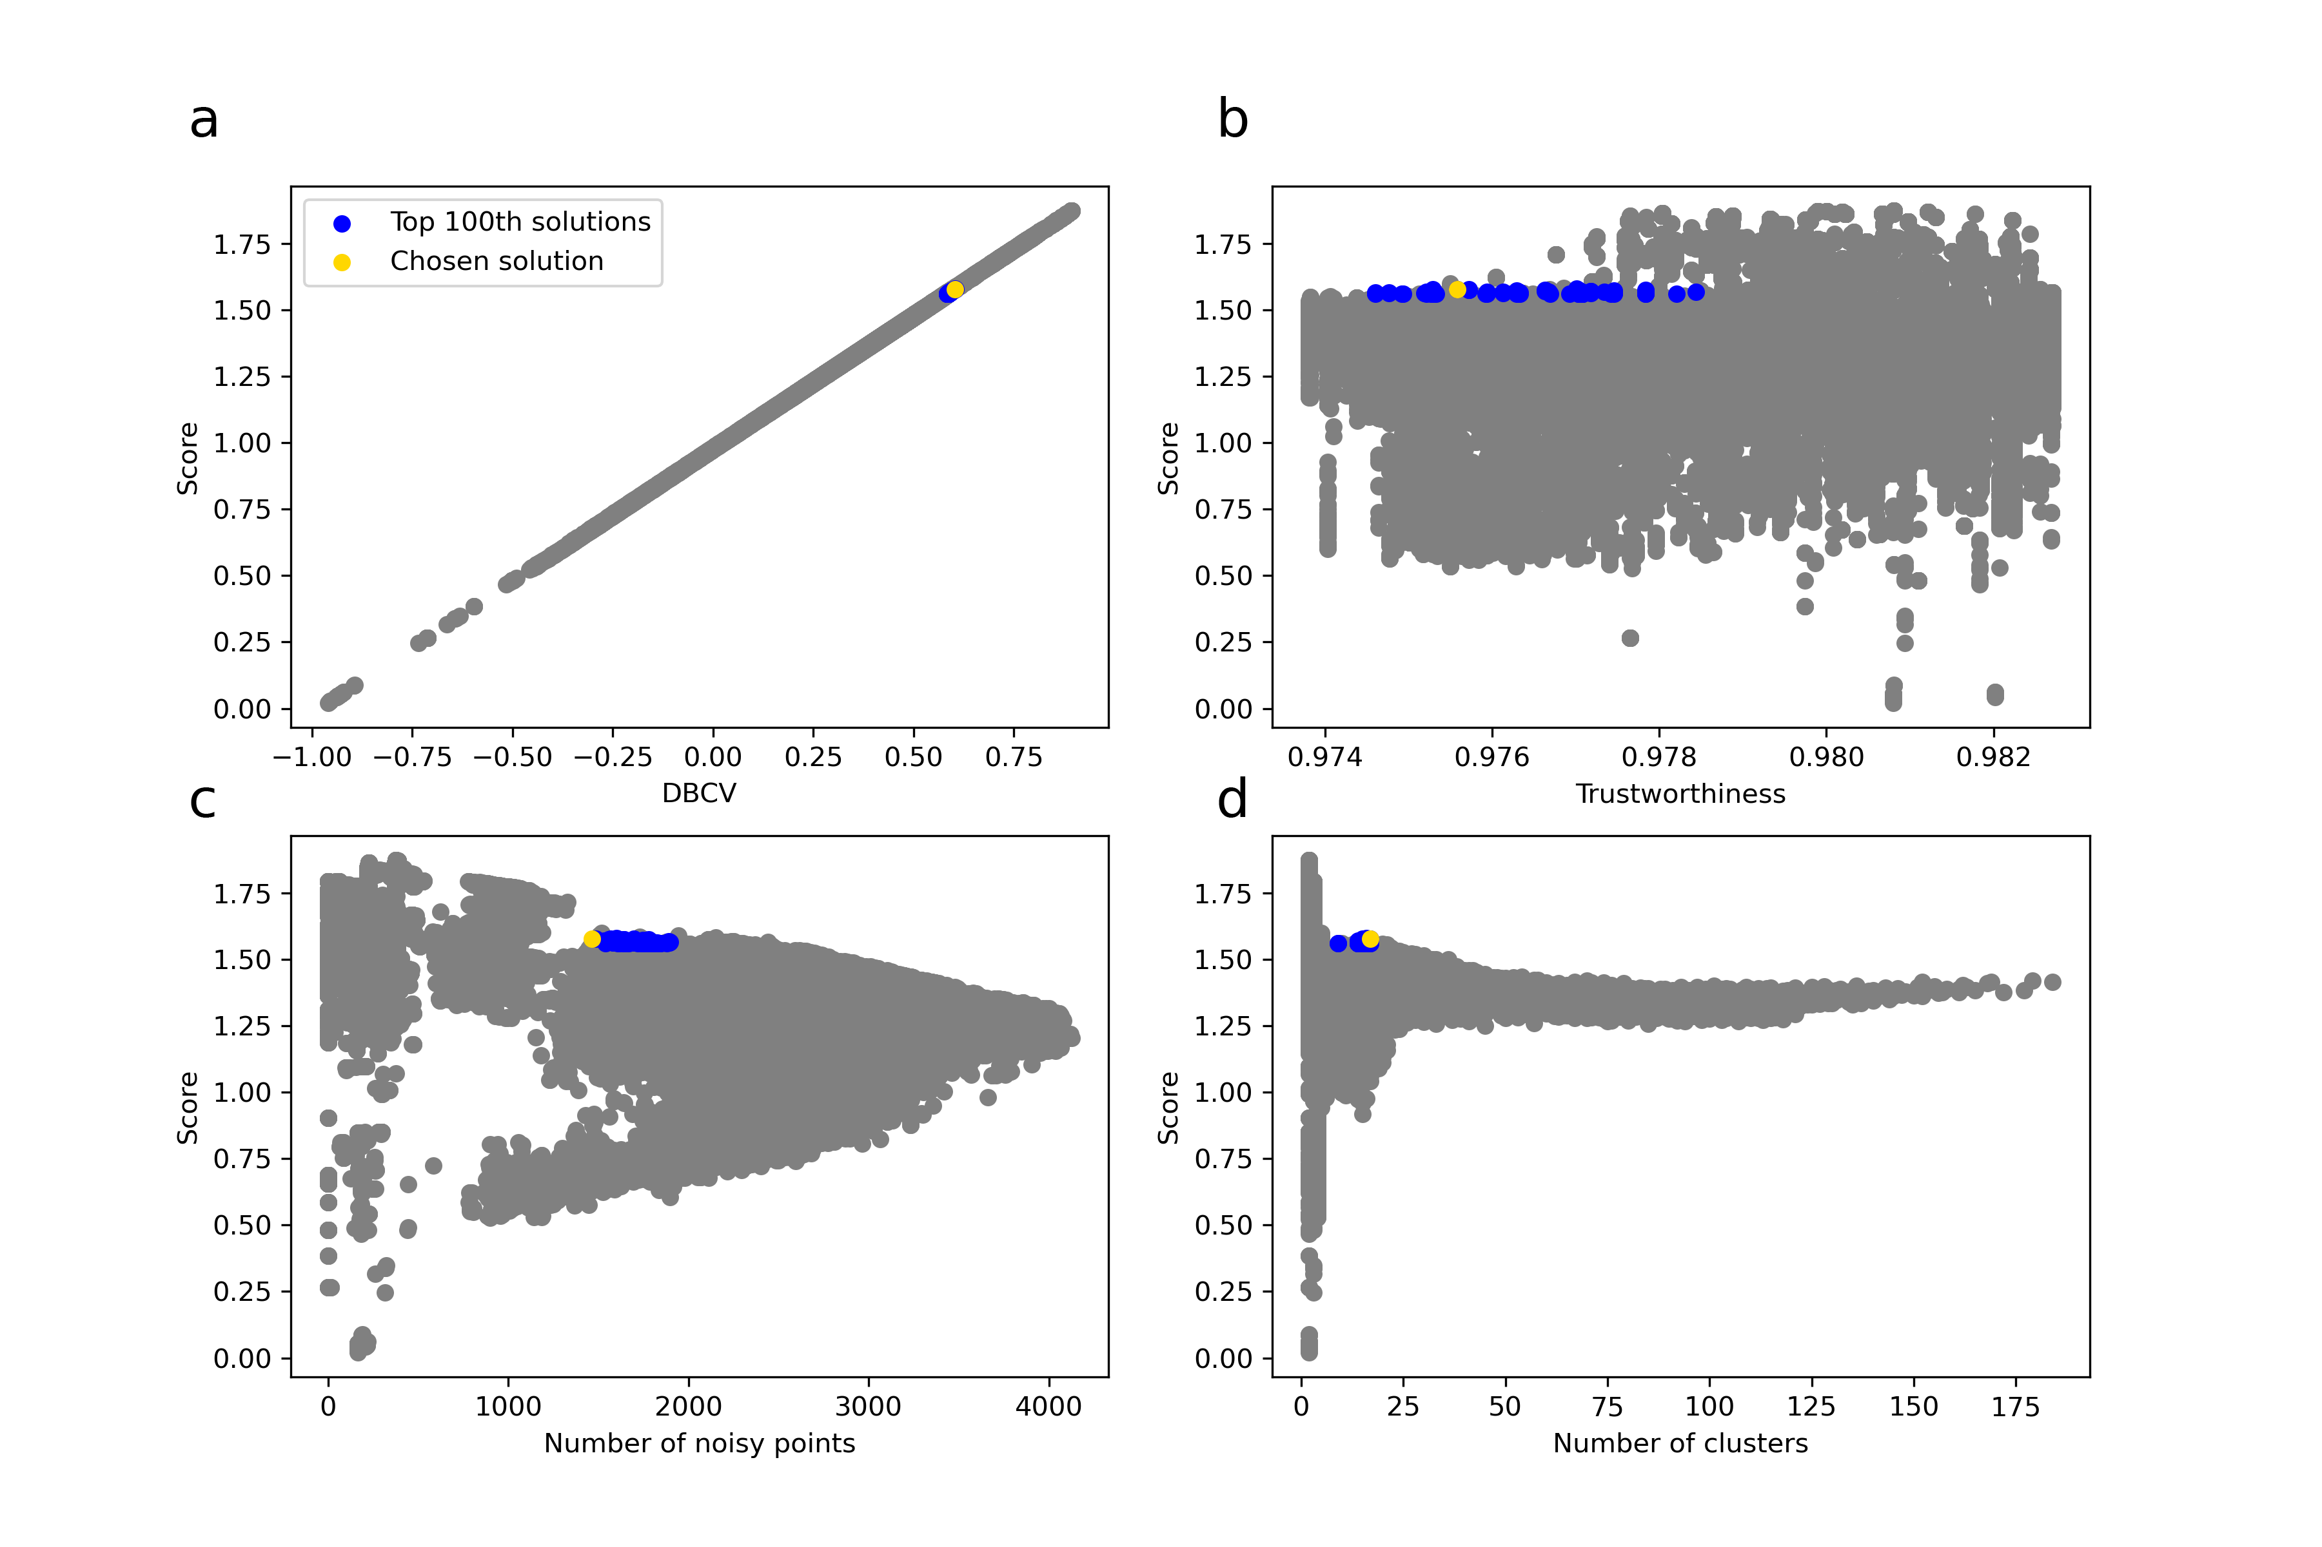
Figure 1: Plot of the evolution of the score (i.e. sum of the DBCV value and the Trustworthiness) according to the different parameters measured (a. DBCV; b. Trustworthiness; c. Number of noisy points; d. Number of clusters). Each of the 241,100 dots represent the evaluation of a unique combination of hyperparameter values for UMAP (n_neighbors) and HDBSCAN (min_cluster_size). Blue dots represent the top 100th solution, while the yellow dot represents the best solution found according to our criteria. All other grey dots represent the other evaluated solutions
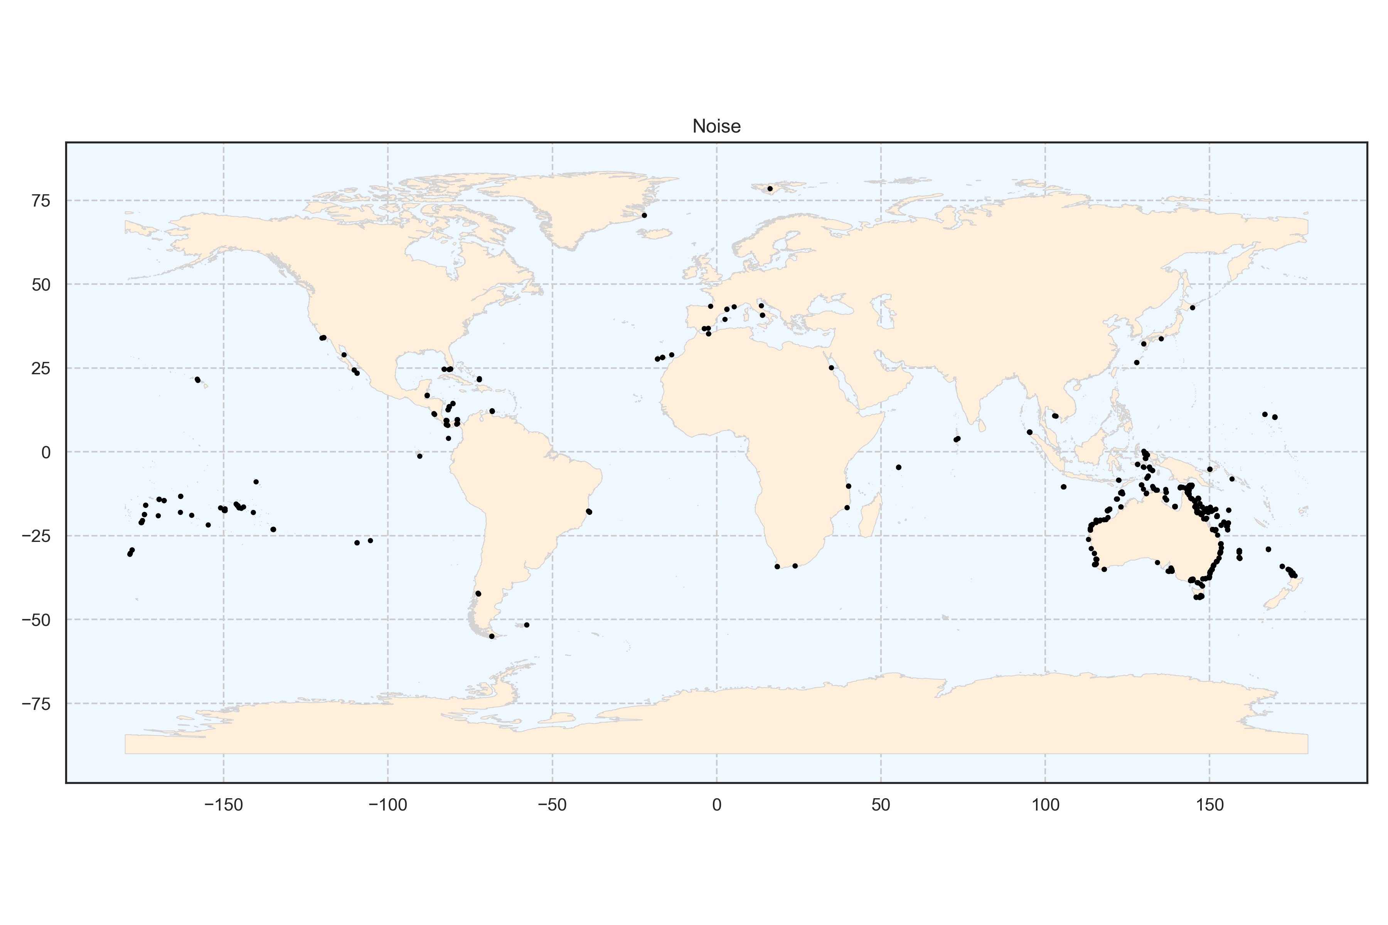
Figure 2: Spatial distribution of the cluster noise at the global scale. Each point represents a transect.
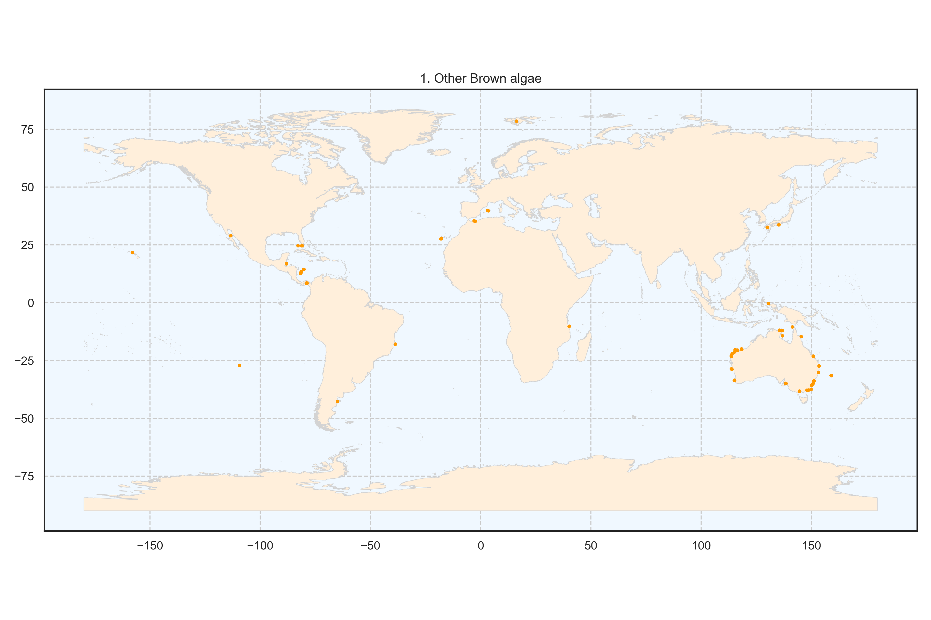
Figure 3: Spatial distribution of the cluster foliose brown algae at the global scale. Each point represents a transect.
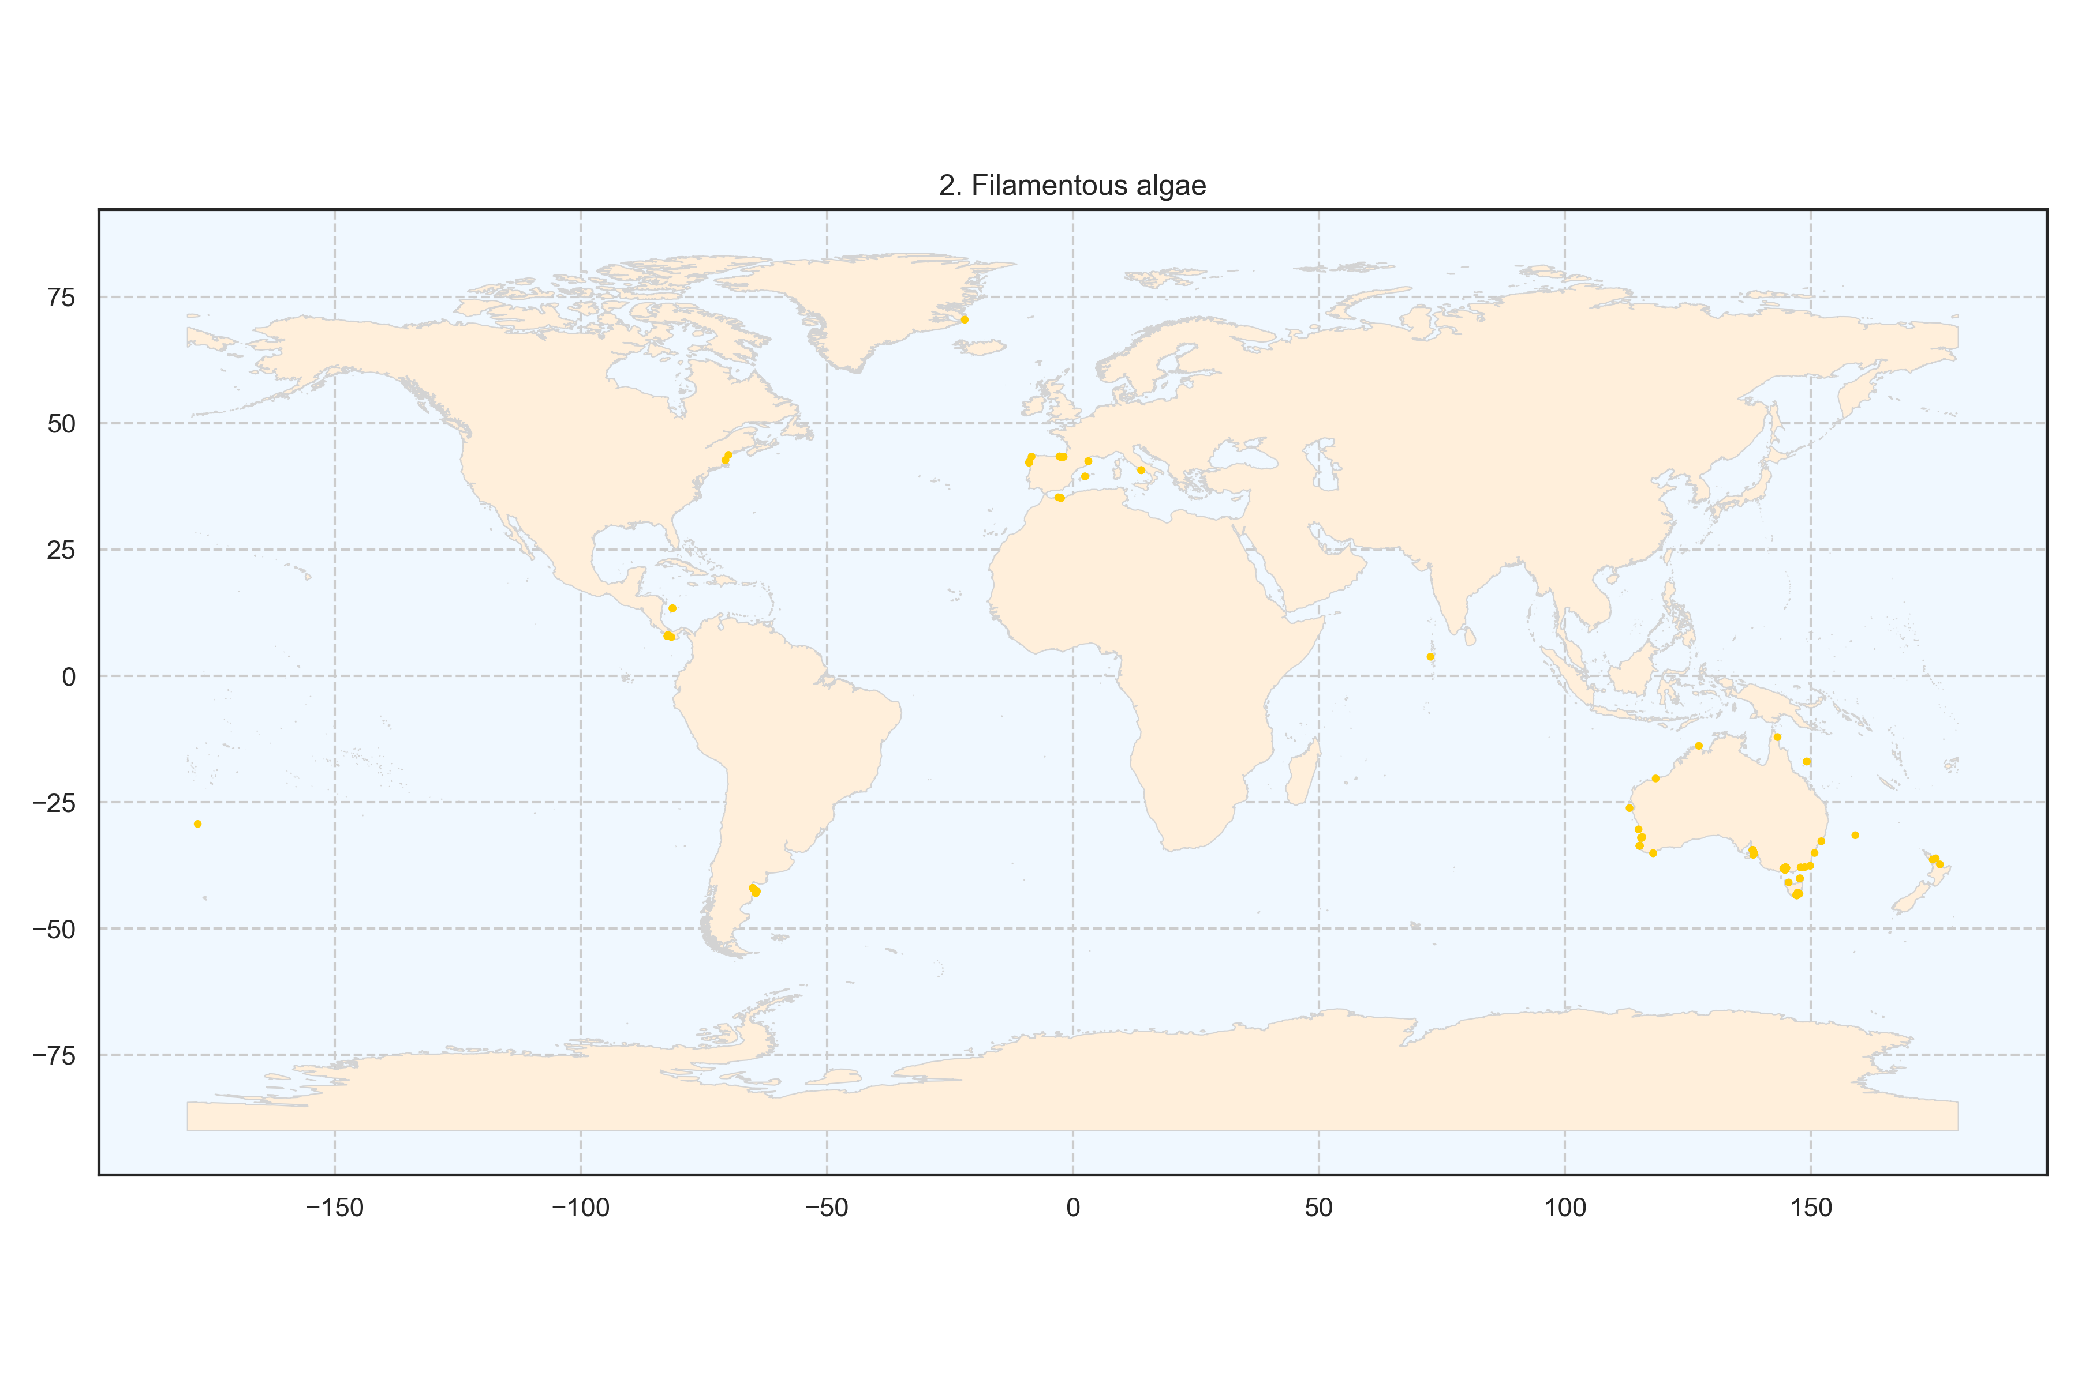
Figure 4: Spatial distribution of the cluster filamentous algae at the global scale. Each point represents a transect.
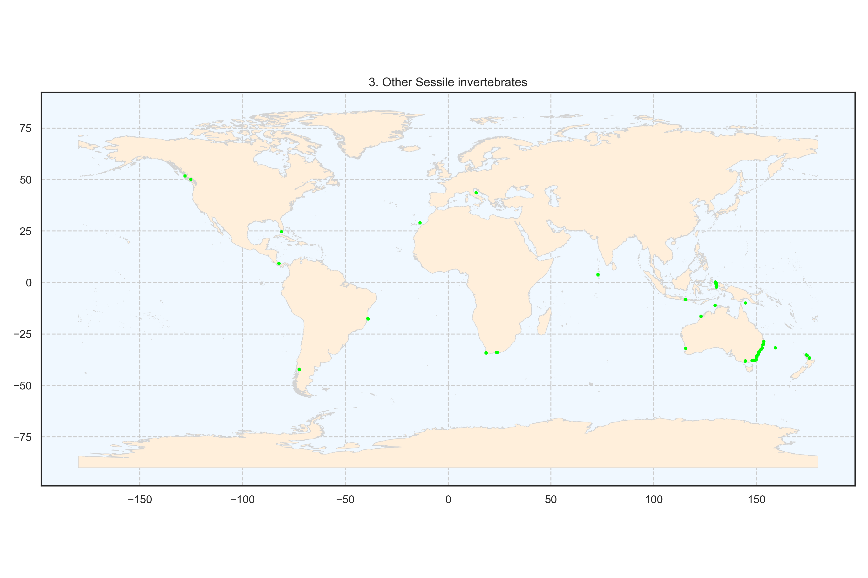
Figure 5: Spatial distribution of the cluster other Sessile invertebrates at the global scale. Each point represents a transect.
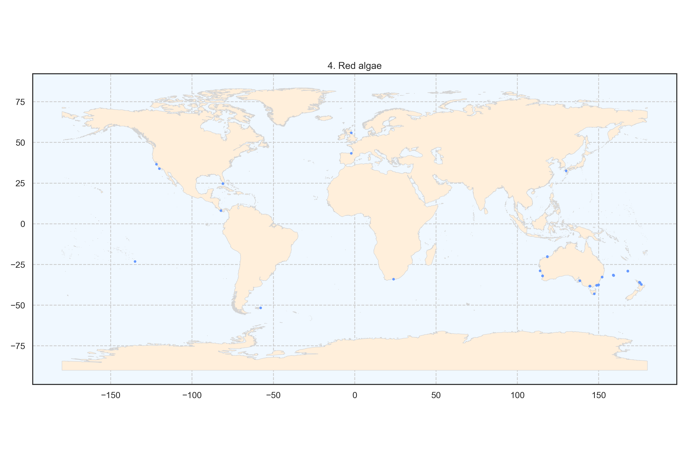
Figure 6: Spatial distribution of the cluster red algae at the global scale. Each point represents a transect.
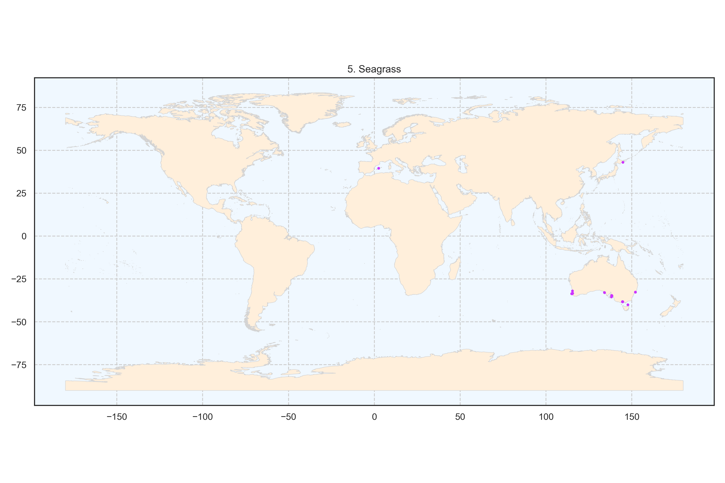
Figure 7: Spatial distribution of the cluster seagrass at the global scale. Each point represents a transect.
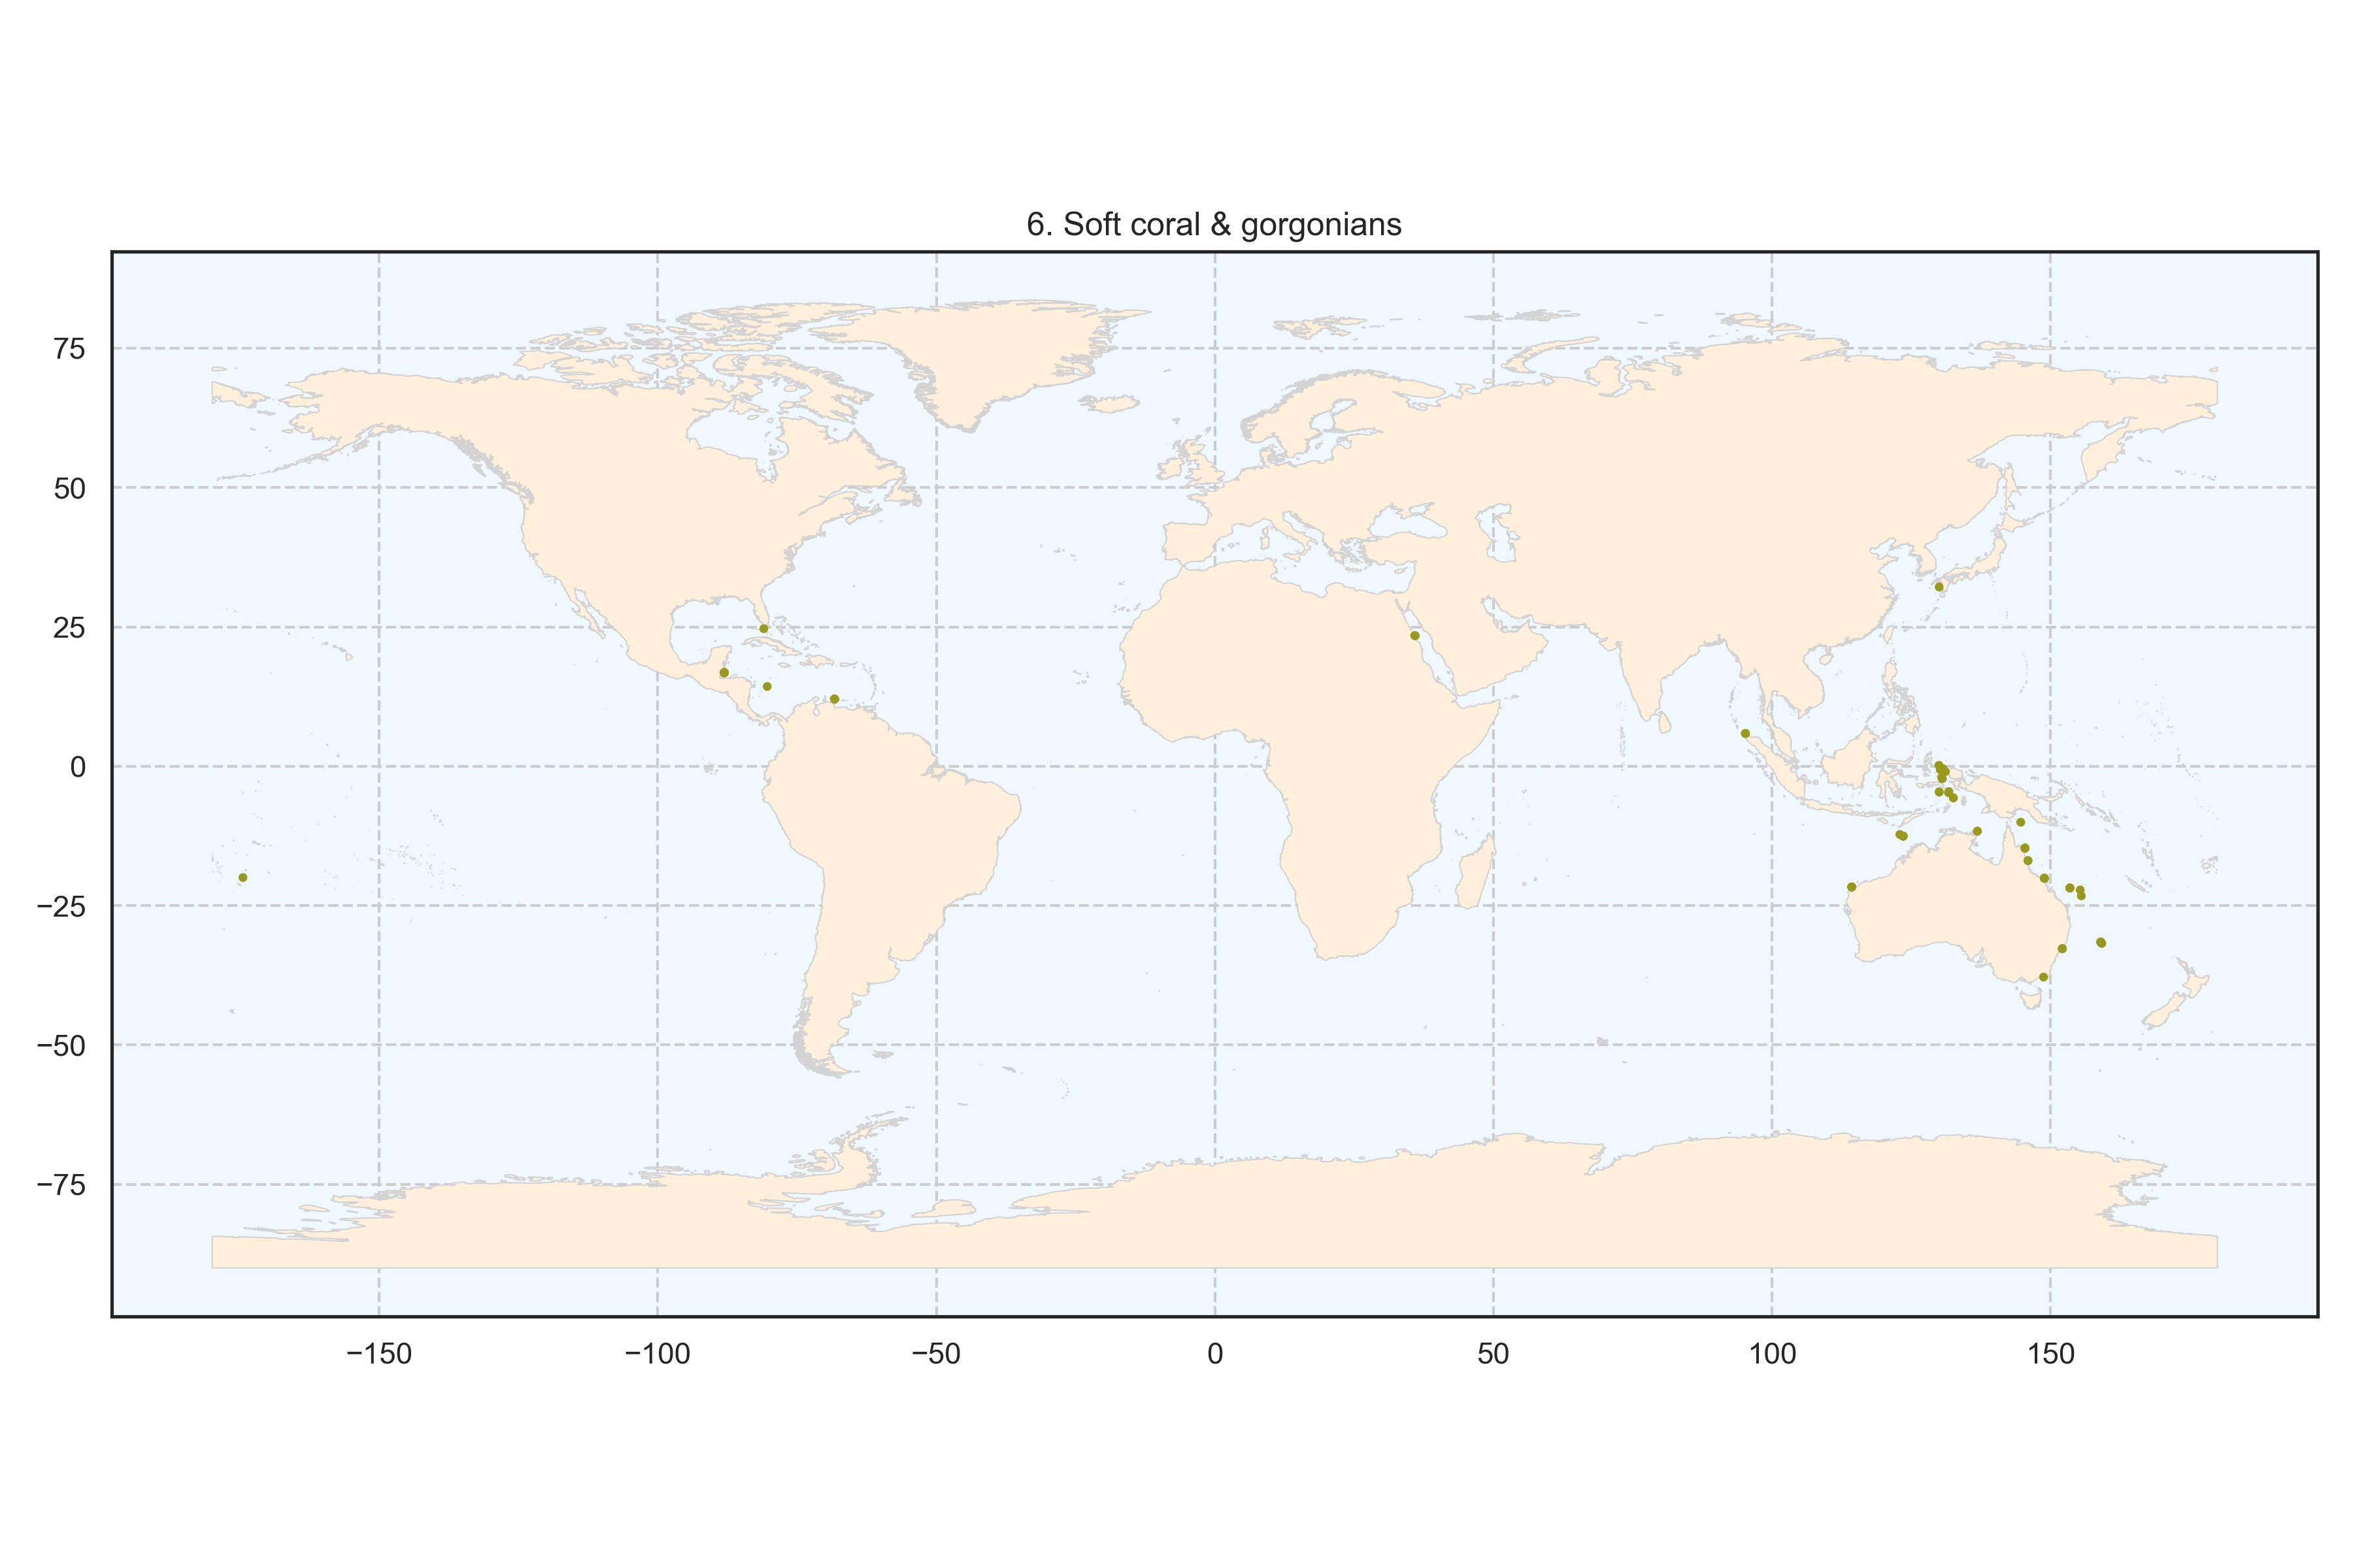
Figure 8: Spatial distribution of the cluster soft coral and gorgonians at the global scale. Each point represents a transect.
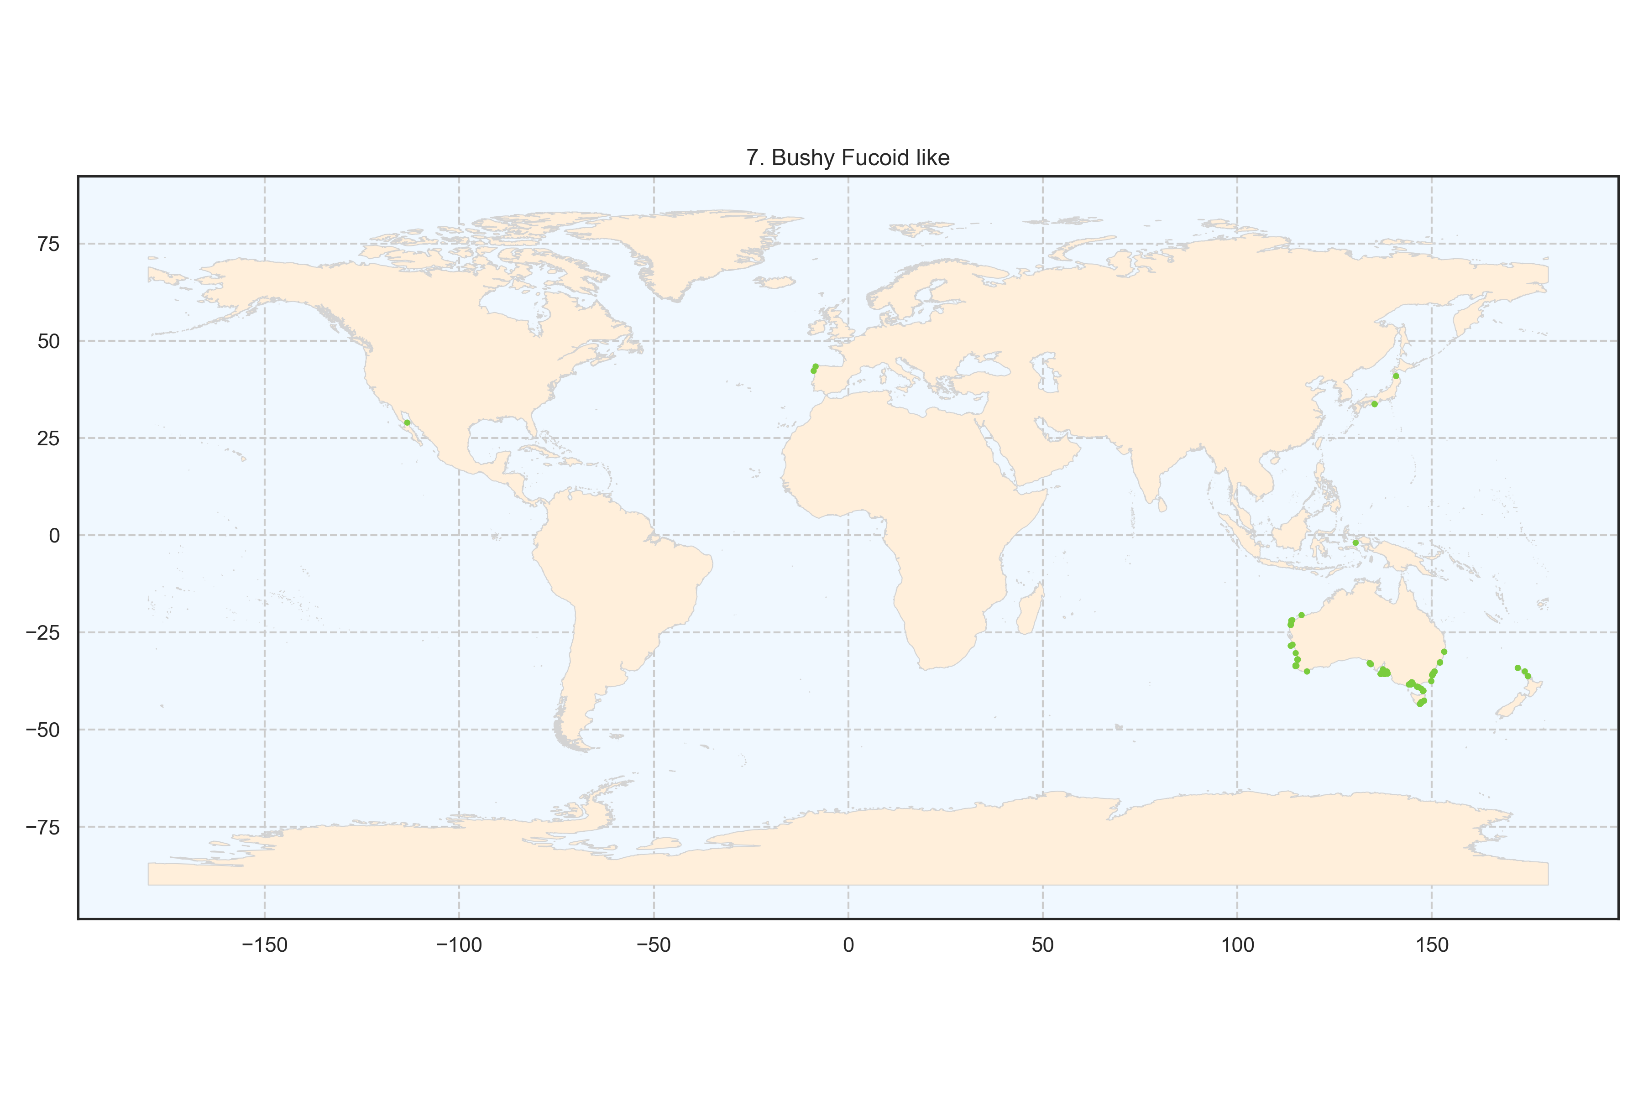
Figure 9: Spatial distribution of the cluster bushy fucoid-like algae at the global scale. Each point represents a transect.
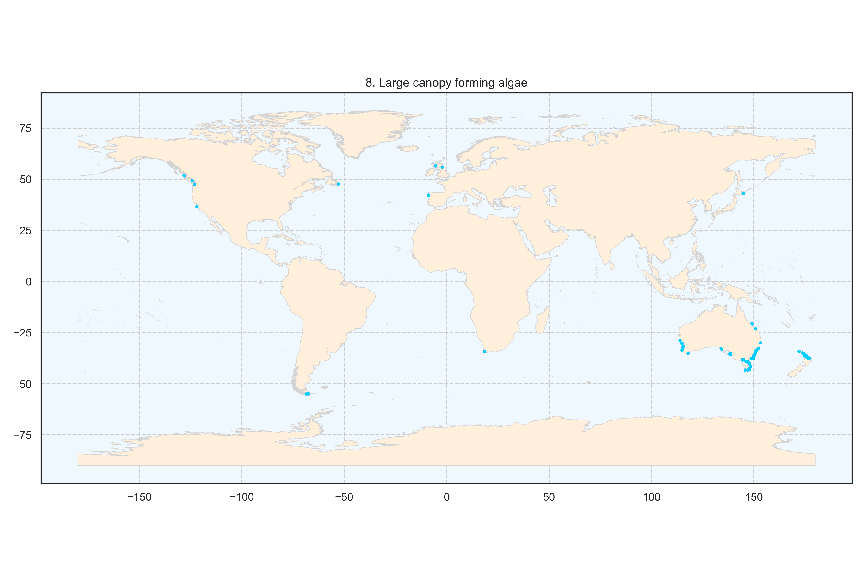
Figure 10: Spatial distribution of the cluster large canopy forming algae at the global scale. Each point represents a transect.
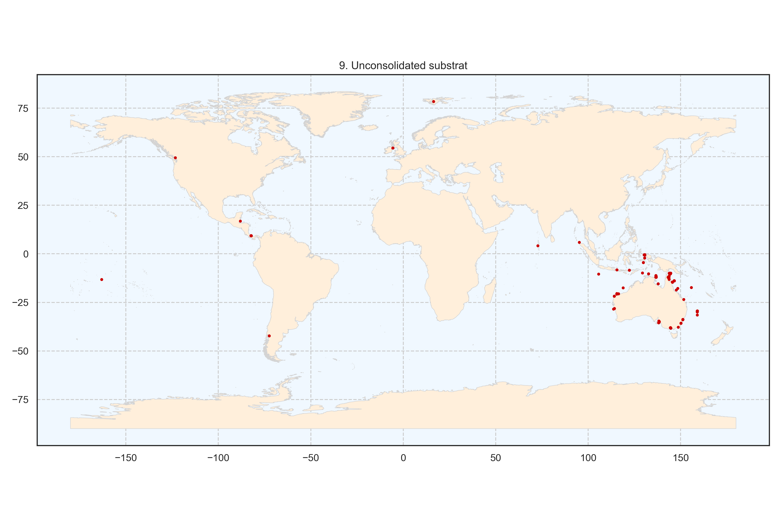
Figure 11: Spatial distribution of the cluster unconsolidated substrate at the global scale. Each point represents a transect.
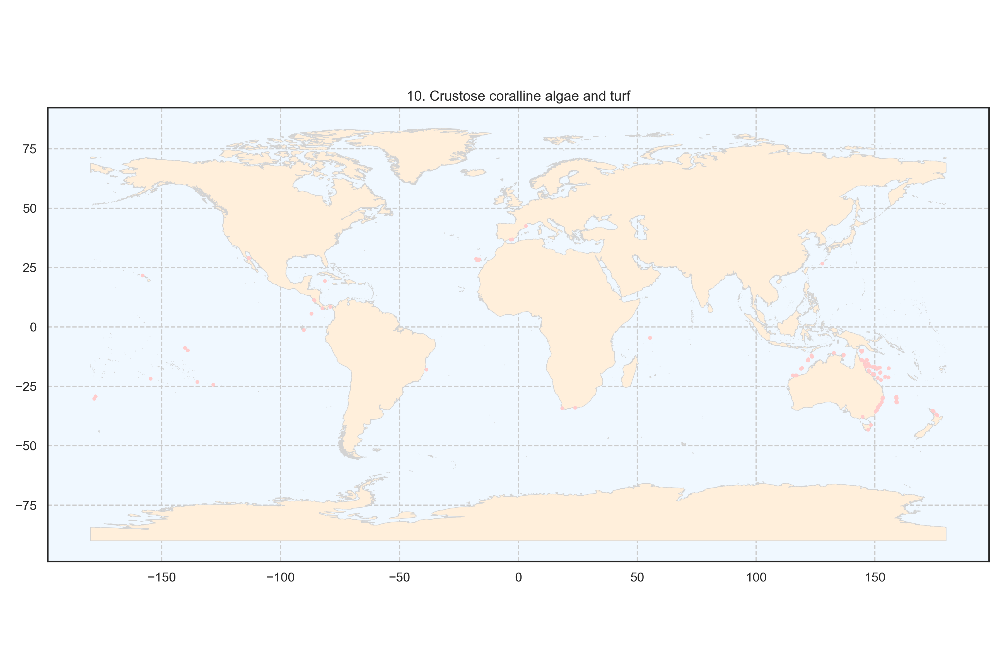
Figure 12: Spatial distribution of the cluster crustose coralline algae and turf at the global scale. Each point represents a transect.
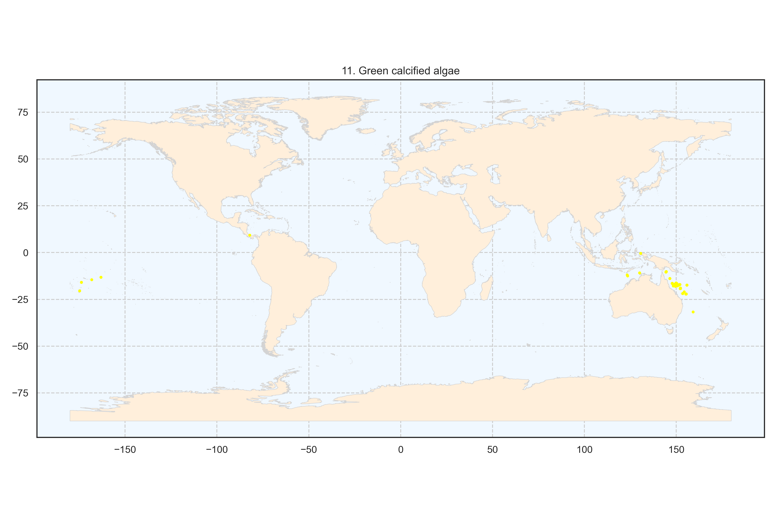
Figure 13: Spatial distribution of the cluster green calcified algae at the global scale. Each point represents a transect.
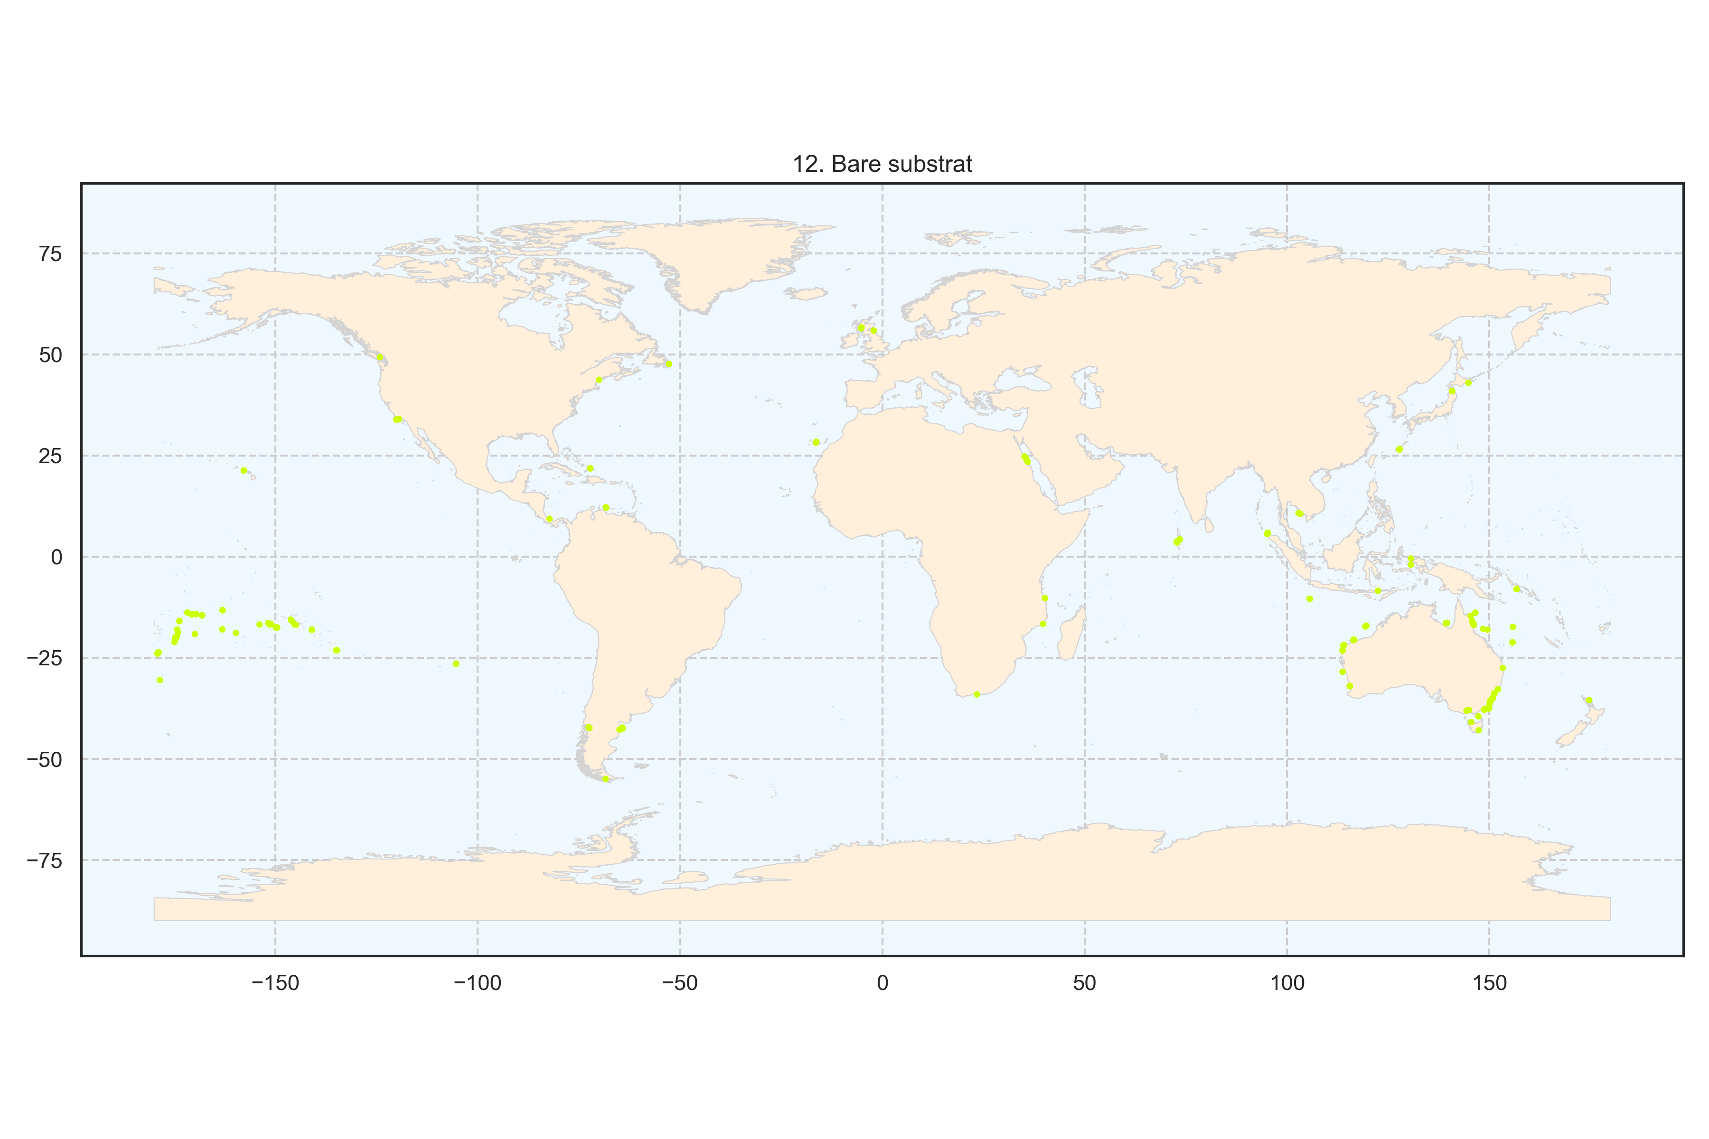
Figure 14: Spatial distribution of the cluster bare substrate at the global scale. Each point represents a transect.
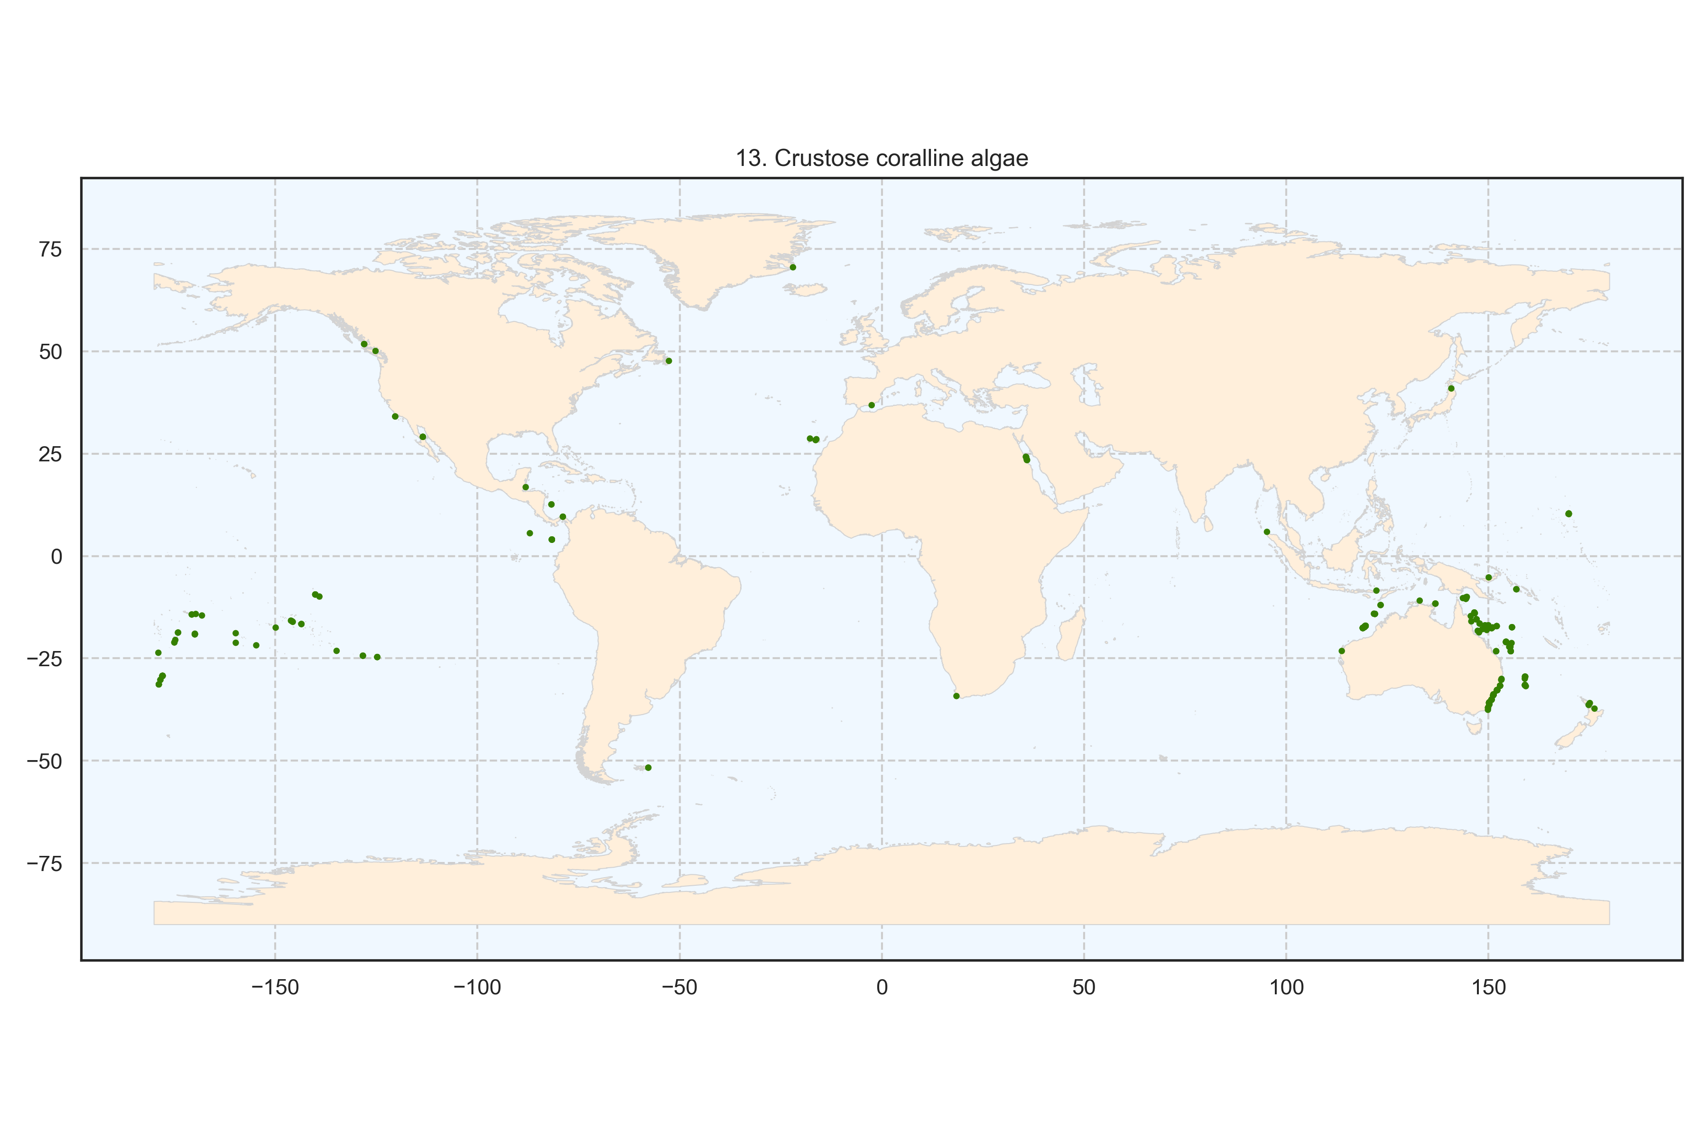
Figure 15: Spatial distribution of the cluster crustose coralline algae at the global scale. Each point represents a transect.
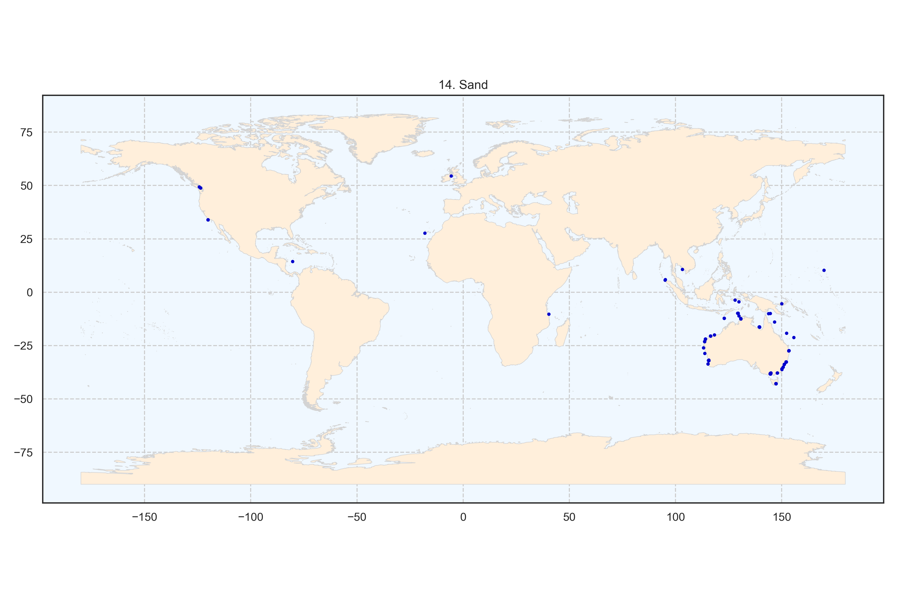
Figure 16: Spatial distribution of the cluster sand at the global scale. Each point represents a transect.
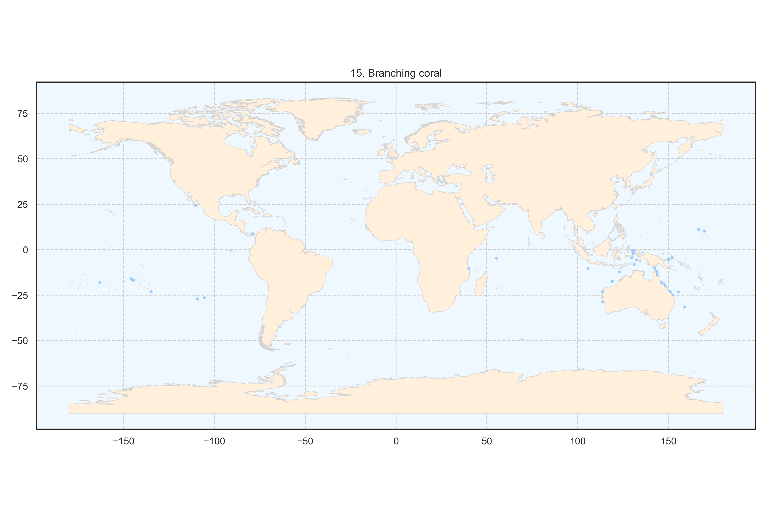
Figure 17: Spatial distribution of the cluster branching coral at the global scale. Each point represents a transect.
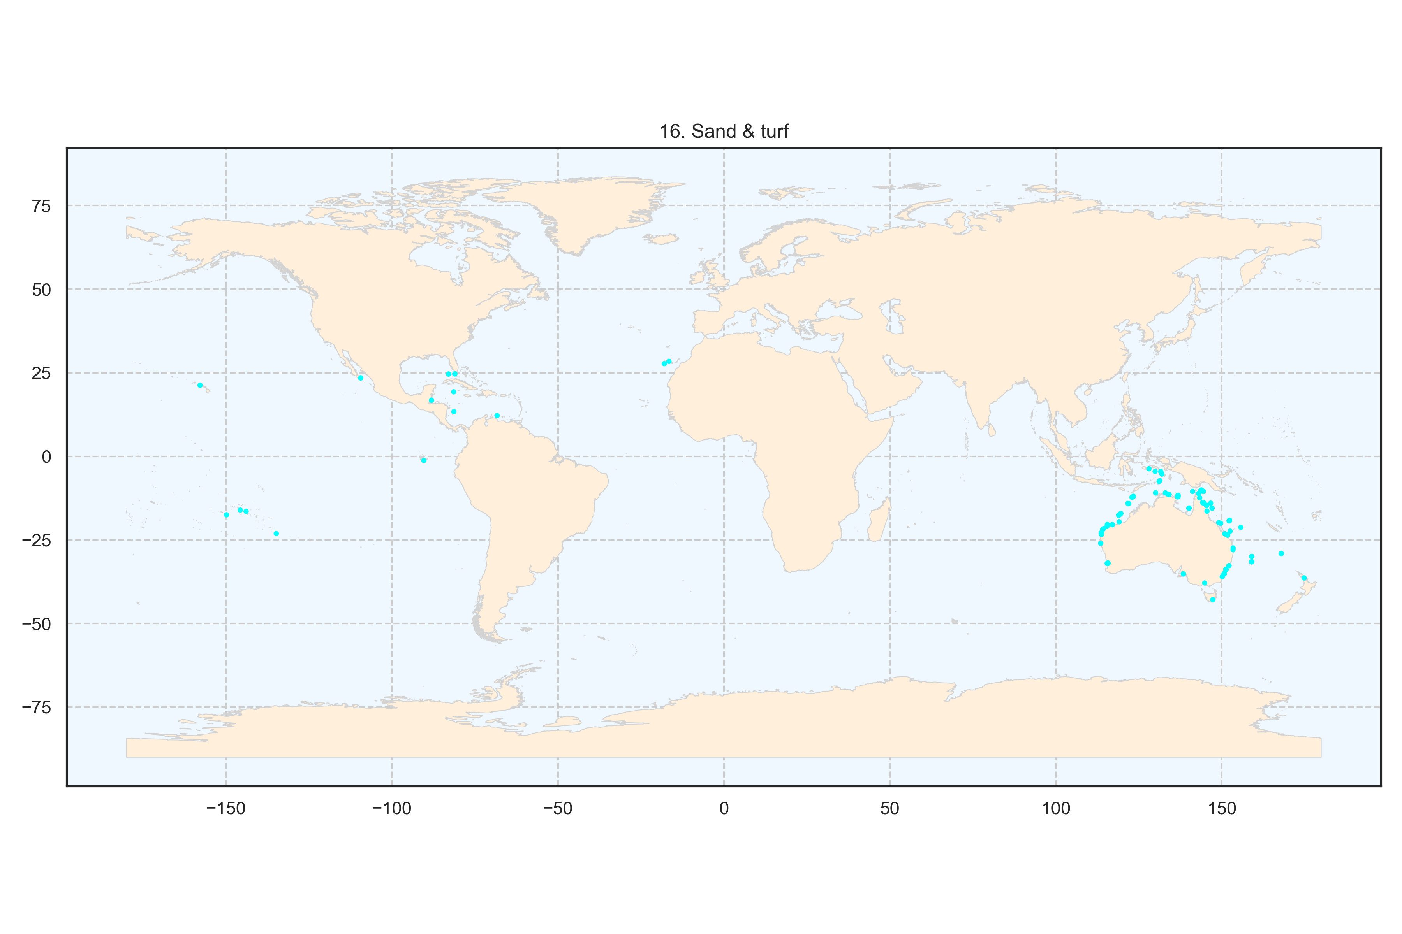
Figure 18: Spatial distribution of the cluster sand and turf algae at the global scale. Each point represents a transect.
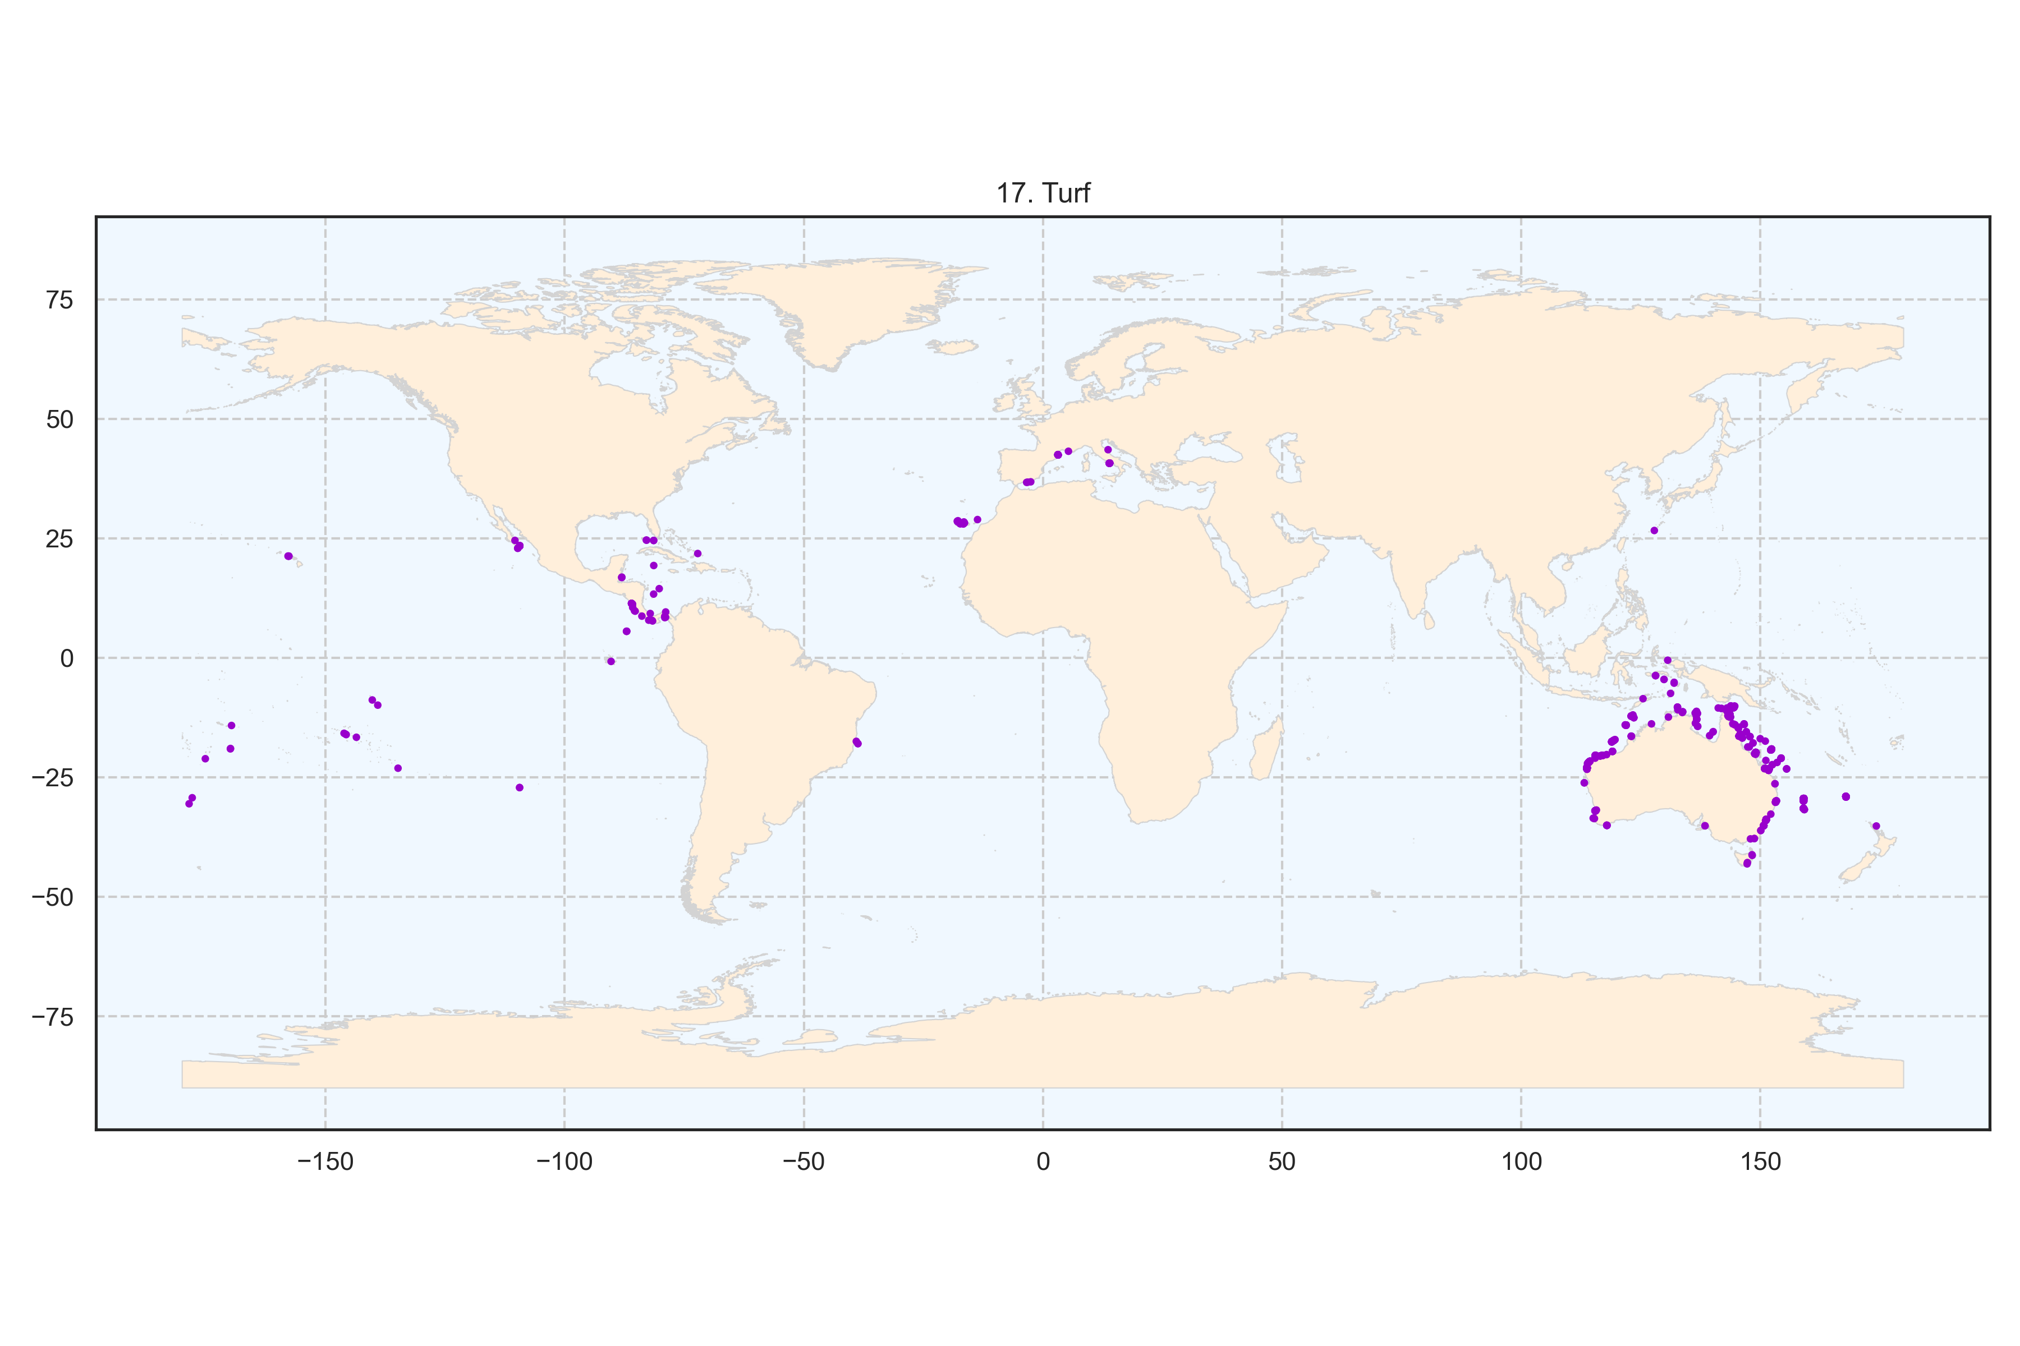
Figure 19: Spatial distribution of the cluster turf algae at the global scale. Each point represents a transect.

