Appendix C
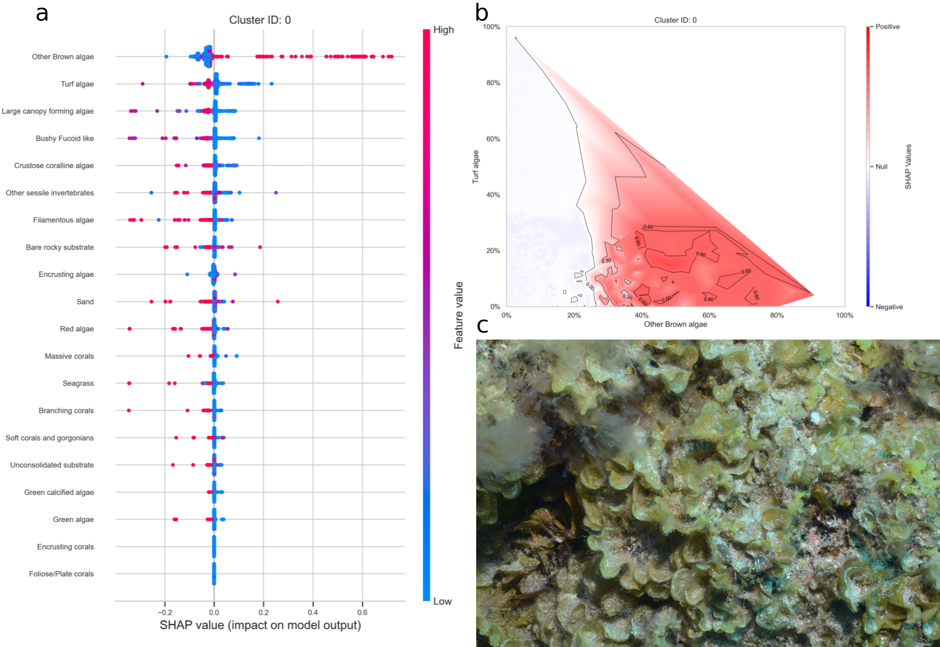
Figure 1: a. SHAP summary plot showing the impact of each habitat substrate on the classification. The position of each habitat group on the y-axis indicates its relative importance for the considered cluster. The position of each point along the x-axis indicates if the observation is associated with a lower or higher affinity with the cluster and the colour of the point indicates if the value of the cover of this habitat is rather high or low. b. Linear interpolation of the SHAP values for the two most influential variables for the cluster brown algae. c. Example of photoquadrat for one transect of the cluster brown algae categorised by HDBSCAN as exemplary.
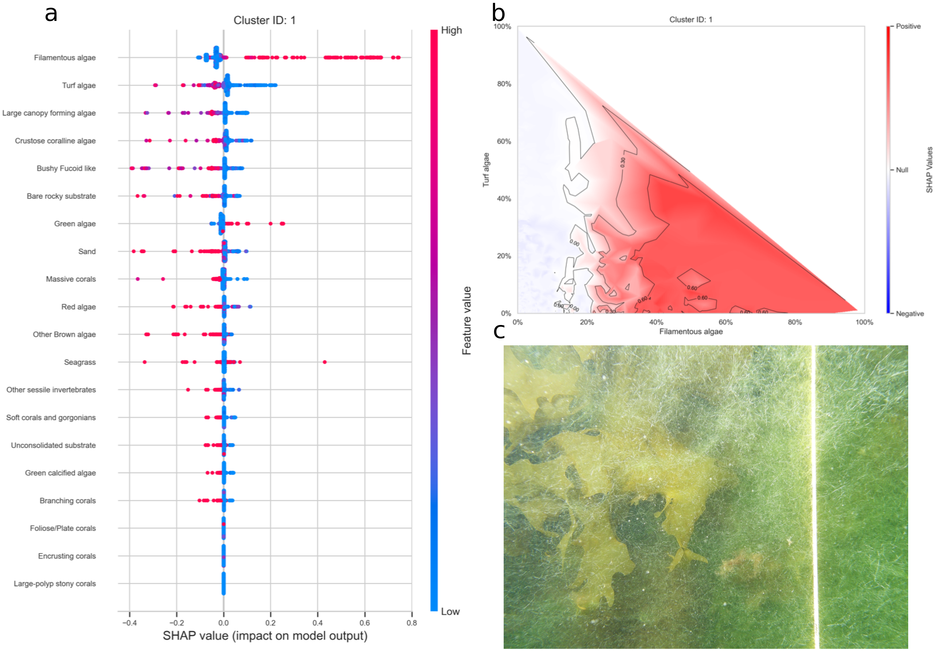
Figure 2: a. SHAP summary plot showing the impact of each habitat substrate on the classification. The position of each habitat group on the y-axis indicates its relative importance for the considered cluster. The position of each point along the x-axis indicates if the observation is associated with a lower or higher affinity with the cluster and the colour of the point indicates if the value of the cover of this habitat is rather high or low. b. Linear interpolation of the SHAP values for the two most influential variables for the cluster filamentous algae. c. Example of photoquadrat for one transect of the cluster filamentous algae categorised by HDBSCAN as exemplary.
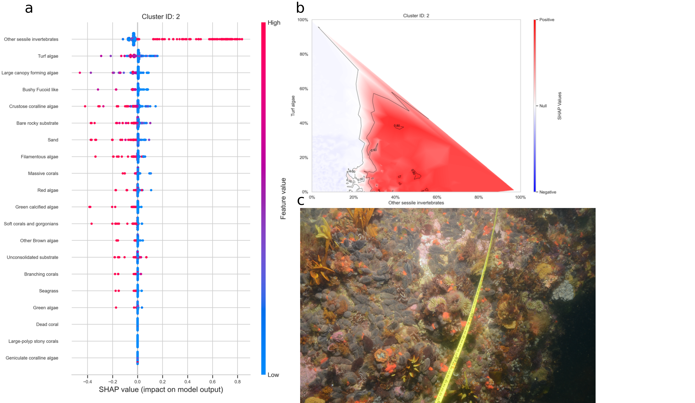
Figure 3: a. SHAP summary plot showing the impact of each habitat substrate on the classification. The position of each habitat group on the y-axis indicates its relative importance for the considered cluster. The position of each point along the x-axis indicates if the observation is associated with a lower or higher affinity with the cluster and the colour of the point indicates if the value of the cover of this habitat is rather high or low. b. Linear interpolation of the SHAP values for the two most influential variables for the cluster sessile invertebrates. c. Example of photoquadrat for one transect of the cluster sessile invertebrates categorised by HDBSCAN as exemplary.
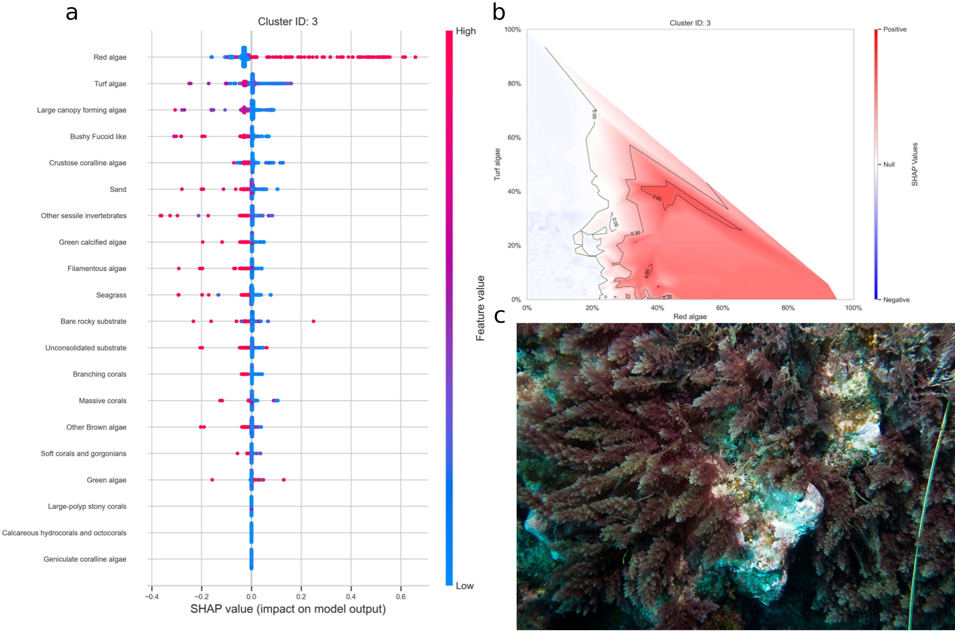
Figure 4: a. SHAP summary plot showing the impact of each habitat substrate on the classification. The position of each habitat group on the y-axis indicates its relative importance for the considered cluster. The position of each point along the x-axis indicates if the observation is associated with a lower or higher affinity with the cluster and the colour of the point indicates if the value of the cover of this habitat is rather high or low. b. Linear interpolation of the SHAP values for the two most influential variables for the cluster red algae. c. Example of photoquadrat for one transect of the cluster red algae categorised by HDBSCAN as exemplary.
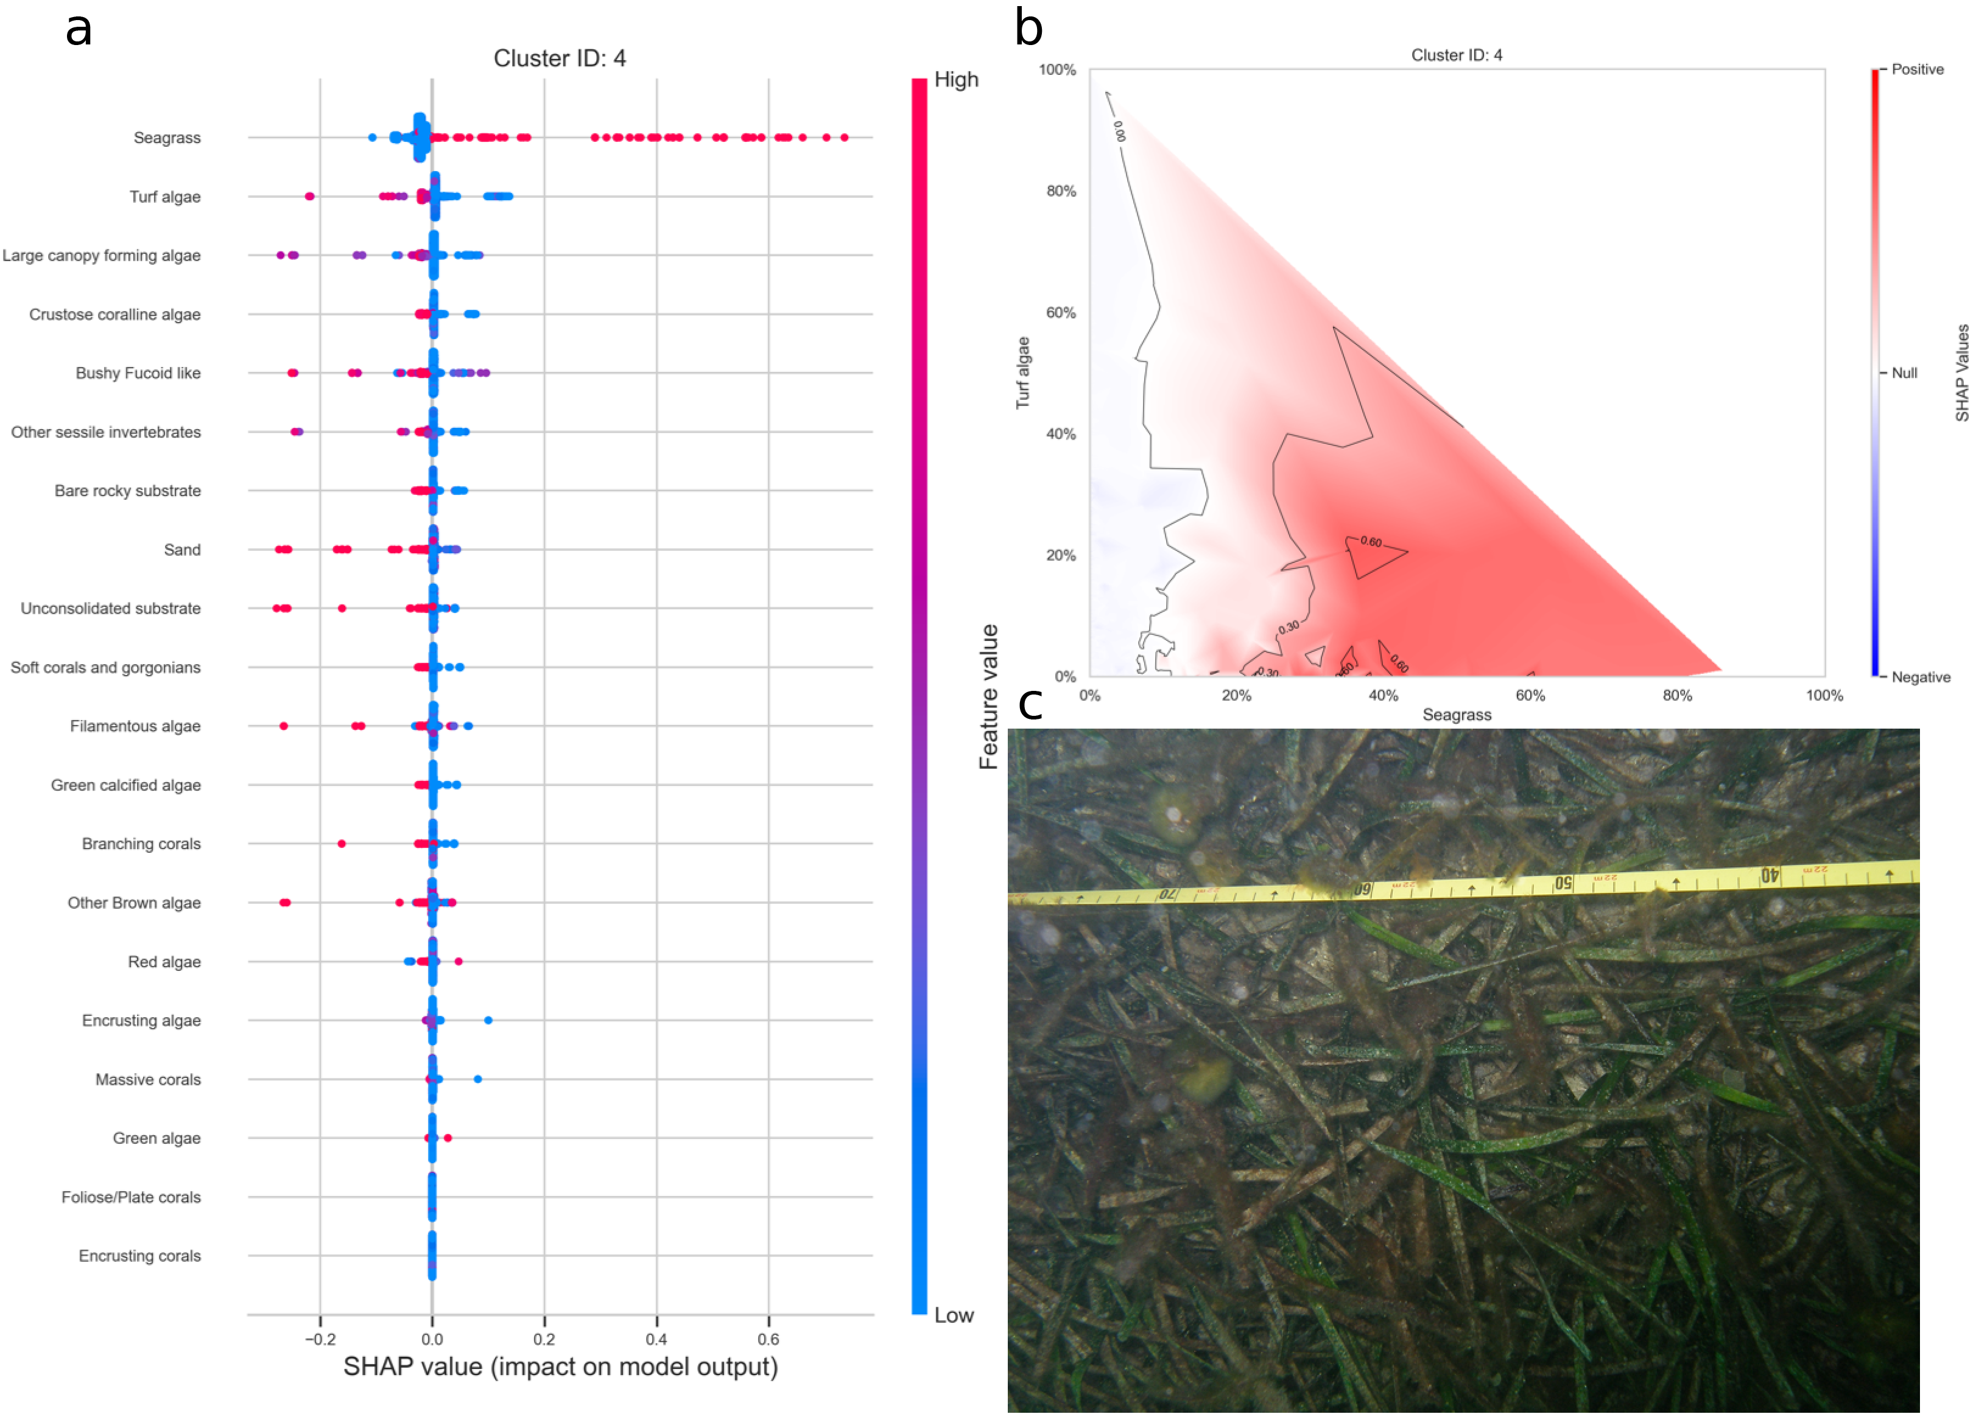
Figure 5: a. SHAP summary plot showing the impact of each habitat substrate on the classification. The position of each habitat group on the y-axis indicates its relative importance for the considered cluster. The position of each point along the x-axis indicates if the observation is associated with a lower or higher affinity with the cluster and the colour of the point indicates if the value of the cover of this habitat is rather high or low. b. Linear interpolation of the SHAP values for the two most influential variables for the cluster seagrass. c. Example of photoquadrat for one transect of the cluster seagrass categorised by HDBSCAN as exemplary.
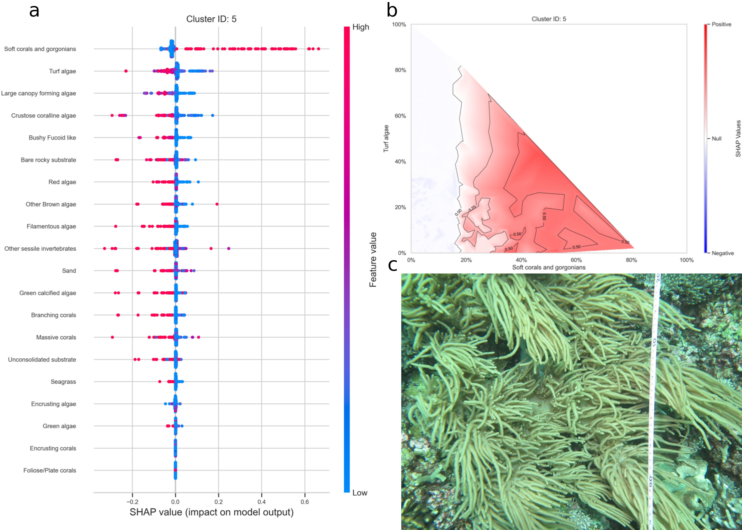
Figure 6: a. SHAP summary plot showing the impact of each habitat substrate on the classification. The position of each habitat group on the y-axis indicates its relative importance for the considered cluster. The position of each point along the x-axis indicates if the observation is associated with a lower or higher affinity with the cluster and the colour of the point indicates if the value of the cover of this habitat is rather high or low. b. Linear interpolation of the SHAP values for the two most influential variables for the cluster soft coral and gorgonians. c. Example of photoquadrat for one transect of the cluster soft coral and gorgonians categorised by HDBSCAN as exemplary.
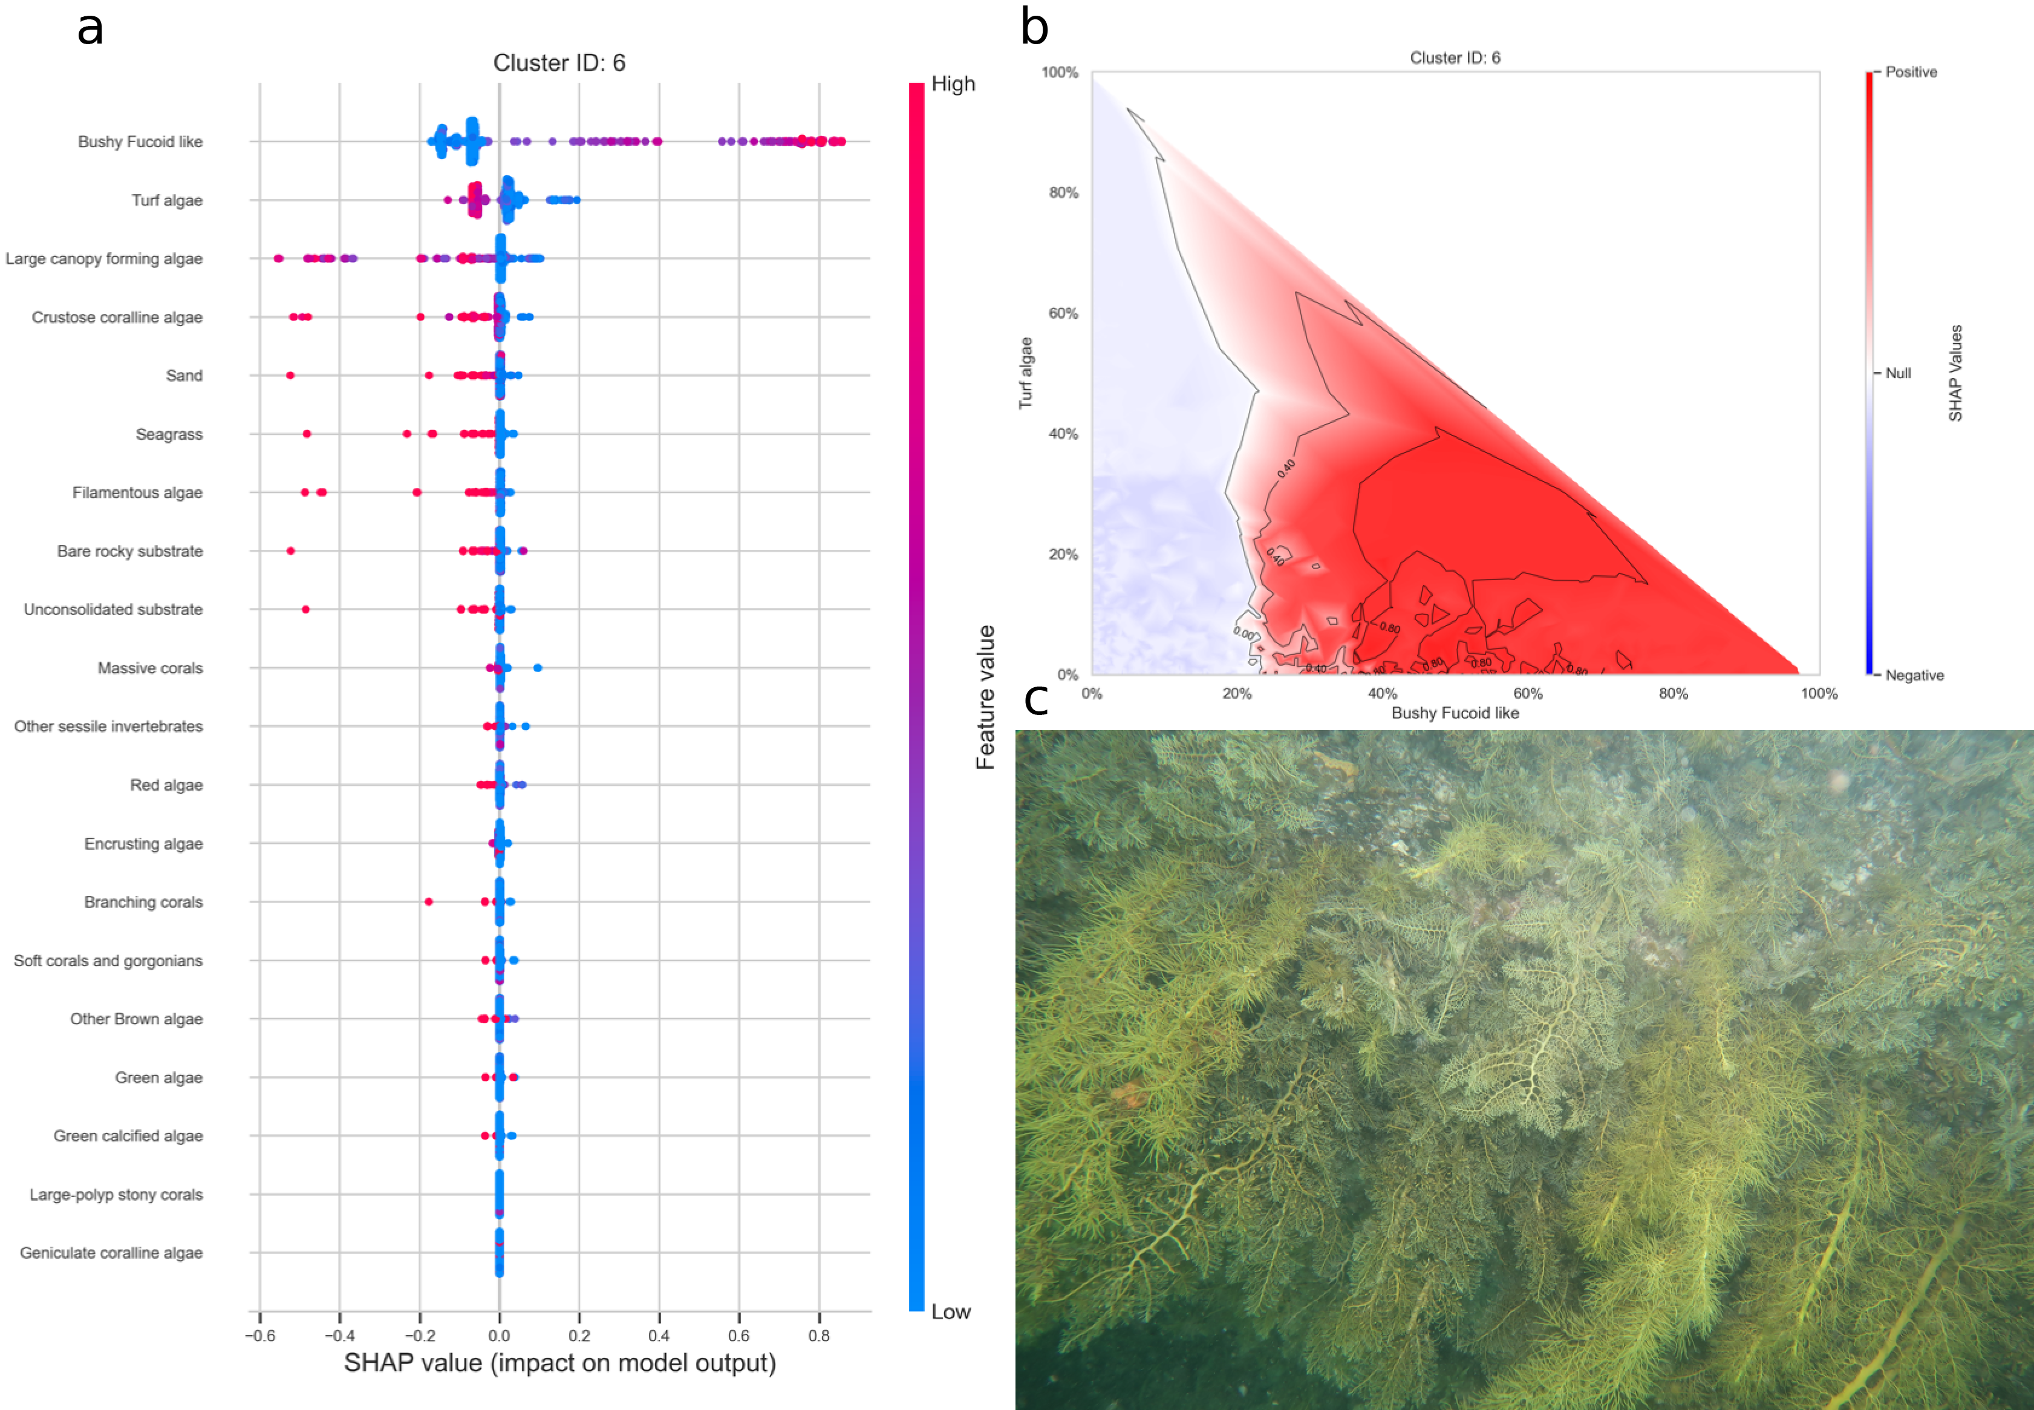
Figure 7: a. SHAP summary plot showing the impact of each habitat substrate on the classification. The position of each habitat group on the y-axis indicates its relative importance for the considered cluster. The position of each point along the x-axis indicates if the observation is associated with a lower or higher affinity with the cluster and the colour of the point indicates if the value of the cover of this habitat is rather high or low. b. Linear interpolation of the SHAP values for the two most influential variables for the cluster bushy fucoid-like. c. Example of photoquadrat for one transect of the cluster bushy fucoid-like categorised by HDBSCAN as exemplary.
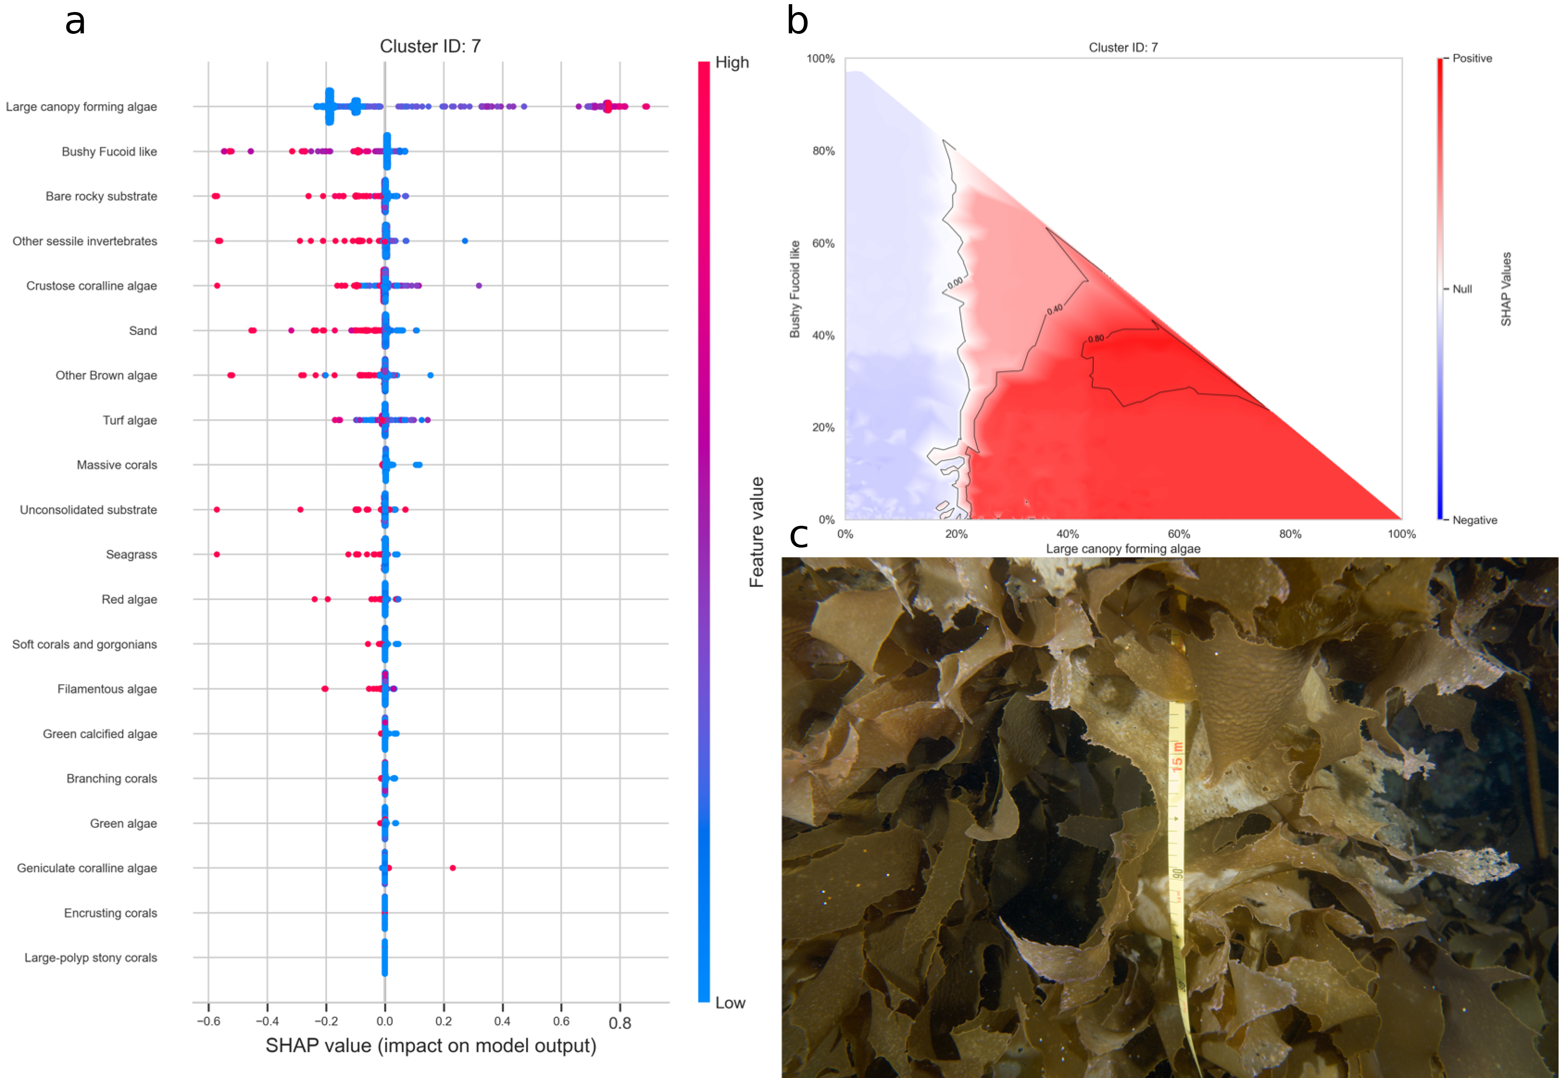
Figure 8: a. SHAP summary plot showing the impact of each habitat substrate on the classification. The position of each habitat group on the y-axis indicates its relative importance for the considered cluster. The position of each point along the x-axis indicates if the observation is associated with a lower or higher affinity with the cluster and the colour of the point indicates if the value of the cover of this habitat is rather high or low. b. Linear interpolation of the SHAP values for the two most influential variables for the cluster large canopy forming algae. c. Example of photoquadrat for one transect of the cluster large canopy forming algae categorised by HDBSCAN as exemplary.
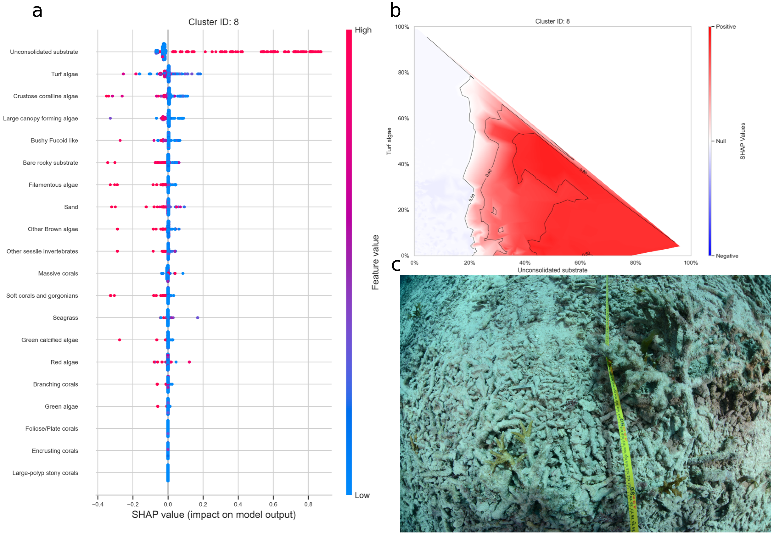
Figure 9: a. SHAP summary plot showing the impact of each habitat substrate on the classification. The position of each habitat group on the y-axis indicates its relative importance for the considered cluster. The position of each point along the x-axis indicates if the observation is associated with a lower or higher affinity with the cluster and the colour of the point indicates if the value of the cover of this habitat is rather high or low. b. Linear interpolation of the SHAP values for the two most influential variables for the cluster unconsolidated substrate. c. Example of photoquadrat for one transect of the cluster unconsolidated substrate categorised by HDBSCAN as exemplary.
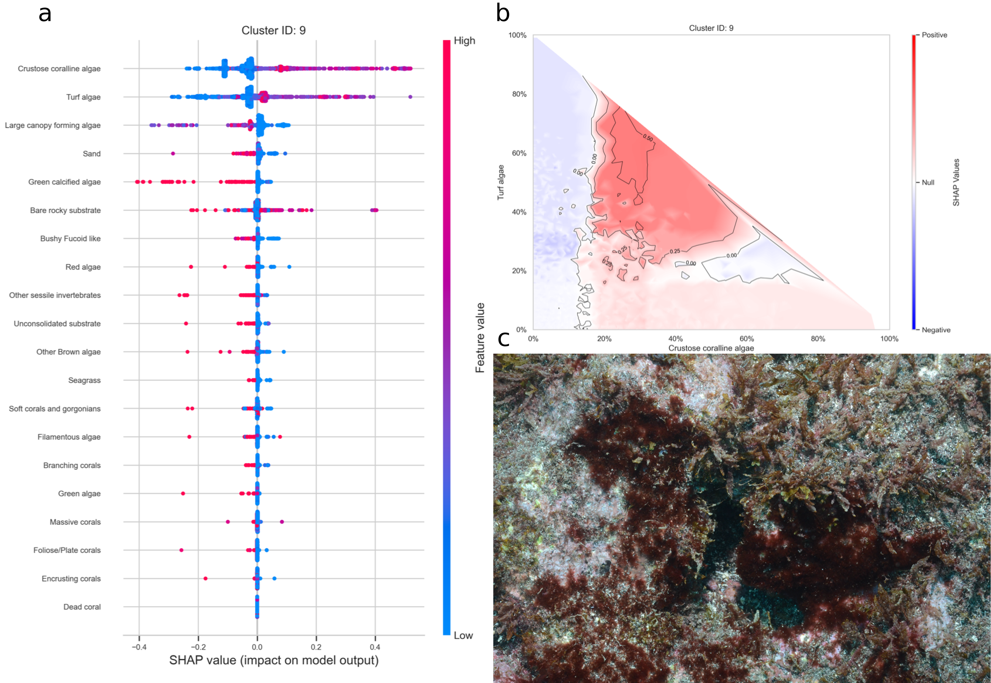
Figure 10: a. SHAP summary plot showing the impact of each habitat substrate on the classification. The position of each habitat group on the y-axis indicates its relative importance for the considered cluster. The position of each point along the x-axis indicates if the observation is associated with a lower or higher affinity with the cluster and the colour of the point indicates if the value of the cover of this habitat is rather high or low. b. Linear interpolation of the SHAP values for the two most influential variables for the cluster crustose coralline algae and turf. c. Example of photoquadrat for one transect of the cluster crustose coralline algae and turf categorised by HDBSCAN as exemplary.
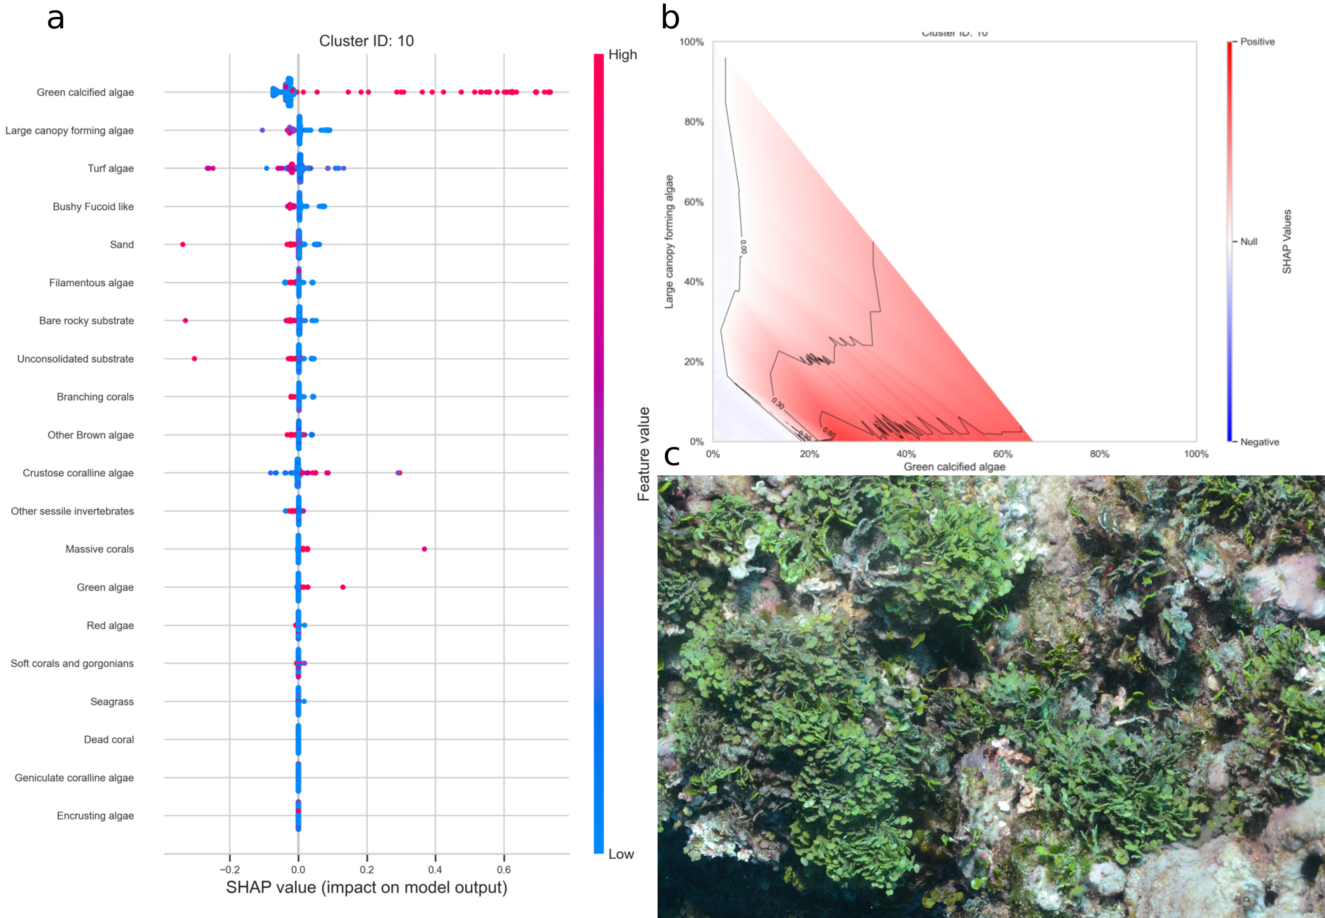
Figure 11: a. SHAP summary plot showing the impact of each habitat substrate on the classification. The position of each habitat group on the y-axis indicates its relative importance for the considered cluster. The position of each point along the x-axis indicates if the observation is associated with a lower or higher affinity with the cluster and the colour of the point indicates if the value of the cover of this habitat is rather high or low. b. Linear interpolation of the SHAP values for the two most influential variables for the cluster green calcified algae. c. Example of photoquadrat for one transect of the cluster green calcified algae categorised by HDBSCAN as exemplary.
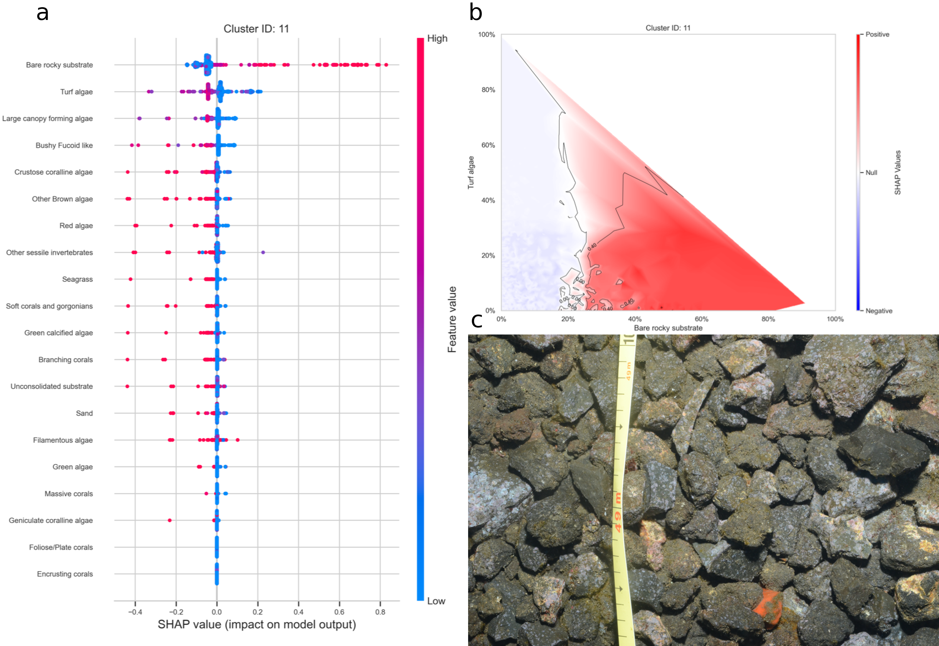
Figure 12: a. SHAP summary plot showing the impact of each habitat substrate on the classification. The position of each habitat group on the y-axis indicates its relative importance for the considered cluster. The position of each point along the x-axis indicates if the observation is associated with a lower or higher affinity with the cluster and the colour of the point indicates if the value of the cover of this habitat is rather high or low. b. Linear interpolation of the SHAP values for the two most influential variables for the cluster bare substrate. c. Example of photoquadrat for one transect of the cluster bare substrate categorised by HDBSCAN as exemplary.
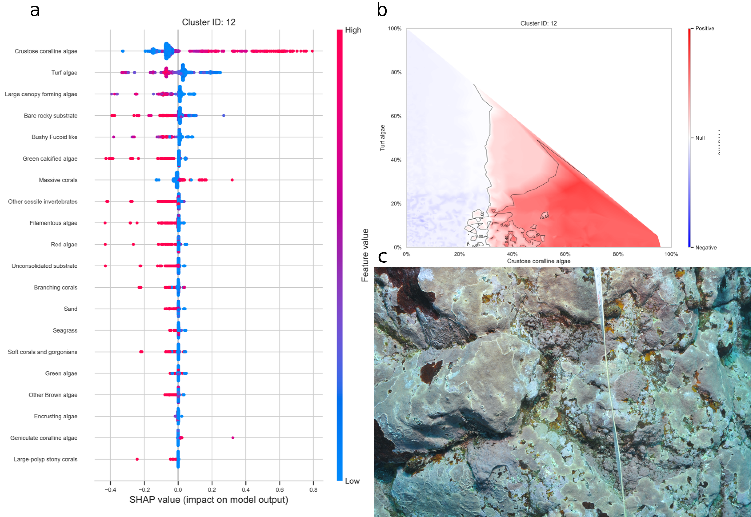
Figure 13: a. SHAP summary plot showing the impact of each habitat substrate on the classification. The position of each habitat group on the y-axis indicates its relative importance for the considered cluster. The position of each point along the x-axis indicates if the observation is associated with a lower or higher affinity with the cluster and the colour of the point indicates if the value of the cover of this habitat is rather high or low. b. Linear interpolation of the SHAP values for the two most influential variables for the cluster crustose coralline algae. c. Example of photoquadrat for one transect of the cluster crustose coralline algae categorised by HDBSCAN as exemplary.
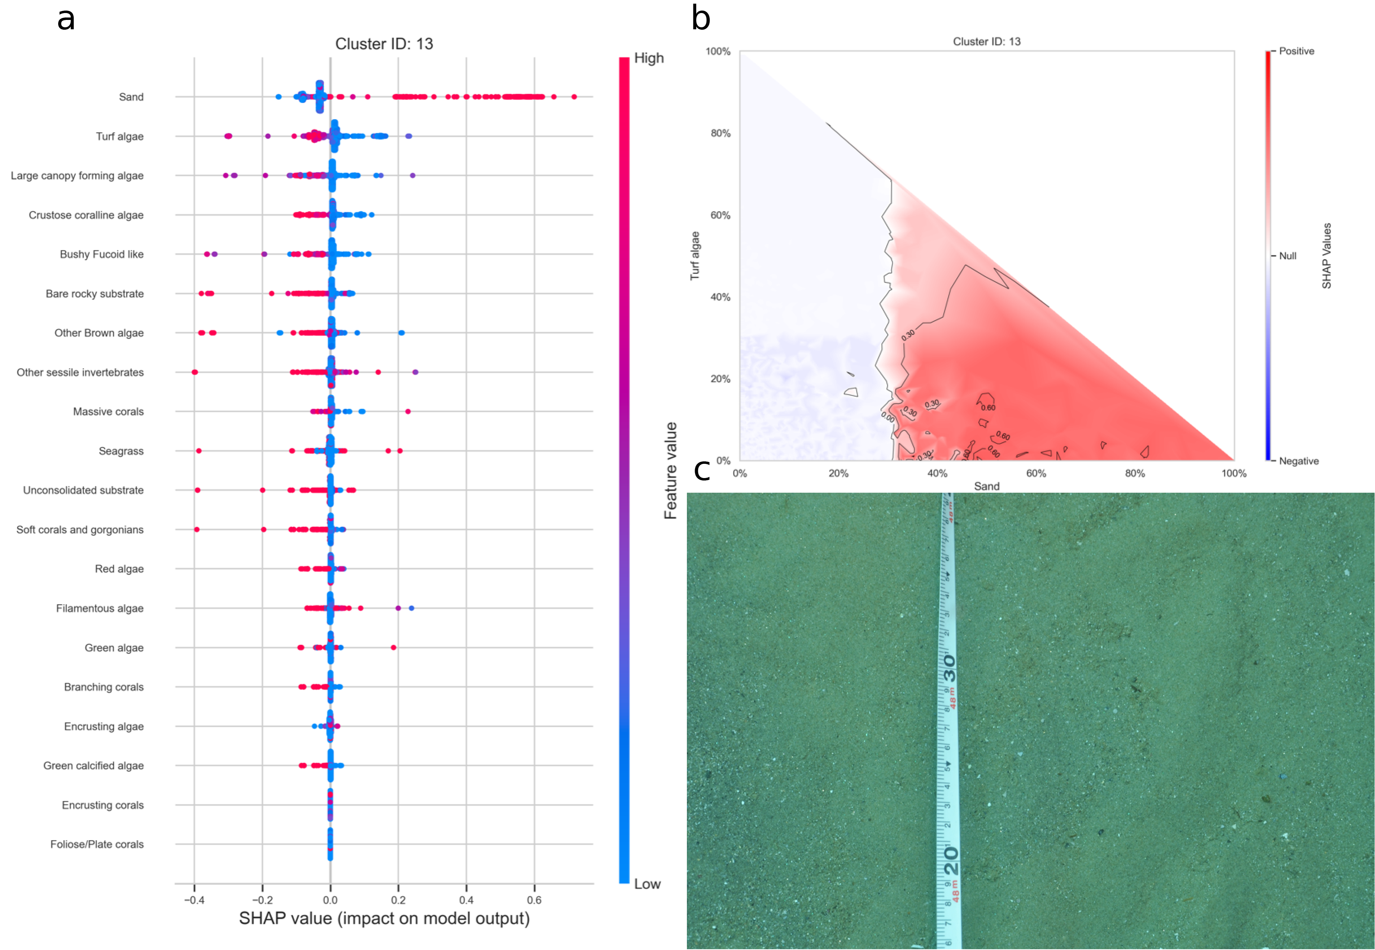
Figure 14: a. SHAP summary plot showing the impact of each habitat substrate on the classification. The position of each habitat group on the y-axis indicates its relative importance for the considered cluster. The position of each point along the x-axis indicates if the observation is associated with a lower or higher affinity with the cluster and the colour of the point indicates if the value of the cover of this habitat is rather high or low. b. Linear interpolation of the SHAP values for the two most influential variables for the cluster sand. c. Example of photoquadrat for one transect of the cluster sand categorised by HDBSCAN as exemplary.
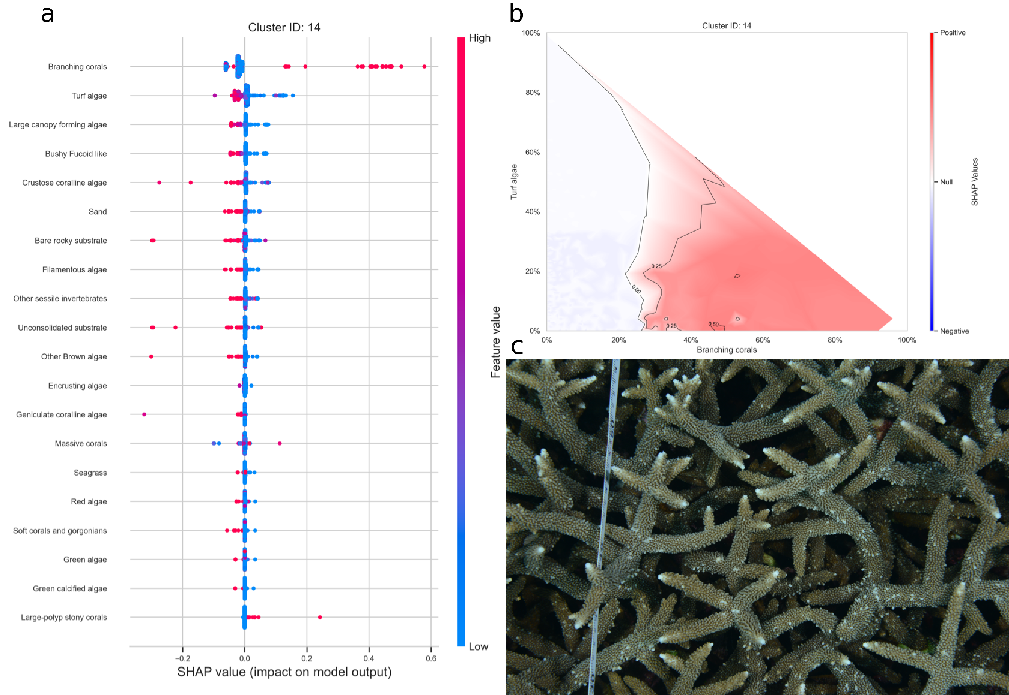
Figure 15: a. SHAP summary plot showing the impact of each habitat substrate on the classification. The position of each habitat group on the y-axis indicates its relative importance for the considered cluster. The position of each point along the x-axis indicates if the observation is associated with a lower or higher affinity with the cluster and the colour of the point indicates if the value of the cover of this habitat is rather high or low. b. Linear interpolation of the SHAP values for the two most influential variables for the cluster branching coral. c. Example of photoquadrat for one transect of the cluster branching coral categorised by HDBSCAN as exemplary.
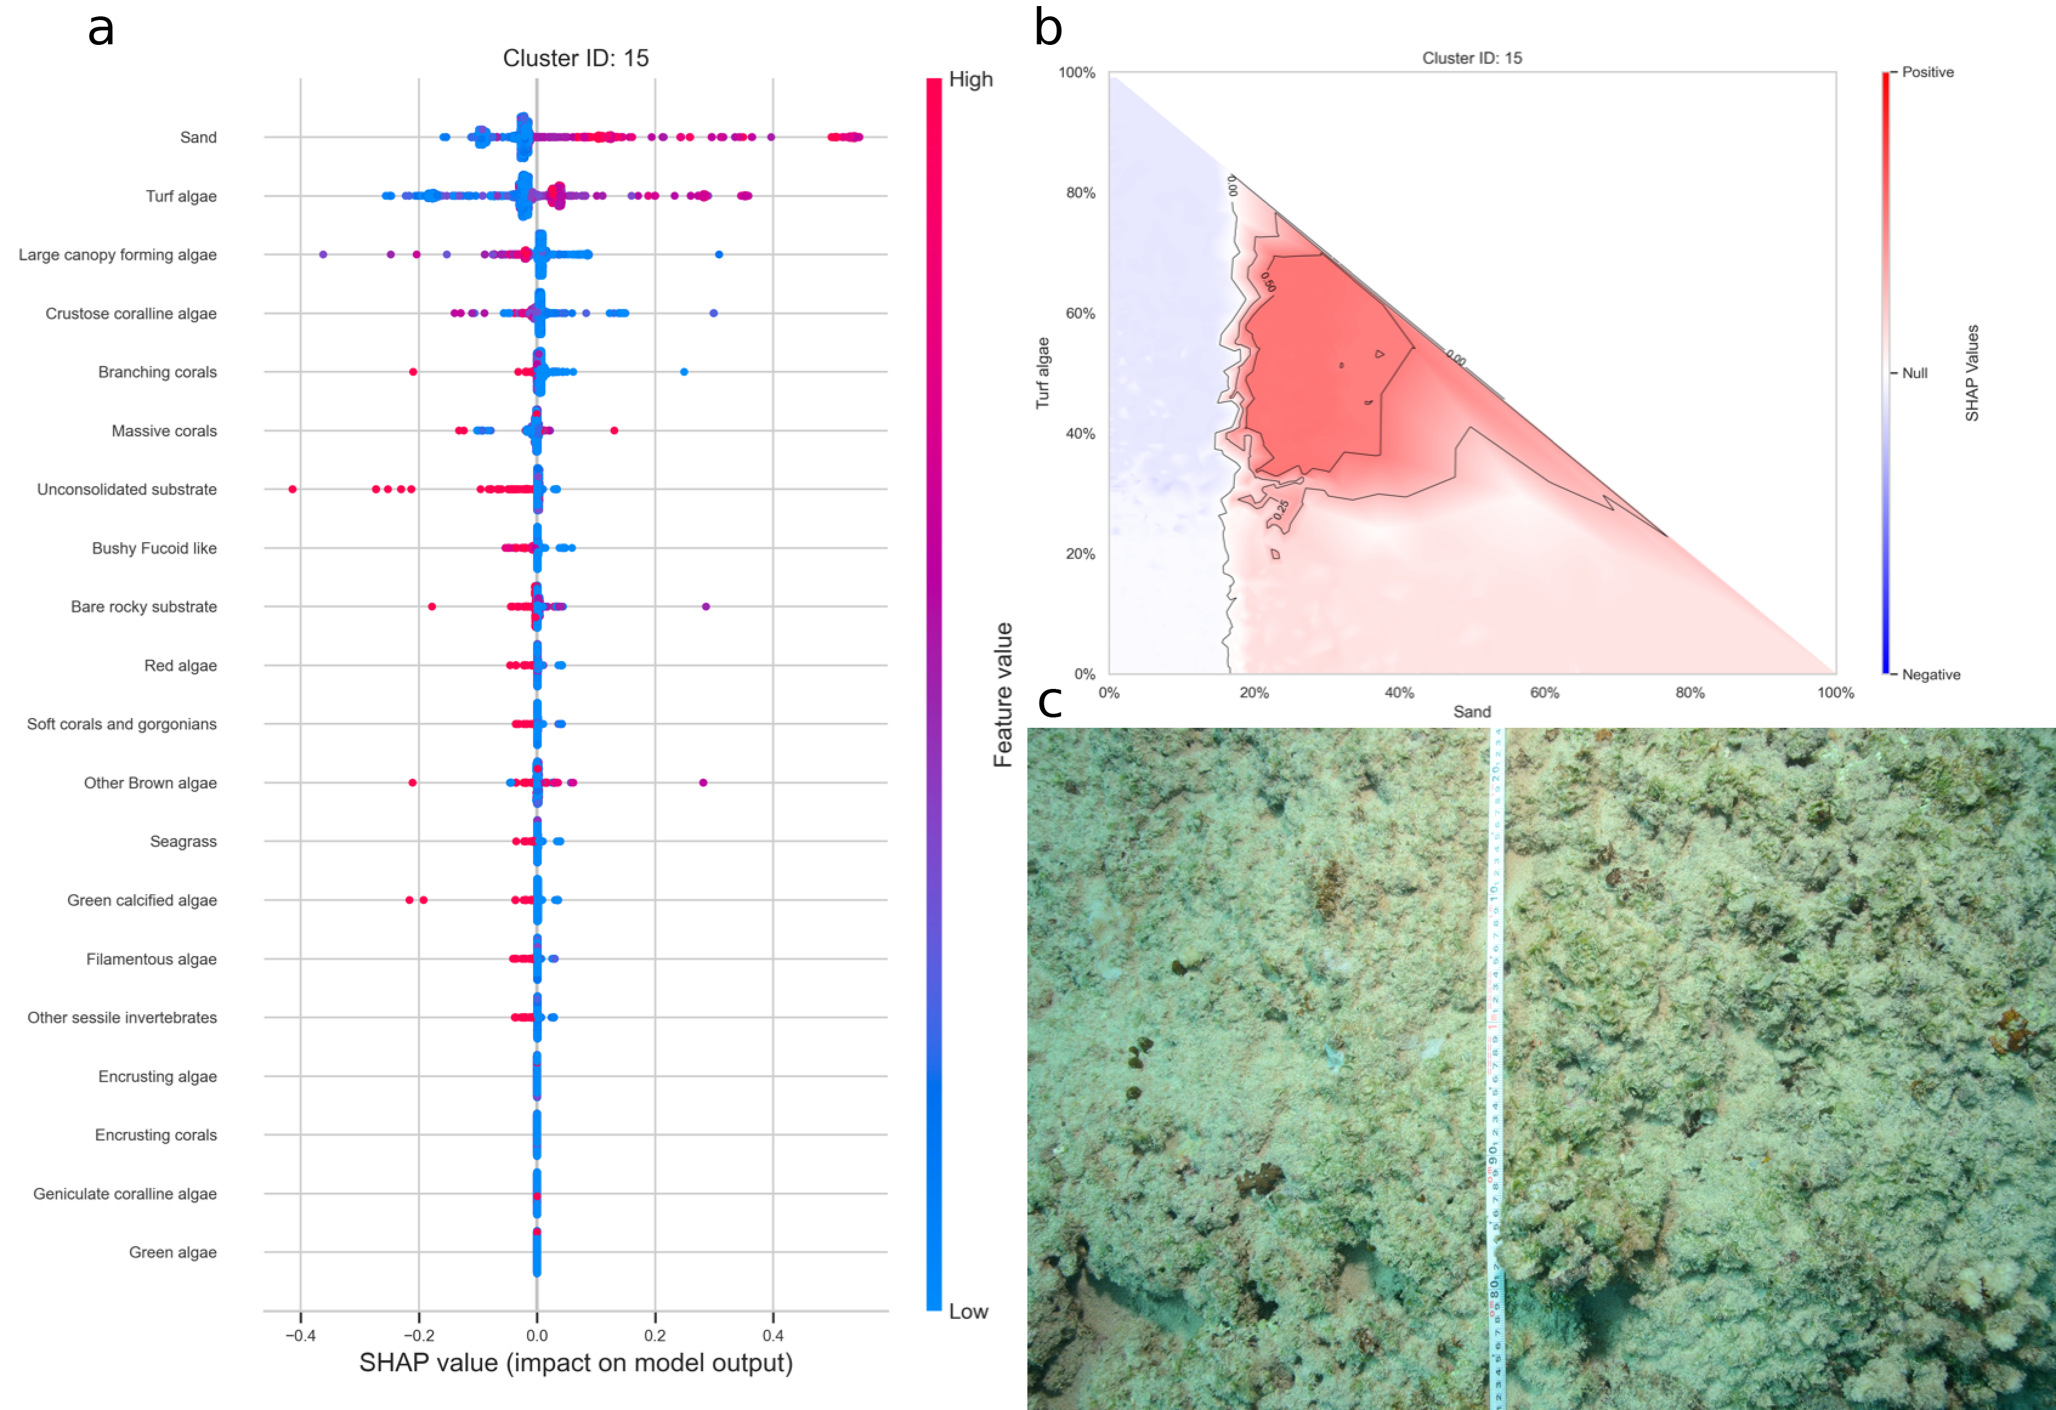
Figure 16: a. SHAP summary plot showing the impact of each habitat substrate on the classification. The position of each habitat group on the y-axis indicates its relative importance for the considered cluster. The position of each point along the x-axis indicates if the observation is associated with a lower or higher affinity with the cluster and the colour of the point indicates if the value of the cover of this habitat is rather high or low. b. Linear interpolation of the SHAP values for the two most influential variables for the cluster sand and turf algae. c. Example of photoquadrat for one transect of the cluster sand and turf algae categorised by HDBSCAN as exemplary.
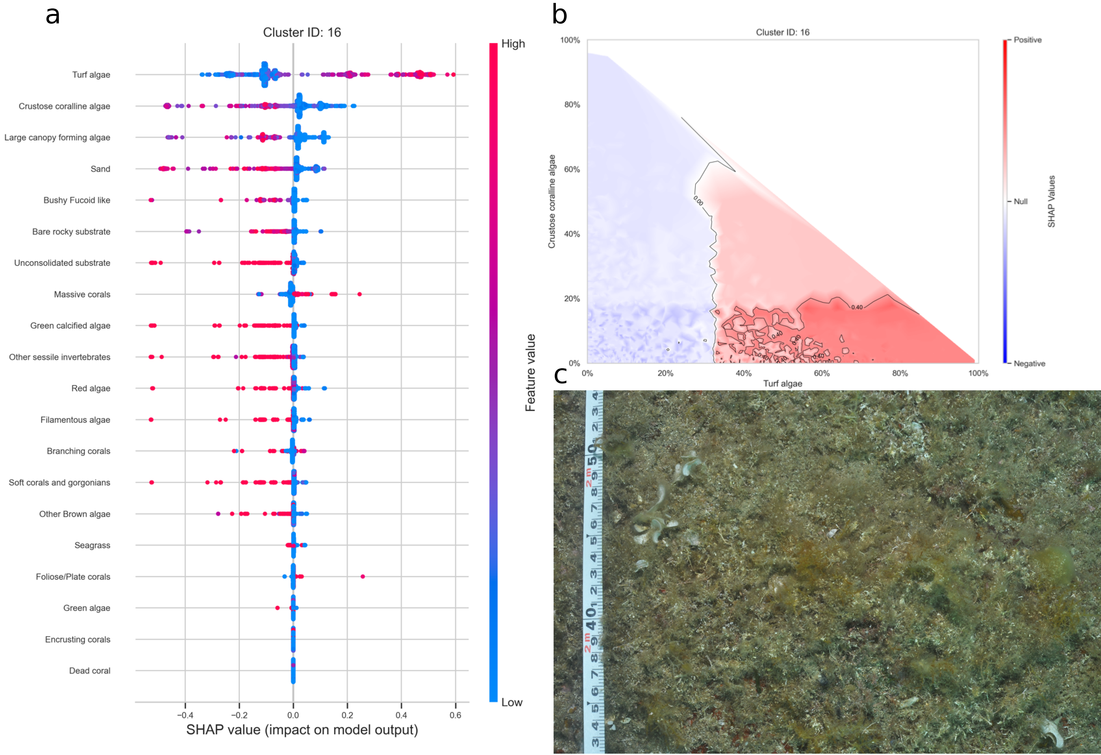
Figure 17: a. SHAP summary plot showing the impact of each habitat substrate on the classification. The position of each habitat group on the y-axis indicates its relative importance for the considered cluster. The position of each point along the x-axis indicates if the observation is associated with a lower or higher affinity with the cluster and the colour of the point indicates if the value of the cover of this habitat is rather high or low. b. Linear interpolation of the SHAP values for the two most influential variables for the cluster turf algae. c. Example of photoquadrat for one transect of the cluster turf algae categorised by HDBSCAN as exemplary.

