Supplementary information

Appendix 1: Functional groups species composition in the Celtic Sea Ecopath with Ecosim (EwE) model, updated from Hernvann et al. (2020) and (Hernvann 2020). The “Guild” column refers to the trophic guild in which functional groups are included. “Province” refers to the biogeographic grouping, “L” or “B” indicating that a majority of group’s species are respectively Boreal or Lusitanian. “New species” indicates the invasive species likely to arrive in the area with climate change. * on some Ecopath functional groups indicates multi-stanza groups.
Common name | Latin name | Ecopath group | Comments | Demersal/  Pelagic | Guild | Province | New species
Northern gannet | Sula bassana | Plunge and pursuit  divers seabirds |  | / | / | /
Common murre | Uria aalge
Razorbills | Alca torda
Atlantic puffin | Fratercula arctica
Herring gull | Larus argentatus | Surface feeders  seabirds | They mainly differ from plunge and pursuit divers by their higher consumption of discards | / | / | /
Yellow-legged gull | Larus michachellis
Lesser black-backed gull | Larus fuscus
great black-backed gull | Larus maritimus
Kittiwakes | Rissa tridactyla
Minke whale | Balaenoptera acutorostrata | Baleen whales |  | / | / | /
Humpback whale | Megaptera novaengliae
Sei whale | Balaenoptera borealis
Fin whale | Balaenoptera physalus
Blue whale | Balaenoptera musculus
Harbour porpoise | Phocoena phocoena | Toothed whales  and Seals |  | / | / | /
Common dolphin | Delphinus delphis
Striped dolphin | Stenella coeruleoalba
Bottlenose dolphin | Tursiops truncates
Risso's dolphin | Grampus griseus
White-beaked dolphin | Lagenorhynchus albirostris
Atlantic White-sided dolphin | Lagenorhynchus acutus
False Killer Whale | Pseudorca crassidens
Long-finned Pilot Whale | Globicephala melas
Short-finned Pilot Whale | Globicephala macrorhynchus
Killer Whale (Orca) | Orcinus orca
Halichoerus grypus | Grey seal
Phoca vitulina | Harbour seal
Gervais beaked whale | Mesoplodon europaeus
True's beaked whale | Mesoplodon mirus
pygmy sperm whale | Kogia breviceps
dwarf sperm whale | Kogia simus
Thresher | Alopias vulpinus | Pelagic sharks |  | Pelagic | Piscivore | /
Bluntnose sixgill shark | Hexanchus griseus
Shortfin mako | Isurus oxyrinchus
Porbeagle | Lamna nasus
Blue shark | Prionace glauca
Tope shark | Galeorhinus galeus
Shagreen ray | Leucoraja fullonica | Piscivorous demersal  elasmobranchs - B | Demersal sharks and rays that feed largely on fish, especially pelagic species | Demersal | Piscivore | B
Blue skate | Raja batis
Picked dogfish | Squalus acanthias
White skate | Raja alba | Piscivorous demersal  elasmobranchs - L | Demersal sharks and rays that feed largely on fish, especially pelagic species | Demersal | Piscivore | L
Angelshark | Squatina squatina
Longnose spurdog | Squalus blainville
Marbled electric ray | Torpedo marmorata
 | Myliobatis aquila |  |  |  |  |  | X
 | Tetronarce nobiliana |  |  |  |  |  | X
Starry smooth-hound | Mustelus asterias | Benthivorous demersal  elasmobrancs | Demersal sharks and rays that mainly feed on benthic invertebrates and, to a lesser extent, on small benthic fish | Demersal | Benthivore | L
Cuckoo ray | Leucoraja naevus
Smooth-hound | Mustelus mustelus
Blonde ray | Raja brachyura
Spotted ray | Raja montagui
Thornback ray | Raja clavata
Blackmouth catshark | Galeus melastomus
Common stingray | Dasyatis pastinaca
Common eagle ray | Myliobatis aquila
Sandy ray | Raja circularis
Longnosed skate | Raja oxyrinchus
Undulate ray | Raja undulata
Small-spotted catshark | Scyliorhinus canicula
Nursehound | Scyliorhinus stellaris
Small-eyed ray | Raja microocellata
 | Galeus atlanticus |  |  |  |  |  | X
 | Mustelus |  |  |  |  |  | X
 | Leucoraja circularis |  |  |  |  |  | X
Blackbellied angler | Lophius budegassa | Anglerfish* |  | Demersal | Piscivore | L
Angler(=Monk) | Lophius piscatorius
European seabass | Dicentrarchus labrax | Sea bass* |  | Demersal | Benthivore | L
European hake | Merluccius merluccius | Hake* |  | Demersal | Piscivore | L
Atlantic cod | Gadus morhua | Cod* |  | Demersal | Piscivore | B
Haddock | Melanogrammus aeglefinus | Haddock* |  | Demersal | Benthivore | B
Whiting | Merlangius merlangus | Whiting* |  | Demersal | Piscivore | L
Megrim | Lepidorhombus whiffiagonis | Megrim* |  | Demersal | Piscivore | L
Norway pout | Trisopterus esmarkii | Pouts - B |  | Demersal | Planktivore | B
Pouting(=Bib) | Trisopterus luscus | Pouts - L |  | Demersal | Planktivore | L
Poor cod | Trisopterus minutus
European plaice | Pleuronectes platessa | Plaice* |  | Demersal | Benthivore | B
Common sole | Solea solea | Sole* |  | Demersal | Benthivore | L
Pollack | Pollachius pollachius | Piscivorous  demersal fish - B | Demersal fish mainly that feed on fish, both benthic and pelagic. Usually of large size (max. length > 60cm). | Demersal | Piscivore | B
Turbot | Psetta maxima
Brill | Scophthalmus rhombus
Ling | Molva molva
Saithe(=Pollock) | Pollachius virens
Black Sea brill | Psetta maeotica
Atlantic halibut | Hippoglossus hippoglossus
 | Notacanthus chemnitzii
European conger | Conger conger | Piscivorous  demersal fish - L | Demersal fish mainly that feed on fish, both benthic and pelagic. Usually of large size (max. length > 60cm). | Demersal | Piscivore | L
John dory | Zeus faber
Common lingue | Molva macrophthalma
Common dentex | Dentex dentex
Meagre | Argyrosomus regius
Silver scabbardfish | Lepidopus caudatus
Blackbelly rosefish | Helicolenus dactylopterus
Wreckfish | Polyprion americanus
European eel | Anguilla anguilla
Atlantic salmon | Salmo salar
Sea trout | Salmo trutta
Atlantic thornyhead | Trachyscorpia cristulata
Spotted seabass | Dicentrarchus punctatus
Barracudas nei | Sphyraena spp |  |  |  |  |  | X
Fourbeard rockling | Enchelyopus cimbrius | Epibenthivorous  demersal fish | Demersal fish that mainly feed on benthic invertebrates, especially crustaceans decapods, as well as on some small demersal fish. Usually of medium size (max. length between 30 and 60 cm) | Demersal | Benthivore | L
 | Centrolabrus exoletus
Three-bearded rocling | Gaidropsarus vulgaris
Atlantic wolffish | Anarhichas lupus
Lumpfish(=Lumpsucke) | Cyclopterus lumpus
Red gurnard | Chelidonichthys cuculus
Red bandfish | Cepola macrophthalma
Four-spot megrim | Lepidorhombus boscii
Greater forkbeard | Phycis blennoides
Surmullet | Mullus surmuletus
Blackspot seabream | Pagellus bogaraveo
Argentine | Argentina sphyraena
Tub gurnard | Chelidonichthys lucerna
Grey gurnard | Eutrigla gurnardus
Red scorpionfish | Scorpaena scrofa
Black scorpionfish | Scorpaena porcus
Comber | Serranus cabrilla
Greater weever | Trachinus draco
Gilthead seabream | Sparus aurata
Streaked gurnard | Chelidonichthys lastoviza
Thicklip grey mullet | Chelon labrosus
Ballan wrasse | Labrus bergylta
Axillary seabream | Pagellus acarne
Common pandora | Pagellus erythrinus
Black seabream | Spondyliosoma cantharus
Golden grey mullet | Liza aurata
Thinlip grey mullet | Liza ramada
Flathead grey mullet | Mugil cephalus
Piper gurnard | Eutrigla lyra
Longfin gurnard | Chelidonichthys obscurus
Lesser weever | Echiichthys vipera
Lesser weever | Labrus mixtus
Grey triggerfish | Balistes capriscus
Cuckoo wrasse | Pagrus pagrus
 | Ctenolabrus rupestris |  |  |  |  |  | X
 | Pagellus bellottii |  |  |  |  |  | X
 | Gaidropsarus macrophthalmus |  |  |  |  |  | X
 | Gaidropsarus mediterraneus |  |  |  |  |  | X
 | Gaidropsarus biscayensis |  |  |  |  |  | X
 | Scorpaena |  |  |  |  |  | X
 | Scorpaena loppei |  |  |  |  |  | X
 | Scorpaena notata |  |  |  |  |  | X
 | Serranus hepatus |  |  |  |  |  | X
 | Umbrina cirrosa |  |  |  |  |  | X
 | Umbrina canariensis |  |  |  |  |  | X
 | Diplodus vulgaris |  |  |  |  |  | X
 | Diplodus sargus |  |  |  |  |  | X
 | Trigloporus lastoviza |  |  |  |  |  | X
 | Symphodus rostratus |  |  |  |  |  | X
 | Symphodus melops |  |  |  |  |  | X
 | Lithognathus mormyrus |  |  |  |  |  | X
Common dab | Limanda limanda | Endobenthivorous  demersal fish | Benthic fish mainly that feed on benthic invertebrates, especially polychaetes, gastropods and bivalves (large part of the endobenthos). Mainly flatfish of medium or large size. | Demersal | Benthivore | L
Witch flounder | Glyptocephalus cynoglossus
Lemon sole | Microstomus kitt
European flounder | Platichthys flesus
 | Zeugopterus punctatus
Amer. Plaice | Hippoglossoides platessoides
Thickback sole | Microchirus variegatus
Sand sole | Solea lascaris
 | Dicoglossa cuneata |  |  |  |  |  | X
 | Pegusa lascaris |  |  |  |  |  | X
 | Solea senegalensis |  |  |  |  |  | X
 | Ciliata septentrionalis | Small benthivorous  demersal fish | Demersal fish that feed on benthic invertebrates and large proportions of plankton and/or micronekton. Usually of small size (max. length < 30 cm). They represent important fish prey for other demersal fish. | Demersal | Benthivore | L
 | Echiodon drummondii
Fivebeard rockling | Ciliata mustela
 | Entelurus aequoreus
 | Pomatochistus pisctus
 | Liparis montagui
 | Pomatochistus norvegicus
Norwegian topknot | Phrynorhombus norvegicus
 | Buenia jeffreysii
 | Spinachia spinachia
 | Raniceps raninus
 | Taurulus bubalis
Lozano's goby | Pomatoschistus lozanoi
Dragonet | Callionymus lyra
Spotted dragonet | Callionymus maculatus
Greater pipefish | Syngnathus acus
Sand goby | Pomatoschistus minutus
Butterfly blenny | Blennius ocellaris
Imperial scaldfish | Arnoglossus imperialis
Scale-rayed wrasse | Acantholabrus palloni
Mediterranean scaldfish | Arnoglossus laterna
Solenette | Buglossidium luteum
Fries's goby | Lesueurigobius friesii
Black goby | Gobius niger
 | Hippocampus gottolatus |  |  |  |  |  | X
 | Parablennius gattorugine |  |  |  |  |  | X
 | Trachinus draco |  |  |  |  |  | X
 | Arnoglossus thori |  |  |  |  |  | X
 | Lepidotrigla dieuzeidei |  |  |  |  |  | X
 | Lepidotrigla cavillone |  |  |  |  |  | X
 | Ophidion barbatum |  |  |  |  |  | X
 | Syngnathus |  |  |  |  |  | X
 | Syngnathus typhle |  |  |  |  |  | X
 | Syngnathus rostellatus |  |  |  |  |  | X
 | Callyonimus reticulatus |  |  |  |  |  | X
 | Deltentosteus quadrimaculatus |  |  |  |  |  | X
 | Hippocampus hippocampus |  |  |  |  |  | X
 | Symphodus roissali |  |  |  |  |  | X
 | Symphodus bailloni |  |  |  |  |  | X
 | Echiichthys vipera |  |  |  |  |  | X
 | Nerophis lumbriciformis |  |  |  |  |  | X
 | Nerophis ophidion |  |  |  |  |  | X
 | Gobius paganellus |  |  |  |  |  | X
 | Holtbyrnia macrops | Suprabenthivorous  demersal fish | Demersal fish feeding on benthic invertebrates and large proportions of plankton and/or micronekton. Usually of small size (max length < 30 cm). They play an important role in the transfer of organic material from the pelagic to the demersal compartment. | Demersal | Benthivore | L
Greater argentine | Argentina silus
Greater sand-eel | Hyperoplus immaculatus
Great sandeel | Hyperoplus lanceolatus
Small sandeel | Ammodytes tobianus
 | Ammodytes marinus
Smooth sandeel | Gymnammodytes semisquamatus
Silvery pout | Gadiculus argenteus
Transparent goby | Aphia minuta
Longspine snipefish | Macrorhamphosus scolopax
Silvery lightfish | Maurolicus muelleri
Bogue | Boops boops
 | Epigonus denticulatus |  |  |  |  |  | X
 | Gonostoma elongatum |  |  |  |  |  | X
 | Cyttopsis rosea |  |  |  |  |  | X
 | Crystallogobius linearis |  |  |  |  |  | X
 | Argyropelecus hemigymnus |  |  |  |  |  | X
 | Myctophum punctatum |  |  |  |  |  | X
 | Myctophum |  |  |  |  |  | X
 | Ceratoscopelus maderensis |  |  |  |  |  | X
 | Chlorophthalmus agassizi |  |  |  |  |  | X
Atlantic mackerel | Scomber scombrus | Mackerel |  | Pelagic | Planktivore | L
Atlantic horse mackerel | Trachurus trachurus | Horse mackerel |  | Pelagic | Piscivore | L
Blue whiting | Micromesistius poutassou | Blue whiting |  | Pelagic | Planktivore | B
Boarfish | Capros aper | Boarfish |  | Demersal | Planktivore | L
Atlantic herring | Clupea harengus | Herring |  | Pelagic | Planktivore | B
European sprat | Sprattus sprattus | Sprat |  | Pelagic | Planktivore | B
European pilchard | Sardina pilchardus | Pilchard |  | Pelagic | Planktivore | L
Garfish | Belone belone | Large pelagic fish |  | Pelagic | Piscivore | /
Atlantic bonito | Sarda sarda
Golden redfish | Sebastes marinus
Albacore | Thunnus alalunga
Atlantic bluefin tuna | Thunnus thynnus
Swordfish | Xiphias gladius
Atlantic pomfret | Brama brama
Little tunny | Euthynnus alletteratus
Skipjack tuna | Katsuwonus pelamis
 | Seriola |  |  |  |  |  | X
 | Trichiurus lepturus |  |  |  |  |  | X
 | Auxis rochei rochei |  |  |  |  |  | X
Allis and twaite shads | Alosa alosa, A. fallax | Medium Pelagic Fish |  | Pelagic | Planktivore | L
European anchovy | Engraulis encrasicolus
European smelt | Osmerus eperlanus
Atlantic saury | Scomberesox saurus
Sand smelt | Atherina presbyter
Atlantic chub mackerel | Scomber colias
Chub mackerel | Scomber japonicus
Mediterranean horse mackerel | Trachurus mediterraneus
 | Trachurus pisctatus |  |  |  |  |  | X
Broadtail shortfin squid | Illex coindetii | Squids | Pelagic and bentho-pelagic squids. | / | / | L
Northern shortfin squid | Illex illecebrosus
European squid | Loligo vulgaris
European flying squid | Todarodes sagittatus
European common squid | Alloteuthis subulata
Veined squid | Loligo forbesi
Lesser flying squid | Todaropsis eblanae
 | Abralia (Asteroteuthis) veranyi |  |  |  |  |  | X
Common cuttlefish | Sepia officinalis | Benthic cephalopods |  | / | / | L
Pink cuttlefish | Sepia orbignyana
Elegant cuttlefish | Sepia elegans
Bobtail squid | Sepiola sp
Horned octopus | Eledone cirrhosa
Common octopus | Octopus vulgaris
Stout bobtail | Rossia macrosoma
 | Sepiola atlantica |  |  |  |  |  | X
 | Sepiola pfefferi |  |  |  |  |  | X
 | Sepiola tridens |  |  |  |  |  | X
 | Sepiola ligulata |  |  |  |  |  | X
 | Sepiola robusta |  |  |  |  |  | X
 | Bathypolypus sponsalis |  |  |  |  |  | X
 | Octopus salutii |  |  |  |  |  | X
 | Opisthoteuthis agassizii |  |  |  |  |  | X
 | Scaeurgus unicirrhus |  |  |  |  |  | X
 | Stoloteuthis leucoptera |  |  |  |  |  | X
 | Sepietta oweniana |  |  |  |  |  | X
 | Sepietta neglecta |  |  |  |  |  | X
 | Rondeletiola minor |  |  |  |  |  | X
Norway lobster | Nephrops norvegicus | Nephrops |  | / | / | /
Edible crab | Cancer pagurus | Large commercial crustaceans |  | / | / | /
European lobster | Homarus gammarus
Spinous spider crab | Maja squinado/brachydactyla
Velvet swimcrab | Necora puber
Common spiny lobster | Palinurus elephas
 | Palinurus |  |  |  |  |  | X
 | Palinurus mauritanicus |  |  |  |  |  | X
 | Cancer bellianus |  |  |  |  |  | X
 | Paromola cuvieri |  |  |  |  |  | X
 | Geryon trispinosus |  |  |  |  |  | X
 | Geryon longpipes |  |  |  |  |  | X
Shrimps |  |  | Benthic Shrimps-like invertebrates | / | / | /
Commercial bivalves |  |  | Bivalve suspension feeders that are commercially exploited (e.g. Pectinids) | / | / | /
Suprabenthos |  |  | Suspension feeders (e.g.mysids) that live in the water layer close to the seabed and with sufficient swimming ability to move within this layer | / | / | /
Suspension feeders |  |  | Suspension feeder filtering suspended particles from the seabed | / | / | /
Deposit feeders |  |  | Deposivorous organisms that feed on particles within the sediments, by ingesting and filtering sediment or by directly selecting particles (mainly polychaetes, few amphipods and irregular urchins) | / | / | /
Carnivores and necrophages |  |  | Benthic invertebrates that are either predators or scavengers (small crabs, squat lobsters, welks, ophiurids, worms, amphipods...) | / | / | /
Benthic meiofauna (Meio) |  |  | Invertebrates living in the sediment (nematods) | / | / | /
Macrozooplankton (MacroZ) |  |  | Zooplankton of size ≥ 1cm (omnivorous and carnivorous; they mainly include  euphausiids, large carnivorous plankton, gelatinous, tunicates, thecostomates, chaetognathes, and larvae) | / | / | /
Mesozooplankton - Large |  |  | Zooplankton of size ≥ 2mm and < 1cm. (larger copepods, with limited planktivorous behaviour) | / | / | /
Mesozooplankton - Small |  |  | Zooplankton of size ≥ 0.5mm and < 2mm (essentially herbivorous copepods) | / | / | /
Microzooplankton (MicroZ) |  |  | Zooplankton of size < 0.5mm (ciliates and heterotrophic flagellates) | / | / | /
Phytoplankton - Large (PhL) |  |  | Phytoplankton of size ≥ 5 μm. Mainly diatoms and dinoflagellates | / | / | /
Phytoplankton - Small (PhS) |  |  | Phytoplankton of size < 5 μm. Nano- and picoplankton | / | / | /

Appendix 2: Multi-stanza groups definition and parameterization in Ecopath.
Group definition
Multi-stanza groups are defined to 1) improve the model ecological realism by defining distinct biological parameters (e.g. P/B, Q/B…) and diet for juveniles and adults 2) better represents the impact of fishing on juvenile stages and 3) to better estimate predation mortality on juveniles within the model. For demersal species where stock assessment data are sufficient to parameterize groups, 9 multi-stanza groups are defined. Multi-stanza groups are separated into several life stages, with cut-offs based on maturity (when 50% of the population is considered mature in the stock assessment), known trends in natural mortality at age in stock assessments, and on the age at which the assessment begins. Only for anglerfish the maturity cut-off point is replaced to take account of the regime shift that, according to Rault et al. (2017), occurs at 2 years.
Table: Multi-stanza groups cut-off points. * Here, Age min/ Lmin are included in the considered stanza and Age max/Lmax are excluded from the considered stanza. Age is in year and length in cm.
Group common name | Group latin name | Stanza name | Age min* | Age max* | Lmin* | Lmax* | Juvenile/adult stanza
Seabass | D. labrax | Seabass 0-4 | 0 | 5 | 0 | 36 | Juvenile
 |  | Seabass >5 | 5 | 16+ | 36 | 66+ | Adult
Anglerfish | L. budegassa and piscatorius | Anglerfish 0-1 | 0 | 2 | 0 | 33 | Juvenile
 |  | Anglerfish >2 | 2 | 7+ | 33 | 98+ | Juvenile and adult
Hake | M. merluccius | Hake 0-1 | 0 | 2 | 0 | 38 | Juvenile
 |  | Hake >2 | 2 | 15+ | 38 | 122 | Adult
Cod | G. morhua | Cod 0 | 0 | 1 | 0 | 31 | Juvenile
 |  | Cod 1 | 1 | 2 | 31 | 52 | Juvenile
 |  | Cod 2 | 2 | 3 | 52 | 67 | Adult
 |  | Cod >3 | 3 | 7+ | 67 | 94+ | Adult
Whiting | M. merlangus | Whiting 0 | 0 | 1 | 0 | 20 | Juvenile
 |  | Whiting 1 | 1 | 2 | 20 | 26 | Adult
 |  | Whiting >2 | 2 | 7+ | 26 | 38+ | Adult
Haddock | M. aeglefinus | Haddock 0 | 0 | 1 | 0 | 27 | Juvenile
 |  | Haddock 1 | 1 | 2 | 27 | 34 | Juvenile
 |  | Haddock >2 | 2 | 8+ | 34 | 56+ | Adult
Megrim | L. whiffiagonis | Megrim 0-2 | 0 | 3 | 0 | 27 | Juvenile
 |  | Megrim >3 | 3 | 10+ | 27 | 45+ | Adult
Sole | S. solea | Sole 0-1 | 0 | 2 | 0 | 22 | Juvenile
 |  | Sole >2 | 2 | 12+ | 22 | 43+ | Adult
Plaice | P. platessa | Plaice 0-2 | 0 | 3 | 0 | 25 | Juvenile
 |  | Plaice >3 | 3 | 10+ | 25 | 48+ | Adult

Group parameterization
The Ecopath multi-stanza sub-model simulates the number and weight of fish within a stanza to obtain a biomass by stanza for the Ecopath base year (Walters et al. 2006).The parameters required to parameterize the Ecopath stanza sub-model are therefore the von Bertalanffy growth rate K, the total mortality Z by stanza and the biomass of the adult stanza (hereafter referred as “leading stanza”). To simulate temporal biomass trends in Ecosim, the model needs to be fed with the number of spawning individuals within the stanza and the weight at first reproduction, assuming that the higher the fish weight is past the weight of first reproduction, the heavier the individuals, the more they reproduce. K is obtained by applying a nls optimization procedure on weight-at-age from stock assessments over 10 years of data centered around 2003 (1998-2008). K is not taken directly from stock assessments or the literature because Ecopath assumes isometric growth and K is often based on old literature. Total mortalities by stanza are obtained by adding the fishing mortality from stock assessment and the natural mortality from several estimators: natural mortality from Lorenzen (Lorenzen 1996, Kenchington 2014, Then et al. 2015) for natural ecosystem and ocean, and Peterson natural mortality (Peterson & Wroblewski 1984, Kenchington 2014, Then et al. 2015). One of these natural mortality estimations is selected for each species based on the consistency with the fishing mortality value and other mortality sources estimated by Ecopath. However, we allow a 20% modulation of the selected value during model balancing. Stock assessment data are used to determine the individual weight at first reproduction, the leading stanza biomass and the proportion of spawners in each stanza. To estimate biological parameters for stanza groups, Ecopath takes Z as a production rate proxy and a consumption rate needs to be entered for the leading stanza so that Ecopath retrocalculates other consumption rates for each stanza (Walters et al. 2006, 2010). Consumption rate for the leading stanza is thus entered so that the mean consumption rates for the whole multi-stanza group is equal to the consumption rates in Hernvann (2020).
Table: Multi-stanza parameterization.
Group name | Weight at First reproducti | Stanza name | Leading biomass | Biomass (t/km²) | Z | Consumption rate | Spawners proportion
Seabass | 0,0394 | Seabass 0-4 | False | 0,014 | 0,37 | 3,32 | 0,06
 |  | Seabass >5 | True | 0,039 | 0,40 | 1,62 | 0,78
Anglerfish | 0,0694 | Anglerfish 0-1 | False | 0,022 | 1,03 | 6,75 | 0
 |  | Anglerfish >2 | True | 0,179 | 0,67 | 2,39 | 0,44
Hake | 0,0060 | Hake 0-1 | False | 0,023 | 0,92 | 6,99 | 0,05
 |  | Hake >2 | True | 0,125 | 0,72 | 2,93 | 0,91
Cod | 0,1500 | Cod 0 | False | 0,003 | 0,41 | 9,20 | 0
 |  | Cod 1 | False | 0,018 | 0,68 | 5,09 | 0
 |  | Cod 2 | False | 0,023 | 0,85 | 3,73 | 0,54
 |  | Cod >3 | True | 0,033 | 0,90 | 2,93 | 0,96
Whiting | 0,0070 | Whiting 0 | False | 0,008 | 1,45 | 12,48 | 0
 |  | Whiting 1 | False | 0,038 | 0,90 | 6,17 | 0,61
 |  | Whiting >2 | True | 0,146 | 1,00 | 3,40 | 0,96
Haddock | 0,0080 | Haddock 0 | False | 0,004 | 1,40 | 12,05 | 0
 |  | Haddock 1 | False | 0,017 | 0,79 | 5,94 | 0,04
 |  | Haddock >2 | True | 0,058 | 1,00 | 3,35 | 0,93
Megrim | 0,0010 | Megrim 0-2 | False | 0,036 | 0,58 | 6,56 | 0,08
 |  | Megrim >3 | True | 0,119 | 0,70 | 2,99 | 0,86
Sole | 0,0270 | Sole 0-1 | False | 0,005 | 0,83 | 7,55 | 0
 |  | Sole >2 | True | 0,036 | 0,69 | 3,09 | 0,93
Plaice | 0,0034 | Plaice 0-2 | False | 0,010 | 0,79 | 6,46 | 0
 |  | Plaice >3 | True | 0,018 | 1,03 | 3,08 | 0,86

Appendix 3: Ecopath input and estimates (in bold) parameters.
Functionnal group | TL | B | P/B | Q/B | EE | P/Q | BA rate
Seabirds - Divers | 4,43 | 0,002 | 0,15 | 135,26 | 0 | 0,00 | 0
Seabirds - Surface | 4,17 | 0,002 | 0,25 | 114,47 | 0 | 0,00 | 0
Baleen whales | 3,68 | 0,050 | 0,04 | 4,77 | 0 | 0,01 | 0
Toothed cetaceans/Seals | 4,63 | 0,031 | 0,14 | 12,00 | 0 | 0,01 | 0
Pelagic sharks | 4,72 | 0,053 | 0,20 | 1,96 | 0,60 | 0,10 | 0
Piscivorous dem. elasmobranchs - B | 4,41 | 0,014 | 0,52 | 3,49 | 0,65 | 0,15 | 0
Piscivorous dem. elasmobranchs - L | 4,41 | 0,002 | 0,48 | 3,20 | 0,65 | 0,15 | 0
Benthivorous dem. elasmobranchs | 3,85 | 0,221 | 0,53 | 3,54 | 0,65 | 0,15 | 0
Seabass 0-4 | 4,32 | 0,014 | 0,37 | 3,32 | 0,85 | 0,11 | 0
Seabass >5 | 4,30 | 0,039 | 0,40 | 1,62 | 0,21 | 0,25 | 0
Anglerfish 0-1 | 4,46 | 0,022 | 1,03 | 6,75 | 0,86 | 0,15 | 0
Anglerfish >2 | 4,62 | 0,179 | 0,67 | 2,39 | 0,83 | 0,28 | 0
Hake 0-1 | 4,00 | 0,023 | 0,92 | 6,99 | 0,80 | 0,13 | 0
Hake >2 | 4,22 | 0,125 | 0,72 | 2,93 | 0,90 | 0,25 | 0
Cod 0 | 3,97 | 0,003 | 0,42 | 9,19 | 0,95 | 0,05 | 0
Cod 1 | 3,97 | 0,018 | 0,68 | 5,09 | 0,88 | 0,13 | 0
Cod 2 | 4,15 | 0,023 | 0,85 | 3,73 | 0,94 | 0,23 | 0
Cod >3 | 4,15 | 0,033 | 0,90 | 2,93 | 0,99 | 0,31 | 0
Whiting 0 | 4,04 | 0,008 | 1,45 | 12,48 | 0,85 | 0,12 | -0,08
Whiting 1 | 4,04 | 0,037 | 0,90 | 6,17 | 0,86 | 0,15 | -0,08
Whiting >2 | 4,09 | 0,146 | 1,00 | 3,40 | 0,95 | 0,29 | -0,08
Haddock 0 | 3,42 | 0,004 | 1,40 | 12,05 | 0,79 | 0,12 | 0
Haddock 1 | 3,52 | 0,017 | 0,79 | 5,94 | 0,85 | 0,13 | 0
Haddock >2 | 3,52 | 0,058 | 1,01 | 3,35 | 0,71 | 0,30 | 0
Pout - B | 3,49 | 0,070 | 1,53 | 6,10 | 0,95 | 0,25 | 0
Pout - L | 3,49 | 0,687 | 1,11 | 4,45 | 0,95 | 0,25 | 0
Megrim 0-2 | 3,78 | 0,036 | 0,58 | 6,56 | 0,87 | 0,09 | 0
Megrim >3 | 4,03 | 0,119 | 0,70 | 2,98 | 0,81 | 0,23 | 0
Sole 0-1 | 3,60 | 0,005 | 0,83 | 7,55 | 0,51 | 0,11 | -0,06
Sole >2 | 3,45 | 0,036 | 0,69 | 3,09 | 0,78 | 0,22 | -0,06
Plaice 0-2 | 3,48 | 0,011 | 0,79 | 6,46 | 0,77 | 0,12 | -0,05
Plaice >3 | 3,44 | 0,018 | 1,03 | 3,08 | 0,81 | 0,34 | -0,05
Piscivorous demersal fish - B | 4,42 | 0,085 | 0,61 | 3,06 | 0,85 | 0,20 | 0
Piscivorous demersal fish - L | 4,42 | 0,057 | 0,64 | 3,22 | 0,85 | 0,20 | 0
Epibenthivorous demersal fish | 3,68 | 0,282 | 0,86 | 4,30 | 0,95 | 0,20 | 0
Endobenthivorous demersal fish | 3,41 | 0,083 | 0,99 | 4,96 | 0,95 | 0,20 | 0
Suprabenthivorous demersal fish | 3,44 | 0,147 | 2,24 | 8,94 | 0,95 | 0,25 | -0,82
Small benthivorous demersal fish | 3,51 | 0,327 | 2,22 | 8,87 | 0,95 | 0,25 | -0,30
Mackerel | 3,47 | 0,813 | 0,49 | 1,96 | 0,88 | 0,25 | 0
Horse mackerel | 3,50 | 3,753 | 0,48 | 1,92 | 0,40 | 0,25 | -0,18
Boarfish | 3,32 | 0,251 | 1,20 | 4,80 | 0,21 | 0,25 | 0,16
Sprat | 3,38 | 0,128 | 0,85 | 7,00 | 0,95 | 0,12 | 0
Blue whiting | 3,35 | 0,096 | 1,63 | 6,50 | 1,00 | 0,25 | -0,10
Pilchard | 3,40 | 0,378 | 0,68 | 6,80 | 0,77 | 0,10 | 0
Herring | 3,37 | 0,138 | 0,51 | 4,59 | 0,97 | 0,11 | 0
Pelagic - Large | 4,26 | 0,040 | 0,28 | 2,80 | 0,90 | 0,10 | 0
Pelagic - Medium | 3,32 | 0,842 | 0,88 | 5,93 | 0,95 | 0,15 | 0
Squids | 4,11 | 0,036 | 3,90 | 13,00 | 0,90 | 0,30 | 0
Benthic cephalopods | 3,88 | 0,128 | 3,90 | 13,00 | 0,90 | 0,30 | 0
Commercial crustaceans | 3,55 | 0,383 | 0,55 | 3,67 | 0,80 | 0,15 | 0
Nephrops | 3,32 | 0,269 | 0,60 | 4,00 | 0,29 | 0,15 | 0
Commercial bivalves | 2,04 | 0,618 | 3,50 | 17,50 | 0,88 | 0,20 | 0,35
Shrimps | 3,11 | 0,751 | 3,00 | 20,00 | 0,95 | 0,15 | 0
Carnivores/Necrophages | 2,76 | 3,912 | 1,89 | 12,57 | 0,95 | 0,15 | 0
Suspension feeders | 2,05 | 6,578 | 1,60 | 8,00 | 0,90 | 0,20 | 0
Deposit feeders | 2,48 | 10,612 | 2,20 | 11,00 | 0,93 | 0,20 | 0
Suprabenthos | 2,35 | 4,886 | 2,80 | 14,00 | 0,95 | 0,20 | 0
Benthic meiofauna | 2,09 | 4,215 | 10,00 | 50,00 | 0,95 | 0,20 | 0
Macrozooplankton | 2,81 | 2,155 | 7,50 | 25,00 | 0,36 | 0,30 | 0
Mesozooplankton - Large | 2,27 | 7,251 | 8,01 | 26,69 | 0,46 | 0,30 | 0
Mesozooplankton - Small | 2,12 | 5,837 | 25,35 | 84,50 | 0,44 | 0,30 | 0
Microzooplankton | 2,12 | 1,963 | 33,70 | 112,32 | 0,96 | 0,30 | 0
Bacteria | 2,00 | 2,186 | 54,48 | 136,20 | 0,65 | 0,40 | 0
Phytoplankton - Large | 1,00 | 5,592 | 76,45 |  | 0,97 |  | 0
Phytoplankton - Small | 1,00 | 18,689 | 76,45 |  | 0,19 |  | 0
Discards | 1,00 | 0,177 |  |  | 0,77 |  | 0,23
Detritus | 1,00 | 66,989 |  |  | 0,40 |  | 0

Input biomass (B) of functional groups are obtained from several data sources. Seabirds’ groups biomasses were taken from Hernvann et al. (2020) and came from the Joint Nature Conservation Committee. Cetaceans biomasses are taken from densities of cetaceans in the area (Hammond et al. 2011, 2013, Waggitt et al. 2020) multiplied by mean species weight (Sigurjónsson & Víkingsson 1997, Cronin et al. 2003, Lockyer 2003, Cozzi et al. 2016). Fish input biomasses were extracted from Celtic Sea stock assessments except for multi-stanza groups for which the method is different (see Appendix 2). Benthic invertebrates’ and plankton biomasses are obtained from Hernvann et al. (2020) and modified pro rata to changes between the two Ecopath base years (1985 and 2003) thanks to survey data (respectively EVHOE and CPR data). Detritus abundance are estimated thanks to the formula of Pauly et al. (1993).
Input production rate (P/B) are taken from Hernvann (2020) except for multi-stanza groups (see Appendix 2). Hernvann (2020) values were themselves taken in Moullec et al. (2017) for plankton groups, benthic invertebrates, seabirds, cetaceans. For fish groups, production rate is calculated as the sum of fishing and natural mortalities. For multispecies fish groups, a geometric mean of individual species production rate is applied.
Input consumption rate (Q/B) are taken from Hernvann (2020) except for multi-stanza groups (see Appendix 2). For plankton, benthic invertebrates, seabirds and cetaceans, input values were themselves obtained in Moullec et al. (2017). For fish groups, species consumption rates were either taken from FishBase (Froese & Pauly 2021) or calculated using Palomares & Pauly equation (1989). The minimum of both sources was selected for each species. Multi-species groups’ consumption rate was then calculated as a geometric mean of species individual consumption rate.
Inputs of Ecotrophic Efficiencies (EE) are the same as in Hernvann (2020) which were themselves taken from Moullec et al. (2017).
Inputs of production to consumption (P/Q) are also taken from Hernvann (2020) where it was calculated as the ratio between P/B and Q/B. P/B and Q/B being calculated as previously.
Finally, biomass accumulation rates in the base year are calculated for each species with available data over a 5-year period centered around base year (2003) using either stock assessment data for commercial assessed species or EVHOE survey data for non-commercial and not assessed species. Only significant biomass accumulation rates are added to Ecopath inputs.

Appendix 4 : Ecopath diet matrix estimation.

The diet matrix implemented in Ecopath is issued from the 2022’s estimation with the Bayesian-approach Ecodiet model (Hernvann et al. 2022). As the 2022’s estimation is a recent one, the matrix is modified pro-rata to biomass changes between recent years and the Ecopath base year (2003). Due to the addition of multi-stanza groups in comparison to the previous model (Hernvann et al. 2020), diets are added for juveniles stages (i.e. Seabass, whiting, haddock, megrim, sole, plaice) by modifying adult diet. Another diet estimation is performed with Ecodiet (R package version 2.0.1.) by implementing a juvenile stage for those species and determine the proportion of each prey eaten by juveniles compared to adults. More recent stomach (i.e. for seabass; DAPSTOM data from Cefas; Pinnegar et al. 2023) and isotope data from the Celtic Sea (EATME project data, IFREMER) and Eastern Channel (Cresson et al. 2017, 2023) are used to infer the new estimation based on sufficient data by stanza. The literature data used in the previous estimation are distributed between the stanzas with a prey/predator length ratio assuming that a predator could not eat preys greater than 40% of its length, the gape size implemented in the Atlantis ecosystem model to condition prey/predator interactions (Fulton et al. 2004). The quality estimation is checked using several tests: the Gelman-Rubin convergence test (Gelman & Rubin 1992), the Geweke stationarity test (Geweke 1992) and the Raftery and Lewis test (Raftery, A.E. & Lewis 1992).
Appendix 5 : Ecopath diet matrix. Numbers are proportions of preys in the predator diet. The sum by predator equals 1.
 | Prey \ predator | 1 | 2 | 3 | 4 | 5 | 6 | 7 | 8 | 9 | 10 | 11 | 12 | 13 | 14 | 15 | 16 | 17 | 18 | 19 | 20 | 21 | 22 | 23
1 | Seabirds - Divers
2 | Seabirds - Surface
3 | Baleen whales
4 | Toothed cetaceans/Seals
5 | Pelagic sharks |  | 0,0054 |  | 0,0085 | 0,0006
6 | Piscivorous dem. elasmobranchs - B |  |  |  | 0,0006 | 0,0033
7 | Piscivorous dem. elasmobranchs - L |  |  |  | 0,0006 | 0,0033
8 | Benthivorous dem. elasmobranchs |  |  |  | 0,0018 |  | 0,0003 | 0,0003
9 | Seabass 0-4 |  |  |  |  |  |  |  |  | 0,0146 | 0,0133
10 | Seabass >5
11 | Anglerfish 0-1 |  |  |  |  |  |  |  |  |  |  |  | 0,0005 | 0,0007 | 0,0004 |  |  | 0,0060 | 0,0060 | 0,0003 | 0,0003 | 0,0003
12 | Anglerfish >2 |  |  |  | 0,0141 | 0,0065 |  |  |  |  |  |  | 0,0002 |  | 0,0008 |  |  | 0,0012 | 0,0012 |  |  | 0,0005
13 | Hake 0-1 |  |  |  |  |  |  |  |  | 0,0002 | 0,0003 | 0,0013 | 0,0006 | 0,0011 | 0,0020 | 0,0019 | 0,0019 | 0,0017 | 0,0017 | 0,0004 | 0,0004 | 0,0003
14 | Hake >2 |  |  |  | 0,0150 | 0,0004 |  |  |  |  |  |  | 0,0150 |  | 0,0051
15 | Cod 0 |  |  |  |  | 0,0004 | 0,0000 | 0,0000 |  |  |  | 0,0001 | 0,0002 |  |  |  |  |  |  | 0,0000 | 0,0000 | 0,0000
16 | Cod 1 |  |  |  |  | 0,0023 | 0,0002 | 0,0002 |  |  |  | 0,0007 | 0,0102 |  |  |  |  |  |  | 0,0003 | 0,0003 | 0,0001
17 | Cod 2 |  |  |  | 0,0005 | 0,0030 | 0,0003 | 0,0003 |  |  |  |  | 0,0304 |  |  |  |  |  |  |  |  | 0,0007
18 | Cod >3 |  |  |  | 0,0004 | 0,0024 | 0,0003 | 0,0003 |  |  |  |  | 0,0280 |  |  |  |  |  |  |  |  | 0,0005
19 | Whiting 0 |  |  |  |  | 0,0004 | 0,0000 | 0,0000 | 0,0004 | 0,0004 | 0,0005 | 0,0018 | 0,0028 | 0,0007 | 0,0000 | 0,0017 | 0,0017 | 0,0010 | 0,0010 | 0,0016 | 0,0016 | 0,0011
20 | Whiting 1 |  |  |  |  | 0,0017 | 0,0000 | 0,0000 | 0,0016 | 0,0016 | 0,0018 | 0,0024 | 0,0053 | 0,0030 | 0,0001 | 0,0071 | 0,0071 | 0,0042 | 0,0042 | 0,0063 | 0,0063 | 0,0045
21 | Whiting >2 |  |  |  | 0,0003 | 0,0059 | 0,0002 | 0,0002 | 0,0058 |  |  |  | 0,0503 |  | 0,0003 |  |  | 0,0149 | 0,0149
22 | Haddock 0 |  |  |  |  | 0,0005 | 0,0003 | 0,0003 | 0,0001 |  |  | 0,0009 | 0,0002 |  |  | 0,0014 | 0,0014 | 0,0000 | 0,0000 | 0,0066 | 0,0066 | 0,0017
23 | Haddock 1 |  |  |  |  | 0,0064 | 0,0057 | 0,0057 | 0,0009 |  |  |  | 0,0063 |  |  |  |  | 0,0011 | 0,0011
24 | Haddock >2 |  |  |  |  | 0,0231 | 0,0217 | 0,0217 | 0,0026 |  |  |  | 0,0034 |  |  |  |  | 0,0018 | 0,0018
25 | Pout - B |  |  |  | 0,0058 | 0,0170 | 0,0139 | 0,0139 | 0,0066 | 0,0063 | 0,0075 | 0,0212 | 0,0295 | 0,0013 | 0,0775 | 0,0063 | 0,0063 | 0,0119 | 0,0119 | 0,0119 | 0,0119 | 0,0218 | 0,0002 | 0,0002
26 | Pout - L |  |  |  | 0,0483 | 0,1187 | 0,1022 | 0,1022 | 0,0798 | 0,0475 | 0,0574 | 0,1981 | 0,2273 | 0,0100 | 0,2539 | 0,0474 | 0,0474 | 0,0989 | 0,0989 | 0,1105 | 0,1105 | 0,1941 | 0,0012 | 0,0014
27 | Megrim 0-2 |  |  |  |  |  |  |  |  |  |  | 0,0152 | 0,0167 |  | 0,0010 | 0,0048 | 0,0048 | 0,0041 | 0,0041
28 | Megrim >3 |  |  |  |  |  |  |  |  |  |  | 0,0250 | 0,0286 |  | 0,0051 |  |  | 0,0160 | 0,0160
29 | Sole 0-1 |  |  |  |  |  |  |  |  | 0,0023 | 0,0015 |  | 0,0007 |  |  | 0,0038 | 0,0038 | 0,0021 | 0,0021
30 | Sole >2 |  |  |  |  |  |  |  |  |  | 0,0040 |  | 0,0103 |  |  |  |  | 0,0148 | 0,0148
31 | Plaice 0-2 |  |  |  |  |  | 0,0001 | 0,0001 |  | 0,0008 | 0,0007 |  | 0,0001 |  |  | 0,0009 | 0,0009 | 0,0033 | 0,0033
32 | Plaice >3 |  |  |  | 0,0003 |  | 0,0001 | 0,0001 |  |  | 0,0009 |  | 0,0002 |  |  |  |  | 0,0046 | 0,0046
33 | Piscivorous demersal fish - B |  |  |  | 0,0043 | 0,0019 |  |  |  | 0,0004 | 0,0005 |  | 0,0089 |  |  |  |  | 0,0004 | 0,0004
34 | Piscivorous demersal fish - L |  |  |  | 0,0058 | 0,0025 |  |  |  | 0,0005 | 0,0006 |  | 0,0121 |  |  |  |  | 0,0006 | 0,0006
35 | Epibenthivorous demersal fish | 0,0287 |  |  | 0,0191 | 0,0399 | 0,0014 | 0,0014 | 0,0023 | 0,0017 | 0,0026 | 0,0058 | 0,0444 | 0,0076 | 0,0011 | 0,0403 | 0,0403 | 0,0040 | 0,0040 | 0,0027 | 0,0027 | 0,0019
36 | Endobenthivorous demersal fish |  |  | 0,0982 |  | 0,0843 | 0,0048 | 0,0048 |  | 0,0029 | 0,0052 | 0,0192 | 0,0381 |  |  | 0,0057 | 0,0057 | 0,0006 | 0,0006
37 | Suprabenthivorous demersal fish |  |  |  |  |  |  |  | 0,0001 | 0,0018 | 0,0031 | 0,0081 | 0,0040 | 0,0120 | 0,0017 | 0,0100 | 0,0100 | 0,0025 | 0,0025 | 0,0092 | 0,0092 | 0,0063 | 0,0008 | 0,0009
38 | Small benthivorous demersal fish |  |  | 0,0614 | 0,0427 | 0,0014 | 0,0063 | 0,0063 | 0,0075 | 0,0022 | 0,0029 | 0,3140 | 0,0080 | 0,0015 | 0,0012 | 0,0227 | 0,0227 | 0,0063 | 0,0063 | 0,0029 | 0,0029 | 0,0020 | 0,0009 | 0,0011
39 | Mackerel | 0,1061 | 0,0510 | 0,0671 | 0,0317 | 0,0023 | 0,0489 | 0,0489 | 0,0001 | 0,2593 | 0,2100 | 0,0001 | 0,0471 |  | 0,0278 | 0,0030 | 0,0030 | 0,0033 | 0,0033 | 0,0033 | 0,0033 | 0,0012
40 | Horse mackerel | 0,6252 | 0,5271 |  | 0,0379 | 0,0448 | 0,5588 | 0,5588 | 0,0205 | 0,3279 | 0,3100 |  | 0,1311 | 0,4640 | 0,2206 |  |  | 0,0310 | 0,0310 | 0,1857 | 0,1857 | 0,1748
41 | Boarfish |  |  |  | 0,0002 |  |  |  | 0,0021 |  |  |  |  |  |  |  |  |  |  | 0,0044 | 0,0044 | 0,0034
42 | Sprat |  | 0,0022 |  | 0,0234 | 0,0234 | 0,0373 | 0,0373 | 0,0025 | 0,0353 | 0,0628 |  |  | 0,0009 | 0,0043 | 0,0027 | 0,0027 | 0,0039 | 0,0039 | 0,0586 | 0,0586 | 0,0532 | 0,0040 | 0,0044
43 | Blue whiting |  |  |  | 0,0108 | 0,0002 | 0,0110 | 0,0110 | 0,0052 | 0,0002 | 0,0007 | 0,0888 | 0,0305 | 0,0301 | 0,1209 | 0,0094 | 0,0094 | 0,0443 | 0,0443 | 0,0261 | 0,0261 | 0,0428
44 | Pilchard | 0,1529 | 0,1797 |  | 0,0614 | 0,0049 | 0,0046 | 0,0046 |  | 0,0200 | 0,0211 |  | 0,0005 | 0,0077 | 0,0403 |  |  |  |  | 0,0334 | 0,0334 | 0,0228
45 | Herring | 0,0151 | 0,0108 | 0,0107 | 0,0106 | 0,0139 | 0,0509 | 0,0509 | 0,0013 |  |  | 0,0152 | 0,0088 |  | 0,0018 | 0,0028 | 0,0028 | 0,0022 | 0,0022 | 0,0065 | 0,0065 | 0,0043 | 0,0004 | 0,0005
46 | Pelagic - Large |  |  |  | 0,0056 | 0,0284 | 0,0007 | 0,0007 |  |  |  |  |  |  | 0,0002
47 | Pelagic - Medium | 0,0536 | 0,0626 | 0,0627 | 0,3100 | 0,0894 | 0,0139 | 0,0139 | 0,0018 | 0,0690 | 0,0644 | 0,1565 | 0,0765 | 0,0352 | 0,0088 | 0,0005 | 0,0005 | 0,1450 | 0,1450 | 0,0884 | 0,0884 | 0,0721 | 0,0038 | 0,0048
48 | Squids |  |  | 0,0358 | 0,0764 | 0,2116 | 0,0014 | 0,0014 | 0,0058 |  |  | 0,0027 | 0,0131 | 0,0013 |  | 0,0048 | 0,0048 | 0,0351 | 0,0351 | 0,0062 | 0,0062 | 0,0050
49 | Benthic cephalopods |  |  | 0,0146 | 0,2478 | 0,2006 | 0,0124 | 0,0124 | 0,0045 | 0,0044 | 0,0057 | 0,0129 | 0,0140 | 0,0009 | 0,0014 | 0,0001 | 0,0001 | 0,0046 | 0,0046 | 0,0322 | 0,0322 | 0,0277 | 0,0009 | 0,0010
50 | Commercial crustaceans |  |  |  |  |  | 0,0004 | 0,0004 | 0,0207 | 0,0003 | 0,0004 |  |  |  |  | 0,0057 | 0,0057 | 0,0033 | 0,0033
51 | Nephrops |  |  |  |  |  | 0,0036 | 0,0036 | 0,0030 |  |  |  | 0,0039 |  |  | 0,0222 | 0,0222 | 0,0220 | 0,0220 | 0,0013 | 0,0013 | 0,0009
52 | Commercial bivalves |  |  |  |  |  |  |  |  |  |  |  |  |  |  | 0,0027 | 0,0027 | 0,0008 | 0,0008
53 | Shrimps |  |  |  |  | 0,0443 | 0,0023 | 0,0023 | 0,1689 | 0,0619 | 0,0616 | 0,0155 | 0,0094 | 0,0097 | 0,0099 | 0,2348 | 0,2348 | 0,1305 | 0,1305 | 0,0479 | 0,0479 | 0,0428 | 0,0053 | 0,0073
54 | Carnivores/Necrophages |  |  |  |  |  | 0,0025 | 0,0025 | 0,4417 | 0,0575 | 0,0775 | 0,0053 | 0,0037 | 0,0015 | 0,0017 | 0,4906 | 0,4906 | 0,2946 | 0,2946 | 0,0048 | 0,0048 | 0,0040 | 0,2311 | 0,4170
55 | Suspension feeders |  |  |  |  |  | 0,0013 | 0,0013 | 0,0060 | 0,0341 | 0,0319 | 0,0046 | 0,0028 | 0,0059 | 0,0035 | 0,0071 | 0,0071 | 0,0099 | 0,0099 | 0,0105 | 0,0105 | 0,0073 | 0,3178 | 0,2124
56 | Deposit feeders |  |  |  |  |  | 0,0013 | 0,0013 | 0,0082 | 0,0341 | 0,0319 | 0,0078 | 0,0028 | 0,0059 | 0,0040 | 0,0098 | 0,0098 | 0,0193 | 0,0193 | 0,0183 | 0,0183 | 0,0161 | 0,3765 | 0,2905
57 | Suprabenthos |  |  |  |  |  |  |  | 0,0018 | 0,0127 | 0,0193 |  |  | 0,1936 | 0,0040 | 0,0011 | 0,0011 | 0,0008 | 0,0008 | 0,0085 | 0,0085 | 0,0067 | 0,0112 | 0,0118
58 | Benthic meiofauna
59 | Macrozooplankton |  | 0,0118 |  |  |  | 0,0700 | 0,0700 |  |  |  |  |  |  |  | 0,0005 | 0,0005 | 0,0028 | 0,0028 | 0,0021 | 0,0021 | 0,0037 | 0,0177 | 0,0190
60 | Mesozooplankton - Large |  | 0,0629 | 0,4734 |  |  | 0,0208 | 0,0208 | 0,1945 |  |  |  |  | 0,2034 | 0,2006 | 0,0480 | 0,0480 | 0,0446 | 0,0446 | 0,3067 | 0,3067 | 0,2735 | 0,0281 | 0,0278
61 | Mesozooplankton - Small |  |  | 0,1760
62 | Microzooplankton |  |  |  |  |  |  |  |  |  |  |  |  | 0,0017 |  |  |  |  |  | 0,0025 | 0,0025 | 0,0022
63 | Bacteria
64 | Phytoplankton - Large
65 | Phytoplankton - Small
66 | Discards | 0,0184 | 0,0866
67 | Detritus |  |  |  |  |  |  |  | 0,0037
 | Import |  |  |  | 0,0162 | 0,0105 |  |  |  |  |  | 0,0769 | 0,0734

 | Prey \ predator | 24 | 25 | 26 | 27 | 28 | 29 | 30 | 31 | 32 | 33 | 34 | 35 | 36 | 37 | 38 | 39 | 40 | 41 | 42 | 43 | 44 | 45 | 46
1 | Seabirds - Divers
2 | Seabirds - Surface
3 | Baleen whales
4 | Toothed cetaceans/Seals
5 | Pelagic sharks |  |  |  |  |  |  |  |  |  |  |  |  |  |  |  |  |  |  |  |  |  |  | 0,0088
6 | Piscivorous dem. elasmobranchs - B
7 | Piscivorous dem. elasmobranchs - L
8 | Benthivorous dem. elasmobranchs
9 | Seabass 0-4
10 | Seabass >5
11 | Anglerfish 0-1 |  |  |  | 0,0001 | 0,0001 |  |  |  |  | 0,0008 | 0,0008
12 | Anglerfish >2 |  |  |  |  | 0,0027 |  |  |  |  | 0,0002 | 0,0002
13 | Hake 0-1 |  |  |  | 0,0006 | 0,0006 |  |  |  |  | 0,0002 | 0,0002 |  |  |  |  |  | 0,0004
14 | Hake >2 |  |  |  |  | 0,0000 |  |  |  |  | 0,0306 | 0,0306
15 | Cod 0 |  |  |  | 0,0001 | 0,0001 |  |  |  |  | 0,0005 | 0,0005 | 0,0001 |  |  |  |  | 0,0001
16 | Cod 1 |  |  |  | 0,0004 | 0,0005 |  |  |  |  | 0,0008 | 0,0008 | 0,0003 |  |  |  |  | 0,0004
17 | Cod 2 |  |  |  |  |  |  |  |  |  | 0,0009 | 0,0009
18 | Cod >3 |  |  |  |  |  |  |  |  |  | 0,0010 | 0,0010
19 | Whiting 0 |  |  |  | 0,0001 | 0,0002 |  |  |  |  | 0,0028 | 0,0028 | 0,0004 |  |  |  |  | 0,0005
20 | Whiting 1 |  |  |  | 0,0003 | 0,0004 |  |  |  |  | 0,0127 | 0,0127 | 0,0016 |  |  |  |  | 0,0003
21 | Whiting >2 |  |  |  |  |  |  |  |  |  | 0,1190 | 0,1190 | 0,0058
22 | Haddock 0 |  |  |  | 0,0005 | 0,0007 |  |  |  |  | 0,0001 | 0,0001 | 0,0000
23 | Haddock 1 |  |  |  |  |  |  |  |  |  | 0,0012 | 0,0012 | 0,0024
24 | Haddock >2 |  |  |  |  |  |  |  |  |  | 0,0012 | 0,0012 | 0,0076
25 | Pout - B | 0,0002 | 0,0019 | 0,0019 | 0,0113 | 0,0072 |  |  |  |  | 0,0220 | 0,0220 | 0,0030 |  |  |  |  |  |  |  |  |  |  | 0,0002
26 | Pout - L | 0,0014 | 0,0143 | 0,0143 | 0,0926 | 0,0638 |  |  |  |  | 0,1508 | 0,1508 | 0,0227 |  |  |  |  |  |  |  |  |  |  | 0,0013
27 | Megrim 0-2 |  |  |  | 0,0040 | 0,0046
28 | Megrim >3
29 | Sole 0-1
30 | Sole >2
31 | Plaice 0-2 |  |  |  | 0,0002 | 0,0004 |  |  |  |  | 0,0000 | 0,0000
32 | Plaice >3 |  |  |  |  |  |  |  |  |  | 0,0000 | 0,0000
33 | Piscivorous demersal fish - B |  |  |  |  |  |  |  |  |  | 0,0039 | 0,0039
34 | Piscivorous demersal fish - L |  |  |  |  |  |  |  |  |  | 0,0052 | 0,0052
35 | Epibenthivorous demersal fish |  | 0,0164 | 0,0164 | 0,0204 | 0,0239 |  |  |  |  | 0,1252 | 0,1252 |  |  |  |  |  | 0,0014 |  |  |  |  |  | 0,0015
36 | Endobenthivorous demersal fish |  |  |  | 0,0067 | 0,0109 |  |  |  |  | 0,0006 | 0,0006 | 0,0021 |  |  |  |  |  |  |  |  |  |  | 0,0138
37 | Suprabenthivorous demersal fish | 0,0009 |  |  | 0,0261 | 0,0278 |  |  |  |  | 0,0231 | 0,0231 |  |  | 0,0421 |  |  | 0,0274 |  |  | 0,0334 |  |  | 0,0047
38 | Small benthivorous demersal fish | 0,0011 | 0,0057 | 0,0057 | 0,0590 | 0,0387 |  |  |  |  | 0,0916 | 0,0916 | 0,0798 | 0,0022 |  | 0,0515 |  |  |  |  | 0,0012 |  |  | 0,0124
39 | Mackerel |  |  |  | 0,0022 | 0,0022 |  |  |  |  | 0,0022 | 0,0022 |  |  | 0,0011 |  |  |  |  |  |  |  |  | 0,0012
40 | Horse mackerel |  |  |  | 0,0780 | 0,1292 |  |  |  |  | 0,0824 | 0,0824 |  |  | 0,0234 | 0,0129 |  |  |  |  |  |  |  | 0,3091
41 | Boarfish |  |  |  |  |  |  |  |  |  | 0,0010 | 0,0010 |  |  |  |  |  |  |  |  |  |  |  | 0,1513
42 | Sprat | 0,0044 |  |  | 0,0120 | 0,0142 |  |  |  |  | 0,0057 | 0,0057 |  |  |  |  |  | 0,0010 |  |  |  |  |  | 0,0103
43 | Blue whiting |  |  |  | 0,0152 | 0,0133 |  |  |  |  | 0,0528 | 0,0528 |  |  |  |  | 0,0013 | 0,0001 |  |  | 0,0002
44 | Pilchard |  |  |  | 0,0032 | 0,0036 |  |  |  |  | 0,0333 | 0,0333 |  |  | 0,0082 |  |  |  |  |  |  |  |  | 0,0303
45 | Herring | 0,0005 | 0,0002 | 0,0002 |  |  |  |  |  |  | 0,0070 | 0,0070 | 0,0010 |  |  |  |  | 0,0007 |  |  |  |  |  | 0,0049
46 | Pelagic - Large |  |  |  |  |  |  |  |  |  |  |  |  |  |  |  |  |  |  |  |  |  |  | 0,0151
47 | Pelagic - Medium | 0,0048 | 0,0009 | 0,0009 |  |  |  |  | 0,0304 | 0,0198 |  |  | 0,0286 |  |  |  | 0,0202 | 0,0365 |  |  | 0,0084 |  | 0,0154 | 0,0666
48 | Squids |  |  |  | 0,0022 | 0,0029 |  |  |  |  | 0,0066 | 0,0066 |  |  |  |  | 0,0019 | 0,0005 |  |  | 0,0018 |  |  | 0,0619
49 | Benthic cephalopods | 0,0010 |  |  | 0,0079 | 0,0081 | 0,1406 | 0,0511 |  |  | 0,0169 | 0,0169 | 0,0068 |  | 0,0025 | 0,0109 | 0,0011 | 0,0057 |  |  | 0,0017 |  | 0,0022 | 0,0375
50 | Commercial crustaceans |  |  |  |  |  |  |  | 0,0036 | 0,0059 | 0,0083 | 0,0083
51 | Nephrops |  | 0,0004 | 0,0004 | 0,0007 | 0,0011 |  |  |  |  | 0,0021 | 0,0021 | 0,0008 |  | 0,0005 |  |  |  |  |  | 0,0004
52 | Commercial bivalves |  |  |  |  |  |  | 0,0051 |  |  |  |  |  |  |  |  |  |  |  |  |  |  |  | 0,1106
53 | Shrimps | 0,0073 | 0,0973 | 0,0973 | 0,0175 | 0,2477 | 0,0107 | 0,0114 | 0,0005 | 0,0011 | 0,0233 | 0,0233 | 0,1035 | 0,0306 | 0,0760 | 0,0211 | 0,0072 | 0,0358 | 0,0034 | 0,0037 | 0,0023 |  | 0,0127 | 0,0109
54 | Carnivores/Necrophages | 0,4170 | 0,1090 | 0,1090 | 0,0530 | 0,1921 | 0,1728 | 0,1564 | 0,1521 | 0,1773 | 0,0046 | 0,0046 | 0,1742 | 0,1742 | 0,0055 | 0,1087 |  | 0,0052 | 0,0371 | 0,0023 | 0,0038 |  | 0,0035 | 0,0385
55 | Suspension feeders | 0,2124 | 0,0151 | 0,0151 | 0,0032 | 0,0041 | 0,2493 | 0,3193 | 0,1733 | 0,2522 |  |  | 0,0361 | 0,2422 | 0,0084 | 0,1506 |  | 0,0004 | 0,0158 | 0,0026 | 0,0020 | 0,0244 | 0,0102 | 0,0019
56 | Deposit feeders | 0,2905 | 0,0165 | 0,0165 | 0,0041 | 0,0054 | 0,3234 | 0,3794 | 0,6254 | 0,5226 |  |  | 0,0370 | 0,3349 | 0,0084 | 0,2673 |  | 0,0004 | 0,0194 | 0,0026 | 0,0025 | 0,0244 | 0,0102 | 0,0019
57 | Suprabenthos | 0,0118 | 0,2438 | 0,2438 | 0,4392 | 0,0567 | 0,0044 | 0,0071 | 0,0122 | 0,0169 | 0,0032 | 0,0032 | 0,3638 | 0,0607 | 0,0194 | 0,0900 | 0,0046 | 0,0024 | 0,0504 |  | 0,0096
58 | Benthic meiofauna |  |  |  |  |  | 0,0006 | 0,0012 |  |  |  |  |  |  |  | 0,0120
59 | Macrozooplankton | 0,0190 | 0,0448 | 0,0448 | 0,0068 | 0,0053 | 0,0033 | 0,0021 | 0,0026 | 0,0043 |  |  | 0,0114 | 0,0033 | 0,0286 | 0,1006 | 0,3084 | 0,1996 | 0,0458 | 0,1972 | 0,0300 | 0,3186 | 0,1353 | 0,1054
60 | Mesozooplankton - Large | 0,0278 | 0,4262 | 0,4262 | 0,1323 | 0,1316 | 0,0917 | 0,0593 |  |  | 0,1559 | 0,1559 | 0,1098 | 0,1499 | 0,7373 | 0,1255 | 0,6361 | 0,6808 | 0,8128 | 0,7797 | 0,9027 | 0,3581 | 0,7441
61 | Mesozooplankton - Small |  |  |  |  |  | 0,0032 | 0,0077 |  |  |  |  | 0,0002 | 0,0020 | 0,0386 | 0,0488 | 0,0183 | 0,0005 | 0,0152 | 0,0119 |  | 0,2521 | 0,0378
62 | Microzooplankton |  |  |  |  |  |  |  |  |  |  |  |  |  |  |  | 0,0008 |  |  |  |  | 0,0209 | 0,0287
63 | Bacteria
64 | Phytoplankton - Large |  |  |  |  |  |  |  |  |  |  |  | 0,0009 |  |  |  |  | 0,0003 |  |  |  | 0,0014
65 | Phytoplankton - Small
66 | Discards
67 | Detritus |  | 0,0074 | 0,0074
 | Import

 | Prey \ predator | 47 | 48 | 49 | 50 | 51 | 52 | 53 | 54 | 55 | 56 | 57 | 58 | 59 | 60 | 61 | 62 | 63
1 | Seabirds - Divers
2 | Seabirds - Surface
3 | Baleen whales
4 | Toothed cetaceans/Seals
5 | Pelagic sharks
6 | Piscivorous dem. elasmobranchs - B
7 | Piscivorous dem. elasmobranchs - L
8 | Benthivorous dem. elasmobranchs
9 | Seabass 0-4
10 | Seabass >5
11 | Anglerfish 0-1 |  | 0,0002
12 | Anglerfish >2
13 | Hake 0-1 |  | 0,0004 | 0,0003
14 | Hake >2
15 | Cod 0 |  | 0,0001
16 | Cod 1 |  | 0,0003
17 | Cod 2
18 | Cod >3
19 | Whiting 0
20 | Whiting 1
21 | Whiting >2
22 | Haddock 0
23 | Haddock 1
24 | Haddock >2
25 | Pout - B |  | 0,0083
26 | Pout - L |  | 0,0726
27 | Megrim 0-2
28 | Megrim >3
29 | Sole 0-1 |  |  | 0,0004
30 | Sole >2
31 | Plaice 0-2
32 | Plaice >3
33 | Piscivorous demersal fish - B |  | 0,0011
34 | Piscivorous demersal fish - L |  | 0,0015
35 | Epibenthivorous demersal fish |  | 0,0307 | 0,0002
36 | Endobenthivorous demersal fish
37 | Suprabenthivorous demersal fish |  | 0,2400 | 0,0030
38 | Small benthivorous demersal fish |  | 0,0075 | 0,2102 |  | 0,0011
39 | Mackerel |  | 0,0252 | 0,0002
40 | Horse mackerel |  | 0,1520 | 0,0094
41 | Boarfish
42 | Sprat |  | 0,0146
43 | Blue whiting |  | 0,0010 | 0,0001
44 | Pilchard
45 | Herring |  | 0,0032
46 | Pelagic - Large
47 | Pelagic - Medium |  | 0,0241
48 | Squids |  | 0,0235 | 0,0030
49 | Benthic cephalopods | 0,0036 | 0,0326 | 0,0440 |  | 0,0115
50 | Commercial crustaceans |  |  | 0,0304 | 0,0207
51 | Nephrops |  | 0,0025 | 0,0013
52 | Commercial bivalves |  |  |  | 0,1274 |  |  | 0,0168 | 0,0223
53 | Shrimps |  | 0,0303 | 0,0754 | 0,1719 |  |  | 0,0320
54 | Carnivores/Necrophages | 0,0207 | 0,0014 | 0,2732 | 0,2815 | 0,2315 |  | 0,0914 | 0,0522
55 | Suspension feeders | 0,0384 |  | 0,0205 | 0,0579 | 0,1432 | 0,0020 | 0,0513 | 0,1487
56 | Deposit feeders | 0,0526 |  | 0,0304 | 0,2263 | 0,2885 | 0,0226 | 0,1940 | 0,3277
57 | Suprabenthos | 0,0939 |  | 0,1582 |  |  |  | 0,1358 |  |  |  |  |  | 0,1552
58 | Benthic meiofauna |  |  |  |  |  |  | 0,0313 |  |  | 0,3188 | 0,0340
59 | Macrozooplankton | 0,0802 | 0,0264 |  | 0,0605 | 0,0437 |  | 0,1113
60 | Mesozooplankton - Large | 0,5827 | 0,3004 | 0,1395 |  | 0,1401 |  | 0,0702 |  |  |  |  |  | 0,1668
61 | Mesozooplankton - Small | 0,1279 |  | 0,0003 |  | 0,0350 |  | 0,0148 |  |  |  | 0,1372 |  | 0,1954 | 0,2259
62 | Microzooplankton |  |  |  |  |  |  | 0,0017 |  |  |  | 0,0116 |  | 0,0161 | 0,0168 | 0,1100 | 0,0199
63 | Bacteria |  |  |  |  |  |  |  |  | 0,0531 | 0,1304 | 0,1489 | 0,0909 | 0,1505 |  |  | 0,0995
64 | Phytoplankton - Large |  |  |  |  |  | 0,0505 | 0,0139 | 0,0107 | 0,5313 | 0,0014 | 0,2039 |  | 0,0903 | 0,6664 | 0,3600 | 0,2788
65 | Phytoplankton - Small |  |  |  |  |  |  |  |  | 0,1063 |  | 0,2039 |  | 0,0451 |  | 0,3800 | 0,2396 | 0,0200
66 | Discards |  |  |  | 0,0039 | 0,0040 |  |  | 0,0022
67 | Detritus |  |  |  | 0,0500 | 0,1014 | 0,9249 | 0,2355 | 0,4362 | 0,3093 | 0,5494 | 0,2605 | 0,9091 | 0,1805 | 0,0909 | 0,1500 | 0,3621 | 0,9800
 | Import

Appendix 6 : Ecopath diet matrix. With PI the prey proportion in the predator diet.
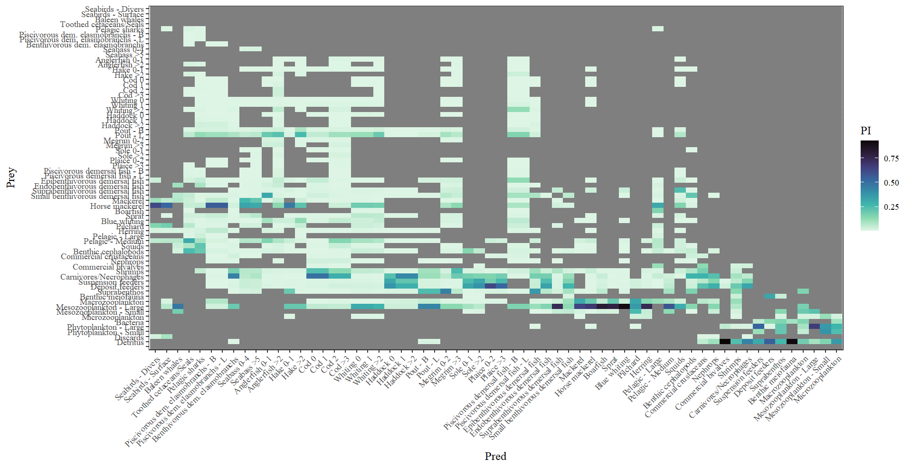

Appendix 7 : Fleet constitution and description
The 44 fishing fleets implemented in the new Ecopath model correspond to the combinations of several aggregation strata: fishing country, main gear family, fishing vessel length and targeted species assemblage. Based on fisheries dependent information data from STECF on the 2014-2020 catch data are aggregated following several steps to create fleets. 1) All countries which are landing less than 1% of the total are grouped in an “other countries” category (i.e. Belgium, The Netherlands, Portugal, Germany). 2) Gears are grouped in larger gear families if technical properties are similar based on expert knowledge. 3) For a given gear family, several vessel length classes are considered if the targeted species assemblage diverge for large and small vessels. The vessel length cut off is decided based on the data. 4) Based on expert knowledge, very specific fleets are separated from others (i.e. UK nephrops fisheries). Final fleets are checked with regard to expert knowledge and literature and are considered realistic on a management point of view. Implemented fleets are as following.
Table: Fleet description in terms of country, gears, vessel length and landed species
Fleet_name | Country | Gears | Vessel length category | Main_landed_species | Functional groups
FRA_DRA<12m | France | Dredges | < 12m | King scallop (Pecten maximus), Common European bittersweet (Glycymeris glycymeris) | Commercial bivalves
FRA_DRA>12m | France | Dredges | > 12m | Common European bittersweet (Glycymeris glycymeris), King scallop (Pecten maximus) | Commercial bivalves
FRA_FPO<12m | France | Pots and traps | < 12m | Common whelk (Buccinum undatum), European spider crab (Maja squinado) | Commercial bivalves, commercial crustaceans
FRA_FPO>12m | France | Pots and traps | > 12m | Edible crab (Cancer pagurus), Common whelk (Buccinum undatum), European spider crab (Maja squinado) | Commercial crustaceans, Commercial bivalves
FRA_GNT<18m | France | Gillnets and trammel nets | < 18m | European spider crab (Maja squinado), Anglerfish (Lophius spp) | Commercial crustaceans, Anglerfish
FRA_GNT>18m | France | Gillnets and trammel nets | > 18m | European hake (Merluccius merluccius), Anglerfish (Lophius spp.) | Hake, Anglerfish
FRA_LON<18m | France | Longlines | < 18m | Pollack (Pollachius pollachius), European seabass (Dicentrarchus labrax), European conger (Conger conger), Black seabream (Spondyliosoma cantharus) | Piscivorous demersal fish, Seabass, Epibenthivorous demersal fish
FRA_LON>18m | France | Longlines | > 18m | European hake (Merluccius merluccius), European conger (Conger conger) | Hake, Piscivorous demersal fish
FRA_TBB | France | Bottom beam trawls | All | Common sole (Solea solea), small-spotted catshark (Scyliorhinus canicula), Common cuttlefish (Sepia officinalis) and other demersal species | Sole, benthivorous demersal elasmobranch, benthic cephalopods
FRA_OTT_OTB<18m | France | Bottom otter trawls and twin otter trawls | < 18m | Common cuttlefish (Sepia officinalis), Queen scallop (Aequipecten opercularis), small-spotted catshark (Scyliorhinus canicula), anglerfish (Lophius spp) and other demersal species | Benthic cephalopods, Commercial bivalves, Benthivorous demersal elasmobranch, Anglerfish
FRA_OTT_OTB>18m | France | Bottom otter trawls and twin otter trawls | > 18m | Anglerfish (Lophius spp), haddock (Melanogrammus aeglefinus), Whiting (Merlangius merlangus) and other demersal species | Anglerfish, Haddock, Whiting
FRA_PS | France | Purse seines | All | European pilchard (Sardina pilchardus), Anchovy (Engraulis encrasicolus) | Sardine, Medium pelagic fish
FRA_SEN | France | Demersal seines | All | Haddock (Melanogramus aeglefinus), European hake (Merluccius merluccius), Atlantic cod (Gadus morhua), whiting (Melanogrammus aeglefinus) | Haddock, Hake, Cod, Whiting
FRA_PTR | France | Midwater pair trawls | All | Albacore (Thunnus alalunga) and black seabream (Spondyliosoma cantharus) | Large pelagic fish, Epibenthivorous demersal fish
FRA_OTM | France | Midwater otter trawls | All | Atlantic mackerel (Scomber scombrus), Atlantic horse mackerel (Trachurus trachurus), Blue whiting (Micromesistius poutassou) | Mackerel, Horse mackerel, Blue whiting
UK_DRA | United-Kingdom | Dredges | All | King scallop (Pecten maximus), Queen scallop (Aequipecten opercularis) | Commercial bivalves
UK_FPO<12m | United-Kingdom | Pots and traps | < 12m | Common whelk (Buccinum undatum), Edible crab (Cancer pagurus) and European lobster (Homarus gammarus) | Commercial bivalves, Commercial crustaceans
UK_FPO>12m | United-Kingdom | Pots and traps | > 12m | Edible crab (Cancer pagurus) and common whelk (Buccinum undatum) | Commercial crustaceans, Commercial bivalves
UK_GNT<12m | United-Kingdom | Gillnets and trammel nets | < 12m | European pilchard (Sardina pilchardus) and pollack (Pollachius pollachius) | Sardine, Piscivorous demersal fish
UK_GNT>12m | United-Kingdom | Gillnets and trammel nets | > 12m | European hake (Merluccius merluccius), pollack (Pollachius pollachius) and anglerfish (Lophius spp) | Hake, Piscivorous demersal fish, Anglerfish
UK_LON<18m | United-Kingdom | Longlines | <18m | Atlantic mackerel (Scomber scombrus), pollack (Pollachius pollachius) and Seabass (Dicentrachus labrax) | Mackerel, Piscivorous demersal, Seabass
UK_LON>18m | United-Kingdom | Longlines | > 18m | European hake (Merluccius merluccius) | Hake
UK_TBB<18m | United-Kingdom | Bottom beam trawls | < 18m | European plaice (Pleuronectes platessa), Common cuttlefish (Sepia officinalis), Rays, soles and other demersal species | Plaice, Benthic cephalopods, Benthivorous demersal elasmobranchs, sole, Endobenthivorous demersal fish
UK_TBB>18m | United-Kingdom | Bottom beam trawls | > 18m | Common cuttlefish (Sepia officinalis), anglerfish (Lophius spp) and other demersal species | Benthic cephalopods, Anglerfish
UK_OTT_OTB<18m | United-Kingdom | Bottom otter trawls and twin otter trawls | < 18m | Common cuttlefish (Sepia officinalis), small-spotted catshark (Scyliorhinus canicula) and flatfishes | Benthic cephalopods, Benthivorous demersal elasmobranchs, sole, plaice, endobenthivorous demersal fish
UK_OTT_OTB>18m | United-Kingdom | Bottom otter trawls and twin otter trawls | > 18m | Anglerfish (Lophius spp), megrim (Lepidorhombus spp) and hake (Merluccius merluccius) | Anglerfish, Megrim, Epibenthivorous demersal fish, Hake
UK_OTT_OTB_nephrops | United-Kingdom | Bottom otter trawls and twin otter trawls | All | Norway lobster (Nephrops norvegicus), cuttlefishes (Sepiolidae), haddock (Melanogrammus aeglefinus) and other demersal species | Norway lobster, Benthic cephalopods, Haddock
UK_OTM_PTR<18m | United-Kingdom | Midwater pair trawls and midwater otter trawls | < 18m | European sprat (Sprattus sprattus) and European pilchard (Sardina pilchardus) | Sprat, Sardine
UK_OTM_PTR>18m | United-Kingdom | Midwater pair trawls and midwater otter trawls | > 18m | Atlantic mackerel (Scomber scombrus), Atlantic horse mackerel (Trachurus trachurus) and European pilchard (Sardina pilchardus) | Mackerel, Horse mackerel, Sardine
UK_PS | United-Kingdom | Purse seines | All | European pilchard (Sardina pilchardus), Anchovy (Engraulis encrasicolus) | Sardine, Medium pelagic fish
UK_SEN | United-Kingdom | Demersal seines | All | Haddock (Melanogrammus aeglefinus), Whiting (Merlangius merlangus), Surmullets (Mullus surmuletus) and other demersal species | Haddock, Whiting, Epibenthivorous demersal fish
IRL_DRA | Ireland | Dredges | All | King scallop (Pecten maximus) | Commercial bivalves
IRL_FPO | Ireland | Pots and traps | All | Edible crab (Cancer pagurus), shrimps (Palaemonidae), European lobster crab (Hommarus gammarus) | Commercial crustaceans, shrimps
IRL_GNT | Ireland | Gillnets and trammel nets | All | European hake (Merluccius merluccius), pollack (Pollachius pollachius) and saithe (Pollachius virens) | Hake, Piscivorous demersal fish
IRL_TBB | Ireland | Bottom beam trawls | All | Anglerfish (Lophius spp), Megrim (Lepidorhombus spp), haddock (Melanogrammus aeglefinus) and other demersal species | Anglerfish, Megrim, Haddock
IRL_OTT_OTB | Ireland | Bottom otter trawls and twin otter trawls | All | Whiting (Merlangius merlangus), Norway lobster (Nephrops norvegicus), anglerfish (Lophius spp), megrim (Lepidorhombus spp. and other demersal species | Whiting, Norway lobster, Anglerfish, Megrim
IRL_SEN | Ireland | Demersal seines | All | Whiting (Merlangius merlangus), European hake (Merluccius merluccius), haddock (Melanogrammus aeglefinus) and other demersal species | Whiting, Hake, Haddock
IRL_OTM_PTR>40m | Ireland | Midwater pair trawls and midwater otter trawls | > 40m | Boarfish (Capros aper), Atlantic mackerel (Scomber scombrus) and herring (Clupea harengus) | Boarfish, Mackerel, Herring
IRL_OTM_PTR<40m | Ireland | Midwater pair trawls and midwater otter trawls | < 40m | Herring (Clupa harengus) and Atlantic mackerel (Scomber scombrus) | Herring, Mackerel
ESP_GNT_LON>24m | Spain | Gillnets, trammel nets and longlines | < 24m | Albacore (Thunnus alalunga) | Large pelagic fish
ESP_GNT_LON<24m | Spain | Gillnets, trammel nets and longlines | > 24m | European hake (Merluccius merluccius), Blue shark (Prionace glauca) | Hake, Pelagic sharks
ESP_OTB | Spain | Bottom otter trawls | All | Megrim (Lepidorhombus spp) , Anglerfish (Lophius spp), European hake (Merluccius merluccius), Northern shortfin squid (Illex illecebrosus) and other demersal species | Megrim, Anglerfish, Hake, Squids
OTH_demersal | Other Countries | Mainly demersal trawls | All | Anglerfish (Lophius piscatorius) , Common sole (Solea solea), European plaice (Pleuronectes platessa) and other demersal species | Anglerfish, Sole, Plaice
OTH_pelagic | Other Countries | Mainly pelagic trawls | All | Horse mackerels (Trachurus spp), European sardine (Sardina pilchardus), Atlantic mackerel (Scomber scombrus) adn herring (Clupea harengus) | Horse mackerel, Sardine, Mackerel, Herring

Appendix 8 : Landings and discards (t/km²) by functional group
Functional group name | Landings | Discards
Pelagic sharks | 0,001014018 | 1,23E-06
Piscivorous demersal elasmobranchs - B | 0,003638171 | 0,00064798
Benthivorous demersal elasmobranchs | 0,04987724 | 0,02562695
Seabass 0-4 | 0,002618695 | 0,0002724
Seabass >5 | 0,003310226 | 0
Anglerfish 0-1 | 0,007103729 | 0,01038732
Anglerfish >2 | 0,08910362 | 0,00259682
Hake 0-1 | 0,008957218 | 0,00134187
Hake >2 | 0,04573343 | 0,00760409
Cod 1 | 0,001839509 | 0,00025971
Cod 2 | 0,00364279 | 0,00025971
Cod >3 | 0,01629855 | 0
Whiting 0 | 0,001261252 | 0,00039334
Whiting 1 | 0,005409561 | 0,00249134
Whiting >2 | 0,03956397 | 0,01022754
Haddock 1 | 0,000297549 | 0,00272519
Haddock >2 | 0,02155023 | 0,00241661
Pout - B | 4,06E-06 | 0
Pout - L | 0,01398132 | 0,00565565
Megrim 0-2 | 0,002849952 | 0,00175609
Megrim >3 | 0,04675311 | 0
Sole >2 | 0,0116388 | 0,00028709
Plaice 0-2 | 0,001389557 | 0,00404578
Plaice >3 | 0,007624493 | 0,00606856
Piscivorous demersal fish - B | 0,03607444 | 0,00028576
Piscivorous demersal fish - L | 0,02007747 | 2,24E-04
Epibenthivorous demersal fish | 0,02429987 | 0,00662111
Endobenthivorous demersal fish | 0,01458553 | 0,00111067
Suprabenthivorous demersal fish | 0,000223024 | 0
Small benthivorous demersal fish | 1,22E-05 | 0,00039773
Mackerel | 0,1878874 | 2,67E-02
Horse mackerel | 0,3628676 | 0,04421546
Boarfish | 0,000726043 | 0
Sprat | 0,006428771 | 0
Blue whiting | 0,006010445 | 3,78E-09
Pilchard | 0,03890747 | 0
Herring | 0,0279791 | 0,00011089
Pelagic - Large | 0,003208361 | 0
Pelagic - Medium | 0,000709819 | 0
Squids | 0,01129198 | 6,91E-05
Benthic cephalopods | 0,05593286 | 0,00213299
Commercial crustaceans | 0,06554155 | 0,00169042
Nephrops | 0,02634328 | 0,00060316
Commercial bivalves | 0,1297447 | 0,00753723
Shrimps | 0,000174387 | 0
Carnivores/Necrophages | 0,05377888 | 0
Suspension feeders | 0,000208872 | 0
Deposit feeders | 0,000208872 | 0

Absolute landings over 2003-2020 are either issued from stock assessment in the area for assessed commercial species or from International Catch Statistics for non-commercial non-assessed species. Discards being available only from 2014, discards are calculated using a discard rate by gear available on the three first available years (2014-2016). Landings and discards are then shared among fleets using information from two STECF fisheries dependent databases (Zanzi & Holmes 2017, Gibin et al. 2021) and MIXFISH ICES working group for UK, Ireland, Spain and the “other country” category. National French fisheries database (SIH database) is used for French fleets as it is a more detailed database. Using various database allows the use of the available and more complete database for each fleet by time period and thus prevent losing too much information due to the confidentiality rules applied to strata with too few boats in the STECF database. In the end, catch data distribution is compared to Catch statistics data by country in the area to check distribution consistency. The distribution was pretty realistic, slightly underestimating “other countries” catches due to more confidential data in STECF databases. Even if this underestimation is observed, the distribution by fleet is only used in the Ecopath base year which prevent the model to be temporally calibrated with high uncertain data in the Ecosim model.

Appendix 9 : PREBAL diagnostics for the Celtic Sea Ecopath base year (2003)
Classical scientific PREBAL diagnostics (Link 2010) are carried out to check if the model is in accordance with ecological and thermodynamic rules, which is the case (e.g. check if there is enough production in the model to sustain the whole ecosystem).
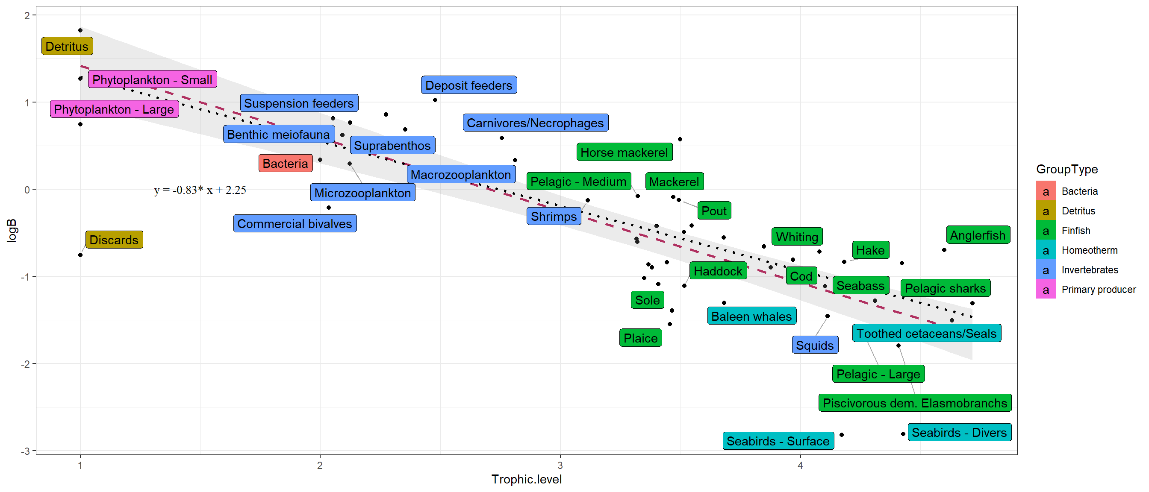
Figure 1 : PREBAL diagnostic on biomass repartition according to TL. *The red dashed line is the regression line including all the group types apart from detritus. The black dotted line is the same regression line but excludes homeotherms.

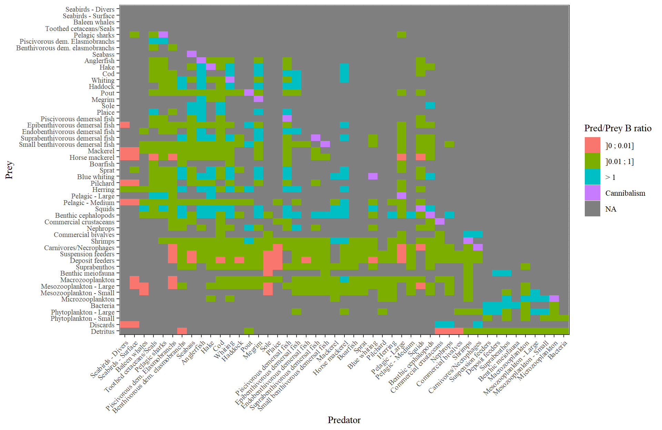
Figure 2 : PREBAL diagnostic on the consistency of preys’ biomass compared to the predators’ biomass
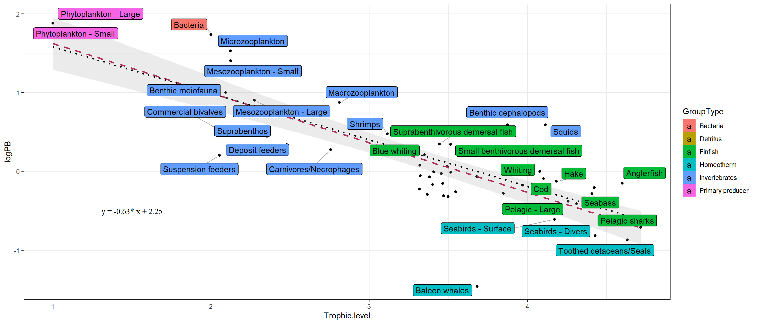
Figure 3 : PREBAL diagnostic on P/B according to TL. *The red dashed line is the regression line including all the group types apart from detritus. The black dotted line is the same regression line but excludes homeotherms.

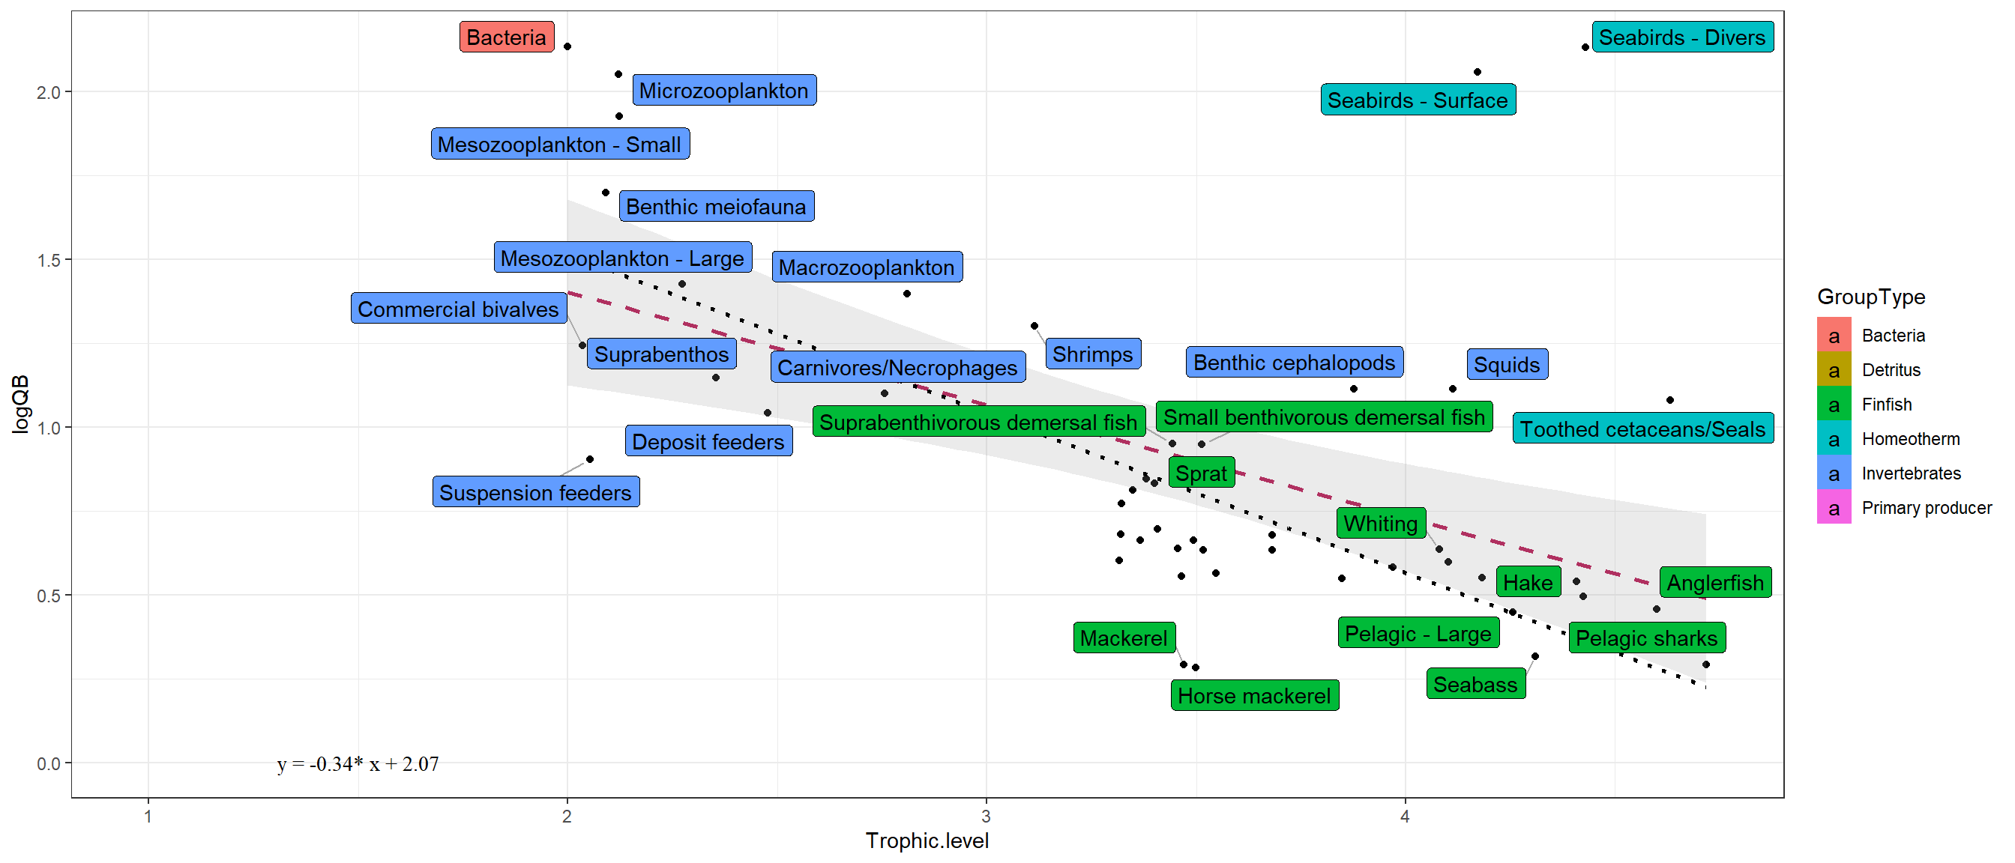
Figure 4: PREBAL diagnostic on Q/B ratio according to TL. *The red dashed line is the regression line including all the group types apart from detritus. The black dotted line is the same regression line but excludes homeotherms.

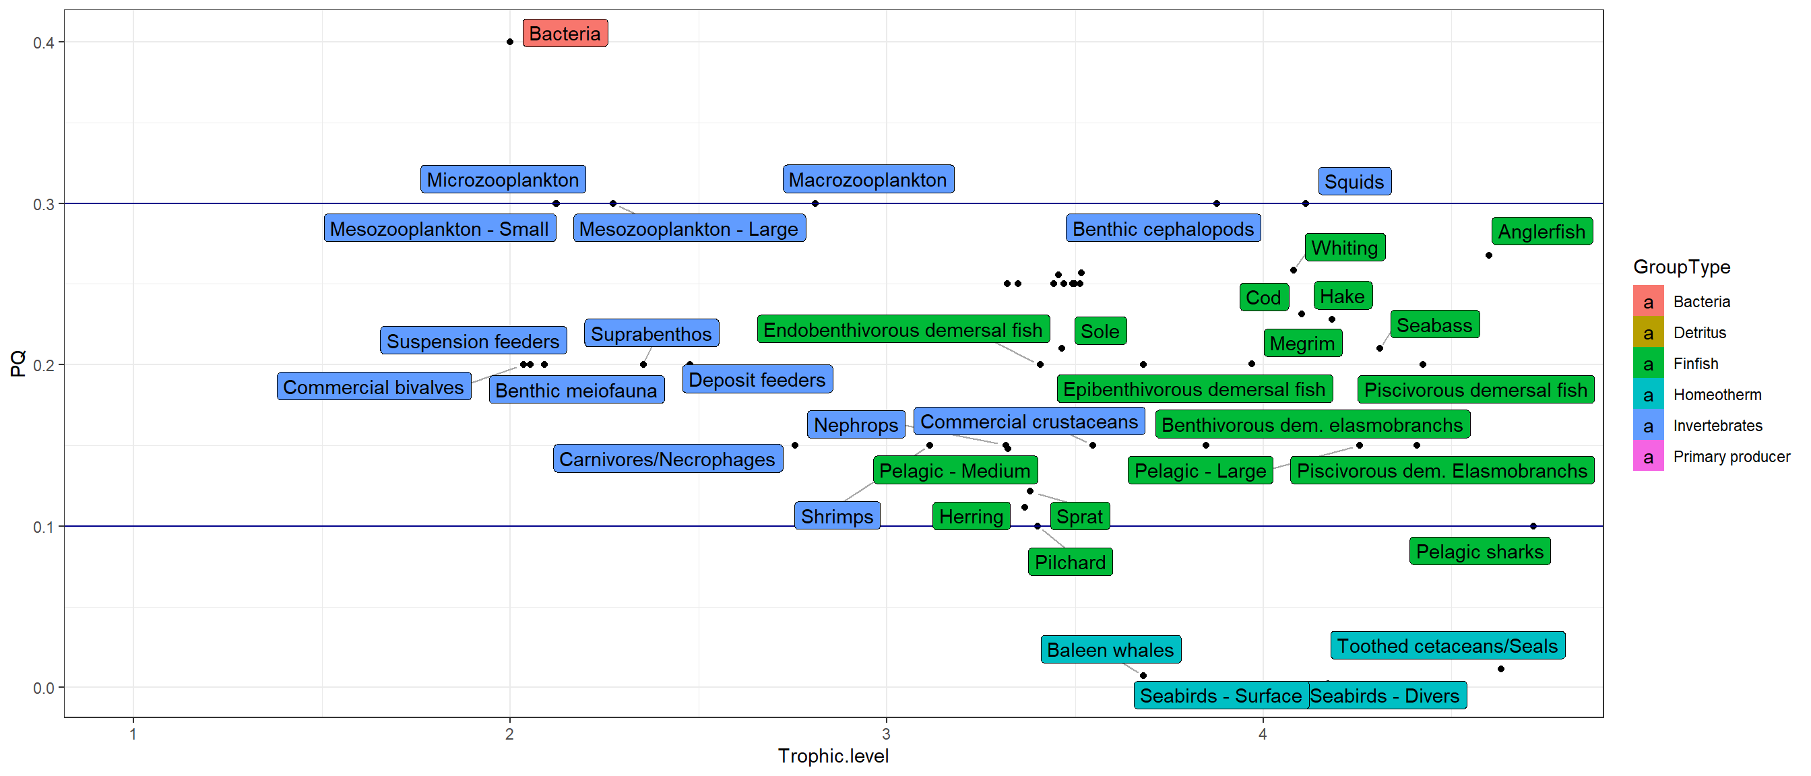
Figure 5: PREBAL diagnostic on P/Q ratio. *Blue lines are minimum and maximum limits not to pass if we want to respect PREBAL diagnostic
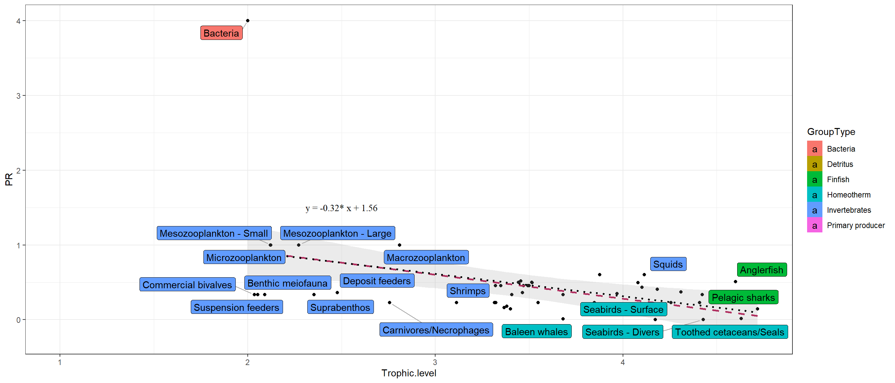
Figure 6: PREBAL diagnostic on P/R ratio according to TL. *The red dashed line is the regression line including all the group types apart from detritus. The black dotted line is the same regression line but excludes homeotherms.

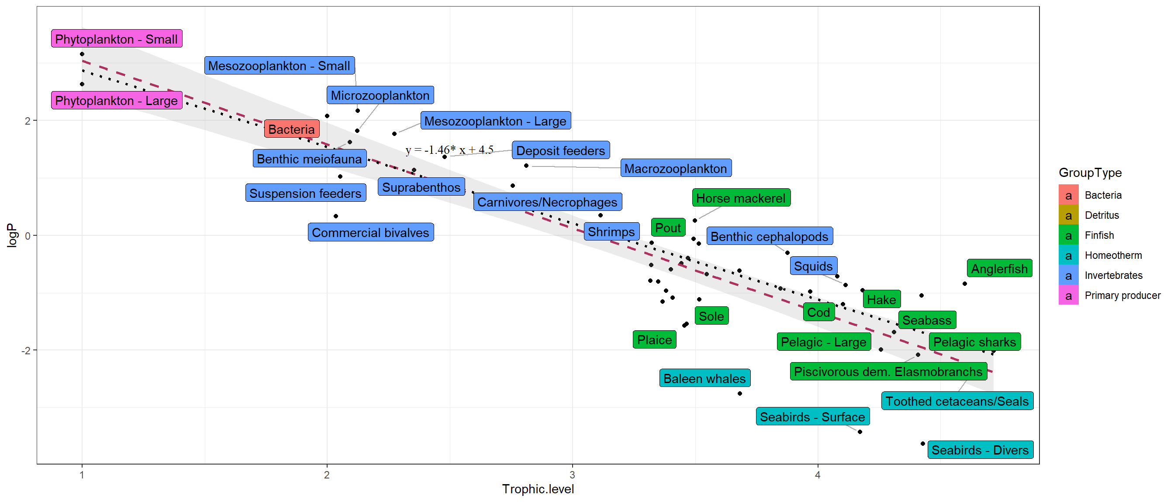
Figure 7: PREBAL diagnostic on production according to TL. *The red dashed line is the regression line including all the group types apart from detritus. The black dotted line is the same regression line but excludes homeotherms.

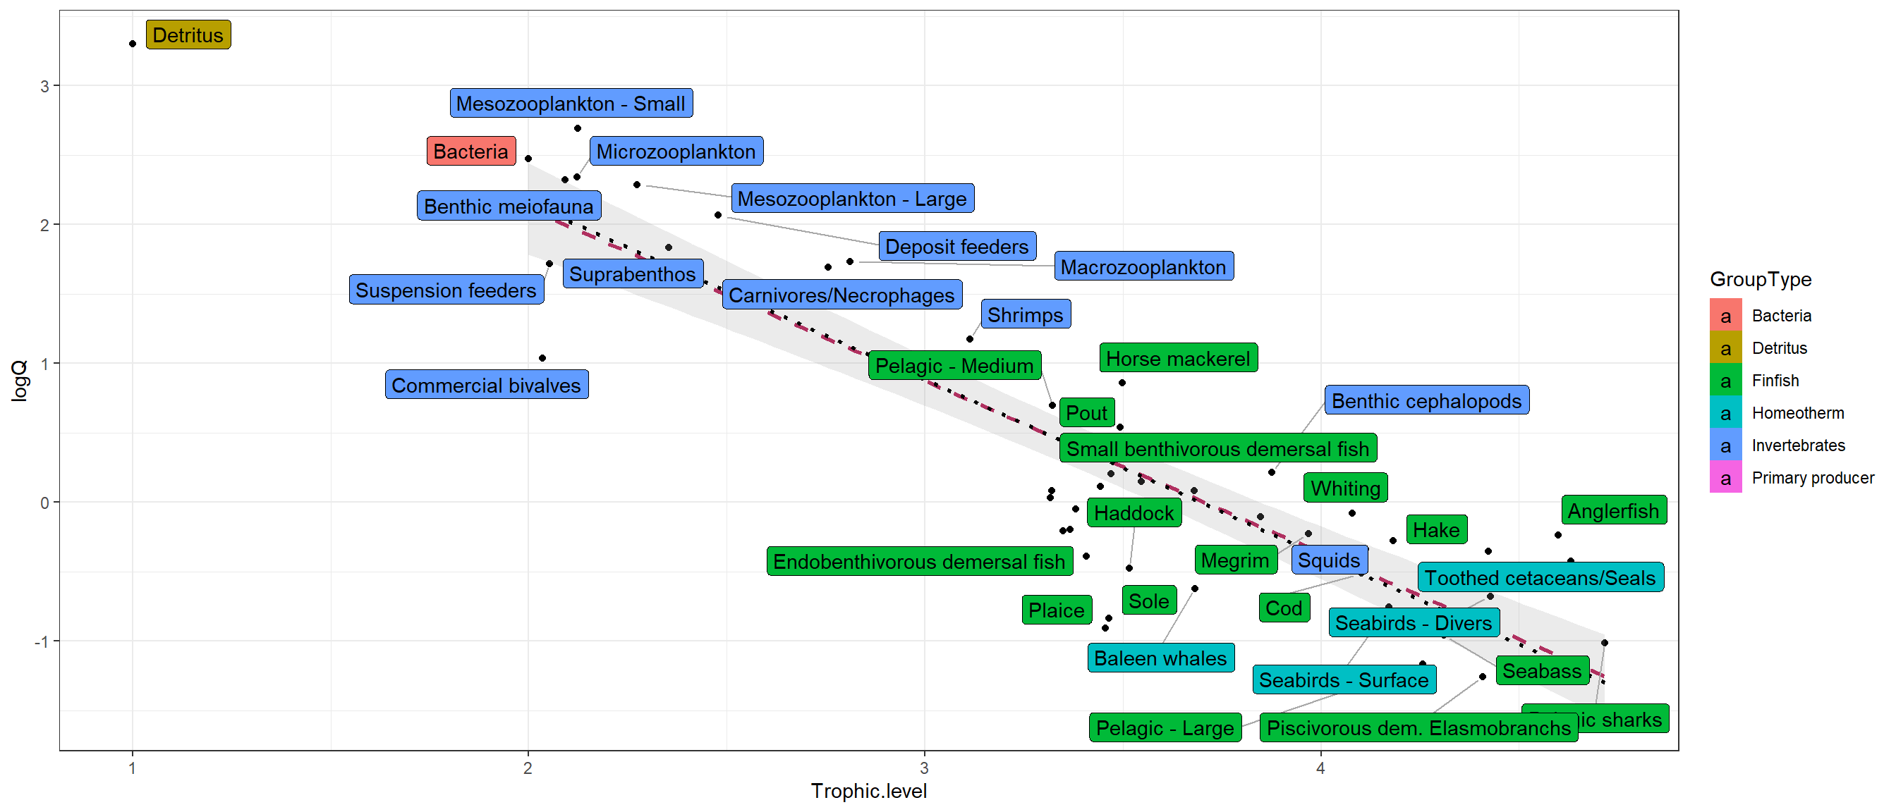
Figure 8: PREBAL diagnostic on consumption according to TL. *The red dashed line is the regression line including all the group types apart from detritus. The black dotted line is the same regression line but excludes homeotherms.

Appendix 10 : Ecosim input parameters.
Functional group name | Max relative feeding time | Feeding time adjustment rate [0,1] | Fraction of other mortality sensitive to changes in feeding time | Predator effect on feeding time [0,1] | QBmax/QBo (for handling time) [>1] | Switching power parameter [0,2]
Seabirds - Divers | 1,25 | 0,5 | 1 | 0 | 3 | 2
Seabirds - Surface | 1,25 | 0,5 | 1 | 0 | 3 | 2
Baleen whales | 1,25 | 0,1 | 1 | 0 | 3 | 2
Toothed cetaceans/Seals | 1,25 | 0,1 | 1 | 0 | 3 | 2
Pelagic sharks | 1,25 | 0,1 | 1 | 0 | 10 | 2
Piscivorous demersal elasmobranchs - B | 1,25 | 0,1 | 1 | 1 | 3 | 1
Piscivorous demersal elasmobranchs - L | 1,25 | 0,1 | 1 | 1 | 3 | 1
Benthivorous demersal elasmobranchs | 1,25 | 0,1 | 1 | 1 | 3 | 1
Seabass 0-4 | 1,25 | 0,2 | 1 | 0,75 | 3 | 2
Seabass >5 | 1,25 | 0,1 | 1 | 1 | 3 | 2
Anglerfish 0-1 | 1,25 | 0,2 | 1 | 0,75 | 3 | 1
Anglerfish >2 | 1,25 | 0,1 | 1 | 1 | 3 | 1
Hake 0-1 | 1,25 | 0,2 | 1 | 0,75 | 3 | 1
Hake >2 | 1,25 | 0,1 | 1 | 1 | 3 | 2
Cod 0 | 1,25 | 0,2 | 1 | 0,75 | 3 | 2
Cod 1 | 1,25 | 0,2 | 1 | 0,75 | 3 | 2
Cod 2 | 1,25 | 0,1 | 1 | 1 | 3 | 2
Cod >3 | 1,25 | 0,1 | 1 | 1 | 3 | 2
Whiting 0 | 1,25 | 0,2 | 1 | 0,75 | 3 | 2
Whiting 1 | 1,25 | 0,1 | 1 | 1 | 3 | 2
Whiting >2 | 1,25 | 0,1 | 1 | 1 | 3 | 2
Haddock 0 | 1,25 | 0,2 | 1 | 0,75 | 3 | 1
Haddock 1 | 1,25 | 0,2 | 1 | 0,75 | 3 | 1
Haddock >2 | 1,25 | 0,1 | 1 | 1 | 3 | 1
Pout - B | 1,25 | 0,1 | 1 | 1 | 3 | 2
Pout - L | 1,25 | 0,1 | 1 | 1 | 3 | 2
Megrim 0-2 | 1,25 | 0,2 | 1 | 0,75 | 3 | 1
Megrim >3 | 1,25 | 0,1 | 1 | 1 | 3 | 1
Sole 0-1 | 1,25 | 0,6 | 1 | 0,75 | 10 | 0,5
Sole >2 | 1,25 | 0,5 | 1 | 1 | 10 | 0,5
Plaice 0-2 | 1,25 | 0,6 | 1 | 0,75 | 10 | 0,5
Plaice >3 | 1,25 | 0,5 | 1 | 1 | 10 | 0,5
Piscivorous demersal fish - B | 1,25 | 0,1 | 1 | 1 | 3 | 2
Piscivorous demersal fish - L | 1,25 | 0,1 | 1 | 1 | 3 | 2
Epibenthivorous demersal fish | 1,25 | 0,1 | 1 | 1 | 3 | 2
Endobenthivorous demersal fish | 1,25 | 0,5 | 1 | 1 | 10 | 0,5
Suprabenthivorous demersal fish | 1,25 | 0,1 | 1 | 0,75 | 3 | 0
Small benthivorous demersal fish | 1,25 | 0,5 | 1 | 0,75 | 3 | 0,5
Mackerel | 1,25 | 0,5 | 1 | 0,5 | 3 | 0
Horse mackerel | 1,25 | 0,5 | 1 | 0,5 | 3 | 0
Boarfish | 1,25 | 0,5 | 1 | 0,5 | 3 | 0
Sprat | 1,25 | 0,5 | 1 | 0,5 | 3 | 0
Blue whiting | 1,25 | 0,5 | 1 | 0,5 | 3 | 0
Pilchard | 1,25 | 0,5 | 1 | 0,5 | 3 | 0
Herring | 1,25 | 0,5 | 1 | 0,5 | 3 | 0
Pelagic - Large | 1,25 | 0,1 | 1 | 1 | 10 | 1
Pelagic - Medium | 1,25 | 0,5 | 1 | 0,5 | 3 | 0
Squids | 1,25 | 0,1 | 1 | 1 | 3 | 1
Benthic cephalopods | 1,25 | 0,1 | 1 | 1 | 3 | 1
Commercial crustaceans | 1,25 | 0,1 | 1 | 0,75 | 3 | 1
Nephrops | 1,25 | 0,1 | 1 | 0,75 | 3 | 1
Commercial bivalves | 1 | 0,05 | 0 | 0 | 3 | 0
Shrimps | 1,25 | 0,1 | 1 | 0,5 | 3 | 1
Carnivores/Necrophages | 1,25 | 0,1 | 1 | 0,5 | 3 | 1
Suspension feeders | 1,25 | 0,1 | 1 | 0,5 | 3 | 0
Deposit feeders | 1,25 | 0,1 | 1 | 0,5 | 3 | 0
Suprabenthos | 1,25 | 1 | 1 | 0,5 | 3 | 0
Benthic meiofauna | 1,5 | 1 | 0 | 0 | 3 | 0
Macrozooplankton | 1,5 | 1 | 1 | 0 | 3 | 1
Mesozooplankton - Large | 1,5 | 1 | 1 | 0 | 3 | 0
Mesozooplankton - Small | 1,5 | 1 | 1 | 0 | 3 | 0
Microzooplankton | 1,5 | 1 | 1 | 0 | 3 | 0
Bacteria | 1,5 | 0,05 | 1 | 0 | 3 | 0
Phytoplankton - Large | 1 | 0,5 | 1 | 0 | 1000 | 0
Phytoplankton - Small | 1 | 0,5 | 1 | 0 | 1000 | 0
For all groups, maximum relative P/B is fixed at 2 and density-dependence catchability at 1. Ecosim input parameters come from Hernvann et al. (2020). Only juvenile multi-stanza input parameters are modified to have a higher feeding time adjustment rate and a lower predator effect on feeding time following EwE user’s guide.
Appendix 11 : Ecosim stability test.
Before any forcing or fitting, a stability test is performed following literature guidelines from Bentley et al. (2019) and Hernvann et al. (2020). This test aims at identifying problems such as prey-predator cycles over multiple trophic levels, drastic reduction in the biomass of some compartments in response to predation or competition or stock recruitment instabilities. Simulations are carried out over 100 years and 4 scenarios are considered: 1) A cessation of fishing effort just after the base year (Figure 9), 2) a brutal and temporary (8 years; effort multiplied by two; Figure 10) increase in effort after the base year (between 2003 and 2011), 3) a brutal and temporary (8 years; effort divided by two; Figure 11) decrease in effort after the base year (between 2003 and 2011), and 4) a constant effort (Figure 12). Test results do not show highly weird model behaviour. When fishing increases, commercial species biomass declines and when fishing declines, commercial species biomass re increases. Some oscillations are detected for anglerfish which is a multi-stanza group. Even if oscillations are reported in the technical literature (Bentley et al. 2019) as potentially being a recruitment model artefact, recruitment instabilities were checked and oscillations were not due to this phenomenon.
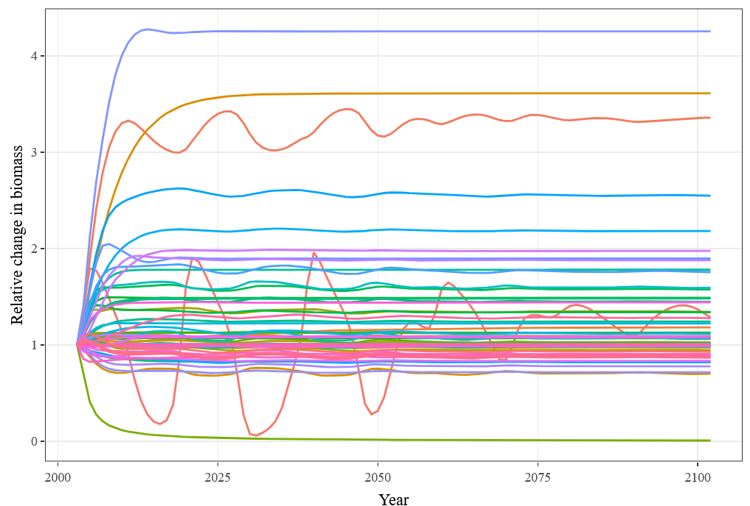
Anglerfish adults
Anglerfish juveniles
Figure 9 : Stability test, scenario 1 being an effort cessation over 2004-2104

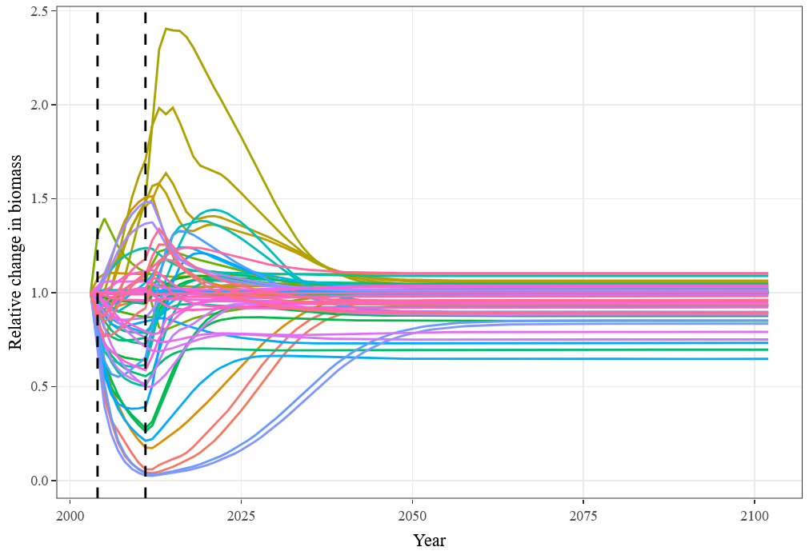
Figure 10 : Stability test, scenario 2 being an effort brutal increase during 8 years

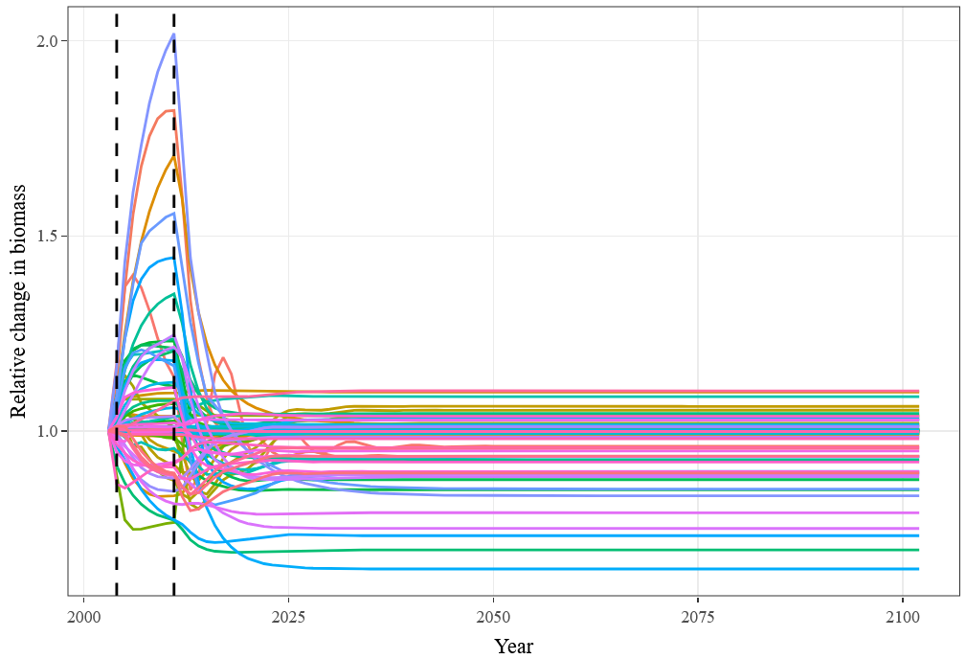
Figure 11 : Stability test, scenario 3 being an effort brutal decrease during 8 years

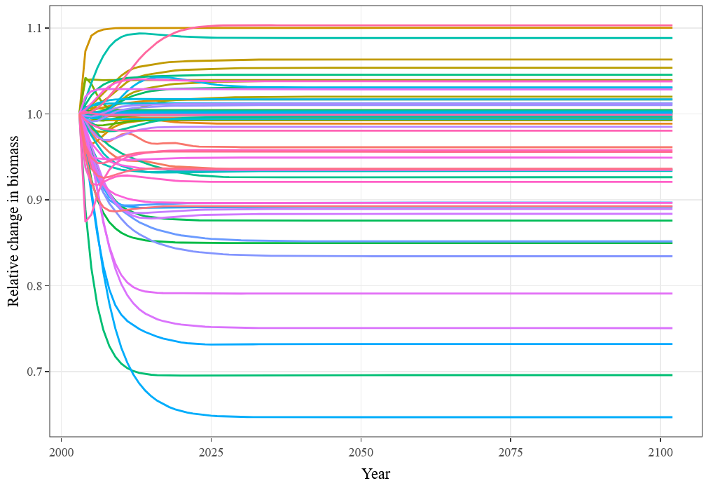
Figure 12 : Stability test, Scenario 4 being a constant effort over 2003-2024

Appendix 12 : Fitting and driving time series and their data sources for the Ecosim model
Two time series type are used to build and calibrate the EwE model: “fitting time series” and “driving time series”. Driving time series (also named “forcing”) are used as absolute drivers within the model whereas fitting time series are implemented to adjust the model to data. Overall, 173 time series are implemented.
Effort time series relative to 2003 are implemented to drive effort by fleet within the model. Data are issued from SIH data (Système d'Informations Halieutiques, Ifremer) for French fleets and from STECF fisheries dependent databases (Zanzi & Holmes 2017, Gibin et al. 2021) for other countries’ fleets. Recruitment driving time series from stock assessments are also used to better simulate multi-stanza group dynamics. The catchabilities per fleet and species are considered constant for all groups, except for boarfish, for which a catchability time series is implemented, as this species was not heavily fished in 2003 and represents a large catch in the rest of the time series. This catchability time series is produced on the basis of the outputs of previous EwE models. 2 seabirds driving biomass time series coming from JNCC data (Joint Nature Conservation Committee) are also implemented to constrain the model.
Fitting time series are either absolute biomass, biomass indices or catches by functional group. Catches data are produced following the method in Appendix 8. Absolute biomass time series are added for multi-stanza oldest groups and other assessed groups for which ICES stock assessment data are available. Biomass indices time series are issued from various data sources. For multi-stanza youngest groups, the biomass time series come from ICES stock assessment. For non-assessed fish and benthic groups, series are calculated thanks to EVHOE survey data. Plankton biomass indices are taken from CPR survey data (Continuous Plankton Recorder, www.cprsurvey.org ).
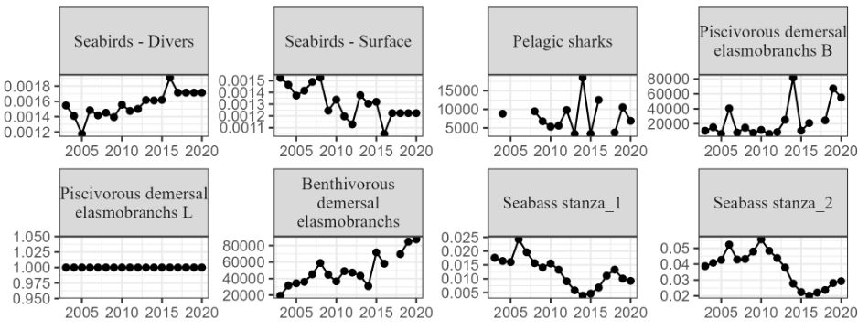
Fitting time series are 'weighted' according to the confidence we have in each data source to assess species dynamics. During the fitting process, the model will prioritise high weighted time series over low weighted time series. Absolute biomass time series from stock assessment are given a high weight. Biomass indices derived from stock assessments are given a lower weight than absolute biomasses. Biomass indices for the first stages of multi-stanza groups are given a lower weight, assuming that the low natural mortalities used in the stock assessments for juveniles are sources of biases. Finally, survey time series are given lower weights than stock assessment time series. For EVHOE data, based on field knowledge, different weights are assigned depending on the ability of the surveys to assess the dynamics of each species. For instance, benthic species that are poorly sampled by the EVHOE survey are assigned the lowest weights.
(to be continued)

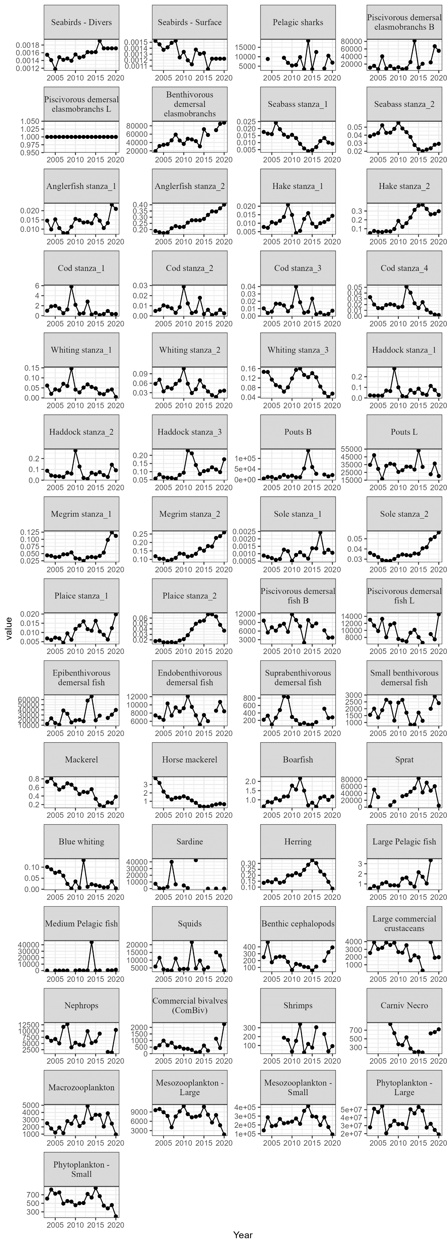
(to be continued)
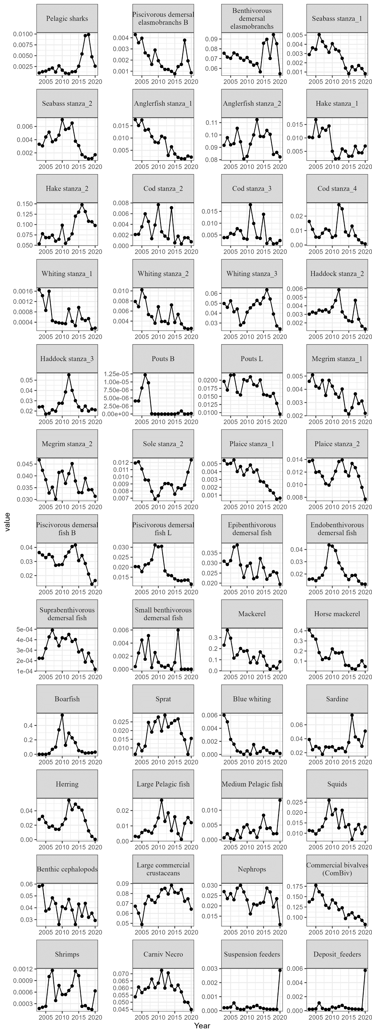
(to be continued)
Figure 13 : Absolute biomass and biomass indices fitting time series

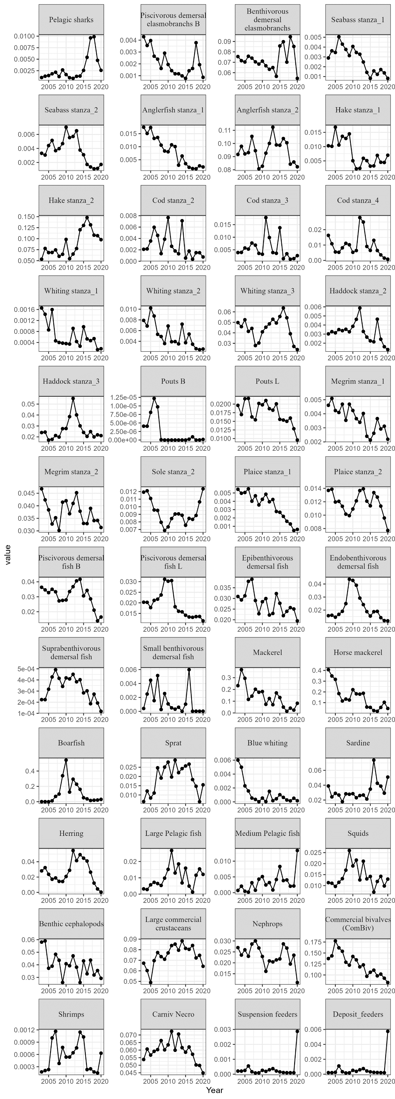
(to be continued)
Figure 14 : Catches by functional group fitting time series

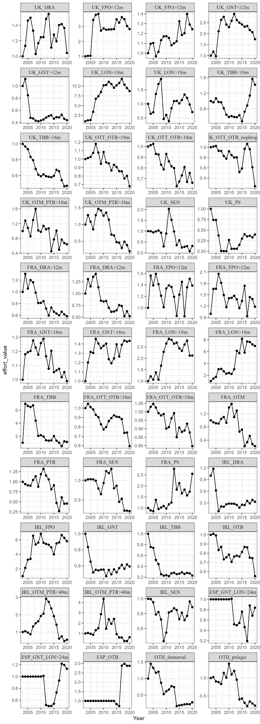
(to be continued)
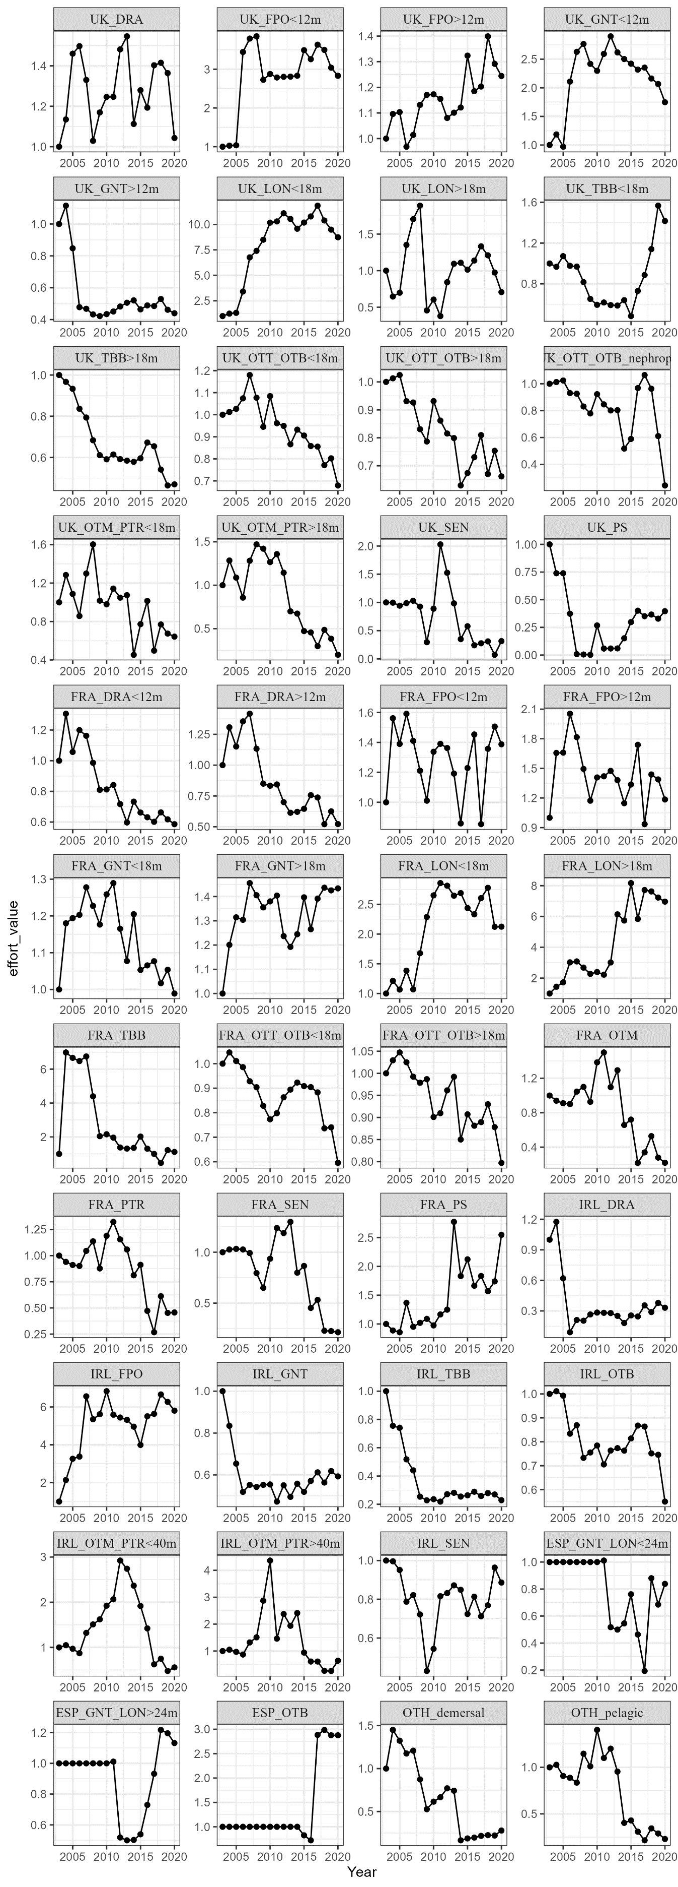
(to be continued)
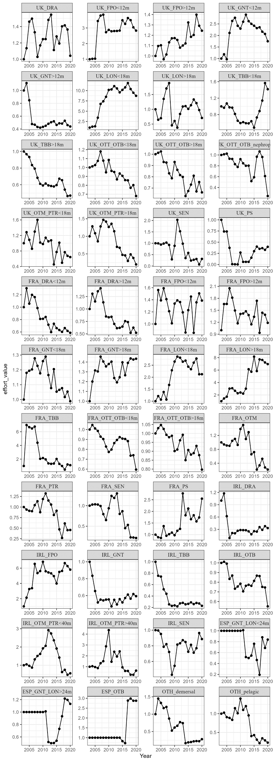
Figure 15 : Fishing effort by fleet, driving time series relative to 2003

Appendix 13 : Environmental drivers time series
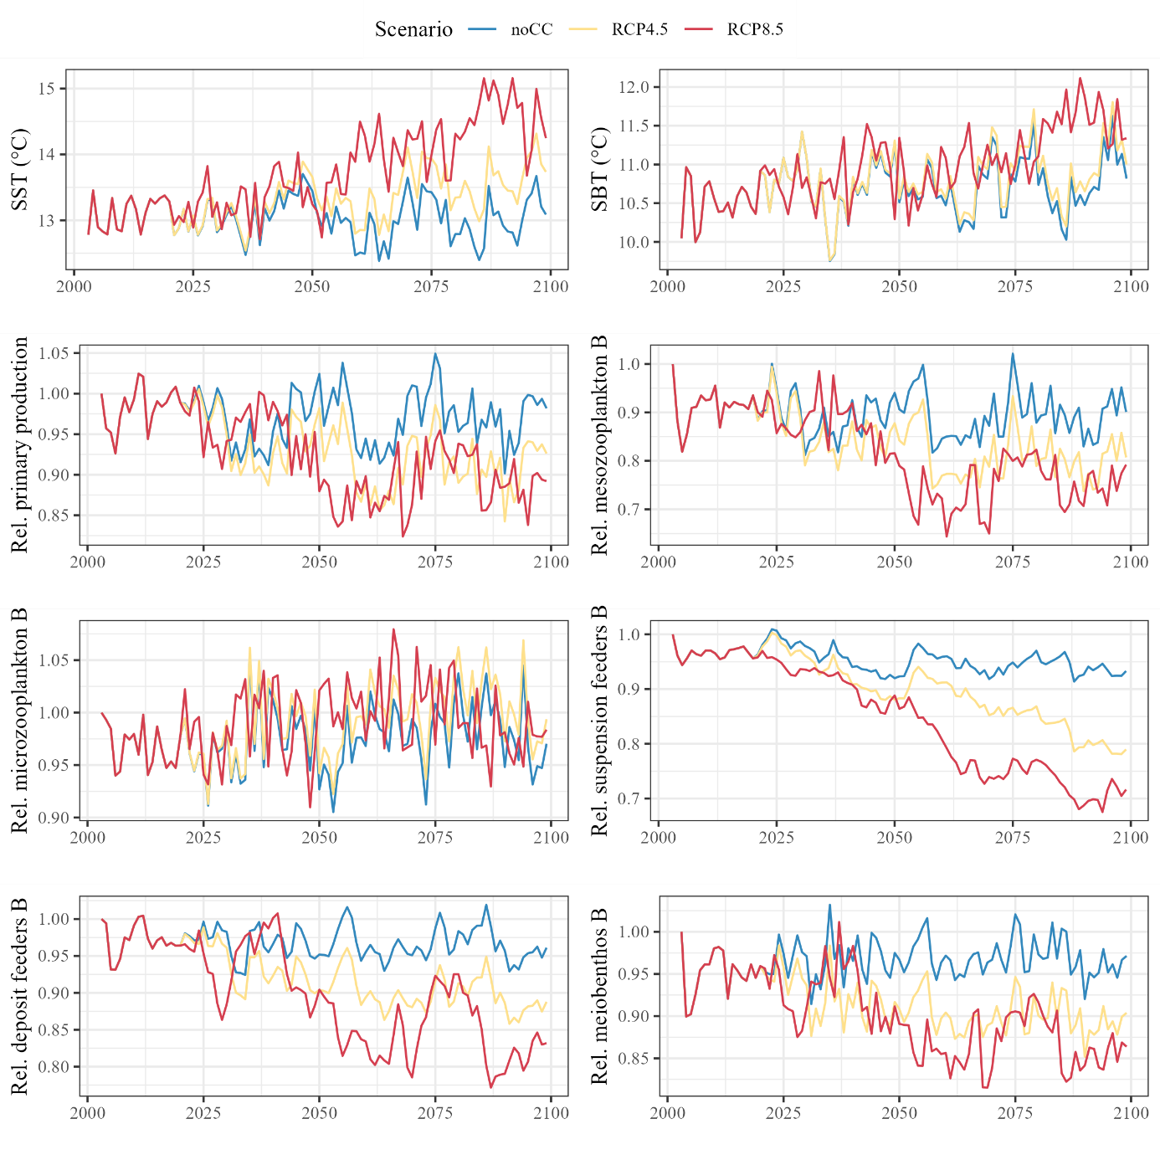
Figure 16 : polcoms-ersem environmental drivers used to force the EwE model on the historical and forecast periods. Primary production and carbon biomass time series are expressed relatively to 2003.

Appendix 14 : Functional responses of groups to Surface and Bottom Temperature
36 functional responses to temperature (either SBT or SST; Figure 17 and 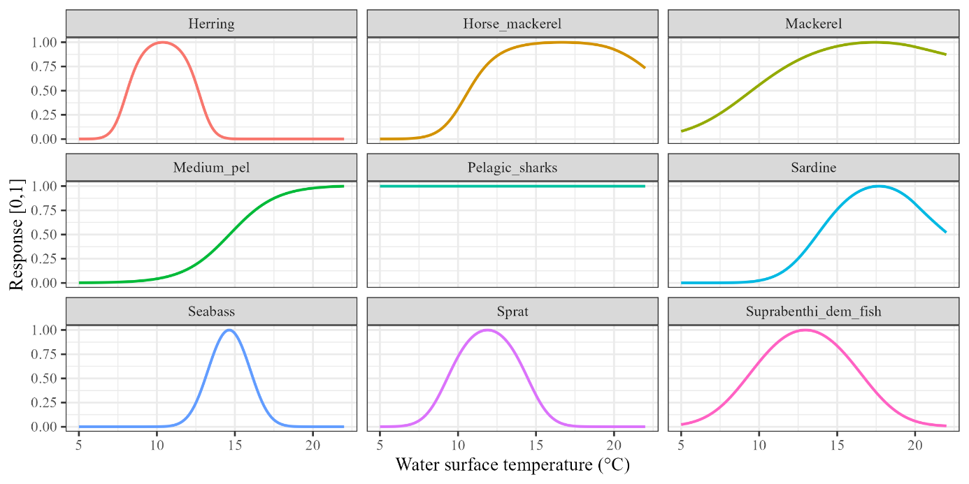Figure 18) are implemented in the Ecosim model to represent the effect of temperature on functional groups’ consumption. These responses of species, ranging from 0 to 1, come from SCAM models (Shape Constrained Additive Models) issued from previous work (Hernvann 2020) and fitted to survey data covering a large geographic area to consider a wider temperature range.
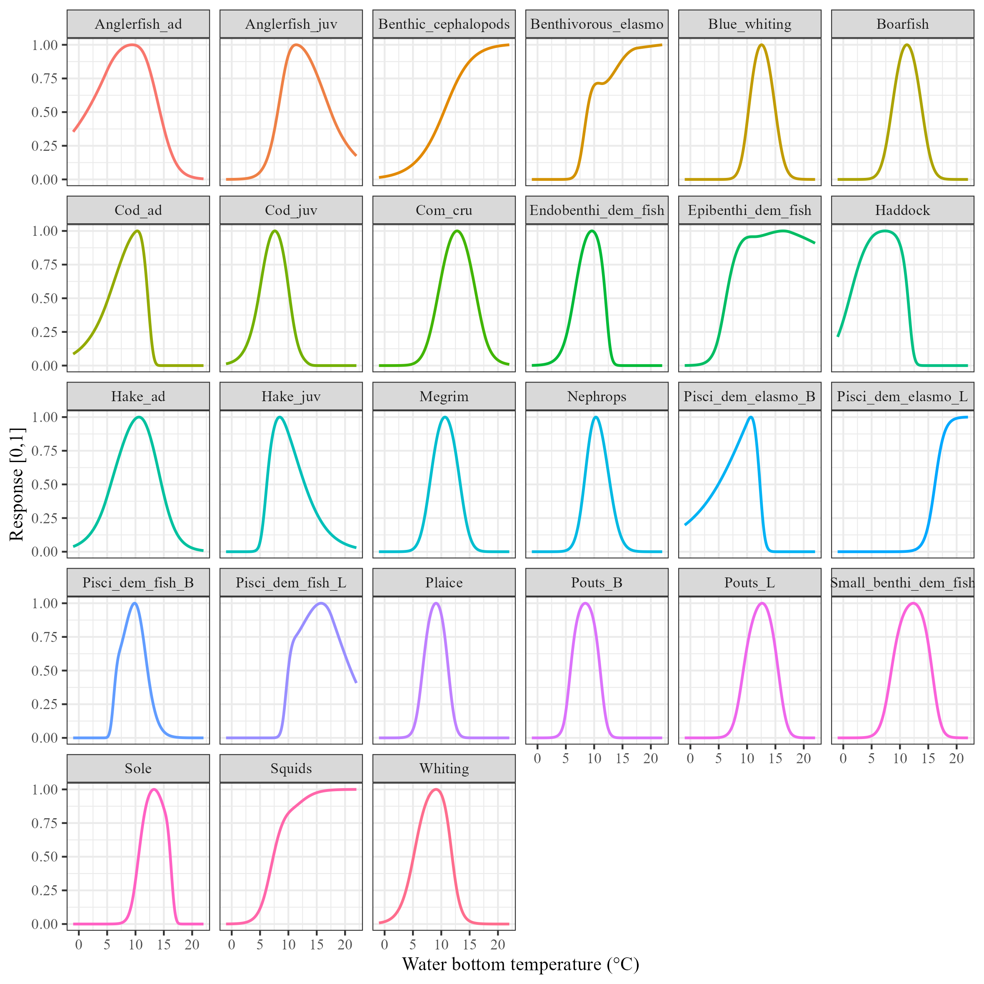
Figure 17 : Functional responses of species for sea surface temperature included in the Ecosim model to simulate the effect of surface temperature on functional groups’ consumption.

Figure 18 : Functional responses of species for sea bottom temperature included in the Ecosim model to simulate the effect of bottom temperature on functional groups’ consumption.

Appendix 15 : Fitting procedure to fit Ecosim model to data
The Ecosim model including input parameters, driving and environmental time series coupled to functional responses to temperature is fitted to data through the automated stepwise fitting procedure (Scott et al. 2016).
EwE models are fitted to data by estimating vulnerability multipliers which represent the vulnerability of prey’s species for their predators according to the foraging arena theory (Ahrens et al. 2012). The maximum number of vulnerability multipliers that can be estimated by the fitting procedure is equal to the number of prey/predator pairs (hereafter referred to as N). For the sake of parsimony, not every pair is estimated. If the vulnerability parameter of a prey/predator pair does not significantly influence model fit to data, it is not worth concentrating the estimation effort on it. The fitting procedure therefore includes a sensitivity analysis of the model fit to data measured by the Sum of Squares deviation (SS) to vulnerability parameters and the selection of vulnerability multipliers to be estimated. A Monte Carlo Markov Chain (MCMC) estimation algorithm is then used to infer the values of the selected vulnerability multipliers. The stepwise fitting procedure routinely estimates vulnerability values from 1 to N, one at a time, and measure the model fit to data (SS) and the Akaike Information Criteria for small sample sizes (AICc; Burnham et al. 2011). AICc is an adaptation of AIC (Akaike 1974), which means that it measures the model fit to data penalised by the number of estimated parameters and also includes an adjustment for small sample sizes.
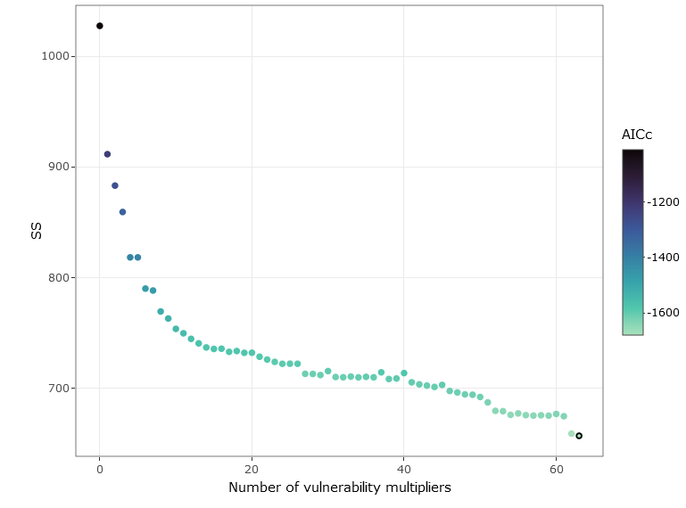
Vulnerability parameters are estimated here by predator, assuming that prey vulnerability is ecologically dependent on predator species characteristics. Based on the results of the stepwise fitting procedure, (Figure 19), a model with 63 vulnerability multipliers is selected. No additional vulnerability multipliers are added for specific prey/predator pairs, as the estimation of the most sensitive parameters was close to the values already estimated by the predator.
Figure 19 : Sum of Squares deviation (SS) and AICc according to the number of estimated vulnerability multipliers. The black circle represents the elected EwE model.

Appendix 16 : Vulnerability parameters by predator estimated during the fitting procedure
Predator | Vulnerability parameter by predator
Seabirds - Divers | 1,00E+10
Seabirds - Surface | 1,00E+10
Baleen whales | 1
Toothed cetaceans/Seals | 1
Pelagic sharks | 1,00E+10
Piscivorous dem. elasmobranchs - B | 1
Piscivorous dem. elasmobranchs - L | 1
Benthivorous dem. elasmobranchs | 1
Seabass 0-4 | 1
Seabass >5 | 1,000006
Anglerfish 0-1 | 1
Anglerfish >2 | 11,40363
Hake 0-1 | 1
Hake >2 | 1,00E+10
Cod 0 | 1,077386
Cod 1 | 1,002366
Cod 2 | 1,00E+10
Cod >3 | 1,00E+10
Whiting 0 | 1,997504
Whiting 1 | 1
Whiting >2 | 1
Haddock 0 | 2,373978
Haddock 1 | 1,000052
Haddock >2 | 1,78E+07
Pout - B | 1,00E+10
Pout - L | 1
Megrim 0-2 | 1
Megrim >3 | 1
Sole 0-1 | 1,00E+10
Sole >2 | 1
Plaice 0-2 | 1,047234
Plaice >3 | 2,473545
Piscivorous demersal fish - B | 1
Piscivorous demersal fish - L | 1
Epibenthivorous demersal fish | 1
Endobenthivorous demersal fish | 1
Suprabenthivorous demersal fish | 1
Small benthivorous demersal fish | 1,00E+10
Mackerel | 1,00E+10
Horse mackerel | 5,976602
Boarfish | 1
Sprat | 1
Blue whiting | 1,00E+10
Pilchard | 1,171442
Herring | 1,012628
Pelagic - Large | 1,00E+10
Pelagic - Medium | 1
Squids | 1
Benthic cephalopods | 1,243843
Commercial crustaceans | 2,149771
Nephrops | 1
Commercial bivalves | 1
Shrimps | 1
Carnivores/Necrophages | 1
Suspension feeders | 1
Deposit feeders | 1,00E+10
Suprabenthos | 9,164063
Benthic meiofauna | 1,001208
Macrozooplankton | 6,145852
Mesozooplankton - Large | 1
Mesozooplankton - Small | 1
Microzooplankton | 1,00E+10
Bacteria | 1,306728

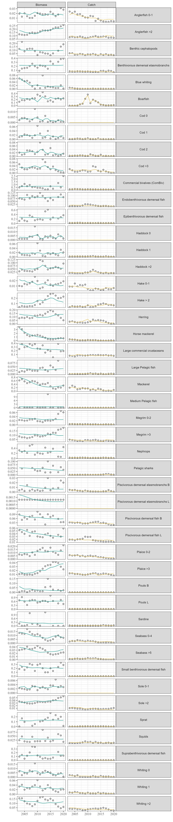
Appendix 17 : Model fit to biomass and catch data for main commercial species
(to be continued)
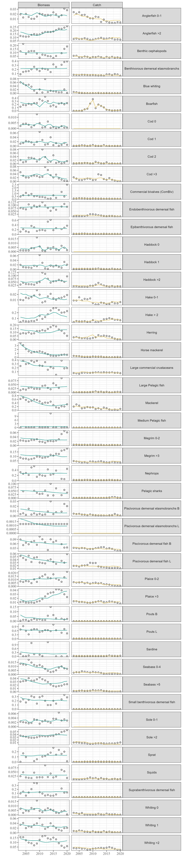
(to be continued)
(to be continued)
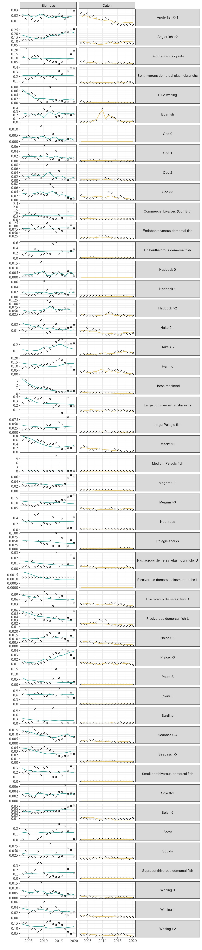
Figure 20 : Biomass (in blue; t/km²) and catches (yellow; t/km²) EwE model outputs (line) compared to data (points) for main fish and benthic functional groups.
The comparison of the model to data shows that the hindcast reproduces quite well the trends of a majority of focal species both in terms of biomass and catch (Figure 20). In general, the model still has some difficulties to catch high and fast variations of biomasses. For instance, this is the case for cod where high biomass variations due to recruitment peaks are not fully caught. It is also the case for hake where high biomass variation due to the stock reconstitution are also not reproduced by the model due to a bad shape of the stock in the base calibration year (2003).

Appendix 18 : Model stabilization
A first exploratory hundred-year simulation was carried out to test if all the functional groups were persisting in an unfished unperturbed run (Figure 21). All the functional groups persist and the model stabilizes within less than 20 years for the vast majority of functional groups. Only three groups are stabilizing afterwards. Additionally, no ecologically impossible variations of biomasses due to potential model productivity issues occur.
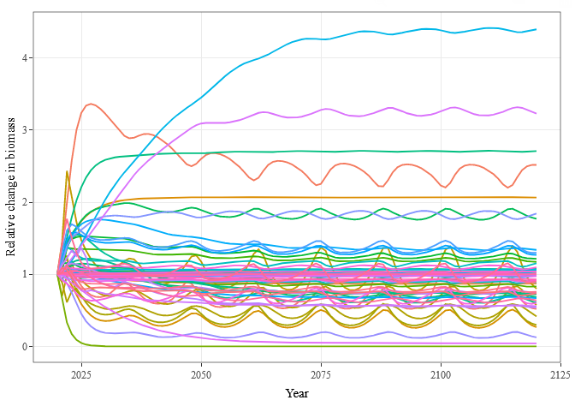
Pelagic sharks
Anglerfish (adult)
Commercial crustaceans
Seabirds (divers)
Hake, Plaice (adult)
Pouts (B), Seabirds (surface)
Discards

Figure 21 : Model stabilization after the historical period

Appendix 19 : Model skill assessment
Several skill assessment metrics are calculated to assess which species have the worst model fit to data. The model distance to data is assessed through three metrics. Individual functional group contribution to SS is obtained from the fitting procedure outputs. In this metric, model distance to data is in log scale to smooth gaps on highly variable biomass time series. Root Mean Square Error (RMSE; Stow et al. 2009, Püts et al. 2020) is calculated by functional group as following:
$$RMSE=\sqrt{\frac{\sum_{n=1}^{N}{{\left({sim}_{n}-{obs}_{n}\right)}^{2}}}{N}}$$
with n a given year, $N$ the number of years in a time series, $sim$ the model prediction and $obs$ the data. According to the literature, an RMSE of less than 0.25 is considered good enough (Püts et al. 2020). Compared to the previous metric, RMSE allow to penalize partial or too short time series compared to more complete time series. Finally, Model Efficiency (MEF; Stow et al. 2009, Püts et al. 2020) is also calculated as following:
$$MEF=\frac{\sum_{n=1}^{N}{{\left({obs}_{n}-obs_{mean}\right)}^{2}} -\sum_{n=1}^{N}{{\left({sim}_{n}-obs_{n}\right)}^{2}}}{\sum_{n=1}^{N}{{\left({obs}_{n}-obs_mean\right)}^{2}}}$$
with the same annotations than for RMSE metric and $obs_mean$ the mean of observations on the whole time series. If MEF < 0, a constant value would be a better predictor of the data than the model itself (Püts et al. 2020). MEF points out the functional groups for which distance to data are higher than natural variability.

Functional groups contribution to SS (Figure 22) reveals that the functional groups’ biomass which have a high contribution in the sum of squares deviation is the pelagic fish (e.g sardine or blue whiting). In fact, these are fish groups for which data quality is poorer in the area due to their large distribution (not restricted to Celtic Sea), high biomass variations due to their life-history strategies and the low availability of survey data about pelagic species to adjust the model. In fact, biomass indices are estimated on EVHOE survey data (which is a demersal survey) because it is deemed to be the best data available for the area. The functional groups’ catch which have a high contribution in the sum of squares are either pelagic groups (for which biomass is not well reproduced by the model and catches also are due to the fact the model is driven by effort; e.g. blue whiting) or demersal functional groups for which the quality of catch data is low because they are not highly commercial (e.g. small benthivores demersal fish).
RMSE values (Figure 23) does not necessarily point out the same functional groups. Model biomass predictions for sardine is also considered to deviate from data (i.e. RMSE for sardine biomass > 0.25) but other species are pointed out: Medium pelagic fish, shrimps and commercial bivalves. Those groups are either species for which complete time series are not available and/or groups for which abundance is considered to be poorly sampled by the demersal survey. RMSE values for catch suggest an overall good model fit to catches data. RMSE metrics are used after the fitting procedure but could be interesting to implement in EwE fitting procedure for fitting purposes.
Several MEF metrics (Figure 23) are under the 0, suggesting a constant would be a better predictor than the model itself. However, this metric is considered to be more useful for statistical models than the one built here.
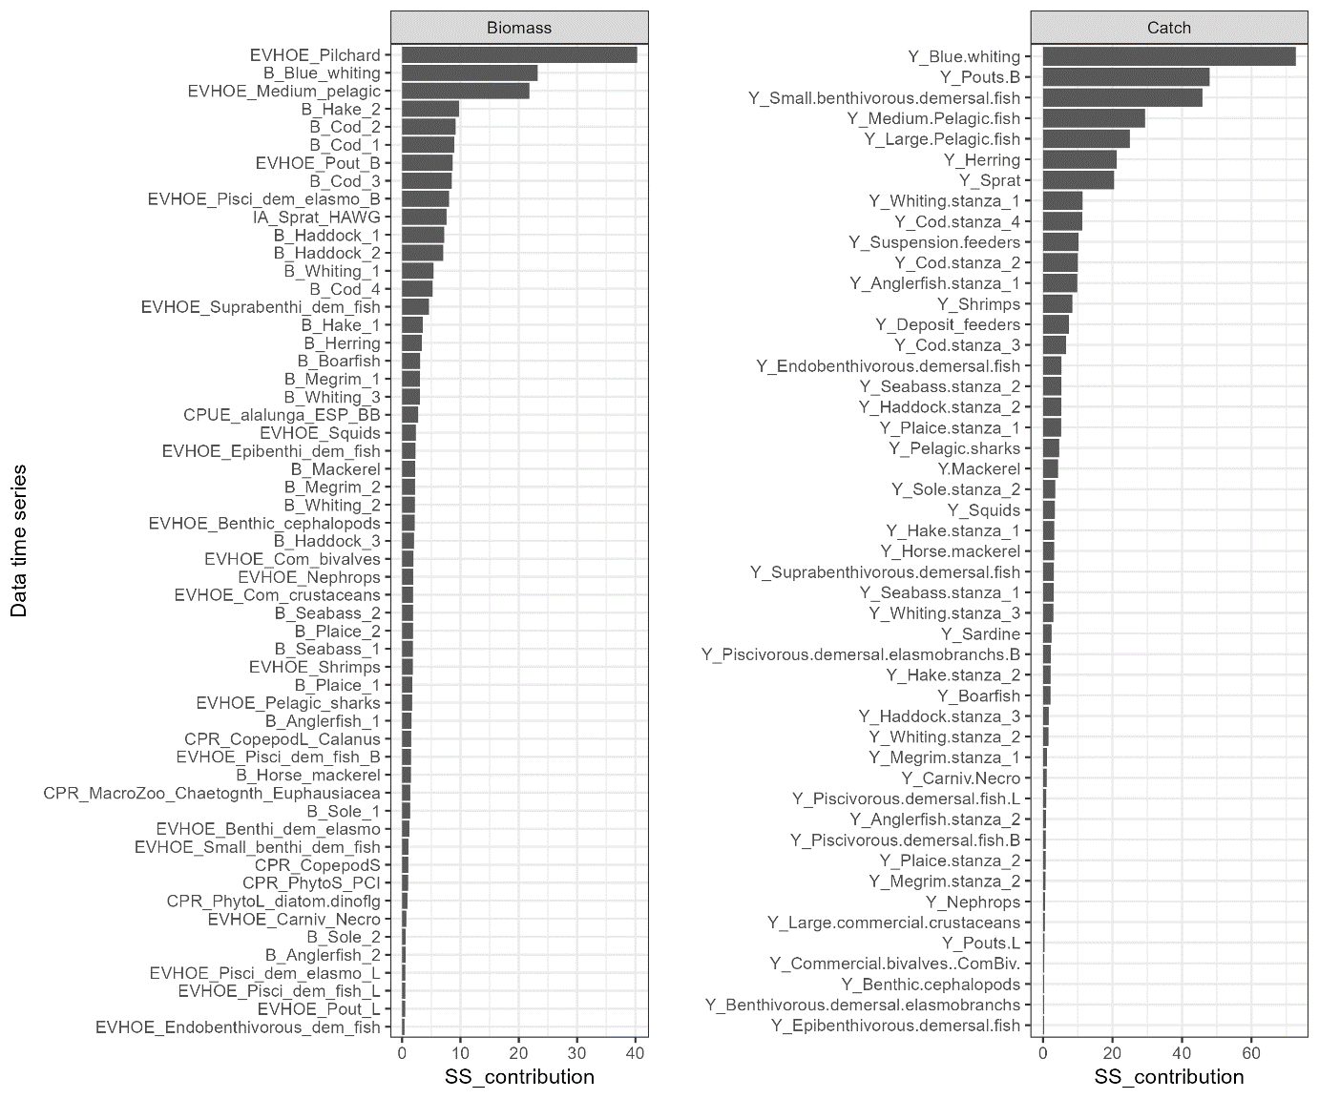
Figure 22 : Ranked functional group participation to the sum of squares deviation (SS) in terms of biomass (left panel) and catches (right panel).
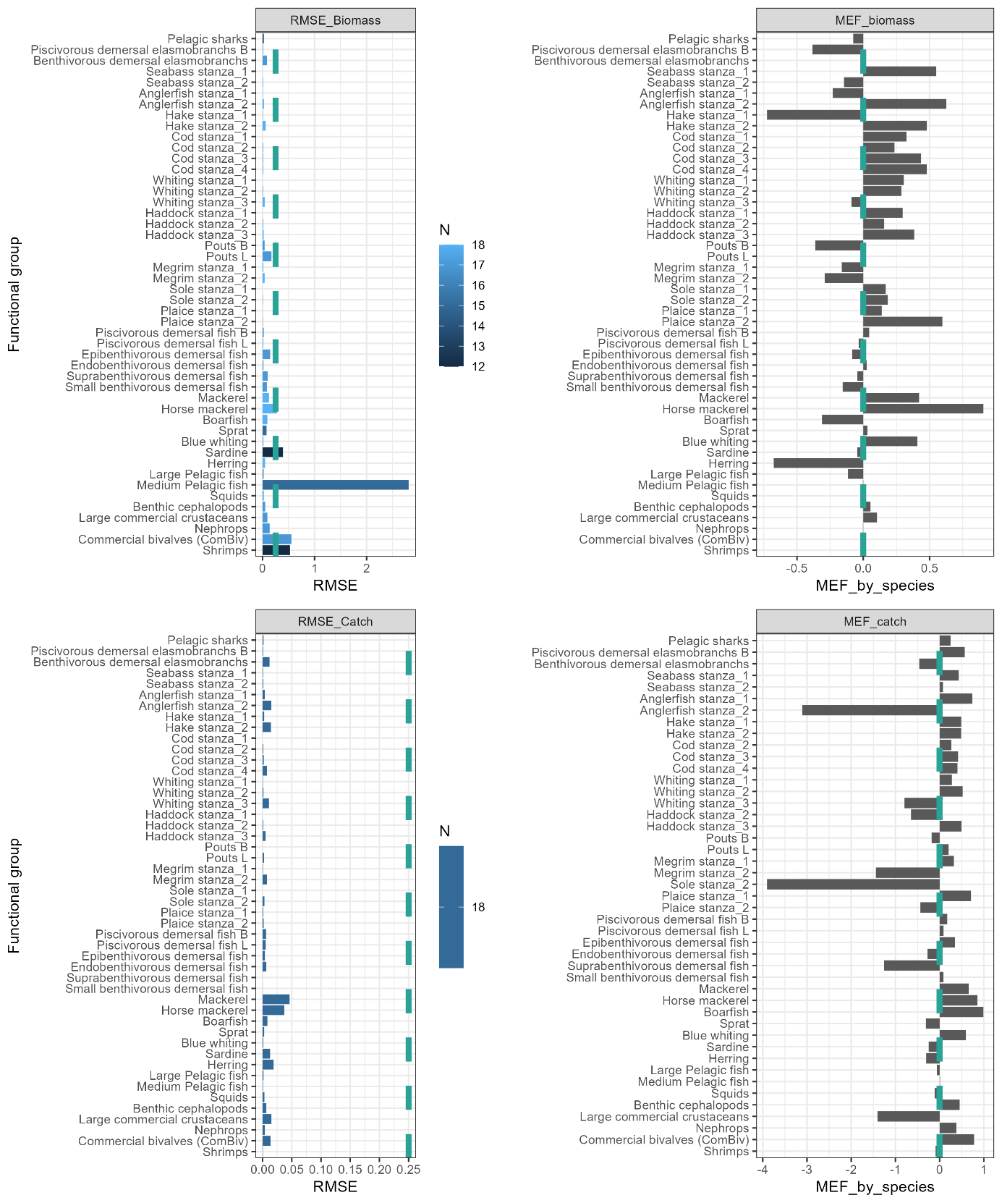
Figure 23 : RMSE (left pannels) and MEF (right pannels) metrics for main functional groups applied to biomass (top pannels) and catch data (bottom pannels). Turquoise dashed lines correspond to “validation thresholds” of both metrics, i.e. respectively 0.25 and 0.

Appendix 20 : Set of ecosystem state’s indicators, technical calculation details and references.
Indicator abbreviation and name | Calculation’s scale(s) | Formula | Description and interest of the indicator | References
Biomass-based indicators
Biomass | All species, all fish, class, guild and province* | $$\sum_{i=1}^{n}{B_{i}}$$ | Aggregation of species biomass at a certain scale. Used to monitor changes in composition within the ecosystem. | Thompson et al. 2020, Lynam et al. 2023
1/CV  Inverse coefficient of variation | Total biomass* | For the last 10 years,  $$\frac{mⅇan_{B_{tot}}}{sd_{B_{tot}}}$$ | Determining ecosystem stability by quantifying biomass variations. The greater the metric, the less variations occur, the more stable the ecosystem. | Shin et al. 2010
Diversity indicators
Shannon  Shannon diversity index | All species, all fish, class, guild | $$-\sum_{i=1}^{n}{\frac{B_{i}}{B_{tot}}}⋅\log{2\left(\frac{B_{i}}{B_{tot}}\right)}$$ | Usually quantify species diversity including species richness and evenness in the community. Here, quantifies species evenness as the number of EwE functional groups is stable in time. | Hill 1973, Lynam et al. 2023
Trait-based indicators
API  Apex Predator Index | All fish | $$\frac{\sum_{i=1}^{n}{B_{i}\left(TL≥4\right)}}{\sum_{i=1}^{n}{B_{i}(TL}≥3.25)}$$ | Proportion of higher TL predators among predators. Indicates the ecosystem trophic health as having top predators bring stability within the ecosystem (Allesina & Tang 2012). The higher, the better health. | Bourdaud et al. 2016
MTL  Mean Trophic Level | All species, all fish, class, guild | $$\frac{\sum_{i=1}^{n}{B_{i}.{TL}_{i}}}{\sum_{i=1}^{n}{B_{i}}}$$ | Mean TL of the community. Indicator which measure the impact of fishing by the removal of higher trophic level targeted species. | Shannon et al. 2014, OSPAR 2017, Lynam et al. 2023
Prop_pred  Predators’ proportion | All fish | $$\frac{\sum_{i=1}^{n}{B_{i}\left(TL≥3.5\right)}}{\sum_{i=1}^{n}{B_{i}}}$$ | Proportion of predators within the community. Indicator of the ecosystem trophic health as having predators bring stability within the ecosystem (Allesina & Tang 2012). The higher, the better health. | Shin et al. 2010
MML  Mean Maximum Length | All species, all fish, class, guild | $$\frac{\sum_{i=1}^{n}{B_{i}.{Lmax}_{ i}}}{\sum_{i=1}^{n}{B_{i}}}$$ | Mean maximum length within the community. Used to track length composition changes within the community. | OSPAR 2017, Lynam et al. 2023
LSI  Large Species Index | All fish, class | $$\frac{\sum_{i=1}^{n}{B_{i}.l}}{\sum_{i=1}^{n}{B_{i}}}$$  l=1 if ${Lmax}_{i}≥80cm$  l=0 else | Large species proportion within the community. Used to track length composition changes within the community. | Shephard et al. 2012, Lynam et al. 2023
CWV_Linf  Community Weighted Variance of the L_{inf} trait | All fish, class | $$\sum_{i=1}^{n}{\frac{B_{i}}{B_{tot}}}⋅{\left({Lmax}_{i}-CWML\right)}^{2}$$ | Variance of the L_{inf} trait. High values indicate a trait divergence (better resilience of the community) while low values indicate convergence. | Beukhof 2019, Beukhof et al. 2019
Habitat-based indicators
CTI  Community Temperature Index | All species*, all fish*, class*, guild* | $$\frac{\sum_{i=1}^{n}{B_{i}.T_{{pref}_{i}}}}{\sum_{i=1}^{n}{B_{i}}}$$ | Mean “preferred temperature” of the community. Used to track changes in temperature community niche due to water temperature increases. | Devictor et al. 2008, Cheung et al. 2013
with i a functional group, $B_{i}$biomass of group i, $B_{tot}$ total biomass (including TL higher than zooplankton), ${TL}_{i}$ Trophic Level of i, ${Lmax}_{i}$ maximum length of i in survey data (proxy of L_{inf}), ${CWML}_{i}$ Community Weighted Mean of $Lmax$ for group i, $T_{{pref}_{i}}$ preferred temperature. Indicators indicated by “*” are the one calculated only to study the climate change effects on the ecosystem.
The variables needed for indicators calculation are taken from simulation outputs except for variables not simulated by the model (i.e. $Lmax$,$CWML$,${ T}_{pref}$). $Lmax$, used in the MML and LSI calculation, is a proxy of L_{inf} and is deduced from the OSPAR assessment (OSPAR 2017, Lynam et al. 2023) to have a regional and more robust value than the one in FishBase. For multispecies groups, if local survey data (EVHOE; 2011-2021 to consider recent length evolutions) are available for group’s species, $Lmax$ is taken as a mean of species $Lmax$ weighted by species biomass. Else, a simple $Lmax$ mean is calculated. $CWML$, used in the CWV_Linf calculation, is an EwE-biomass-weighted mean of all $Lmax$ values of the considered calculation scale. Finally, ${ T}_{pref}$ is the optimum temperature taken from Hernvann et al. niche models (2020) used to simulate the impact of temperature changes on functional groups.

Appendix 21 : Percentage change in the diversity (a), trait-based (b) and habitat-based indicators (c) compared to the reference (i.e. status quo with no climate change) according to RCP scenarios in the 2060s.
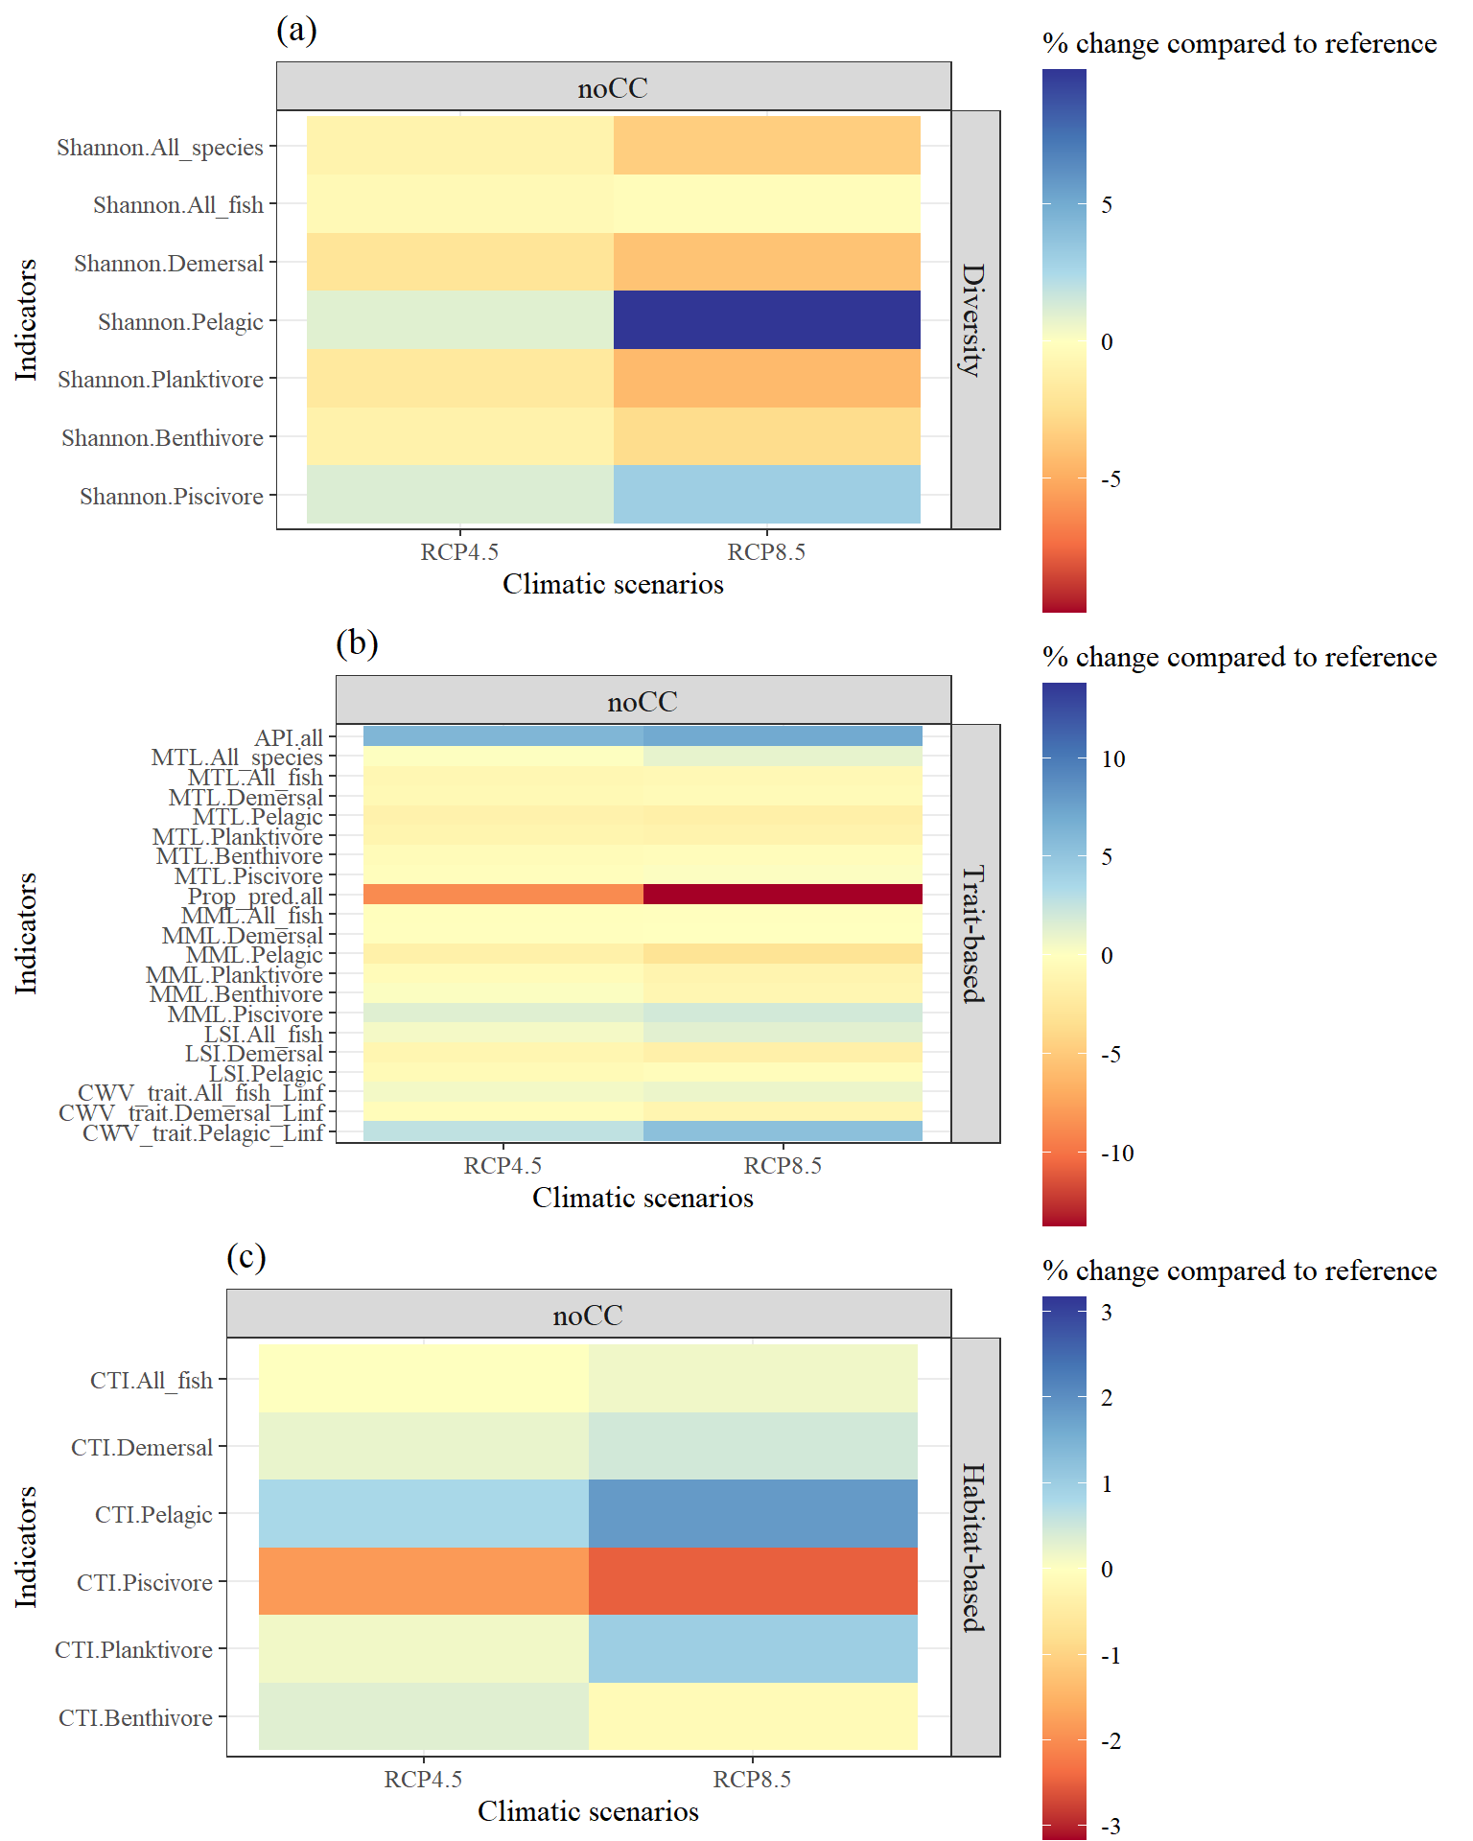

Appendix 22 : Percentage change in the diversity (a), trait-based (b) and habitat-based indicators (c) compared to the reference (i.e. status quo with no climate change) according to fishing scenarios in the 2060s. The references are indicated by a black rectangle.
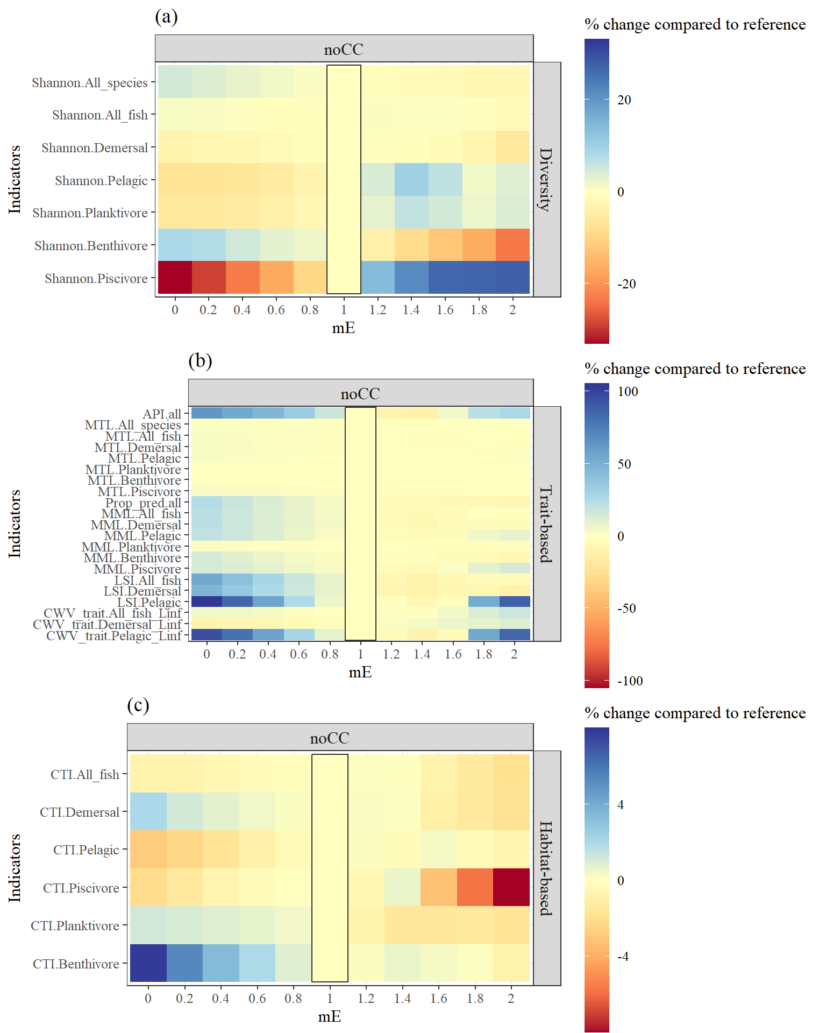

Appendix 23: Delta (difference between cumulative and additive absolute effects of fishing and climate change for a given mE) in the 2060s for RCP4.5 (left panel) and RCP8.5 (right panel) and sensitive indicators for which fishing and climate have analogue effects.
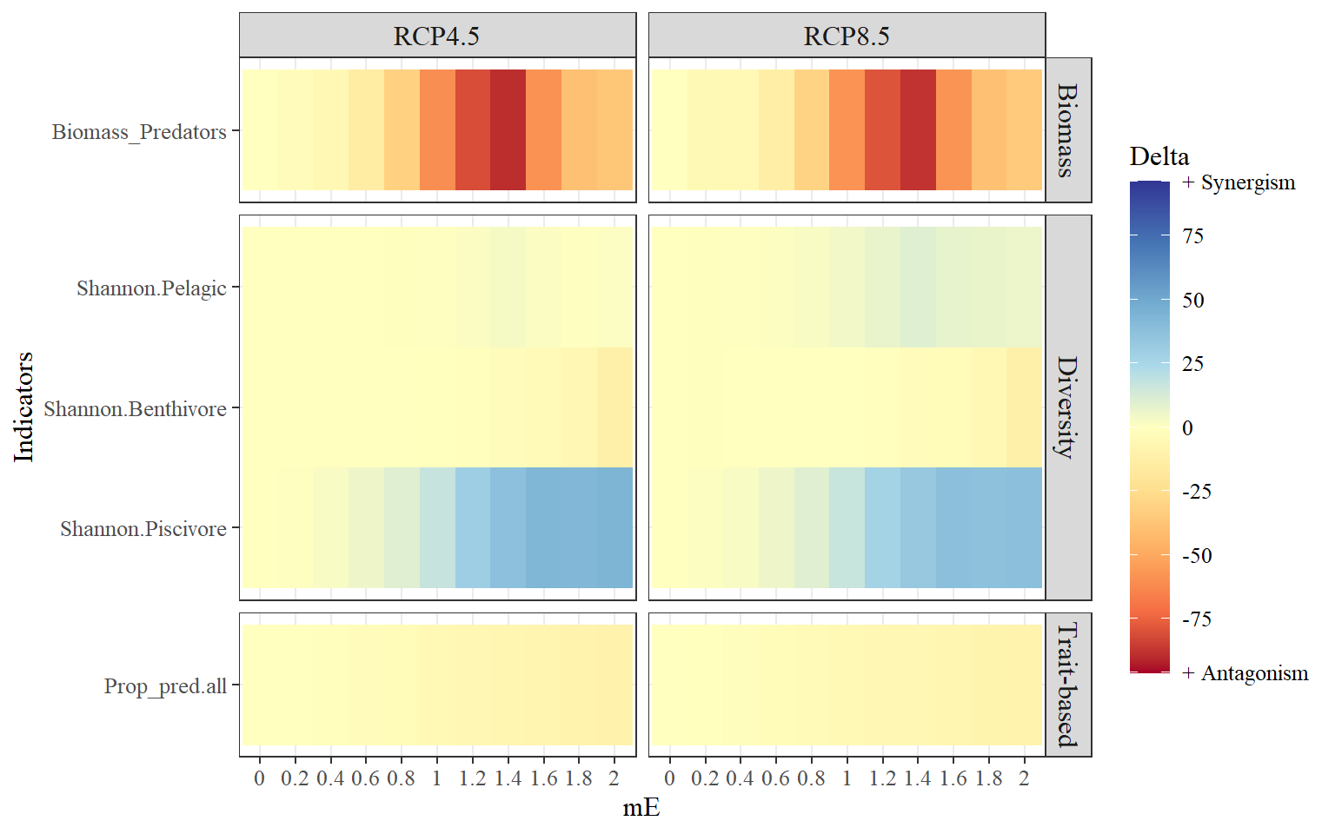
Appendix 24 : Delta (difference between cumulative and additive absolute effects of fishing and climate change for a given mE) in the 2060s for RCP4.5 (left panel) and RCP8.5 (right panel) and sensitive indicators for which fishing and climate have opposed effects.
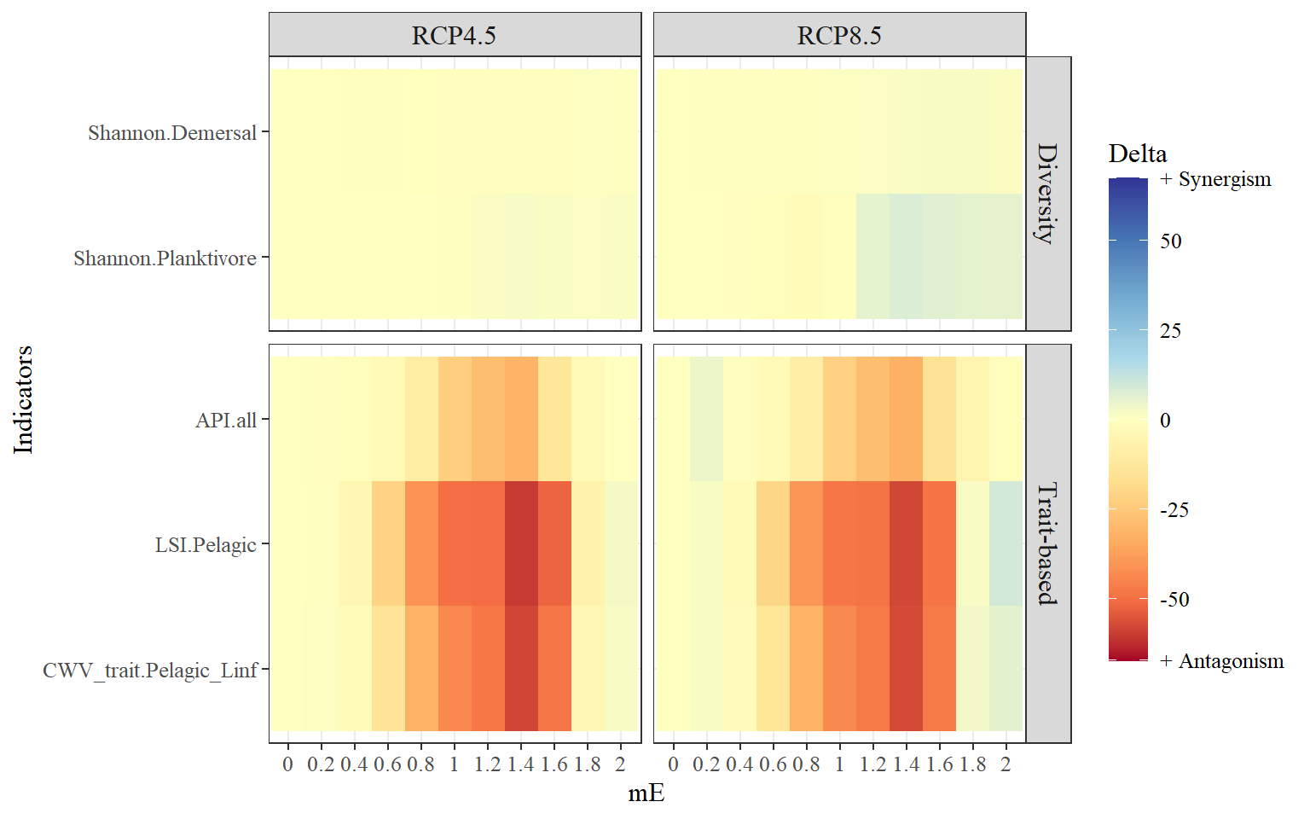

Appendix 25: Percentage change in the diversity (a), trait-based (b) and habitat-based indicators (c) compared to the reference (i.e. no fishing and no climate change) according to fishing scenarios in the 2090s. The references are indicated by a black rectangle.
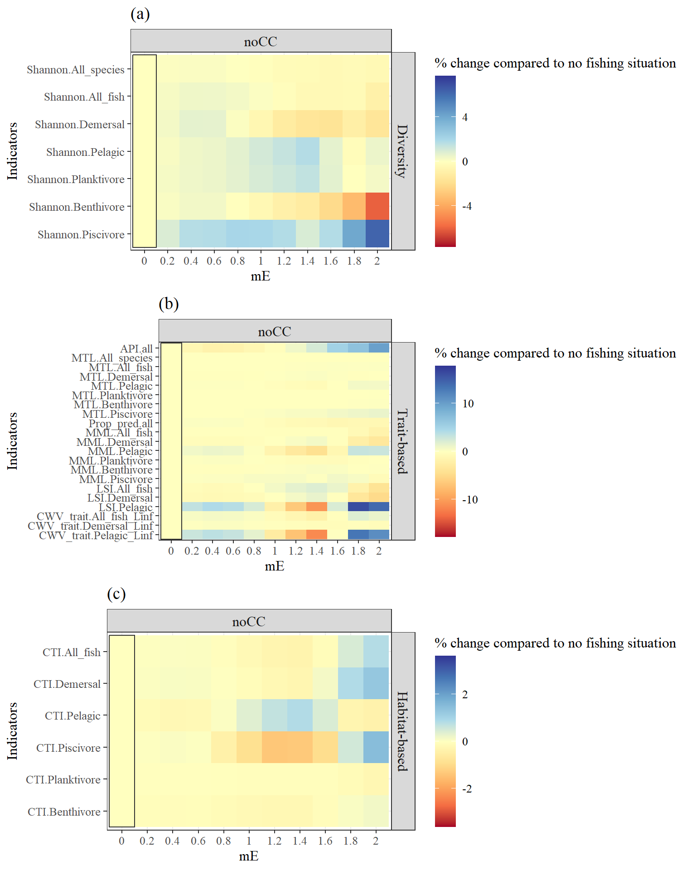

References
Ahrens RNM, Walters CJ, Christensen V (2012) Foraging arena theory. Fish and Fisheries 13:41–59.
Akaike H (1974) A new look at the statistical model identification. IEEE Trans Automat Contr 19:716–723.
Allesina S, Tang S (2012) Stability criteria for complex ecosystems. Nature 483:205–208.
Bentley J, Serpetti N, Fox C, Reid D, Heymans JJ (2019) Modelling the food web in the Irish Sea in the context of a depleted commercial fish community. Part 2: CES Ecopath with Ecosim Key Run.
Beukhof E, Dencker TS, Pecuchet L, Lindegren M (2019) Spatio-temporal variation in marine fish traits reveals community-wide responses to environmental change. Marine Ecology Progress Series 610:205–222.
Beukhof ED (2019) Trait-environment relationships in marine fish: An exploration of patterns, drivers and assembly processes shaping marine fish communities. Technical University of Denmark.
Bourdaud P, Gascuel D, Bentorcha A, Brind’Amour A (2016) New trophic indicators and target values for an ecosystem-based management of fisheries. Ecological Indicators 61:588–601.
Burnham KP, Anderson DR, Huyvaert KP (2011) AIC model selection and multimodel inference in behavioral ecology: some background, observations, and comparisons. Behav Ecol Sociobiol 65:23–35.
Cheung WWL, Watson R, Pauly D (2013) Signature of ocean warming in global fisheries catch. Nature 497:365–368.
Cozzi B, Huggenberger S, Oelschläger HA (2016) Anatomy of dolphins: insights into body structure and function., Academic press.
Cresson P, Travers-Trolet M, Rouquette M, Denamiel M, Auber A (2023) Individual isotopic ratio and trophic levels of fish species in the Eastern English Channel. Seanoe.
Cresson P, Travers-Trolet M, Rouquette M, Timmerman C-A, Giraldo C, Lefebvre S, Ernande B (2017) Individual wet/dry conversion factors in English Channel fish muscle. Seanoe.
Cronin M, Duck, C., O Cadhla, O., Nairn, R., Strong, D. O., Keeffe, C. (2003) Harbour seals population assessment in the Republic of Ireland., Irish Wildlife Manuals Series Editor. National Parks & Wildlife Service, Department of Environment, Heritage and Local Governement, Dublin, Ireland.
Devictor V, Julliard R, Couvet D, Jiguet F (2008) Birds are tracking climate warming, but not fast enough. Proceedings of the Royal Society B: Biological Sciences 275:2743–2748.
Froese RM, Pauly D (2021) FishBase. fishbase.org (accessed April 27, 2021)
Fulton EA, CSIRO, Australian Fisheries Management Authority (2004) Ecological indicators of the ecosystem effects of fishing : final report. CSIRO; Australian Fisheries Management Authority.
Gelman A, Rubin DB (1992) Inference from Iterative Simulation Using Multiple Sequences. Statistical Science 7:457–472.
Geweke J (1992) Evaluating the Accuracy of Sampling-Based Approaches to the Calculation of Posterior Moments. In: Bayesian Statistics 4: Proceedings of the Fourth Valencia International Meeting, Dedicated to the memory of Morris H. DeGroot, 1931–1989. Bernardo JM, Berger JO, Dawid P, Smith AFM (eds) Oxford University Press, p 0
Gibin M, Zanzi A, Hekim Z (2021) Fisheries landings & effort: data by c-square. European Commission, Joint Research Centre (JRC).
Hammond P, MacLeod K, Burt L, Cañadas A, Lens S, Mikkelsen B, Rogan E, Santos MB, Uriarte A, Van-Canneyt O, Vázquez-Bonales JA (2011) Abundance of baleen whales in the European Atlantic.
Hammond PS, Macleod K, Berggren P, Borchers DL, Burt L, Cañadas A, Desportes G, Donovan GP, Gilles A, Gillespie D, Gordon J, Hiby L, Kuklik I, Leaper R, Lehnert K, Leopold M, Lovell P, Øien N, Paxton CGM, Ridoux V, Rogan E, Samarra F, Scheidat M, Sequeira M, Siebert U, Skov H, Swift R, Tasker ML, Teilmann J, Van Canneyt O, Vázquez JA (2013) Cetacean abundance and distribution in European Atlantic shelf waters to inform conservation and management. Biological Conservation 164:107–122.
Hernvann P-Y (2020) Améliorer le réalisme écologique des modèles trophiques afin de mieux comprendre les impacts passés et présents de la pêche sur les écosystèmes marins et de prédire leur réponse future au changement climatique. Agrocampus Ouest, Rennes
Hernvann P-Y, Gascuel D, Grüss A, Druon J-N, Kopp D, Perez I, Piroddi C, Robert M (2020) The Celtic Sea Through Time and Space: Ecosystem Modeling to Unravel Fishing and Climate Change Impacts on Food-Web Structure and Dynamics. Front Mar Sci 7.
Hernvann P-Y, Gascuel D, Kopp D, Robert M, Rivot E (2022) EcoDiet: A hierarchical Bayesian model to combine stomach, biotracer, and literature data into diet matrix estimation. Ecological Applications 32:e2521.
Hill MO (1973) Diversity and Evenness: A Unifying Notation and Its Consequences. Ecology 54:427–432.
Kenchington TJ (2014) Natural mortality estimators for information-limited fisheries. Fish and Fisheries 15:533–562.
Link JS (2010) Adding rigor to ecological network models by evaluating a set of pre-balance diagnostics: A plea for PREBAL. Ecological Modelling 221:1580–1591.
Lockyer C (2003) Harbour porpoises (Phocoena phocoena) in the North Atlantic: Biological parameters. NAMMCO Scientific Publications 5:71–89.
Lorenzen K (1996) The relationship between body weight and natural mortality in juvenile and adult fish: a comparison of natural ecosystems and aquaculture. Journal of Fish Biology 49:627–642.
Lynam C, Thorpe R, Thompson M, Van de Wolfshaar K, Püts M, Corrales X, Romagnoni G, Tsagarakis K, Potier M, Papantoniou G, Halouani G, Heath M, Kempf A, Taylor M, Jacobsen NS (2023) SEAwise Report on the effects of fishing on food webs and community diversity aimed at populating the MSFD Descriptor 4 and based on food web and end-to-end modelling. Technical University of Denmark.
Moullec F, Gascuel D, Bentorcha K, Guénette S, Robert M (2017) Trophic models: What do we learn about Celtic Sea and Bay of Biscay ecosystems? Journal of Marine Systems 172:104–117.
OSPAR (2017) Intermediate Assesssment 2017.
Palomares ML, Pauly D (1989) A multiple regression model for prediction the food consumption of Marine Fish populations. Mar Freshwater Res 40:259–273.
Pauly D, Soriano-Bartz, M. L., Palomares, M. L. D. (1993) Improved construction, parametrization and interpretation of steady-state ecosystem models.
Peterson I, Wroblewski JS (1984) Mortality Rate of Fishes in the Pelagic Ecosystem. Can J Fish Aquat Sci 41:1117–1120.
Pinnegar JK, Cooper KM, Thompson M (2023) DAPSTOM (integrated database and portal for fish stomach records). Cefas, UK V1.
Püts M, Taylor M, Núñez-Riboni I, Steenbeek J, Stäbler M, Möllmann C, Kempf A (2020) Insights on integrating habitat preferences in process-oriented ecological models – a case study of the southern North Sea. Ecological Modelling 431:109189.
Raftery, A.E., Lewis SM (1992) One long run with diagnostics: Implementation strategies for Markov chain Monte Carlo. Statistical Science 7:493–497.
Rault J, Le Bris H, Robert M, Pawlowski L, Denamiel M, Kopp D (2017) Diets and trophic niches of the main commercial fish species from the Celtic Sea: celtic sea fish diets. J Fish Biol 91:1449–1474.
Scott E, Serpetti N, Steenbeek J, Heymans JJ (2016) A Stepwise Fitting Procedure for automated fitting of Ecopath with Ecosim models. SoftwareX 5:25–30.
Shannon L, Coll M, Bundy A, Gascuel D, Heymans J, Kleisner K, Lynam C, Piroddi C, Tam J, Travers-Trolet M, Shin Y (2014) Trophic level-based indicators to track fishing impacts across marine ecosystems. Mar Ecol Prog Ser 512:115–140.
Shephard S, Fung T, Houle JE, Farnsworth KD, Reid DG, Rossberg AG (2012) Size-selective fishing drives species composition in the Celtic Sea. ICES Journal of Marine Science 69:223–234.
Shin Y-J, Shannon LJ, Coll M, Aydin K, Bez N, Blanchard JL, Borges M de F, Cury PM, Diallo I, Diaz E, Heymans S, Hill L, Johannesen E, Jouffre D, Kifani S, Labrosse P, Link J, Mackinson S, Masski H, Neira S, Ojaveer H, Mollmann C, Thiao D, Yemane D (2010) Using indicators for evaluating, comparing and communicating the ecological status of exploited marine ecosystems. 2: Setting the scene. ICES J MAR SCI 67:692–716.
Sigurjónsson J, Víkingsson G (1997) Seasonal Abundance of and Estimated Food Consumption by Cetaceans in Icelandic and Adjacent Waters. J Northw Atl Fish Sci 22:271–287.
Stow CA, Jolliff J, McGillicuddy DJ, Doney SC, Allen JI, Friedrichs MAM, Rose KA, Wallhead P (2009) Skill assessment for coupled biological/physical models of marine systems. Journal of Marine Systems 76:4–15.
Then AY, Hoenig JM, Hall NG, Hewitt DA, Handling editor: Ernesto Jardim (2015) Evaluating the predictive performance of empirical estimators of natural mortality rate using information on over 200 fish species. ICES Journal of Marine Science 72:82–92.
Thompson MSA, Pontalier H, Spence MA, Pinnegar JK, Greenstreet SPR, Moriarty M, Hélaouët P, Lynam CP (2020) A feeding guild indicator to assess environmental change impacts on marine ecosystem structure and functioning. Journal of Applied Ecology 57:1769–1781.
Waggitt JJ, Evans PGH, Andrade J, Banks AN, Boisseau O, Bolton M, Bradbury G, Brereton T, Camphuysen CJ, Durinck J, Felce T, Fijn RC, Garcia-Baron I, Garthe S, Geelhoed SCV, Gilles A, Goodall M, Haelters J, Hamilton S, Hartny-Mills L, Hodgins N, James K, Jessopp M, Kavanagh AS, Leopold M, Lohrengel K, Louzao M, Markones N, Martínez-Cedeira J, Ó Cadhla O, Perry SL, Pierce GJ, Ridoux V, Robinson KP, Santos MB, Saavedra C, Skov H, Stienen EWM, Sveegaard S, Thompson P, Vanermen N, Wall D, Webb A, Wilson J, Wanless S, Hiddink JG (2020) Distribution maps of cetacean and seabird populations in the North-East Atlantic. Journal of Applied Ecology 57:253–269.
Walters C, Christensen V, Walters W, Rose K (2010) Representation of multistanza life histories in Ecospace models for spatial organization of ecosystem trophic interaction patterns. Bulletin of Marine Science 86:439–459.
Walters C, Martell S, Mahmoudi B (2006) An Ecosim model for exploring ecosystem management options for the Gulf of Mexico: implications of including multistanza life history models for policy predictions. Bulletin of Marine Science 83.
Zanzi A, Holmes S (2017) Fisheries data from DCF Fishing Effort Regimes data calls. European Commission, Joint Research Centre (JRC).

