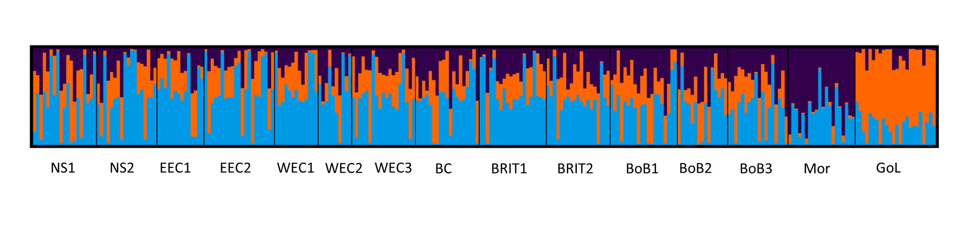

Supplementary Figure 1. Barplot showing clustering results under the optimal model of K = 3 for each individual based on 3369 presumed ‘neutral’ loci i.e. total SNPs (n =3592) minus outlier SNPs (n = 223).