**SUPPLEMENTARY MATERIAL**

***Gambierdiscus polynesiensis* from New Caledonia (South West Pacific Ocean): Morpho-molecular characterization, toxin profile and response to light intensity**

Manoëlla Sibat1*, Tepoerau Mai2,3, Nicolas Chomérat4, Gwenael Bilien4, Korian Lhaute1, Philipp Hess1,5, Véronique Séchet5, Thierry Jauffrais2*

1 Ifremer, ODE/PHYTOX-METALG, Rue de l’île d’Yeu, F-44300 Nantes, France ; [manoella.sibat@ifremer.fr](mailto:manoella.sibat@ifremer.fr) (M.S) ; [korian.lhaute@ifremer.fr](mailto:korian.lhaute@ifremer.fr) (K.L) ; [philipp.hess@ifremer.fr](mailto:philipp.hess@ifremer.fr) (P.H)

2 Ifremer, IRD, Univ Nouvelle-Calédonie, Univ La Réunion, CNRS, UMR 9220 ENTROPIE, BP 32078, 98800, Noumea, New Caledonia ; [thierry.jauffrais@ifremer.fr](mailto:thierry.jauffrais@ifremer.fr) (T.J) ;

3 Institut Louis Malardé (ILM), 98713 Papeete, Tahiti, French Polynesia, [tmai@ilm.pf](mailto:tmai@ilm.pf) (T.M) ;

4 Ifremer, ODE/LITTORAL/LERBO, Station Ifremer de Concarneau, Place de la Croix, Concarneau, F-29900, France ; [gwenael.bilien@ifremer.fr](mailto:gwenael.bilien@ifremer.fr) (G.B) ; [nicolas.chomerat@ifremer.fr](mailto:nicolas.chomerat@ifremer.fr) (N.C)

5 Ifremer, PHYTOX, Laboratoire PHYSALG, F-44300 Nantes, France ; [veronique.sechet@ifremer.fr](mailto:veronique.sechet@ifremer.fr) (V.S)

*Corresponding author

**Fig. S1.** Map of New Caledonia (South Western Pacific Ocean), showing the location of the sampling site. A red point indicates the sampling sites where *Gambierdiscus* *polynesiensis* were collected in Vata Bay (Nouméa).

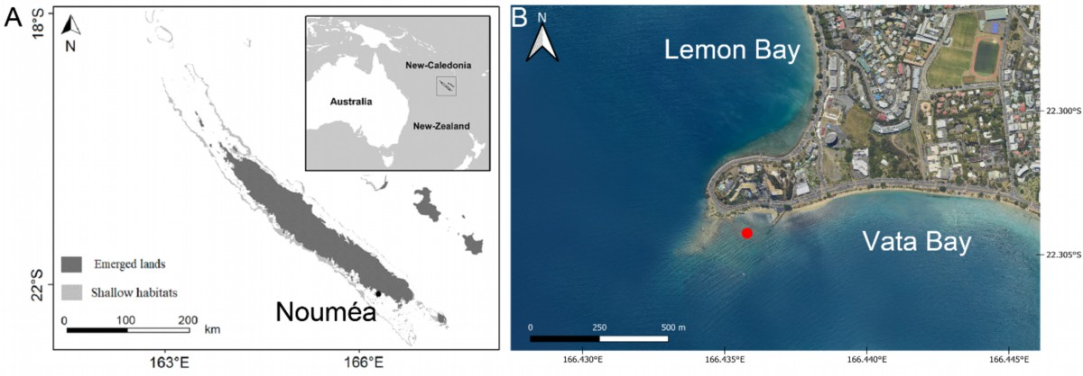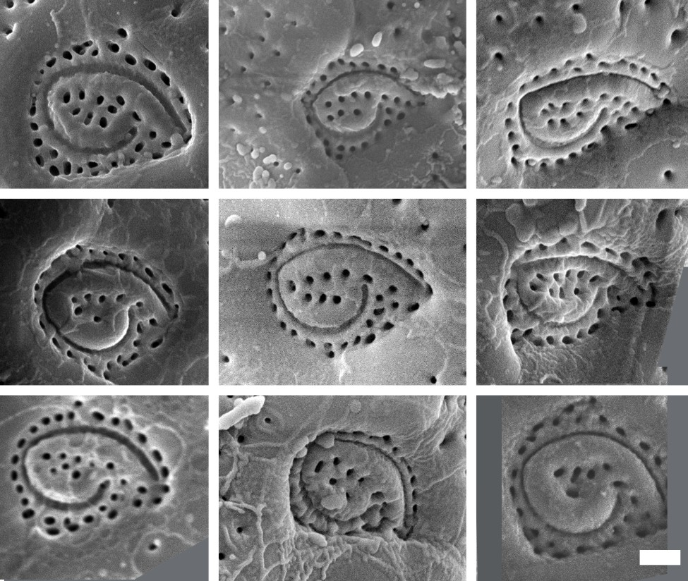

**Fig. S2.** Po plate. Variable number of pores in *Gambierdiscus polynesiensis* 19PV93. Scale bar: 1 μm.

**Table S1:** MRM transitions and MS parameters used for the detection of P-CTX in positive ionization mode on the API 4000QTrap (Sciex) instrument.

|  |  |  |  |  |  |  |
| --- | --- | --- | --- | --- | --- | --- |
| **Compound** | **Detection window** (min) | **Precursor ion** (Q1) *m/z* | **Product ion** (Q3) *m/z* | **DP** (eV) | **CE** (eV) | **CXP** (eV) |
| CTX1B, CTX1A | 3.1 ± 1 | 1128.6 [M+NH4]+ | 1093.6 | 105 | 20 | 12 |
|  |  |  | 1075.6 | 105 | 30 | 12 |
|  |  |  | 95.1 | 105 | 90 | 20 |
| M-*seco*-CTX3C | 4.7 ± 1 | 1041.6 [M+H]+ | 1023.6 | 105 | 30 | 12 |
|  |  |  | 1005.6 | 105 | 20 | 12 |
|  |  |  | 125.1 | 105 | 50 | 18 |
| 2,3-dihydro-2-hydroxyCTX3C and | 5.4 ± 1 | 1058.6 [M+NH4]+ | 1023.6 | 105 | 30 | 12 |
| 2,3-dihydro-3-hydroxyCTX3C |  |  | 1005.6 | 105 | 20 | 12 |
|  |  |  | 125.1 | 105 | 50 | 18 |
| 2,3-dihydro-2,3-dihydroxyCTX3C | 6.0 ± 1 | 1074.6 [M+NH4]+ | 1039.6 | 105 | 30 | 12 |
|  |  | 1057.6 [M+H]+ | 1039.6 | 105 | 20 | 12 |
|  |  |  | 125.1 | 105 | 50 | 18 |
| 51-hydroxyCTX3C | 6.3 ± 1 | 1056.6 [M+NH4]+ | 1021.6 | 105 | 30 | 12 |
|  |  | 1039.6 [M+H]+ | 1021.6 | 105 | 20 | 12 |
|  |  |  | 1003.6 | 105 | 20 | 12 |
| M-*seco*-CTX4A/4B | 6.5 ± 1 | 1096.6 [M+NH4]+ | 1043.7 | 105 | 30 | 12 |
|  |  | 1079.6 [M+H]+ | 1043.7 | 105 | 20 | 12 |
|  |  |  | 125.1 | 105 | 50 | 18 |
| 52-*epi*-54-deoxyCTX1B and 54-deoxyCTX1B | 6.8 ± 1 | 1112.6 [M+NH4]+ | 1077.6 | 105 | 20 | 12 |
|  |  |  | 1059.6 | 105 | 30 | 12 |
|  |  |  | 95.1 | 105 | 90 | 20 |
| CTX3C isomers (1), (2) and (3) | 7.6 ± 1 | 1040.6 [M+NH4]+ | 1005.6 | 105 | 30 | 12 |
|  | 1023.6 [M+H]+ | 1005.6 | 105 | 20 | 12 |
|  |  |  | 125.1 | 105 | 20 | 12 |
| CTX3C, CTX3B and isomer (4) | 10.5 ± 1 | 1040.6 [M+NH4]+ | 1005.6 | 105 | 30 | 12 |
|  | 1023.6 [M+H]+ | 1005.6 | 105 | 20 | 12 |
|  |  |  | 125.1 | 105 | 50 | 18 |
| CTX4A and CTX4B and isomer | 12.2 ± 1 | 1078.6 [M+NH4]+ | 1043.6 | 105 | 30 | 12 |
|  | 1061.6 [M+H]+ | 1043.6 | 105 | 20 | 12 |
|  |  |  | 125.1 | 105 | 50 | 18 |

**Table S2:** MRM transitions and MS parameters used for the detection of MTXs and gambiertoxins in negative ionization mode on the API 4000QTrap (Sciex) instrument.

|  |  |  |  |  |  |
| --- | --- | --- | --- | --- | --- |
| **Compound** | **Precursor ion** (Q1) *m/z* | **Product ion** (Q3) *m/z* | **DP** (eV) | **CE** (eV) | **CXP** (eV) |
| MTX1 | 1689.8 | 1689.8 | -210 | -40 | -15 |
|  |  | 96.9 | -210 | -125 | -21 |
| MTX2 | 1637.8 | 1637.8 | -210 | -40 | -15 |
|  |  | 96.9 | -210 | -125 | -21 |
| MTX4 | 1646.2 | 1646.2 | -210 | -40 | -15 |
|  |  | 96.9 | -210 | -125 | -21 |
| MTX5 | 1668.8 | 1668.8 | -210 | -40 | -15 |
|  |  | 96.9 | -210 | -125 | -21 |
| MTX6 | 1656.3 | 1656.3 | -210 | -40 | -15 |
|  |  | 96.9 | -210 | -125 | -21 |
|  | 1104.1 | 1104.1 | -210 | -40 | -15 |
| MTX7 | 1671.4 | 1671.4 | -210 | -40 | -15 |
|  |  | 96.9 | -210 | -125 | -21 |
|  | 1114.1 | 1114.1 | -210 | -40 | -15 |
| MTX unknown 1 | 1649.8 | 1649.8 | -210 | -40 | -15 |
|  |  | 96.9 | -210 | -125 | -21 |
| MTX unknown 2 | 1641.8 | 1641.8 | -210 | -40 | -15 |
|  |  | 96.9 | -210 | -125 | -21 |
| Gambierone | 1023.5 | 963.5 | -225 | -64 | -23 |
|  |  | 899.4 | -225 | -64 | -21 |
|  |  | 96.9 | -225 | -104 | -21 |
| 44-MeG | 1037.5 | 977.6 | -255 | -62 | -25 |
|  |  | 899.5 | -255 | -64 | -21 |
|  |  | 96.9 | -255 | 130 | -13 |
| disulfo-gambierone | 1103.4 | 1023.5 | -225 | -64 | -21 |
|  |  | 96.9 | -225 | -104 | -21 |
| dihydro-sulfo-gambierone | 1105.4 | 1025.5 | -225 | -64 | -21 |
|  |  | 96.9 | -225 | -104 | -21 |
| Gambieroxide | 1193.6 | 1193.6 | -215 | -20 | -15 |
|  |  | 987.6 | -215 | -116 | -25 |
|  |  | 96.9 | -215 | -130 | -13 |
| Gambieric acid A | 1055.1 | 1055.1 | -210 | -20 | -15 |
|  |  | 1037.1 | -210 | -40 | -15 |
| Gambieric acid B | 1069.1 | 1069.1 | -210 | -20 | -15 |
|  |  | 1051.1 | -210 | -40 | -15 |
| Gambieric acid C | 1183.7 | 1183.7 | -210 | -20 | -15 |
|  |  | 1165.7 | -210 | -40 | -15 |
| Gambieric acid D | 1197.7 | 1197.7 | -210 | -20 | -15 |
|  |  | 1179.7 | -210 | -40 | -15 |

**Table S3**: LOD and LOQ determined with the ordinary least-squares regression data method.

|  |  |  |
| --- | --- | --- |
| Compound | LOD (µg mL-1) | LOQ (µg mL-1) |
| MTX1 | 0.023 | 0.077 |
| Gambierone | 0.011 | 0.035 |
| 44-MeG | 0.009 | 0.028 |

**Table S4.** The significations of the RLCs photosynthetic parameters as described by Ralph and Gadmann (2005) and Perkins et al. (2006): F’, Fm’, Fq’ and Fq’/Fm’ are measured during the rapid light curves. Other parameters are measured in dark-acclimated state (15 min).

|  |  |  |  |
| --- | --- | --- | --- |
| **Parameters** | **Definition** | **Formulas** | **Interpretation** |
| **Rapid Light Curve** | | | |
| F0 | Minimum fluorescence after a dark adaptation |  | Minimum fluorescence when all RC are open |
| Fm | Maximal fluorescence during a saturating flash |  | Maximal fluorescence when all RC are closed |
| Fv | Variable fluorescence | Fm–F0 |  |
| Fv /Fm | Maximal quantum yield of PSII photochemistry | (Fm–F0)/Fm | Maximum light utilisation efficiency of PSII |
| F' | Initial fluorescence intensity in a light adapted state |  |  |
| Fm' | Maximum fluorescence in a light adapted state under a saturating flash |  |  |
| Fq' | Fluorescence quench in actinic light | Fm'–F' |  |
| Fq '/Fm' | Light utilisation efficiency | (Fm'–F')/Fm' |  |
| rETR | relative electron transport rate (rETR) | (Fq'/Fm' )PAR×0.5 | (Ralph and Gademann 2005) |
| rETR(i) | Relative transport rate of electrons *vs* irradiance (i) in the absence of photoinhibition | rETRmax $×$ (1–e(–α x i/rETRm)) | (Platt *et al.* 1980) |
| rETR(i) | Relative transport rate of electrons *vs* irradiance (i) in the presence of photoinhibition | rETRm × (1-e(-alpha*I/ETRm)) × e(-beta*I/ETRm) | (Platt *et al.* 1980) |
| rETRmax | Maximum Relative electron transport rate | In presence of photoinhibition:  rETRm × (α/[ α+β]) × ( β/[ α+β])β/α | rETR before levelling off at a maximum light-saturated rate |
| α | Initial RLC slope  maximum light use coefficient for PSII |  | Ability to use low light intensities |
| Ek | Light saturating index  (µmol photons m–2s–1) | rETRmax/α | Ability to use high light intensities |
| Eopt | Optimum light  (µmol photons m–2s–1) | (rETRm/α) × ln([ α+β]/ β) | Irradiance at which rETR is maximal |
| NPQinduced | Non Photochemical Quenching induced during RLC experiment | (Fm–Fm’)/Fm’ | Ability to dissipate energy into heat as a photoprotective mechanism |

**Table S5.** OJIP parameters based on Strasser et al. (2000), A reaction centre (RC) is considered open when QA is in its oxidative state, conversely RC close up when QA is reduced into QA–. QA: primary quinone acceptor; QB: secondary quinone acceptor; PQ: plastoquinone ; PC: plastocyanine ; Cyt b6f: cytochrome b6f ; PSII: photosystem II.

|  |  |  |  |
| --- | --- | --- | --- |
| **OJIP Parameters** | **Definition** | **Formulas** | **Interpretation** |
| *Specific fluxes* | | | |
| ABS/RC | Absorption flux of photons at the PSII antenna per active RC | MO × (1/VJ) × (1/ φP0) | Relative apparent antenna size per active RC |
| TR0/RC | Maximum specific trapping flux | MO × (1/VJ) | The rate, at time 0, by which an exciton is trapped in RC resulting in the reduction of QA to QA- |
| ET0/RC | Electron transport flux per RC at time 0 | MO × (1/VJ) × ψE0 | The rate, at time 0, by which an electron moves beyond QA-, resulting in a CO2 fixation |
| DI0/RC | Dissipated energy flux per RC at time 0 | (ABS/RC) – (TR0/RC) | The flux of energy dissipated in processes other than trapping per active PSII |
| *Quantum yield or efficiency* | |  |  |
| M0 | Slope at the origin of the fluorescence rise (O-J, in ms-1) |  | The net rate of RC closure corresponding to QA reduction |
| φP0 or φP0 | Maximum quantum yield of primary photochemistry | TR0 /ABS = (1-F0)/FM | The probability (at time 0) that an absorbed photon will be trapped into the PSII.  Also a proxy of the rate of the primary photochemistry |
| Ψ0 or ψE0 | Maximum quantum yield of electron transport | ET0/TR0 | Efficiency/probability by which a PSII trapped electron is transferred from QA- to PQ. |
| φE0 or φE0 | Quantum yield for electron transport at time 0 | ET0/ABS = φP0 × ψE0 | The probability that an absorbed photon leads to the transport of an electron into the transport chain |
| φD0or φD0 | Quantum yield (at time 0) of energy dissipation | 1- ϕP0 | Efficiency/probability by which the energy is dissipated in processes |
| *Performance index* | |  |  |
| PI-ABS | Index for energy conservation from photons absorbed by PSII until the reduction of intersystem electron acceptors by RC | (RC/ABS)×(φP0/1- φP0)×(ψ0/ 1-ψ0) | The probability that an electron moves from PSII to PQ pool |